Appendix B. Nutrition Labeling Schemes for Study 1 (Experimental Study)

Study 1, Scheme 1

Study 1, Scheme 2
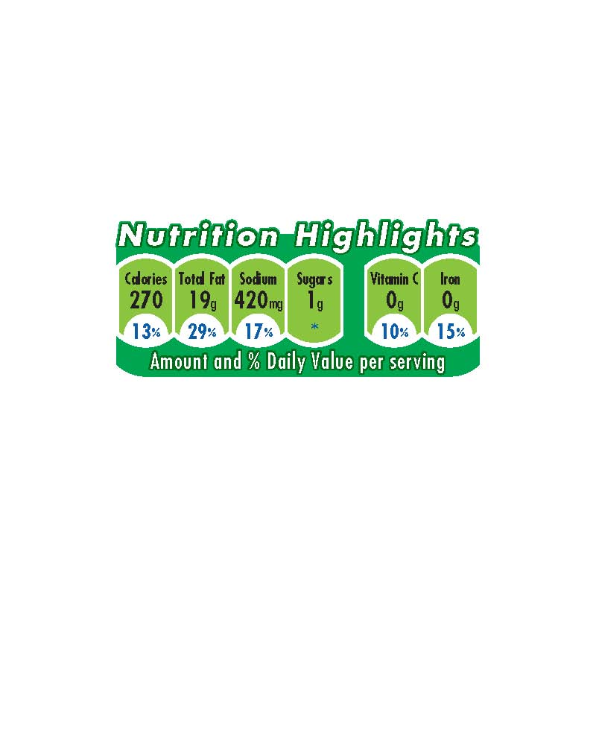

Study 1, Scheme 3
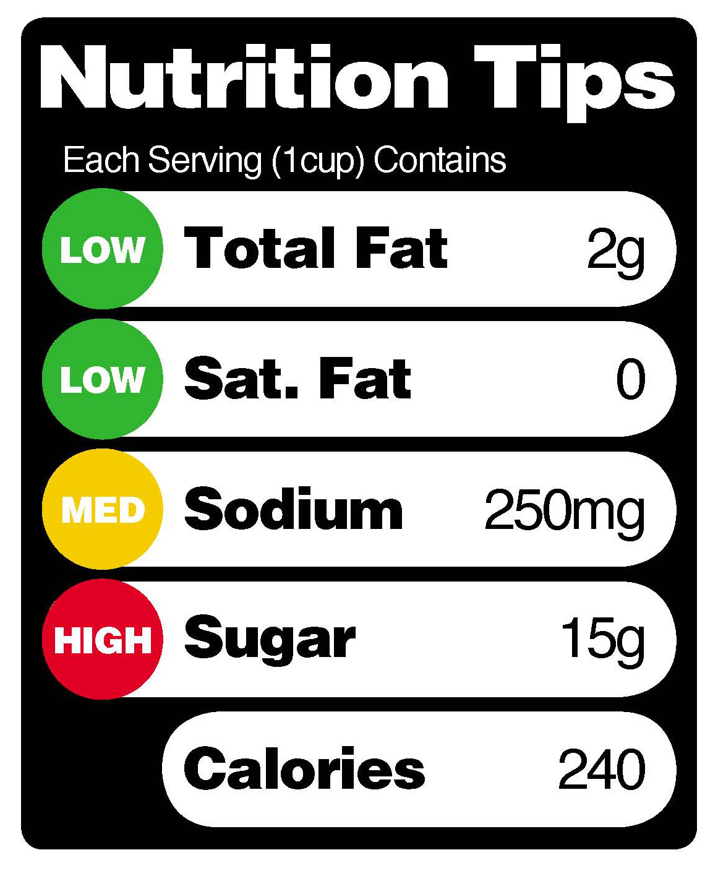

Study 1, Control 1
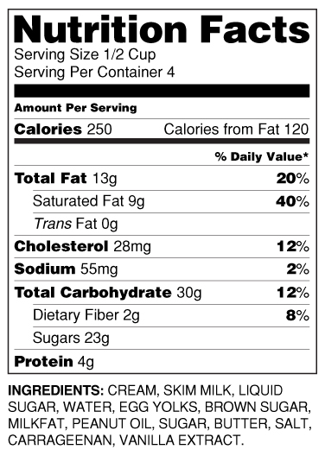

Study 1, Control 2

No symbol on the front of the package

