STUDY 1

Appendix B. Nutrition Labeling Schemes and Examples of Package Fronts for Study 1 (Experimental Study)

Study 1, Scheme 1
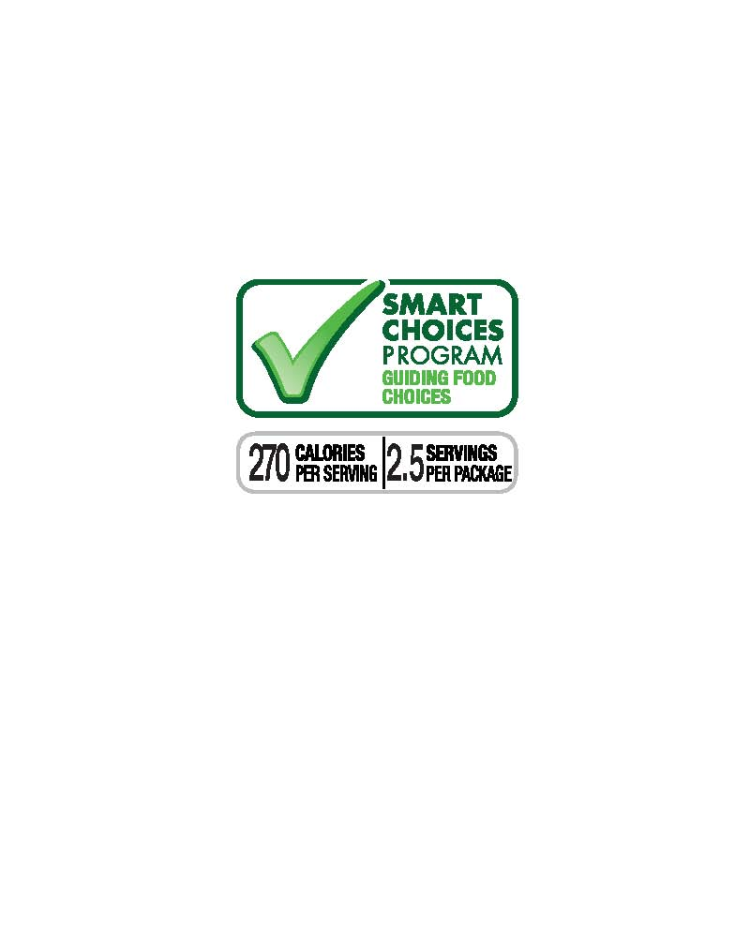
Study 1, Scheme 2
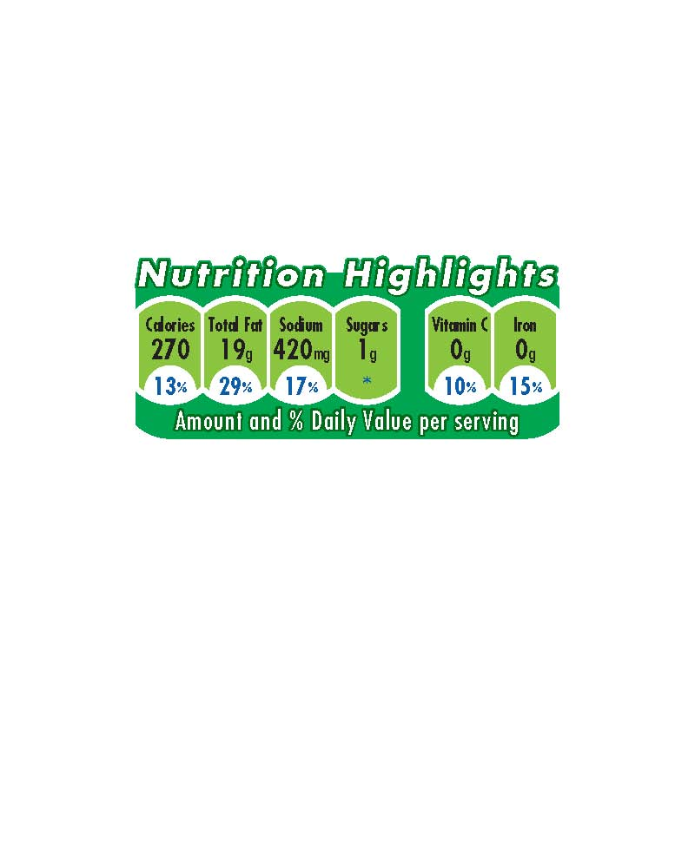

Study 1, Scheme 3
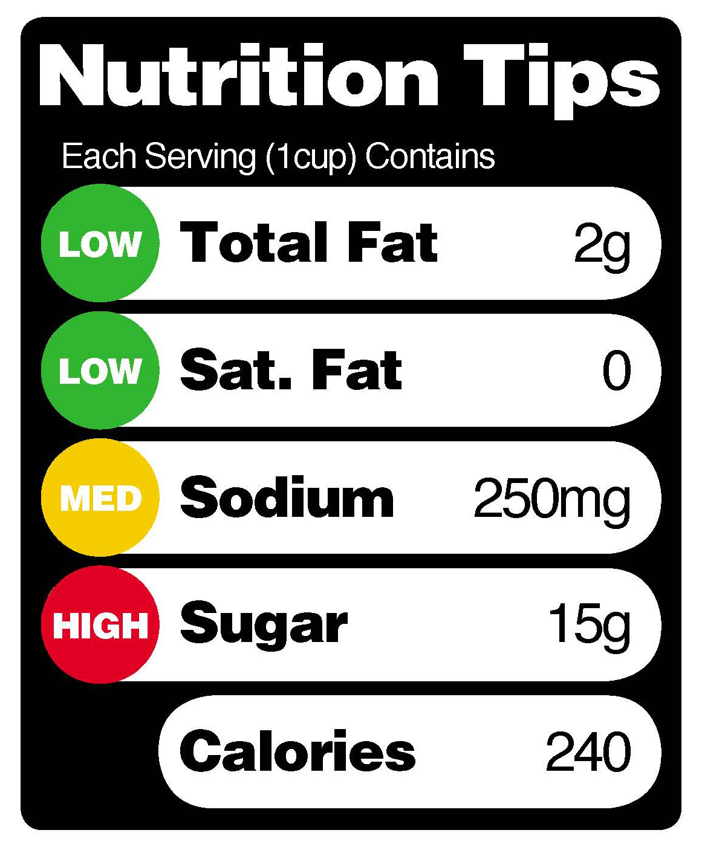

Study 1, Control 1

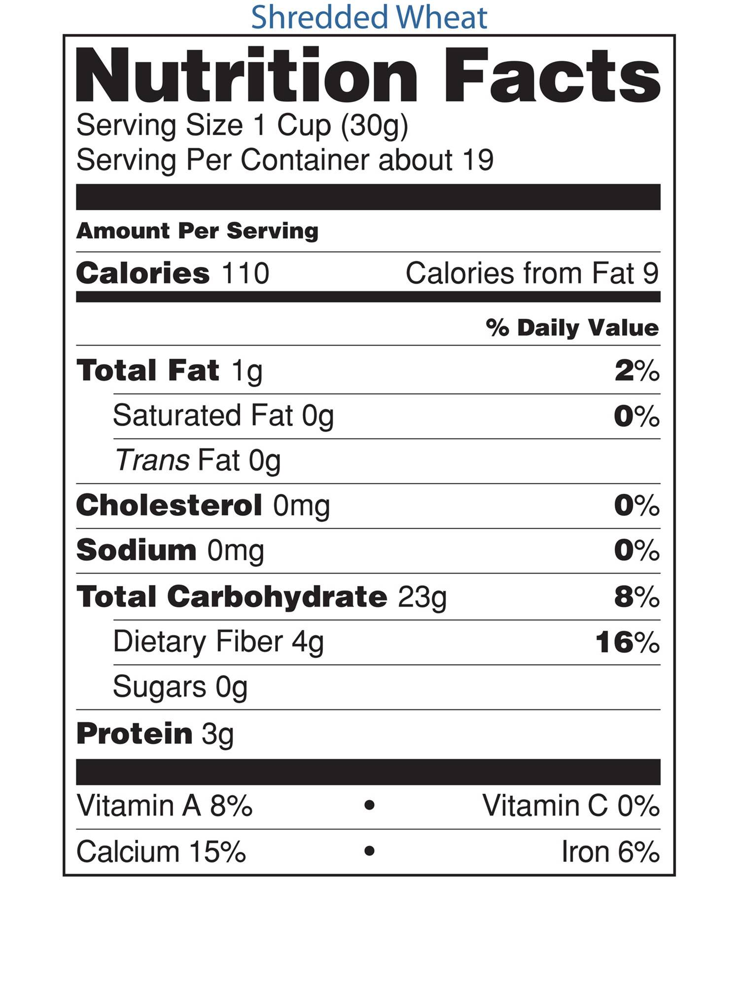

Study 1, Control 2

No symbol on the front of the package

Study 1, Front Package Example 1
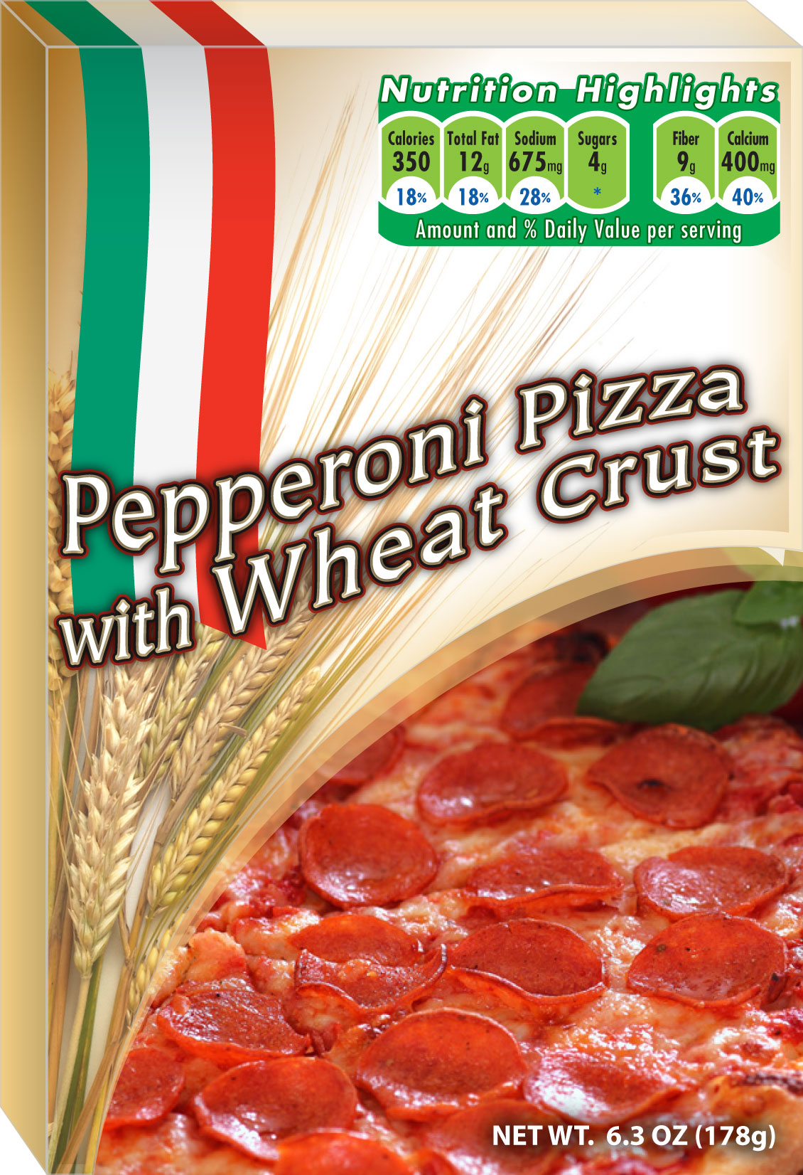

Study 1, Front Package Example 2
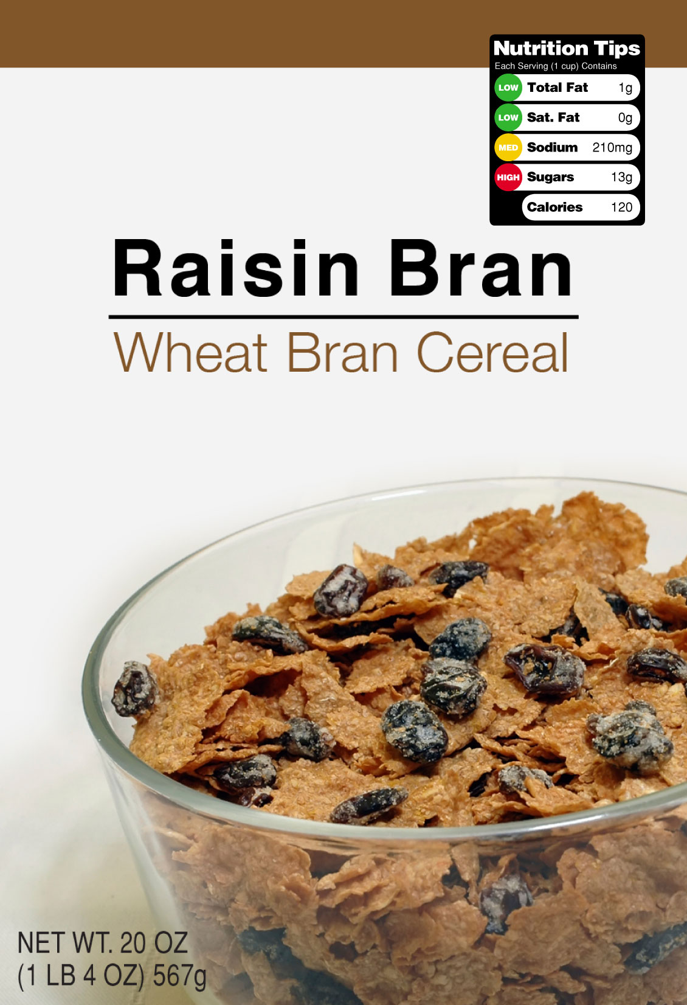
Study 1, Front Package Example 3
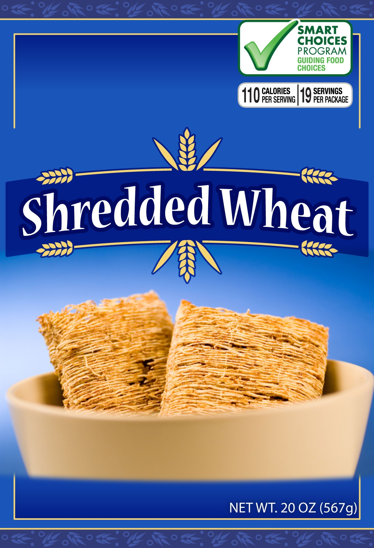

Study 1, Front Package Example 4
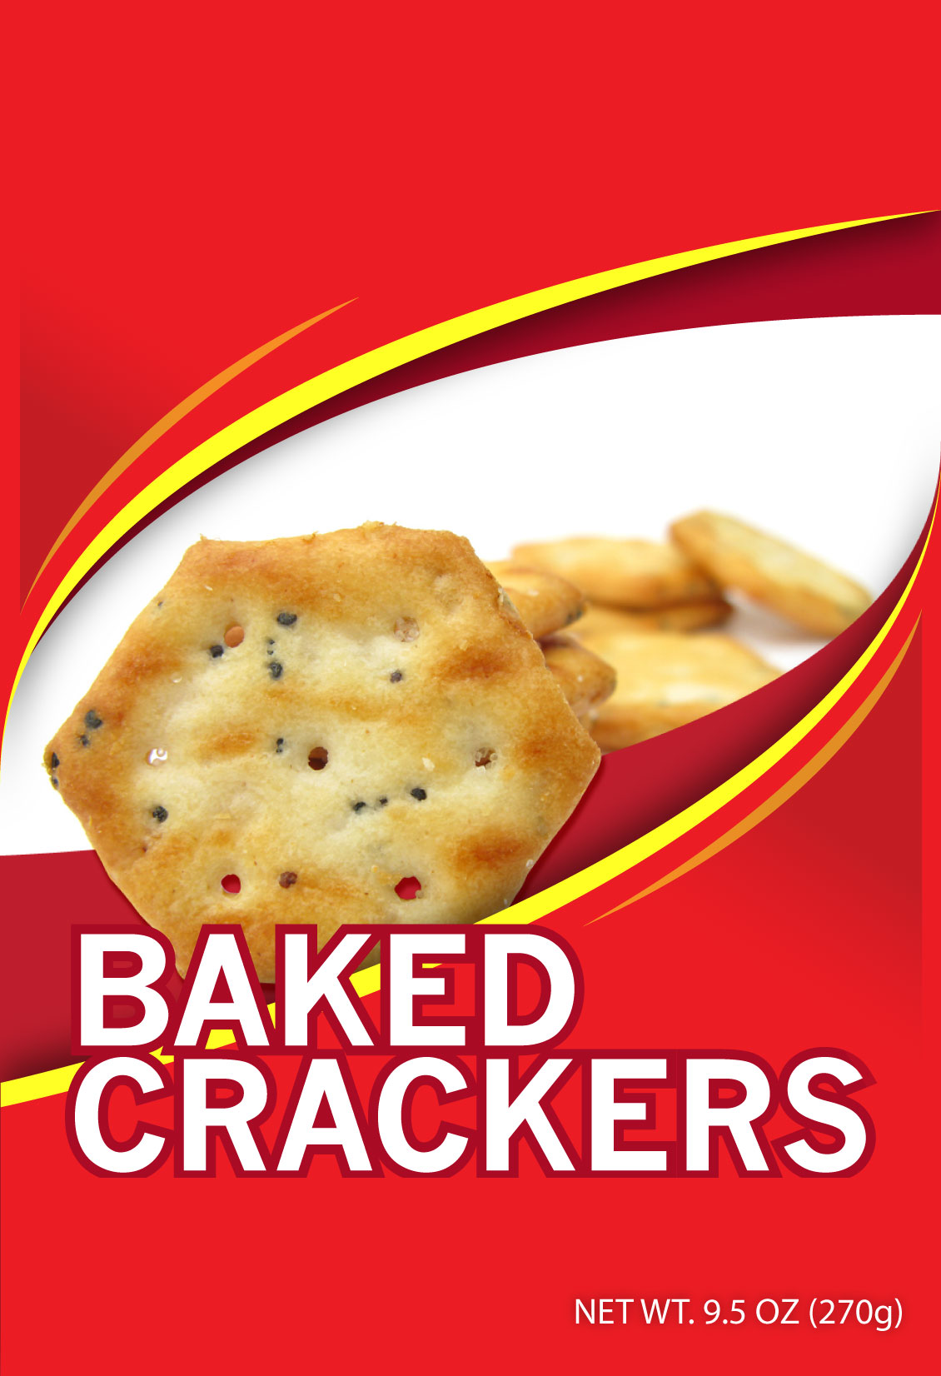

Experimental Studies of Nutrition Symbols on Food Packages

Appendix M

Studies 1

COGNITIVE INTERVIEW SCREENER

Form Approved: OMB No. 0910-0655
Expiration Date: 1/31/2013

PUBLIC Disclosure Burden Statement

Public reporting burden for this collection of information is estimated to average 5 minutes per response, including the time for reviewing instructions, searching existing data sources, gathering and maintaining the data needed, and completing and reviewing the collection of information. An agency may not conduct or sponsor, and a person is not required to respond to, a collection of information unless it displays a currently valid OMB control number. Send comments regarding this burden estimate or any other aspect of this collection of information, including suggestions for reducing this burden, to:
Department of Health and Human Services
Food and Drug Administration
CFSAN/PRB Comments/HFS-24
5100 Paint Branch Parkway
College Park, MD 20740-3835.
An agency may not conduct or sponsor, and a person is not required to respond to, a collection of information unless it displays a currently valid OMB control number.

Hello, my name is xxx and I work for Westat, a local research firm. We're doing research for the Food and Drug Administration about food labels and nutrition. If you are eligible and you agree to participate, we will give you $40 to complete an in-person interview that should last about an hour. In order to find out if you are eligible to be interviewed, I’d like to get some background information.

Before I proceed, I must make sure that you are at least 18 years old.

UNDER 18 :___: [THANK AND END]
18 OR OLDER :___:

1. Do you work either full- or part-time in health services research, or for a food or nutrition company?
YES :___: [THANK AND END]
NO :___:

2. In an average week, how many hours would you say you use the Internet?
NONE: : [THANK AND END]
1 HOUR AND MORE : :
DON’T KNOW :___: [THANK AND END]

3. [RECORD GENDER. IF NOT OBVIOUS, ASK]
Are you male or female?
FEMALE :___:
[RECRUIT 4-5 OF EACH]
MALE :___:

4. What is your age? [CODE INTO ONE OF THE FOLLOWING CATEGORIES].
18-24 :___:
25-39 :___:
40-54 :___:
55-64 :___:
65 OR OLDER :___:
[RECRUIT A MIX]

5. What is the highest level of education that you have completed? [CODE INTO ONE OF THE FOLLOWING CATEGORIES].
LESS THAN A HIGH SCHOOL DIPLOMA :___:
HIGH SCHOOL GRADUATE OR GED :___:
SOME COLLEGE, ASSOCIATES DEGREE :___:
COLLEGE GRADUATE :___:
ADVANCED DEGREE :___:
[RECRUIT 2 WITH HIGH SCHOOL DIPLOMA OR LESS]

6. Are you of Hispanic or Latino origin?
YES: :
NO: :

7. What is your race? You may choose one or more categories as they apply.
WHITE :___:
BLACK OR AFRICAN AMERICAN :___:
ASIAN:___:
NATIVE HAWAIIAN OR OTHER PACIFIC ISLANDER:___:
AMERICAN INDIAN OR ALASKA NATIVE
SOME OTHER RACE (specify)_______________________________________
[RECRUIT 3-4 WHO ARE NOT WHITE]

7. What is your occupation?
______________________________________________________________________

INVITATION
Thank you for answering all my questions. I’d like to invite you to participate in an in-person that will take about an hour to complete. We’ll pay you $40 for your time with us. Let me give you some available times and you tell me what would be best for you.

INTERVIEW DATE AND TIME:
The interview will be held at (location). I would like to send you directions. Where can I send them? Also, may I please have your phone number in case we need to get hold of you for any reason?

COLLECT RESPONDENT NAME, ADDRESS (IF APPLICABLE) AND PHONE
Name: _____________________________________________________________
Address: _____________________________________________________________
City: _________________________________ State: ______ Zip Code: __________
Phone: ________________________________________

In case you need to contact me for any reason, you can reach me at 1-800-xxx-xxxx.
Appendix G. Questionnaire for Study 1 (Cognitive Interview)
Experimental Studies of Nutrition Symbols on Food Packages
Study 1

Questionnaire

Form Approved: OMB No. 0910-0655
Expiration Date: 1/31/2013

PUBLIC Disclosure Burden Statement

Public reporting burden for this collection of information is estimated to average 20 minutes per response, including the time for reviewing instructions, searching existing data sources, gathering and maintaining the data needed, and completing and reviewing the collection of information. An agency may not conduct or sponsor, and a person is not required to respond to, a collection of information unless it displays a currently valid OMB control number. Send comments regarding this burden estimate or any other aspect of this collection of information, including suggestions for reducing this burden, to:
Department of Health and Human Services
Food and Drug Administration
CFSAN/PRB Comments/HFS-24
5100 Paint Branch Parkway
College Park, MD 20740-3835.
An agency may not conduct or sponsor, and a person is not required to respond to, a collection of information unless it displays a currently valid OMB control number.
Thank you for agreeing to help us out today. I appreciate you taking the time to meet with us. My name is ___ and I work here at Westat, a survey research organization. Let me give you a little background information about what we’ll be doing. Westat has been asked by the Food and Drug Administration to help test a survey about food labels and nutrition. The FDA wants to make sure that people understand and can easily answer the questions on the survey. That’s where we’d like your help.
I’m going to have you take the survey, which is on the web, and at the same time find out from you what’s confusing, difficult to understand, or in any way hard to answer. The way I’ll do that is by asking you questions such as what a particular word or phrase means to you, or how you decided on your answers. I’ll also ask you what it was like to work your way through the instrument, navigating the different screens and following the survey instructions.
There are no right or wrong answers to these questions. But what you tell us will help us improve the study. When the questions are easy for people to understand and answer, then the study results are more valid.
If it’s okay with you, I’d like to audio record our interview so that I don’t have to take a lot of detailed notes while we’re talking and can get an accurate record of what you tell me. Only project staff will have access to the audio recording because it will be stored on a secure network drive, and we’ll destroy the recording when our project is finished. Is that okay with you?
You will be paid $40 for helping us out today.
Finally, some of the researchers developing the questions are here today observing our interview to learn if there are things that might need to be changed.
The information you provide will be kept strictly confidential.

Please click the “NEXT” button to begin the survey.

[RANDOM START SECTION B (evaluation of a single product) OR SECTION A (comparison of two products)]

Section A. Comparison of two products
(same product category, and same symbol)

Take a moment to look at these products because you will be asked some questions about them. When you are ready, click on the "CONTINUE" button.

A0. If you were shopping for a [INSERT NAME OF FOOD: CEREAL, SNACK, OR FROZEN MEAL], which of these two products would you be more likely to buy? [ROTATE LEFT-RIGHT POSITON OF THE TWO PRODUCTS]

[Product A, the product on the left]
[Product B, the product on the right]
I can’t tell

A1. Based on what you can see on the labels, if you wanted to buy a healthy product for your family, which of these two products would you select? [USE SAME LEFT-RIGHT POSITION AS IN A1]

[Product A, the product on the left]
[Product B, the product on the right]
I can’t tell [SKIP TO A3]

A2. Why did you decide to choose this product?

[RECORD VERBATIM]__________________

A3. Now we want to ask you a few questions about “the product you chose” [IF ONE OF THE PRODUCTS WAS CHOSEN IN A1] OR “one of the products” [IF ANSWER IN A1 WAS “I can’t tell”]. At any point during the next few questions, you may want to click on the package on the screen to see the Nutrition Facts of the product for more information. [SHOW THE PACKAGE OF THE PRODUCT CHOSEN IN A1. IF ‘CAN’T TELL’ IN A1, SHOW THE PACKAGE OF THE HEALTHIER PRODUCT --- Shredded wheat in the cereal category, baked cracker in the snack category, and Pepperoni pizza in the meal category]

On a scale of 1 to 5 where 1 is strongly disagree and 5 is strongly agree, how much do you agree with the following statements?

 | Strongly disagree  1 | 2 | 3 | 4 | Strongly agree  5
I consider the [INSERT PRODUCT NAME] to be a healthy food
Regularly eating the [INSERT PRODUCT NAME] may raise my risk of gaining weight
Regularly eating the [INSERT PRODUCT NAME] may raise my risk of coronary heart disease
Regularly eating the [INSERT PRODUCT NAME] may raise my risk of high blood pressure
Regularly eating the [INSERT PRODUCT NAME] may raise my risk of diabetes
Regularly eating the [INSERT PRODUCT NAME] will improve my overall diet
If I regularly ate the [INSERT PRODUCT NAME] I would have to be careful about how much of it I ate

A4. Now we want to ask you a few questions about nutrient levels in “the product you chose” [IF ONE OF THE PRODUCTS WAS CHOSEN IN A1] OR “one of the products” [IF ANSWER IN A1 WAS “I can’t tell”]. At any point during the next few questions, you may want to click on the package on the screen to see the Nutrition Facts of the product for more information. [SHOW THE PACKAGE OF THE PRODUCT CHOSEN IN A1. IF ‘CAN’T TELL’ IN A1, SHOW THE PACKAGE OF THE HEALTHIER PRODUCT: Shredded wheat in the cereal category, baked cracker in the snack category, and Pepperoni pizza in the meal category]

On a scale of 1 to 5 where 1 is none or a little and 5 is a lot, how much of each of the following things would you say this product has? [ROTATE ITEMS] [INCLUDE “CALORIES” FOR ALL FOODS; INCLUDE “total fat, sodium, and iron” FOR A SNACK PRODUCT, “total fat, sugar, and fiber” FOR A CEREAL PRODUCT, and “total fat, sodium, Vitamin A” FOR A MEAL PRODUCT]

 | None or a little  1 | 2 | 3 | 4 | A lot  5 | Don’t know
Calories
Total Fat
Sodium
Sugars
Vitamin A
Fiber
Iron

Section B. Evaluation of a single product

B1. Take a moment to look at this product because you will be asked some questions about it. When you are ready, click on the "CONTINUE" button.

B2. Now we want to ask you a few questions about this product. [EXCEPT WHEN THE ‘NUTRITION FACTS’ CONDITION IS ASSIGNED, INSERT:] At any point during this question, you may want to click on the package on the screen to see the Nutrition Facts of the product for more information. On a scale of 1 to 5 where 1 is strongly disagree and 5 is strongly agree, how much do you agree with the following statements.

 | Strongly disagree  1 | 2 | 3 | 4 | Strongly agree  5
I consider the [INSERT PRODUCT NAME] to be a healthy food
Regularly eating the [INSERT PRODUCT NAME] may raise my risk of gaining weight
Regularly eating the [INSERT PRODUCT NAME] may raise my risk of coronary heart disease
Regularly eating the [INSERT PRODUCT NAME] may raise my risk of high blood pressure
Regularly eating the [INSERT PRODUCT NAME] may raise my risk of diabetes
Regularly eating the [INSERT PRODUCT NAME] will improve my overall diet
If I regularly ate the [INSERT PRODUCT NAME] I would have to be careful about how much of it I ate

B3. Now we want to ask you a few questions about nutrient levels in this product. [EXCEPT WHEN THE ‘NUTRITION FACTS’ CONDITION IS ASSIGNED, INSERT:] At any point during this question, you may want to click on the package on the screen to see the Nutrition Facts of the product for more information. On a scale of 1 to 5 where 1 is none or a little and 5 is a lot, how much of each of the following things would you say this product has? [ROTATE ITEMS] [INCLUDE “CALORIES” FOR ALL FOODS; INCLUDE “total fat, sodium, and iron” FOR A SNACK PRODUCT, “total fat, sugar, and fiber” FOR A CEREAL PRODUCT, and “total fat, sodium, Vitamin A” FOR A MEAL PRODUCT]

 | None or a little  1 | 2 | 3 | 4 | A lot  5 | Don’t know
Calories
Total Fat
Sodium
Sugars
Vitamin A
Fiber
Iron

B4. On a scale of 1 to 5 where 1 is not tasty at all and 5 is very tasty. How tasty would you say this product is?

1 = not tasty at all
2
3
4
5 = very tasty

[B5-B7: EXCEPT ‘NO SYMBOL’ OR ‘NUTRITION FACTS’ CONDITION, DISABLE ABILITY TO CLICK ON THE PACKAGE TO SEE BACK PANEL]

B5. On a scale of 1 to 5 where 1 is not helpful at all and 5 is very helpful. How helpful would you say the [INSERT SYMBOL NAME: Nutrition Highlights, Nutrition Tips, Smart Choices Program] symbol is in telling you the nutritional qualities of this product?

1 = not helpful at all
2
3
4
5 = very helpful

B6. On a scale of 1 to 5 where 1 is not helpful at all and 5 is very helpful. How helpful would you say the [INSERT SYMBOL NAME: Nutrition Highlights, Nutrition Tips, Smart Choices Program] symbol is in helping you decide how much to eat this product, if you were to eat it?

1 = not helpful at all
2
3
4
5 = very helpful

B7. On a scale of 1 to 5 where 1 is not trustworthy at all and 5 is very trustworthy. How trustworthy would you say the [INSERT SYMBOL NAME: Nutrition Highlights, Nutrition Tips, Smart Choices Program] symbol is in telling you the nutritional qualities of this product?

1 = not trustworthy at all
2
3
4
5 = very trustworthy

[IF SECTION A WAS THE ASSIGNED AS THE FIRST SECTION, SKIP TO SECTION C. OTHERWISE, GO TO SECTION A]

Section C. Comparison of two products
(different product categories but same symbol)

[EXCEPT THE ‘NUTRITION FACTS’ CONDITION, PROVIDE ABILITY TO CLICK ON THE PACKAGES TO SEE EACH BACK PANEL]

C1. Please take a moment to look at these two products. [EXCEPT WHEN THE ‘NUTRITION FACTS’ CONDITION IS ASSIGNED, INSERT:] you may want to click on the packages on the screen to see the Nutrition Facts of these products for more information. Based on what you can see on the labels, if you wanted to buy a healthy product for your family, which of these two products would you select? [ROTATE LEFT-RIGHT POSITON OF THE TWO PRODUCTS]

[Product A, the product on the left]
[Product B, the product on the right]
I can’t tell

Section D. Other topics on symbols

D1. [ALL PARTICIPANTS EXCEPT THOSE ASSIGNED “NO SYMBOL” OR ‘NUTRITION FACTS’ CONDITION IN SECTION A; SHOW ONLY SYMBOL GRAPHIC; DON’T SHOW FRONT OR NUTRITION FACTS PANEL] Have you seen this symbol before taking this survey?

 | Yes | No | Don’t know
Symbol (shown in Section A)

D2. [IF D1=YES] Have you ever used this symbol [SHOW SYMBOL] to do the following things?

 | Yes | No | Don’t know
To compare how healthy different products are
To find out how much a product has in things like calories, fat, sodium, or vitamins

D3. As far as you know, who decides what food products can show this symbol? You may select more than one answer. [ROTATE MANUFACTURER, RETAILER AND GOVERNMENT]

Yes
Food manufacturer
Food retailer (supermarket)
Government
Other (neither food manufacturer/retailer nor government)
Don’t know

D4. [ALL PARTICIPANTS EXCEPT THOSE ASSIGNED “NO SYMBOL” OR ‘NUTRITION FACTS’ CONDITION IN SECTION B; SHOW ONLY SYMBOL GRAPHIC; DON’T SHOW FRONT OR NUTRITION FACTS PANEL] Have you seen this symbol before taking this survey?

 | Yes | No | Don’t know
Symbol (shown in Section E)

D5. [IF D4=YES] Have you ever used this symbol [SHOW SYMBOL] to do the following things?

 | Yes | No | Don’t know
To compare how healthy different products are
To find out how much a product has in things like calories, fat, sodium, or vitamins

D6. As far as you know, who decides what food products can show this symbol? You may select more than one answer. [ROTATE MANUFACTURER, RETAILER AND GOVERNMENT]

Yes
Food manufacturer
Food retailer (supermarket)
Government
Other (neither food manufacturer/retailer nor government)
Don’t know

Section E. Consumption and purchase

E1. [ALL PARTICIPANTS] First of all, how often do you eat these types of foods in a typical month? Please select one answer for each food. [ROTATE FOODS]

 | Everyday or nearly every day | 2-3 times a week | Once a week | Less than once a week | Never eat it
Food 1
Food 2
Food 3

Note: FOOD 1 is the food category (cereal, snack, or meal) that was asked in Section A; FOOD 2 is the food category that was asked in Section B; FOOD 3 is the other food category (yogurt or salad) that was used in Section C to compare to the food category asked in Section B.

E2. [ALL PARTICIPANTS] In the past six months, did you yourself shop for all, most, some, or none of these foods you ate? Please select one. [USE SAME ORDER OF FOODS AS IN E1]

 | All | Most | Some | None | Don’t eat
Food 1
Food 2
Food 3

[E3-E5: ASK FOOD 1 IF ITS ANSWER IN E2 = ALL/MOST/SOME]
E3. Think about shopping for [FOOD 1] at the store. On a scale of 1 to 5 where 1 is not important at all and 5 very important, how important to you is each of the factors listed below? [ROTATE FACTORS]

 | Not important at all  1 | 2 | 3 | 4 | Very important  5
Price
Brand
Healthiness or nutritional qualities
Taste

E4. At the store, how often do you read labels on [FOOD 1, plural] to compare how healthy or nutritious different [FOOD 1, plural] are?

Regularly
Occasionally
Hardly ever
Never
Don’t know

E5. When you buy a type of [FOOD 1] for the first time, how often do you read the label to find out how much it has in things like calories, fat, sodium, or vitamins?

Regularly
Occasionally
Hardly ever
Never
Don’t know

[E6-E8: ASK FOOD 2 IF ITS ANSWER IN E2 = ALL/MOST/SOME]
E6. Think about shopping for [FOOD 2] at the store. On a scale of 1 to 5 where 1 is not important at all and 5 very important, how important to you is each of the factors listed below? [ROTATE FACTORS]

 | Not important at all  1 | 2 | 3 | 4 | Very important  5
Price
Brand
Healthiness or nutritional qualities
Taste

E7. At the store, how often do you read labels on [FOOD 2, plurals] to compare how healthy or nutritious different [FOOD 2, plural] are?

Regularly
Occasionally
Hardly ever
Never
Don’t know

E8. When you buy a type of [FOOD 2] for the first time, how often do you read the label to find out how much it has in things like calories, fat, sodium, or vitamins?

Regularly
Occasionally
Hardly ever
Never
Don’t know

Section F. Product perception of and familiarity

F1. [ALL PARTICIPANTS] How healthy would you say each of these foods is in general? On a scale of 1 to 5 where 1 is not healthy at all and 5 is very healthy, how healthy is …. [USE SAME ORDER OF FOODS AS IN E1]

 | Not healthy at all  1 | 2 | 3 | 4 | Very healthy  5
Food 1
Food 2
Food 3

[F2-F5, ASK ABOUT FOODS 1 AND 2 ONLY; USE SAME ORDER OF FOODS AS IN F1]

F2. [ALL PARTICIPANTS]

1 | 2 | 3 | (blank) | 4 | 5 | (blank)
Compared to the average consumer, how knowledgeable are you about the average nutritional qualities of [FOOD 1]?
One of the least knowledgeable |  |  |  |  | One of the most knowledge-able
How familiar are you with the average nutritional qualities of [FOOD 1]?
Not at all familiar |  |  |  |  | Extremely familiar

F3. [ALL PARTICIPANTS] Have you ever heard or read that [FOOD 1] may help lower the risk of the following health problems? [ROTATE HEALTH PROBLEMS]

 | Yes | No | Don’t know
Hypertension or high blood pressure
Cancer
Diabetes or high blood sugar
Heart disease
Obesity or overweight

F4. [ALL PARTICIPANTS]

1 | 2 | 3 | (blank) | 4 | 5 | (blank)
Compared to the average consumer, how knowledgeable are you about the average nutritional qualities of [FOOD 2]?
One of the least knowledgeable |  |  |  |  | One of the most knowledge-able
How familiar are you with the average nutritional qualities of [FOOD 2]?
Not at all familiar |  |  |  |  | extremely familiar

F5. [ALL PARTICIPANTS] Have you ever heard or read that [FOOD 2] may help lower the risk of the following health problems? [ROTATE HEALTH PROBLEMS]

 | Yes | No | Don’t know
Hypertension or high blood pressure
Cancer
Diabetes or high blood sugar
Heart disease
Obesity or overweight

Section G. Dietary interests

G2. [ALL PARTICIPANTS] From the list below, which do you try to limit? Select all that apply. [ROTATE ITEMS, EXCEPT “NONE OF THE ABOVE, DON’T KNOW, AND PREFER NOT TO ANSWER”]

Yes
Fat
Carb or carbohydrate
Salt or sodium
Calories
Cholesterol
Sugar
None of the above
Don’t know
Prefer not to answer

[IF G2=NONE OF THE ABOVE/DON’T KNOW/PREFER NOT TO ANSWER, SKIP TO G4. OTHERWISE, GO TO G3]

G3. [SHOW AND ASK ALL ITEMS SELECTED IN G2 EXCEPT “NONE OF THE ABOVE, DON’T KNOW, PREFER NOT TO ANSWER] When did you start trying to limit this/these thing(s)? Was it within the past 3 months or more than 3 months ago?

 | Within the past 3 months | More than 3 months ago | Don’t know | Prefer not to answer
Fat
Carb or carbohydrate
Salt or sodium
Calorie
Cholesterol
Sugar

G4. [ALL PARTICIPANTS] From the list below, which do you try to have enough of? Select all that apply. [ROTATE ITEMS, EXCEPT “NONE OF THE ABOVE, DON’T KNOW, AND PREFER NOT TO ANSWER”]

Yes
Vitamin A
Vitamin C
Calcium
Iron
Fiber
None of the above
Don’t know
Prefer not to answer

G5. [SHOW AND ASK ALL ITEMS SELECTED IN G4 EXCEPT “NONE OF THE ABOVE, DON’T KNOW, PREFER NOT TO ANSWER] When did you start trying to have enough of this/these thing(s)? Was it within the past 3 months or more than 3 months ago?

 | Within the past 3 months | More than 3 months ago | Don’t know | Prefer not to answer
Vitamin A
Vitamin C
Calcium
Iron
Fiber

G6. [ALL PARTICIPANTS] Do you consider yourself to be a vegetarian?

Yes
No
Don’t know
Prefer not to answer

G7. [ALL PARTICIPANTS] Do you have any food allergies?

Yes
No
Don’t know
Prefer not to answer

Section H. Motivation regarding label use

H1. [ALL PARTICIPANTS] On a 1 to 4 scale, where 1 is strongly disagree and 4 is strongly agree. How much do you agree with each of the following statements? Please select one for each statement.

 | Strongly disagree  1 | 2 | 3 | Strongly agree  4 | Don’t know
I feel confident that I know how to use food labels to choose a nutritious diet
The nutrition information on food labels is hard to interpret
Reading food labels takes more time than I can spare
I would like to learn more about how to use food labels to choose a nutritious diet
Using food labels to choose foods would be better than just relying on my own knowledge about what is in them

[THERE IS NO SECTION I]

Section J. Health status and demographics

The next few questions may seem a bit personal, but we need this information because this survey is about nutrition and health.

J1. [ALL PARTICIPANTS] Would you say your health in general is …

excellent
very good
good
fair
poor
Don’t know
Prefer not to answer

J2. [ALL PARTICIPANTS] Are these health problems of concern to you? Please select an answer for each of the health problems. [ROTATE HEALTH PROBLEMS]

 | Yes | No | Don’t know | Prefer not to answer
Cancer
Diabetes
Heart disease
Hypertension or high blood pressure
High cholesterol
Obesity or overweight
Osteoporosis or bone problem
Stroke

J3. [ALL PARTICIPANTS] How tall are you without shoes? Please enter a number in both the “feet” and “inches” or select “prefer not to answer.”

Feet _ [ONE SPACE] Inches _ _ [TWO SPACES]
Prefer not to answer

J4. [ALL PARTICIPANTS] How much do you weight without shoes? Please enter a number in the pounds blank.

Pounds _ _ _ [THREE SPACES]
Prefer not to answer

J5. [ALL PARTICIPANTS] Do you consider yourself to be overweight, underweight, or about the right weight?

Overweight
Underweight
About the right weight
Don’t know
Prefer not to answer

J6. [ALL PARTICIPANTS] What is the highest grade or level of school you have completed or the highest degree you have received? Please select one.

Yes
0 - 11 years or grades
12 years, high school graduate, or GED
1 – 3 years of college or associate degree
4 years of college or college graduate
Postgraduate, masters, doctorate, law degree, MD

J7. [ALL PARTICIPANTS] What year were you born?

19 _ _ [TWO SPACES]

J8. [ALL PARTICIPANTS] Are you …. (please select one)

Female
Male

J9. [ALL PARTICIPANTS] Are you of Hispanic or Latino origin? Please select one.

Yes
No

J10 [ALL PARTICIPANTS] What is your race? You may choose one or more categories as they apply.

Yes
White
Black or African American
Asian
Native Hawaiian or other Pacific Islander
American Indian or Alaska Native
Some other race

Thank you. These are all the questions in this survey. We hope you have enjoyed your participation in the survey.
END
Appendix D. Invitation Emails for Study 1
(Pretest and Experimental Study)
Experimental Studies of Nutrition Symbols on Food Packages
Study 1

INVITATION EMAIL

New Food Survey

Dear Panel Member,

Today I am requesting your participation in an important survey. We are conducting the survey for the Food and Drug Administration (FDA). FDA would like to understand consumers’ opinions about some common food products and find better ways to provide useful information to consumers.

Below you will find the link to the survey. It should take about 15 minutes to complete the survey.

I would appreciate it if this survey could be completed within the next few days.

To participate in this survey, please click on the link below. Or you may copy and paste the entire URL link into the address line of your Internet browser (e.g., Internet Explorer, Netscape, etc.).

Click below to take part in this survey and play the new SurveySpot Instant Win game. You will also be entered into our $25,000 sweepstakes.

[link]

Your opinion makes a difference. Thank you for taking part. If you have questions about this survey, please reference survey number xxxxx.

Cordially

Xxxxxx
Surveyspot.com

Appendix G. Questionnaire for Study 1 (Pretest and Experimental Study)

Experimental Studies of Nutrition Symbols on Food Packages
Study 1

Questionnaire

Form Approved: OMB No. 0910-0655
Expiration Date: 1/31/2013

PUBLIC Disclosure Burden Statement

Public reporting burden for this collection of information is estimated to average 15 minutes per response, including the time for reviewing instructions, searching existing data sources, gathering and maintaining the data needed, and completing and reviewing the collection of information. An agency may not conduct or sponsor, and a person is not required to respond to, a collection of information unless it displays a currently valid OMB control number. Send comments regarding this burden estimate or any other aspect of this collection of information, including suggestions for reducing this burden, to:
Department of Health and Human Services
Food and Drug Administration
CFSAN/PRB Comments/HFS-24
5100 Paint Branch Parkway
College Park, MD 20740-3835.
An agency may not conduct or sponsor, and a person is not required to respond to, a collection of information unless it displays a currently valid OMB control number.
Thank you for agreeing to participate. You will be asked to rate some common food products based on the front and back labels you might see on these products in the store. It usually takes people about 15 minutes to complete the study. The information you provide will be kept strictly confidential.

Please click the “CONTINUE” button to begin the study.

J8. [ALL PARTICIPANTS] Are you …. (please select one)

Female
Male

J7. [ALL PARTICIPANTS] What year were you born?

19 _ _

J9. [ALL PARTICIPANTS] Are you of Hispanic or Latino origin?

Yes
No

J10 [ALL PARTICIPANTS] What is your race? You may choose one or more categories as they apply.

Yes
White
Black or African American
Asian
Native Hawaiian or other Pacific Islander
American Indian or Alaska Native
other

J6. [ALL PARTICIPANTS] What is the highest grade or level of school you have completed or the highest degree you have received? Please select one.

Yes
0 - 11 years or grades
12 years, high school graduate, or GED
1 – 3 years of college or associate degree
4 years of college or college graduate
Postgraduate, masters, doctorate, law degree, MD

[RANDOM START SECTION B (evaluation of a single product) OR SECTION A (comparison of two products)]

Section A. Comparison of two products
(same product category, and same symbol)

[IF THE SURVEY BEGINS WITH SECTION A, DISABLE ‘CLICK’ UNTIL A3. IF THE SURVEY BEGINS WITH SECTION B, ENABLE ‘CLICK’ FOR THE ENTIRE SECTION A.]

Take a moment to look at these products because you will be asked some questions about them. When you are ready, click on the "CONTINUE" button.

A0. If you were shopping for a [INSERT NAME OF FOOD: CEREAL, SNACK, OR FROZEN MEAL], which of these two products would you be more likely to buy? [IF THE SURVEY BEGINS WITH SECTION B, INSERT “Feel free to click on the packages for more information about the products.”] [ROTATE LEFT-RIGHT POSITON OF THE TWO PRODUCTS]

[Product A, the product on the left]
[Product B, the product on the right]
I can’t tell

A1. Based on what you can see on the labels, if you wanted to buy a healthy product for your family, which of these two products would you select? [IF THE SURVEY BEGINS WITH SECTION B, INSERT “Feel free to click on the packages for more information about the products. ”] [USE SAME LEFT-RIGHT POSITION AS IN A1]

[Product A, the product on the left]
[Product B, the product on the right]
I can’t tell [SKIP TO A2a]

A2. Why did you decide to choose [INSERT SELECTED PRODUCT]?

[RECORD VERBATIM]__________________

A2a. Why could you not tell which of the two products you would choose if you wanted to buy a healthy product for your family?

[RECORD VERBATIM]__________________

A3. Now we want to ask you a few questions about “the product you chose” [IF ONE OF THE PRODUCTS WAS CHOSEN IN A1] OR “one of the products” [IF ANSWER IN A1 WAS “I can’t tell”]. At any point during the next few questions, feel free to click on the package for more information about the product. [SHOW THE PACKAGE OF THE PRODUCT CHOSEN IN A1. IF ‘CAN’T TELL’ IN A1, SHOW THE PACKAGE OF THE HEALTHIER PRODUCT --- Shredded wheat in the cereal category, baked cracker in the snack category, and Pepperoni pizza in the meal category]

Please indicate how much do you agree with the following statements?
 | Strongly disagree  1 | 2 | 3 | 4 | Strongly agree  5
I consider the [INSERT PRODUCT NAME] to be a healthy food
Including the [INSERT PRODUCT NAME] as part of my diet may lower my risk of gaining weight
Including the [INSERT PRODUCT NAME] as part of my diet may lower my risk of coronary heart disease
Including the [INSERT PRODUCT NAME] as part of my diet may lower my risk of high blood pressure
Including the [INSERT PRODUCT NAME] as part of my diet may lower my risk of diabetes
Including the [INSERT PRODUCT NAME] as part of my diet will improve my overall diet
If I included the [INSERT PRODUCT NAME] as part of my diet, I would have to be careful about how much of it I ate

A4. Now we want to ask you a few questions about nutrient levels in “the product you chose” [IF ONE OF THE PRODUCTS WAS CHOSEN IN A1] OR “one of the products” [IF ANSWER IN A1 WAS “I can’t tell”]. At any point during the next few questions, feel free to click on the package for more information about the product. [SHOW THE PACKAGE OF THE PRODUCT CHOSEN IN A1. IF ‘CAN’T TELL’ IN A1, SHOW THE PACKAGE OF THE HEALTHIER PRODUCT: Shredded wheat in the cereal category, baked cracker in the snack category, and Pepperoni pizza in the meal category]

On a scale of 1 to 5 where 1 is none or a little and 5 is a lot, how much of each of the following things would you say this product has? [ROTATE ITEMS] [INCLUDE “CALORIES” FOR ALL FOODS; INCLUDE “total fat, sodium, and iron” FOR A SNACK PRODUCT, “total fat, sugar, and fiber” FOR A CEREAL PRODUCT, and “total fat, sodium, Vitamin A” FOR A MEAL PRODUCT]

 | None or a little  1 | 2 | 3 | 4 | A lot  5 | Don’t know
Calories
Total Fat
Sodium
Sugars
Vitamin A
Fiber
Iron

Section B. Evaluation of a single product

B1. Take a moment to look at this product because you will be asked some questions about it. At any point you want to magnify an area on the product image, pass the cursor over it. When you are ready, click on the "CONTINUE" button.

B2. Now we want to ask you a few questions about this product. [EXCEPT WHEN THE ‘NUTRITION FACTS’ CONDITION IS ASSIGNED, INSERT: “At any point during the next few questions, feel free to click on the package for more information about the product.”] On a scale of 1 to 5 where 1 is strongly disagree and 5 is strongly agree, how much do you agree with the following statements.

 | Strongly disagree  1 | 2 | 3 | 4 | Strongly agree  5
I consider the [INSERT PRODUCT NAME] to be a healthy food
Including the [INSERT PRODUCT NAME] as part of my diet may lower my risk of gaining weight
Including the [INSERT PRODUCT NAME] as part of my diet may lower my risk of coronary heart disease
Including the [INSERT PRODUCT NAME] as part of my diet may lower my risk of high blood pressure
Including the [INSERT PRODUCT NAME] as part of my diet may lower my risk of diabetes
Including the [INSERT PRODUCT NAME] as part of my diet will improve my overall diet
If I included the [INSERT PRODUCT NAME] as part of my diet, I would have to be careful about how much of it I ate

B3. Now we want to ask you a few questions about nutrient levels in this product. [EXCEPT WHEN THE ‘NUTRITION FACTS’ CONDITION IS ASSIGNED, INSERT: At any point during this question, feel free to click on the package for more information about the product.”] On a scale of 1 to 5 where 1 is none or a little and 5 is a lot, how much of each of the following things would you say this product has? [ROTATE ITEMS] [INCLUDE “CALORIES” FOR ALL FOODS; INCLUDE “total fat, sodium, and iron” FOR A SNACK PRODUCT, “total fat, sugar, and fiber” FOR A CEREAL PRODUCT, and “total fat, sodium, Vitamin A” FOR A MEAL PRODUCT]

 | None or a little  1 | 2 | 3 | 4 | A lot  5 | Don’t know
Calories
Total Fat
Sodium
Sugars
Vitamin A
Fiber
Iron

B4. On a scale of 1 to 5 where 1 is not tasty at all and 5 is very tasty. How tasty would you say this product is?

1 = not tasty at all
2
3
4
5 = very tasty

[B5-B7: EXCEPT ‘NO SYMBOL’ OR ‘NUTRITION FACTS’ CONDITION, DISABLE ABILITY TO CLICK ON THE PACKAGE TO SEE BACK PANEL]

B5. On a scale of 1 to 5 where 1 is not helpful at all and 5 is very helpful. How helpful would you say the [INSERT SYMBOL NAME: Nutrition Highlights, Nutrition Tips, Smart Choices Program] symbol is in telling you the nutritional qualities of this product?

1 = not helpful at all
2
3
4
5 = very helpful

B6. On a scale of 1 to 5 where 1 is not helpful at all and 5 is very helpful. How helpful would you say the [INSERT SYMBOL NAME: Nutrition Highlights, Nutrition Tips, Smart Choices Program] symbol is in helping you decide how much of this product to eat?

1 = not helpful at all
2
3
4
5 = very helpful

B7. On a scale of 1 to 5 where 1 is not trustworthy at all and 5 is very trustworthy. How trustworthy would you say the [INSERT SYMBOL NAME: Nutrition Highlights, Nutrition Tips, Smart Choices Program] symbol is in telling you the nutritional qualities of this product?

1 = not trustworthy at all
2
3
4
5 = very trustworthy

[IF SECTION A WAS THE ASSIGNED AS THE FIRST SECTION, SKIP TO SECTION C. OTHERWISE, GO TO SECTION A]

Section C. Comparison of two products
(different product categories but same symbol)

[EXCEPT THE ‘NUTRITION FACTS’ CONDITION, PROVIDE ABILITY TO CLICK ON THE PACKAGES TO SEE EACH BACK PANEL]

C1. Take a moment to look at these two products because you will be asked some questions about them. [EXCEPT WHEN THE ‘NUTRITION FACTS’ CONDITION IS ASSIGNED, INSERT: “At any time you want to magnify an area on a product image, pass the cursor over it. Also feel free to click on the packages for more information about the products.”] Based on what you can see on the labels, if you wanted to buy a healthy product for your family, which of these two products would you select? [ROTATE LEFT-RIGHT POSITON OF THE TWO PRODUCTS]

[Product A, the product on the left]
[Product B, the product on the right]
I can’t tell

Section D. Other topics on symbols

D1. [ALL PARTICIPANTS EXCEPT THOSE ASSIGNED “NO SYMBOL” OR ‘NUTRITION FACTS’ CONDITION IN SECTION A; SHOW ONLY SYMBOL GRAPHIC; DON’T SHOW FRONT OR NUTRITION FACTS PANEL] Have you seen this symbol before taking this survey?

 | Yes | No | Don’t know
Symbol (shown in Section A)

D2. [IF D1=YES] Have you ever used this symbol [SHOW SYMBOL] to do the following things?

 | Yes | No | Don’t know
To compare how healthy different products are
To find out how much a product has in things like calories, fat, sodium, or vitamins

D3. As far as you know, who decides what food products can show this symbol? Select all that are appropriate. [ROTATE MANUFACTURER, RETAILER AND GOVERNMENT]

Yes
Food manufacturer
Food retailer (supermarket)
Government
Other
Don’t know

D4. [ALL PARTICIPANTS EXCEPT THOSE ASSIGNED “NO SYMBOL” OR ‘NUTRITION FACTS’ CONDITION IN SECTION B; SHOW ONLY SYMBOL GRAPHIC; DON’T SHOW FRONT OR NUTRITION FACTS PANEL] Have you seen this symbol before taking this survey?

 | Yes | No | Don’t know
Symbol (shown in Section E)

D5. [IF D4=YES] Have you ever used this symbol [SHOW SYMBOL] to do the following things?

 | Yes | No | Don’t know
To compare how healthy different products are
To find out how much a product has in things like calories, fat, sodium, or vitamins

D6. As far as you know, who decides what food products can show this symbol? Select all that are appropriate. [ROTATE MANUFACTURER, RETAILER AND GOVERNMENT]

Yes
Food manufacturer
Food retailer (supermarket)
Government
Other
Don’t know

Section E. Consumption and purchase

E1. [ALL PARTICIPANTS] How often do you eat these types of foods in a typical month? Please select one answer for each food. [ROTATE FOODS]

 | Everyday or nearly every day | 2-3 times a week | Once a week | Less than once a week | Never eat it
Food 1
Food 2
Food 3

Note: FOOD 1 is the food category (cereal, snack, or meal) that was asked in Section A; FOOD 2 is the food category that was asked in Section B; FOOD 3 is the other food category (yogurt or salad) that was used in Section C to compare to the food category asked in Section B.

E2. [ALL PARTICIPANTS] In the past six months, did you yourself shop for all, most, some, or none of these foods you ate? Please select one. [USE SAME ORDER OF FOODS AS IN E1]

 | All | Most | Some | None | Don’t eat
Food 1
Food 2
Food 3

[E3: ASK FOOD 1 IF ITS ANSWER IN E2 = ALL/MOST/SOME]
E3. Think about shopping for [FOOD 1] at the store. On a scale of 1 to 5 where 1 is not important at all and 5 very important, how important to you is each of the factors listed below? [ROTATE FACTORS]

 | Not important at all  1 | 2 | 3 | 4 | Very important  5
Price
Brand
Healthiness or nutritional qualities
Taste

[E6: ASK FOOD 2 IF ITS ANSWER IN E2 = ALL/MOST/SOME]
E6. Think about shopping for [FOOD 2] at the store. On a scale of 1 to 5 where 1 is not important at all and 5 very important, how important to you is each of the factors listed below? [ROTATE FACTORS]

 | Not important at all  1 | 2 | 3 | 4 | Very important  5
Price
Brand
Healthiness or nutritional qualities
Taste

E5. When you buy a food product for the first time, how often do you read the label to find out how much it has in things like calories, fat, sodium, or vitamins?

Regularly
Occasionally
Hardly ever
Never
Don’t know

E4. How often do you read food labels to compare how healthy or nutritious different products are?

Regularly
Occasionally
Hardly ever
Never
Don’t know

Section F. Product perception of and familiarity

F1. [ALL PARTICIPANTS] How healthy would you say each of these foods is in general? On a scale of 1 to 5 where 1 is not healthy at all and 5 is very healthy, how healthy is …. [USE SAME ORDER OF FOODS AS IN E1]

 | Not healthy at all  1 | 2 | 3 | 4 | Very healthy  5
Food 1
Food 2
Food 3

[F2-F5, ASK ABOUT FOODS 1 AND 2 ONLY; USE SAME ORDER OF FOODS AS IN E1]

F2. [ALL PARTICIPANTS]

1 | 2 | 3 | (blank) | 4 | 5 | (blank)
Compared to the average consumer, how knowledgeable are you about the average nutritional qualities of [FOOD 1]?
One of the least knowledgeable |  |  |  |  | One of the most knowledge-able
How familiar are you with the average nutritional qualities of [FOOD 1]?
Not at all familiar |  |  |  |  | Extremely familiar

F3. [ALL PARTICIPANTS] Have you ever heard or read that [FOOD 1] may help lower the risk of the following health problems? [ROTATE HEALTH PROBLEMS]

 | Yes | No | Don’t know
Hypertension or high blood pressure
Cancer
Diabetes or high blood sugar
Heart disease
Obesity or overweight

F4. [ALL PARTICIPANTS]

1 | 2 | 3 | (blank) | 4 | 5 | (blank)
Compared to the average consumer, how knowledgeable are you about the average nutritional qualities of [FOOD 2]?
One of the least knowledgeable |  |  |  |  | One of the most knowledge-able
How familiar are you with the average nutritional qualities of [FOOD 2]?
Not at all familiar |  |  |  |  | extremely familiar

F5. [ALL PARTICIPANTS] Have you ever heard or read that [FOOD 2] may help lower the risk of the following health problems? [ROTATE HEALTH PROBLEMS]

 | Yes | No | Don’t know
Hypertension or high blood pressure
Cancer
Diabetes or high blood sugar
Heart disease
Obesity or overweight

Section G. Dietary interests

G2. [ALL PARTICIPANTS] From the list below, which do you try to limit? Select all that apply. [ROTATE ITEMS, EXCEPT “NONE OF THE ABOVE, DON’T KNOW, AND PREFER NOT TO ANSWER”]

Yes
Fat
Carb or carbohydrate
Salt or sodium
Calories
Cholesterol
Sugar
None of the above
Don’t know
Prefer not to answer

[IF G2=NONE OF THE ABOVE/DON’T KNOW/PREFER NOT TO ANSWER, SKIP TO G4. OTHERWISE, GO TO G3]

G3. [SHOW AND ASK ALL ITEMS SELECTED IN G2 EXCEPT “NONE OF THE ABOVE, DON’T KNOW, PREFER NOT TO ANSWER] When did you start trying to limit this/these thing(s)? Was it within the past 3 months or more than 3 months ago?

 | Within the past 3 months | More than 3 months ago | Don’t know | Prefer not to answer
Fat
Carb or carbohydrate
Salt or sodium
Calorie
Cholesterol
Sugar

G4. [ALL PARTICIPANTS] From the list below, which do you try to have enough of? Select all that apply. [ROTATE ITEMS, EXCEPT “NONE OF THE ABOVE, DON’T KNOW, AND PREFER NOT TO ANSWER”]

Yes
Vitamin A
Vitamin C
Calcium
Iron
Fiber
None of the above
Don’t know
Prefer not to answer

G5. [SHOW AND ASK ALL ITEMS SELECTED IN G4 EXCEPT “NONE OF THE ABOVE, DON’T KNOW, PREFER NOT TO ANSWER] When did you start trying to have enough of this/these thing(s)? Was it within the past 3 months or more than 3 months ago?

 | Within the past 3 months | More than 3 months ago | Don’t know | Prefer not to answer
Vitamin A
Vitamin C
Calcium
Iron
Fiber

G6. [ALL PARTICIPANTS] Do you consider yourself to be a vegetarian?

Yes
No
Don’t know
Prefer not to answer

G7. [ALL PARTICIPANTS] Do you have any food allergies?

Yes
No
Don’t know
Prefer not to answer

Section H. Motivation regarding label use

H1. [ALL PARTICIPANTS] On a 1 to 4 scale, where 1 is strongly disagree and 4 is strongly agree. How much do you agree with each of the following statements? Please select one for each statement.

 | Strongly disagree  1 | 2 | 3 | Strongly agree  4 | Don’t know
I feel confident that I know how to use food labels to choose a nutritious diet
The nutrition information on food labels is hard to interpret
Reading food labels takes more time than I can spare
I would like to learn more about how to use food labels to choose a nutritious diet
Using food labels to choose foods would be better than just relying on my own knowledge about what is in them

[THERE IS NO SECTION I]

Section J. Health status and demographics

The next few questions may seem a bit personal, but we need this information because this survey is about nutrition and health.

J1. [ALL PARTICIPANTS] Would you say your health in general is …

excellent
very good
good
fair
poor
Don’t know
Prefer not to answer

J2. [ALL PARTICIPANTS] Are these health problems of concern to you? Please select an answer for each of the health problems. [ROTATE HEALTH PROBLEMS]

 | Yes | No | Don’t know | Prefer not to answer
Cancer
Diabetes
Heart disease
Hypertension or high blood pressure
High cholesterol
Obesity or overweight
Osteoporosis or bone problem
Stroke

J3. [ALL PARTICIPANTS] How tall are you without shoes? Please enter a number in both the “feet” and “inches” or select “prefer not to answer.”

Feet ___ Inches _ _ _
Prefer not to answer

J4. [ALL PARTICIPANTS] How much do you weight without shoes? Please enter a number in the pounds blank.

Pounds _ _ _
Prefer not to answer

J5. [ALL PARTICIPANTS] Do you consider yourself to be overweight, underweight, or about the right weight?

Overweight
Underweight
About the right weight
Don’t know
Prefer not to answer

Thank you. These are all the questions in this survey. We hope you have enjoyed your participation in the survey.

END
Appendix K. Reminder Email for Study 1 (Pretest and Experimental Study)
Experimental Studies of Nutrition Symbols on Food Packages
Study 1

REMINDER EMAIL

New Food Survey

Dear Panel Member,

Recently, I requested your participation in an important survey that we are doing for the Food and Drug Administration (FDA). FDA would like to understand consumers’ opinions about some common food products and find better ways to provide useful information to consumers.

If the survey has been completed, please accept my thanks. If not, I would like you to complete this particular survey.

I would appreciate it if this survey could be completed within the next few days. It should take about 15 minutes to complete.

Click below to take part in this survey and play the new SurveySpot Instant Win game. You will also be entered into our $25,000 sweepstakes.

[link]

Your opinion makes a difference. Thank you for taking part. If you have questions about this survey, please reference survey number xxxxx.

Cordially

Xxxxxx
Surveyspot.com

Appendix E. Invitation Email for Study 1 (Eye-tracking Study)

Experimental Studies of Nutrition Symbols on Food Packages
Study 1

EYE-TRACKING INVITATION EMAIL

Form Approved: OMB No. 0910-0655
Expiration Date: 1/31/2013

PUBLIC Disclosure Burden Statement

Public reporting burden for this collection of information is estimated to average 5 minutes per response, including the time for reviewing instructions, searching existing data sources, gathering and maintaining the data needed, and completing and reviewing the collection of information. An agency may not conduct or sponsor, and a person is not required to respond to, a collection of information unless it displays a currently valid OMB control number. Send comments regarding this burden estimate or any other aspect of this collection of information, including suggestions for reducing this burden, to:
Department of Health and Human Services
Food and Drug Administration
CFSAN/PRB Comments/HFS-24
5100 Paint Branch Parkway
College Park, MD 20740-3835.
An agency may not conduct or sponsor, and a person is not required to respond to, a collection of information unless it displays a currently valid OMB control number.
Dear [first name],

EyeTracking, Inc. is currently recruiting participants for a new paid research study regarding some food products, and we need your opinions. This eyetracking appointment will take place [study dates]. Each session will last up to an hour and you will be compensated $40 for your time. If you live in or near San Diego and are interested in participating...

1. Please go to http://www.eyetracking.com/study (“study” TBD)
2. Click on the orange "Click here to sign up now" link.
3. Enter your username and password to access the screener
4. Then just answer a few questions to see if you qualify.

If you qualify, you will be given a chance to sign up. If not, we will continue to keep you posted on other studies.

NOTE: All information you provide will remain strictly confidential.

Thanks!

The EyeTracking, Inc. Research Team

- In which age group do you fall? [RECRUIT A MIX ACROSS THE STUDY]

Under 18 [THANK AND TERMINATE]
18-34
35-54
55-64
65 or older
Prefer not to answer [THANK AND TERMINATE]

- What is your gender? [RECRUIT A MIX ACROSS THE STUDY]

Male
Female

- What is your highest level of education? [RECRUIT A MIX ACROSS THE STUDY]

0 - 11 years or grades
12 years, high school graduate, or GED
1 - 3 years of college or associate degree
4 years of college or college graduate
Postgraduate, masters, doctorate, law degree, MD
Prefer not to answer [THANK AND TERMINATE]

4. Are you of Hispanic or Latino origin?

Yes
No
Prefer not to answer

5. What is your race? You may choose one or more categories as they apply. [RECRUIT A MIX ACROSS THE STUDY]

White
Black or African American
Asian
Native Hawaiian or other Pacific Islander
American Indian or Alaska Native
Other

- Do you wear corrective lenses? [CHECK ALL THAT APPLY]

No, I do not wear glasses or contacts
Yes, I wear regular glasses
Yes, I wear bifocals [THANK AND TERMINATE]
Yes, I wear soft contact lenses
Yes, I wear hard contact lenses [THANK AND TERMINATE]
Prefer not to answer

[IF ELIGIBLE]
Congratulations, you have qualified for this study.
Please select a time you would like to come in.
1. Select Day | 2. Select Time
Date TBD | Select a day to view the times for that day.
If none of these times are acceptable click HERE to be added to the waiting list.

Appendix H. Questionnaire for Study 1 (Eye-tracking Study)

Experimental Studies of Nutrition Symbols on Food Packages
Study 1

EYE-TRACKING QUESTIONNAIRE

Form Approved: OMB No. 0910-0655
Expiration Date: 1/31/2013

PUBLIC Disclosure Burden Statement

Public reporting burden for this collection of information is estimated to average 1 hour per response, including the time for reviewing instructions, searching existing data sources, gathering and maintaining the data needed, and completing and reviewing the collection of information. An agency may not conduct or sponsor, and a person is not required to respond to, a collection of information unless it displays a currently valid OMB control number. Send comments regarding this burden estimate or any other aspect of this collection of information, including suggestions for reducing this burden, to:
Department of Health and Human Services
Food and Drug Administration
CFSAN/PRB Comments/HFS-24
5100 Paint Branch Parkway
College Park, MD 20740-3835.
An agency may not conduct or sponsor, and a person is not required to respond to, a collection of information unless it displays a currently valid OMB control number.
Thank you for signing up to participate in the study that we are doing for the Food and Drug Administration (FDA). FDA would like to understand consumers’ opinions about some common food products and find better ways to provide useful information to consumers. Today you will be asked to view some images of food packages. We will ask you some questions about the packages you see. While you are looking at the images on the screen, we will be recording audio and using eye-tracking cameras to collect visual behavior data. All of the recordings will remain confidential and your name will not be associated with any findings from this study. Do you have any questions?

You will now be asked to view some images of food packages. Please look at each image for as long as you like, and feel free to click on the package to view the back or side panel of the package. Later, we will ask you some questions about the packages you see.
Do you have any questions?

.
Click continue to see the first package. Remember, you can click on this package if you would like to see the back or side panel. When you have looked at the package for as long as you want, just say “okay” and we’ll move on to the next one.

A0. [IMAGE # 1, A SINGLE PRODUCT. SHOW ONE PRACTICE PRODUCT AND SIX TEST PRODUCTS. SELF-ADMINISTRATION BY RESPONDENT]

[SELF-ADMINISTRATION BY RESPONDENT]
[IMAGE # 2, TWO PRODUCTS OF THE SAME CATEGORY AND SAME SYMBOL; SHOW SEVEN PAIRS]

You will now be shown two products side by side. For each pair, which product is more healthy (nutritious), or are they about the same? Again, you can click on the package to see the back or side panel. Click “continue” to begin and then when you are ready, just say you answer out loud.

B1. Which product is more healthy (nutritious), or are they about the same? [PRODUCT A(B) IS THE PRODUCT SHOWN ON THE LEFT(RIGHT); RANDOMIZE POSITION OF A AND B]

[Product A] is more healthy
[Product B] is more healthy
They are about the same
Don’t know

[INTERVIEWER ASKS THIS QUESTION AND RECORDS ANSWER]
B2. Can you explain how you came to your answer?

__________________________________

Now, you will be asked to look at products and answer questions about them. Again, you can click on the package to see the back or side panel. Click “continue” to see the first question.
A1. On a scale of 1 to 5 where 1 is none or a little and 5 is a lot, how much of each of the following things would you say this product has? [ROTATE ITEMS] [INCLUDE “CALORIES” FOR ALL FOODS; INCLUDE 3 OTHER ITEMS PER ASSIGNMENT TABLE]

 | None or a little  1 | 2 | 3 | 4 | A lot  5 | Don’t know
Calories
Total Fat
Sodium
Sugars
Vitamin C
Vitamin A
Fiber
Calcium

A2. On a scale of 1 to 6 where 1 is not healthy (nutritious) at all and 6 is very healthy (nutritious). How healthy would you say this product is?

1 = Not healthy at all
2
3
4
5
6 = Very healthy
Don’t know

A3. On a scale of 1 to 5 where 1 means "very likely to raise the risk" and 5 means "very likely to lower the risk," how likely is this product to raise or lower the risk of each of these health problems or does the product have no effect on the risk? [IN THE SCALE LABELS, PUT “RAISE” AND “LOWER” IN BLUE FONT, SAME AS IN THE QUESTION STEM]

 | Very likely to raise the risk  1 | Somewhat likely to raise the risk  2 | No effect on the risk  3 | Somewhat likely to lower the risk  4 | Very likely to lower the risk  5 | Don’t know
Heart disease
High blood pressure or hypertension
Diabetics or high blood sugar
Cancer
Obesity or overweight

A4. On a scale of 1 to 6 where 1 is not tasty at all and 6 is very tasty. How tasty would you say this product is?

1 = not tasty at all
2
3
4
5
6 = very tasty
Don’t know

A5. How likely would you be to consider including this product in your diet if you want to eat a healthier diet?

1 = Definitely would not consider including this product
2
3
4
5
6 = Definitely would consider including this product
Don’t know

[INTERVIEWER ASKS THIS QUESTION AND RECORDS ANSWER]
A5a. Can you explain how did you decide how likely you would or would not consider including this product in your diet if you want to eat a more nutritious diet?

__________________________________

A6. On a scale of 1 to 6 where 1 is very helpful and 6 is not helpful at all. How helpful would you say this label is in telling you the nutritional qualities of this product ?

1 = not helpful at all
2
3
4
5
6 = very helpful
Don’t know

[REPEAT A1-A6 FOR ANOTHER PRODUCT]

[SELF-ADMINISTRATION BY RESPONDENT]
[SHOW THE NUTRITION FACTS LABEL FOR A “DAIRY PRODUCT”]

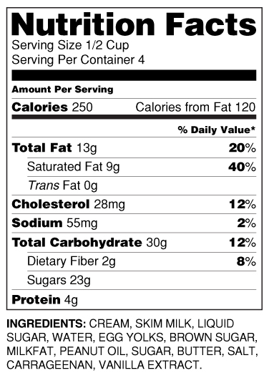

D1. Please look at this label as long as you like. The next six questions will be about this label. [PAUSE] If you eat the entire container, how many calories will you eat?

_ _ _ _

D2. If you are allowed to eat 60 g of carbohydrates as a snack, how much of this product could you have?

__

D3. If your doctor advises to reduce the amount of saturated fat in your diet. You usually have 42 g of saturated fat each day, which includes 1 serving of this product. If you stop eating this product, how many grams of saturated fat would you be consuming each day?

_ _

D4. If you usually eat 2,500 calories in a day, what percentage of your daily value of calories will you be eating if you eat one serving of product?

_ _

D5. Pretend that you are allergic to the following substances: penicillin, peanuts, latex gloves, and bee stings. Is it safe for you to eat this product?

Yes
No
Don’t know

[INTERVIEWER ASKS THIS QUESTION AND RECORDS ANSWER]
D6. [ASK IF ANSWER TO “IS IT SAFE FOR YOU TO EAT …” WAS NO.] Why is it not safe for you to eat this product?

___________________________________

[SELF-ADMINISTRATION BY RESPONDENT]
[SHOW IMAGE 1 AND ITS NUTRITION FACTS LABEL WHILE ASKING E1-E5]
E1. Next, we have some questions about one of the products you saw. How often do you eat [FOOD] in a typical month?

Everyday or nearly every day
2-3 times a week
Once a week
Less than once a week
Never eat
Don’t know

E2. In the past six months, did you yourself shop for all, most, some, or none of the [FOOD] you ate?

All
Most
Some
None
Don’t eat it
Don’t know

[E3-E5: ASK IF E2 = ALL/MOST/SOME]
E3. Think about shopping for this type of [FOOD] at the store. On a scale of 1 to 6 where 1 is not important at all and 6 very important, how important to you is each of the factors listed below?

 | Not important at all  1 | 2 | 3 | 4 | 5 | Very important  6 | Don’t know
Price
Brand
Healthiness or nutritional qualities
Taste

E4. At the store, how often do you read labels on [FOOD, plural] to compare how healthy or nutritious different [FOOD, plural] are?

Regularly
Occasionally
Hardly ever
Never
Don’t know

E5. When you buy a type of [FOOD] for the first time, how often do you read the label to find out how much it has in things like calories, fat, sodium, or vitamins?

Regularly
Occasionally
Hardly ever
Never
Don’t know

[INTERVIEWER ASKS THIS QUESTION AND RECORDS ANSWER]
E6. A few minutes ago, you were asked how nutritious this product was and how much this product has in things like calories, fat, sugars, and vitamins. How did you feel about finding the information you needed to answer these questions, was it easy or hard? Can you say more?

_________________________________

These are all the questions I have today. Thank you for your participation.
Appendix J. Pretest Questions

Experimental Studies of Nutrition Symbols on Food Packages

PRETEST QUESTIONS

EV1. Please indicate how frequently you have encountered the following problems in going through the survey.

 | Always | Often | Sometimes | Only occasionally | Never
Instruction is not clear
Question is not clear
Question is difficult to answer
Answer options are confusing
Answer options don’t make sense
Questions are repetitive

EV2. Please indicate your level of agreement with these two statements.

 | Strongly agree | Somewhat agree | Somewhat disagree | Strongly disagree
I enjoyed doing this survey
I found this survey more difficult than other surveys I have done in the Surveyspot panel

EV3. Please provide any other comments you may have about this survey.

______________________________ [RECORD VERBATIM ANSWERS]

