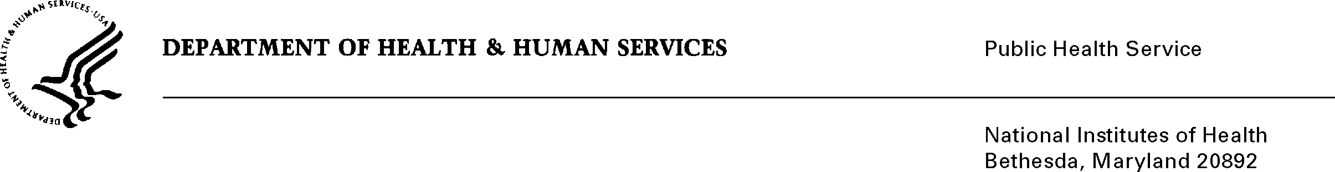

**DATE:** May 3, 2010

**TO:** George J. Nemo, Ph.D.

Transfusion Medicine Branch

National Heart, Lung and Blood Institute (NHLBI)

**FROM:** NIH Privacy Act Officer

**SUBJECT:** Applicability of the Privacy Act: “Investigating the Causes of Post Donation Information (PDI): Errors in the Donor Screening Process (NHLBI)”

I have reviewed the NHLBI submission to OMB entitled, “Investigating the Causes of Post Donation Information (PDI): Errors in the Donor Screening Process (NHLBI),” to collect information regarding the knowledge, attitudes, behaviors and beliefs about the donor health history process.

I have determined that the Privacy Act will apply to this data collection which involves the collection of personally identifiable information such as name, address, contact information, mailing address, level of education completed, and type of occupation. The interviews will be digitally-recorded and the recordings uploaded onto computers as dss files; these files will be transcribed and then coupled to the interviewer notes to form an analytic package for the data analysts. The contact information will only be used by the Coordinating Center (Westat) for the purpose of contacting blood donors for the study interview and Westat will destroy all personal identifying information upon completion of the study and none of this information will be linked to the interview process.

This data collection is covered by NIH Privacy Act Systems of Record 09-25-0156, “Records of Participants in Programs and Respondents in Surveys Used to Evaluate Programs of the Public Health Service, HHS/PHS/NIH/OD.”

If you have any questions, please contact my office at (301) 402-6201.

Karen M. Plá

Attachment