

Fact Sheet
Transition to 10-Fingerprint Collection

The Department of Homeland Security (DHS) is transitioning from collecting two
fingerprints—digital and inkless—to collecting 10 fingerprints from foreign travelers to the United States.

This transition is being led by DHS’ US-VISIT program that provides the technology and analysis of the fingerprints. By collecting 10-fingerprints, DHS supplies immigration and law enforcement officers with comprehensive, biometrics-based information upon which they can make decisions.

The 10-fingerprint enrollment process will happen either when a traveler is entering the country (regardless if the traveler is under the Visa Waiver Program or carrying a visa) or at a U.S. Embassy when applying for a visa.

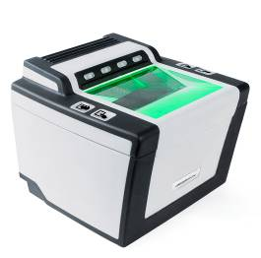
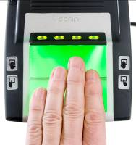
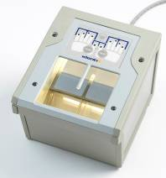
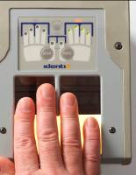
When the decision was made to collect 10-fingerprints, DHS challenged industry to develop the next generation scanners, and improve the size and speed of current scanners. Industry met the challenge and developed smaller, faster, mobile and higher-quality 10-fingerprint scanners to meet the program’s needs of improving the security of the country, while facilitating legitimate travel and trade.

Cross Match Technologies L SCAN® GUARDIAN™

IDENTIX Touch Print 4100 Enhanced Definition Device

These scanners will be evaluated during a pilot program of the 10-fingerprint collection capability at 10 selected U.S. airports launching in late 2007. The following airports are expected to be part of the pilot: Boston Logan International Airport, Chicago O’Hare International Airport, Detroit Metropolitan Wayne County Airport, Hartsfield-Jackson Atlanta International Airport, George Bush Houston Intercontinental Airport, Miami International Airport, John F. Kennedy International Airport, Orlando International Airport, San Francisco International Airport and Washington Dulles International Airport.

Long term, DHS and the Department of State plan to deploy 10-fingerprint scanners to replace current two-fingerprint scanners located at all air, sea and land ports of entry, and all U.S. embassies and consulates.

Additionally, the transition to 10-fingerprint collection is a crucial step toward establishing interoperability between the US-VISIT program’s Automated Biometric Identification System (IDENT) and the FBI’s Integrated Automated Fingerprint Identification System (IAFIS) fingerprint databases.

For more information on US-VISIT, please go to www.dhs.gov/US-VISIT

