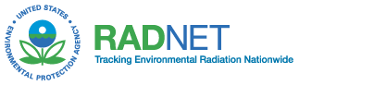 | UNITED STATES ENVIRONMENTAL PROTECTION AGENCY  NATIONAL AIR AND RADIATION ENVIRONMENTAL LABORATORY  540 SOUTH MORRIS AVENUE  MONTGOMERY, AL 36115-2601  PHONE: (334) 270-3400 FAX: (334) 270-3454

RADNET PRECIPITATION REPORT

SECTION I: STATION INFORMATION

COLLECTION DATE: STATION #:

STATION LOCATION:

STATION OPERATOR:

TELEPHONE: EMAIL:

SECTION II: SAMPLE INFORMATION

DID COLLECTION BUCKET OVERFLOW? YES NO

TYPE OF PRECIPITATION: RAIN_______ SNOW_______ OTHER (Specify)__________________

VOLUME COLLECTED (LITERS):

COMMENTS:

FOR USE BY NAREL PERSONNEL ONLY:

DATE REQUEST RECEIVED: DATE REQUEST PROCESSED:

REQUEST PROCESSED BY:

