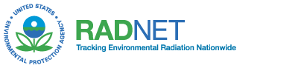 | UNITED STATES ENVIRONMENTAL PROTECTION AGENCY  NATIONAL AIR AND RADIATION ENVIRONMENTAL LABORATORY  540 SOUTH MORRIS AVENUE  MONTGOMERY, AL 36115-2601  PHONE: (334) 270-3400 FAX: (334) 270-3454

RadNet Drinking Water Report

1. Date of Collection:
2. Quarter: (CIRCLE ONE) Jan-Mar Apr-Jun Jul-Sep Oct-Dec Year:
3. Station (City,State):
4. Tap Location:
5. Name of Collector:
6. Office Address:

7. Shipping Address:

8. Telephone: 9. FAX:
10. Comments:

□ Please check here if reporting change of address or collector.
(CIRCLE ONE)

