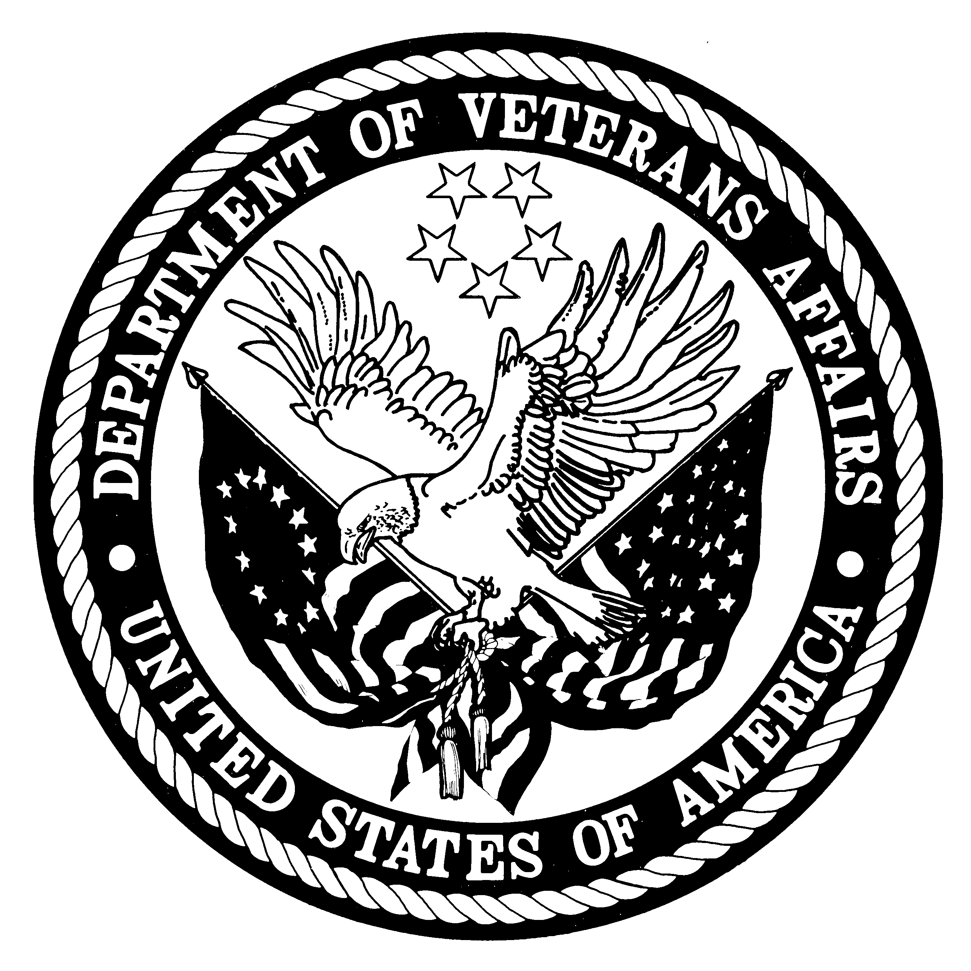
DEPARTMENT OF VETERANS AFFAIRS
Veterans Health Administration
Washington, DC 20420

<<DOCTOR NAME>>
<<FACILITY NAME>>
<<ADDRESS>>
<<CITY>>, <<STATE>> <<ZIP>>

Attn: Medical Records

Dear Health Care Provider or Medical Records Administrator,

The U.S. Department of Veterans Affairs (VA) is conducting a research study called the “Follow-up study of a National Cohort of Gulf War and Gulf Era Veterans.” As a part of this study, we are requesting that you send us <<VETERAN NAME>>’s medical records describing a visit for <<REASON FOR VISIT>> that occurred between <<MONTH, YEAR>> and <<MONTH, YEAR>>. Enclosed is a Consent Form for Release of Medical Records signed by the Veteran, allowing you to send us a copy of these records.

Data collection for this study is being conducted by a research firm under a contract with VA. We have enclosed a postage-paid envelope addressed to the research firm for you to send the requested records. Alternatively, you can FAX the records to (fax number). If there is a charge for photocopies, you may include an invoice with the requested records and the study will pay for the cost. Alternatively, you may wish to send us a letter verifying the condition and visit date.

If you have any questions, please call a study representative at 1-877-###-### between the hours of 8:00 am to 5:00 pm Eastern Standard Time, Monday through Friday. We will follow up with you to determine the status of this request. Please let us know if you do not have these records or if there is another place to request these records.

Your prompt attention to our request is greatly appreciated. Thank you for your cooperation with this very important study.

Sincerely,

Steven S. Coughlin, Ph.D.
Principal Investigator
Follow-up Study of a National Cohort of Gulf War and Gulf Era Veterans
Department of Veterans Affairs

