2010 Business Permits Survey (BPS)
Main menu: ¹
¹This main menu screen is currently just a shell and there will be a “start” button under “Action” and additional information will be added under each column header.
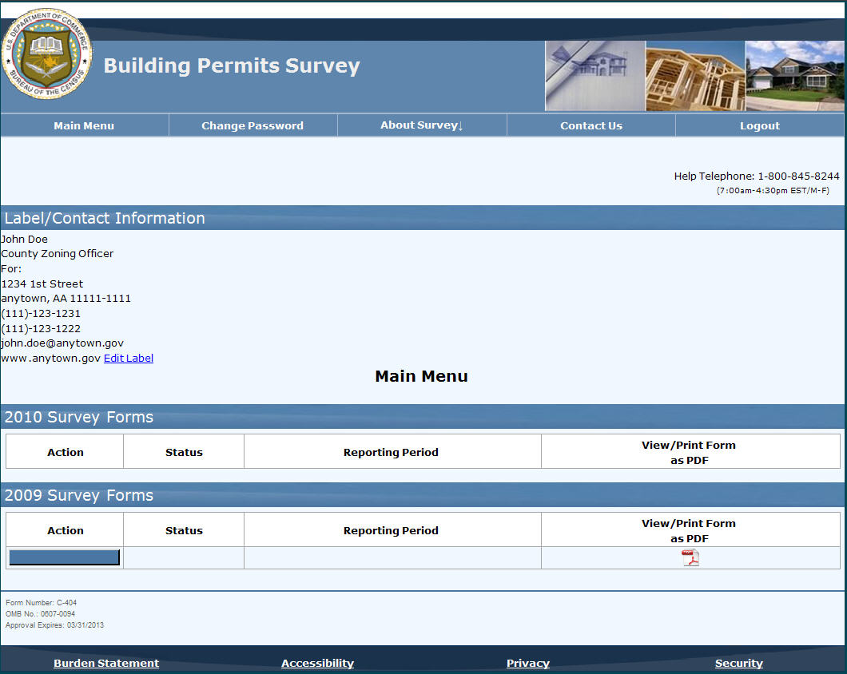

Example question screen: ²
²The contact information that is on file will be pre-printed above this question.
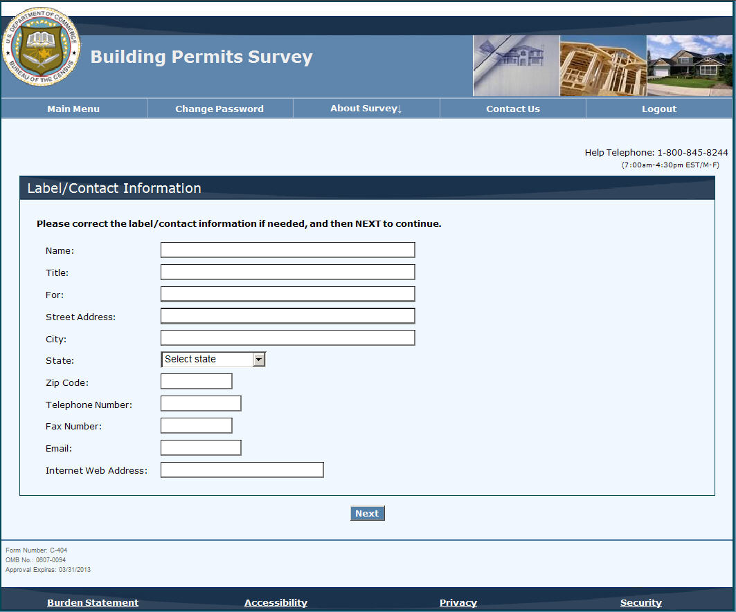

Example question screen: ³
³The wording presenting the various examples will be made consistent (“i.e.” vs. “for example”).
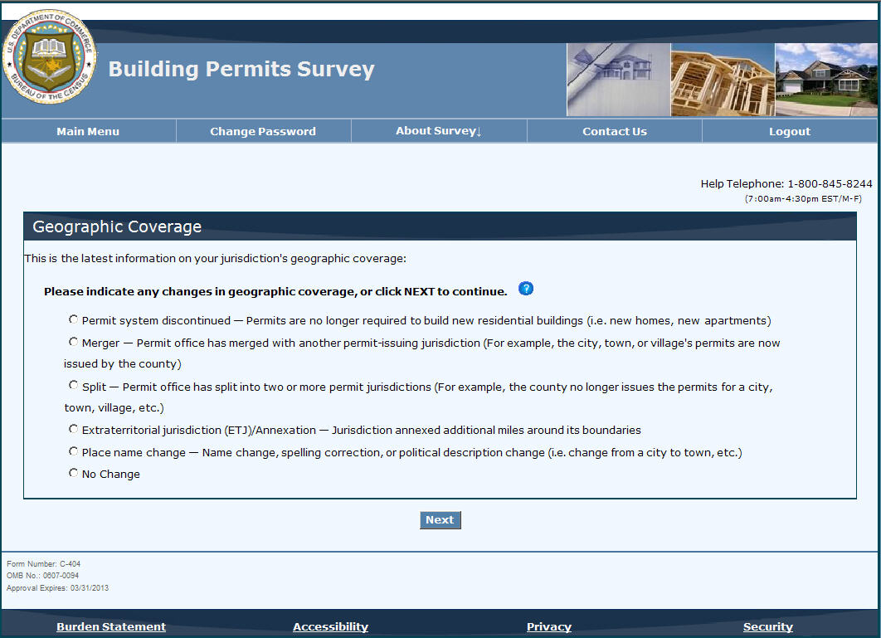

Example question screen:
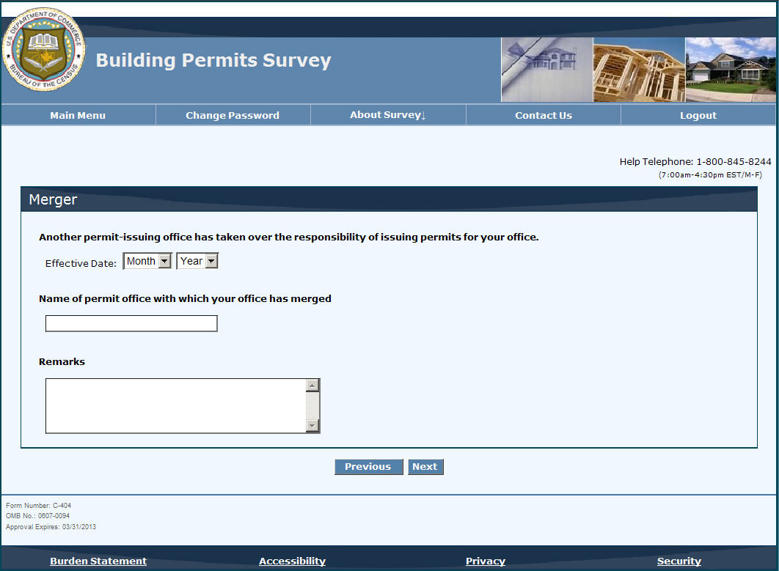

Example question screen:
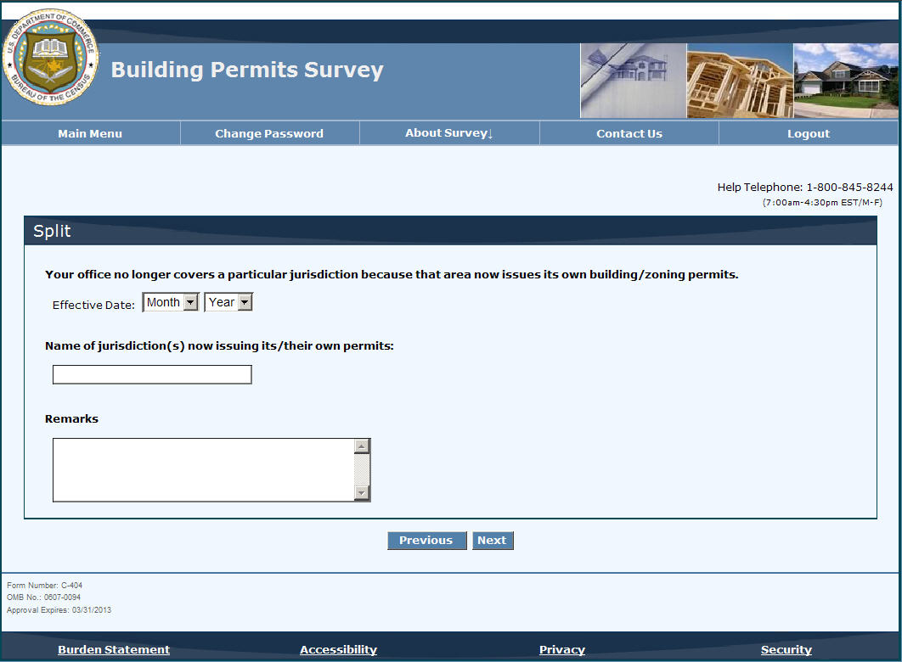
Example question screen: ⁴
⁴The large text box under “Define ETJ or annexation in miles” will be replaced with “__________ miles.”
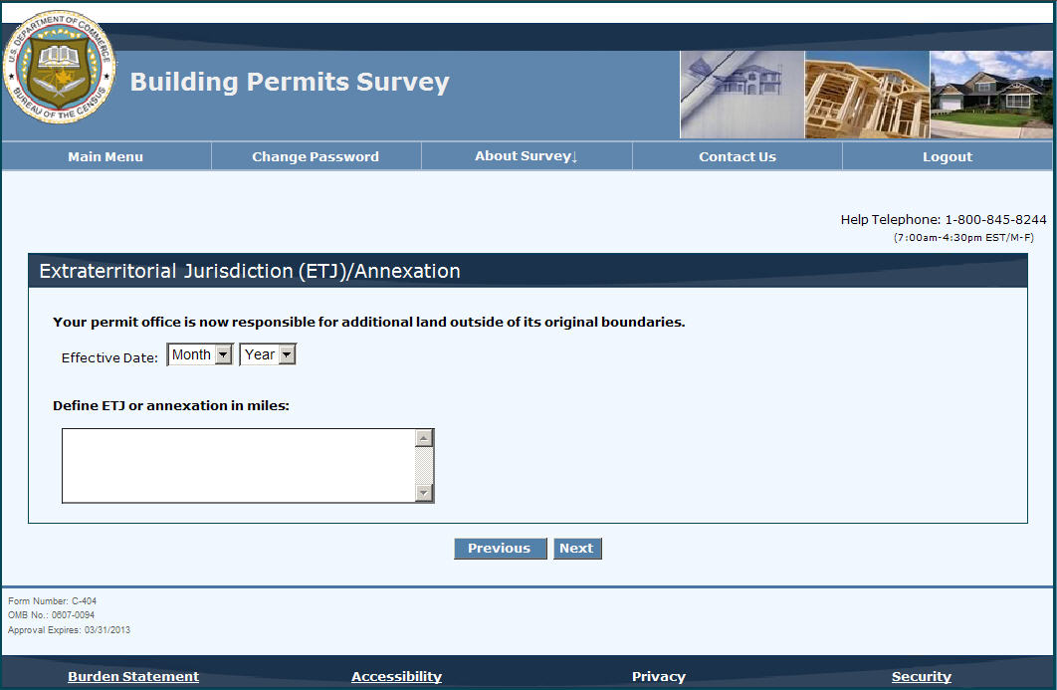

Example question screen: ⁵
⁵The title of this page, “Valuation Table,” will be changed to something more recognizable;
the items will be lettered correctly (starting with “a” instead of “b”);
the questions will be changed to better match the response boxes;
and the “.(“ before each of the last response boxes will be deleted.
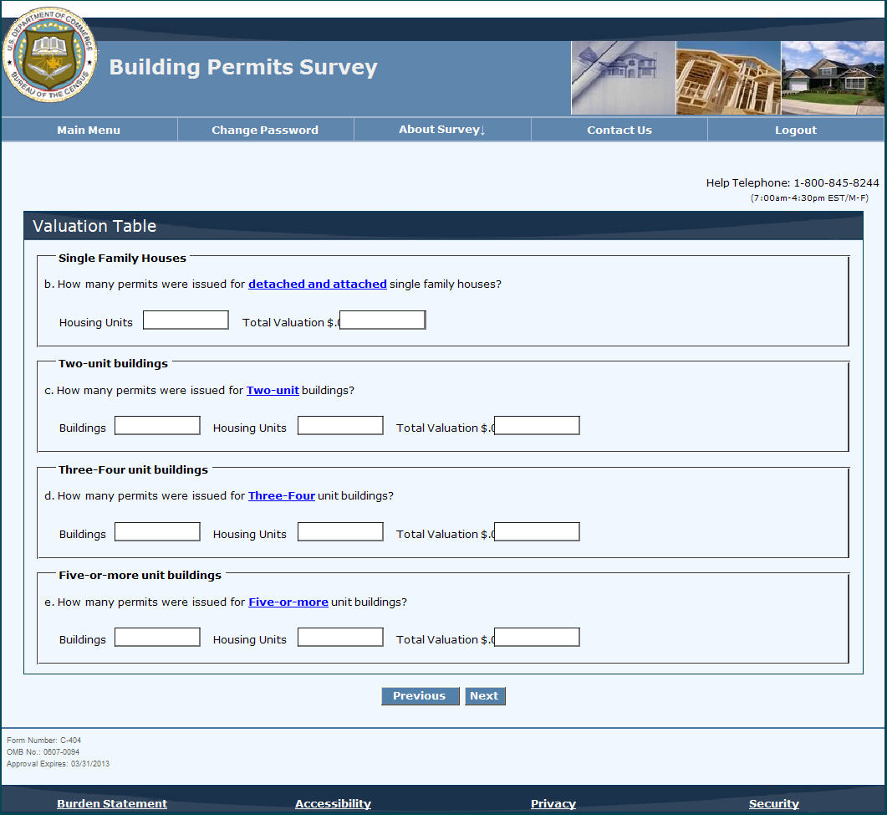

Review screen: ⁶
⁶All individual pages will be listed on this page and pages with errors will be indicated.
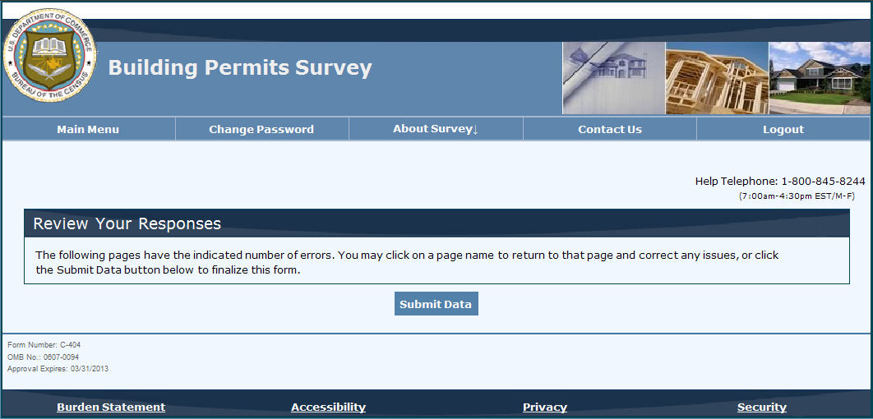
Example question screen:
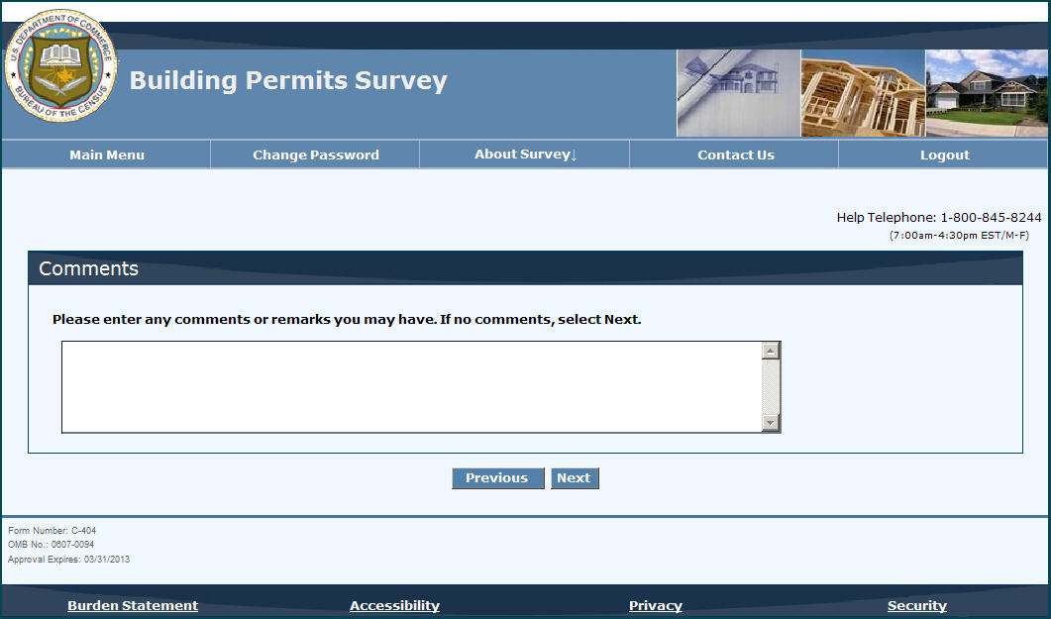

Submission confirmation screen:⁷
⁷The submission confirmation screen will look similar to the submission confirmation screen for the Annual Wholesale Trade Report. The company information and contact person will be completed. The label of “company information” will be replaced with “business permit office information” or similar label.
