**Construction Project Report Survey Screen Shots**

Main menu:

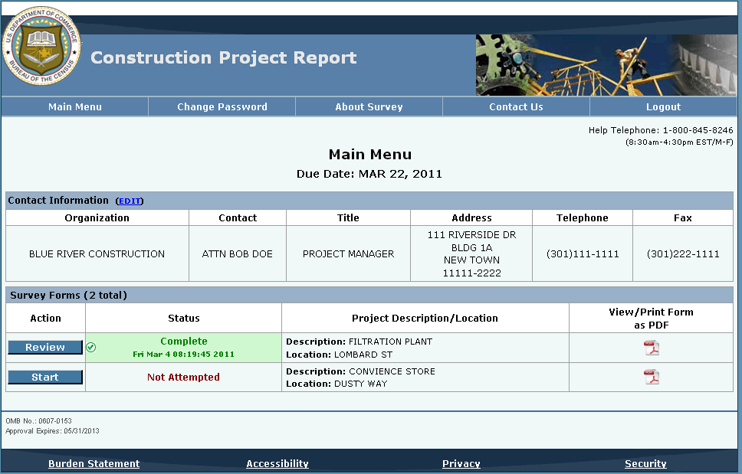

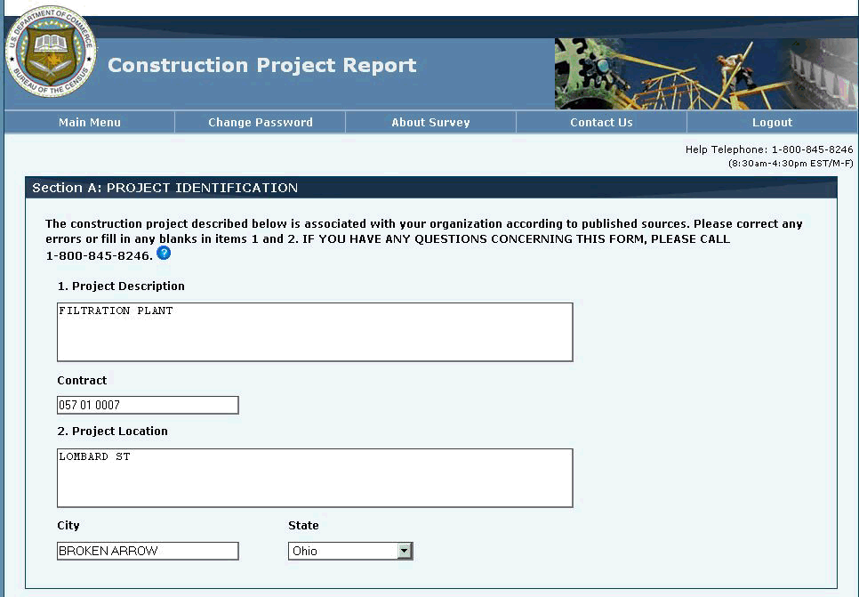Example question screen (Section A & B):

Example question screen (Section A & B cont.):

Example question screen (Section C & D):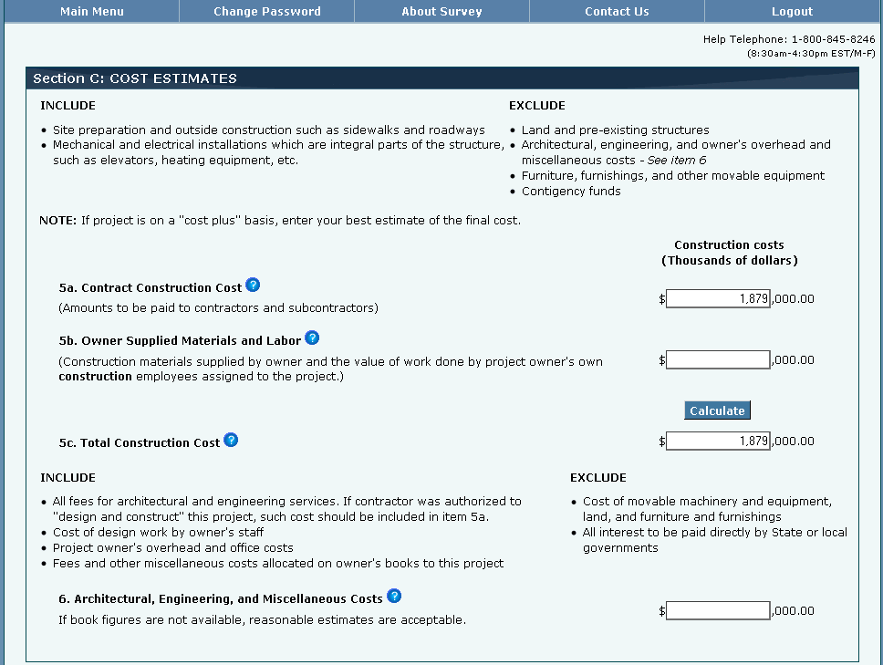

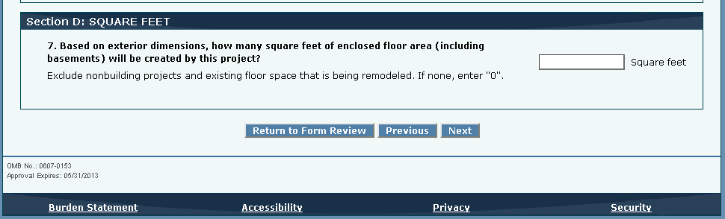 Example question screen (Section C & D cont.):

Example question screen (SectionE):

Example question screen (Section E & F):

Review screen:

