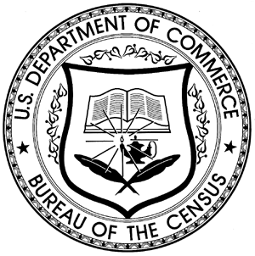
CONSENT TO PARTICIPATE IN A
U. S. CENSUS BUREAU RESEARCH STUDY

Each year the Census Bureau conducts many different surveys. The goal of this project is to ask you questions on how you use communication technologies, and your perception of participating in a survey. We will use the information you provide to improve the survey approach used in one of the Census Bureau’s Survey for students.

Thank you for volunteering to take part in this research. In order to have a complete record of your comments, this focus group will be audio recorded. THE ANSWERS YOU GIVE US ARE STRICTLY CONFIDENTIAL. Only Census Bureau staff and contract researchers will review this information and no information will be released to anyone outside of that staff which could associate your name with any of your answers.

This study is being conducted under the authority of Title 13 United States Code. The Office of Management and Budget (OMB) control number for this study is 0607-0725. This valid approval number legally certifies this information collection.

CONSENT:

I have volunteered to participate in the Census Bureau’s study, and I give permission for the audio recordings to be used as described above.

____________________________________________
Signature

____________________________________________
Printed Name

_______/_______/ 2011
Date

