**Advanced Monthly Retail Trade Survey (MARTS) & Monthly Retail Trade Survey (MRTS) Screen Shots**

Login Screen

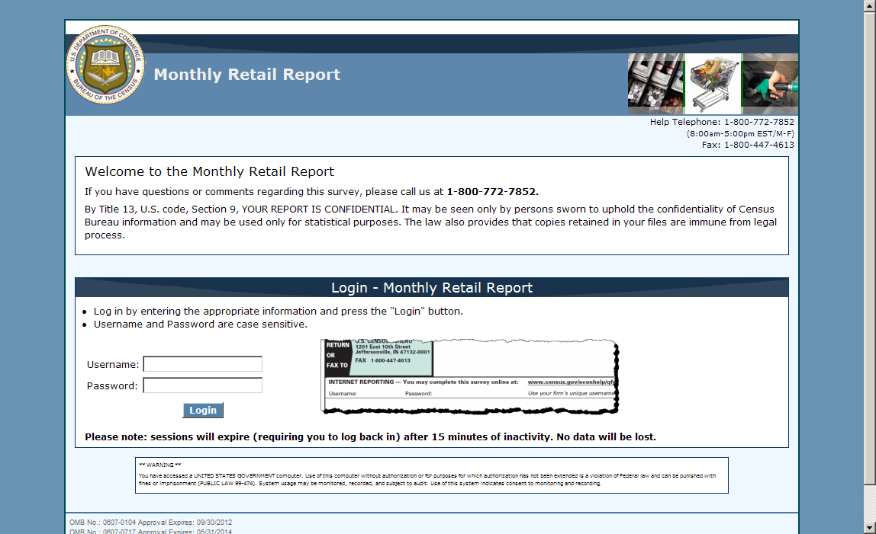

Main Menu screen (under construction)

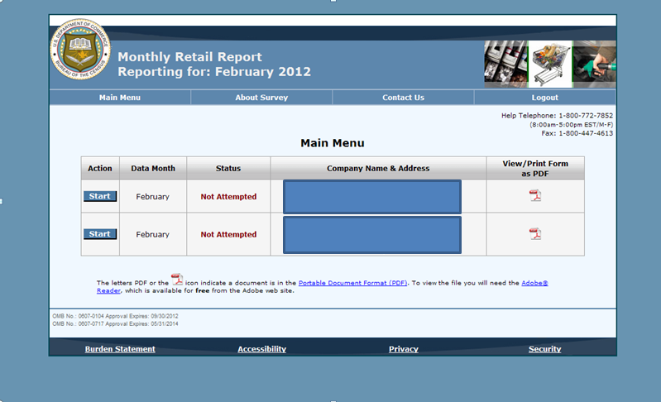

Contact Information Screen

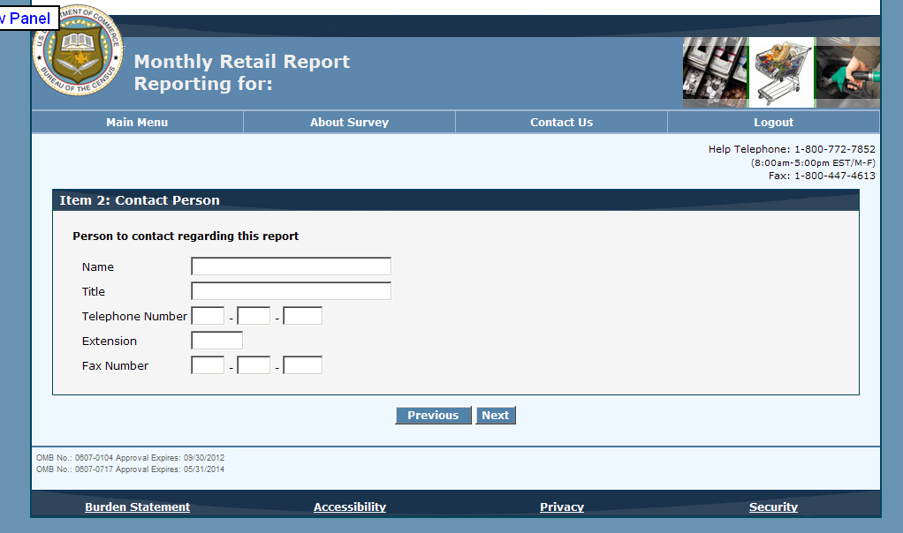

Sales Item

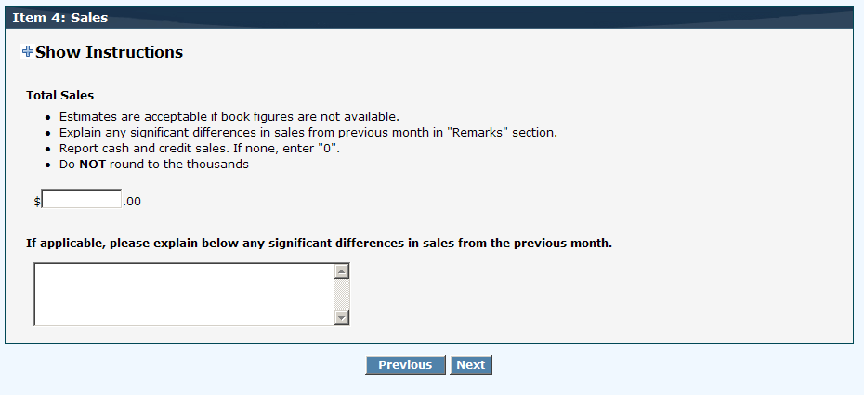

Sales Item for Department Stores

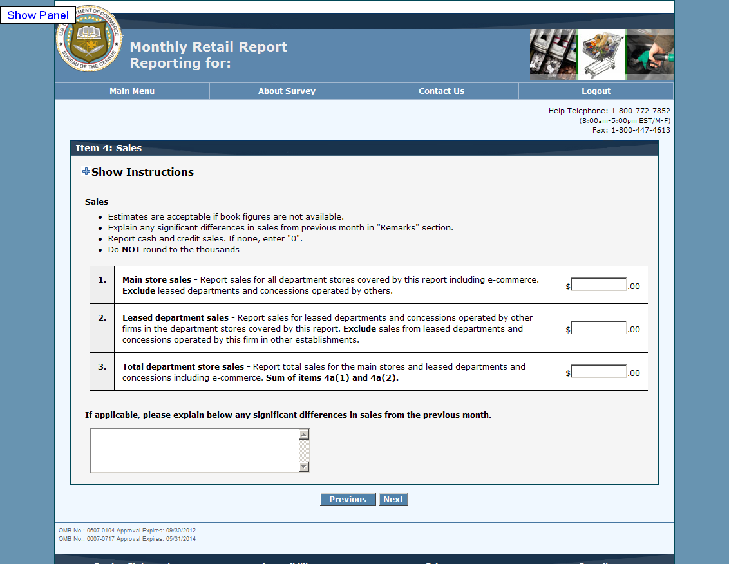

Inventory Item

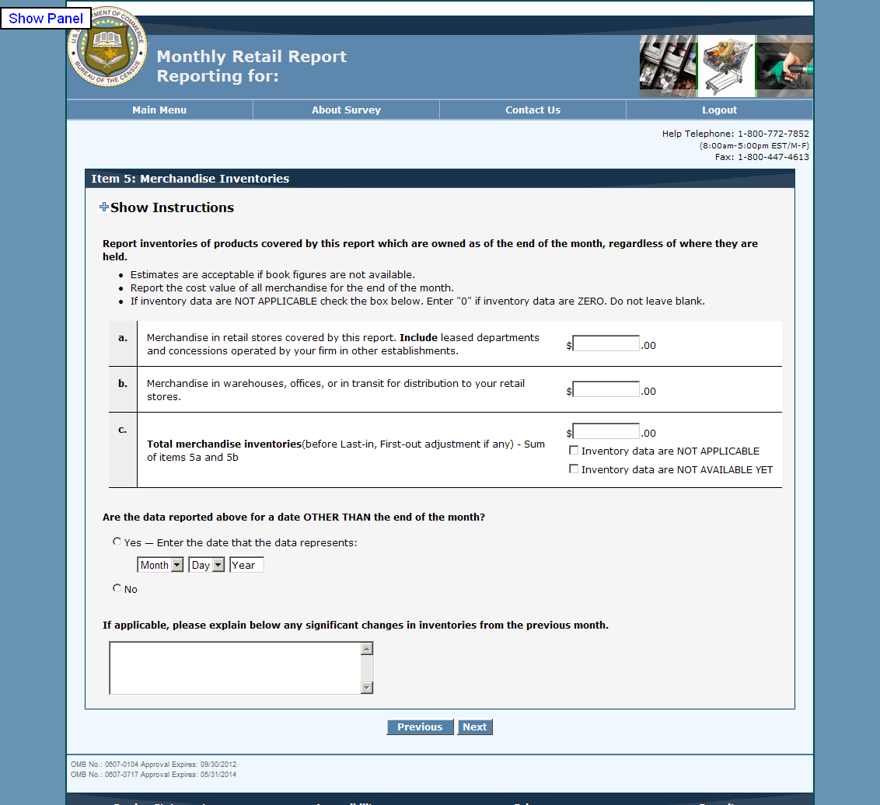

Reporting Period Item

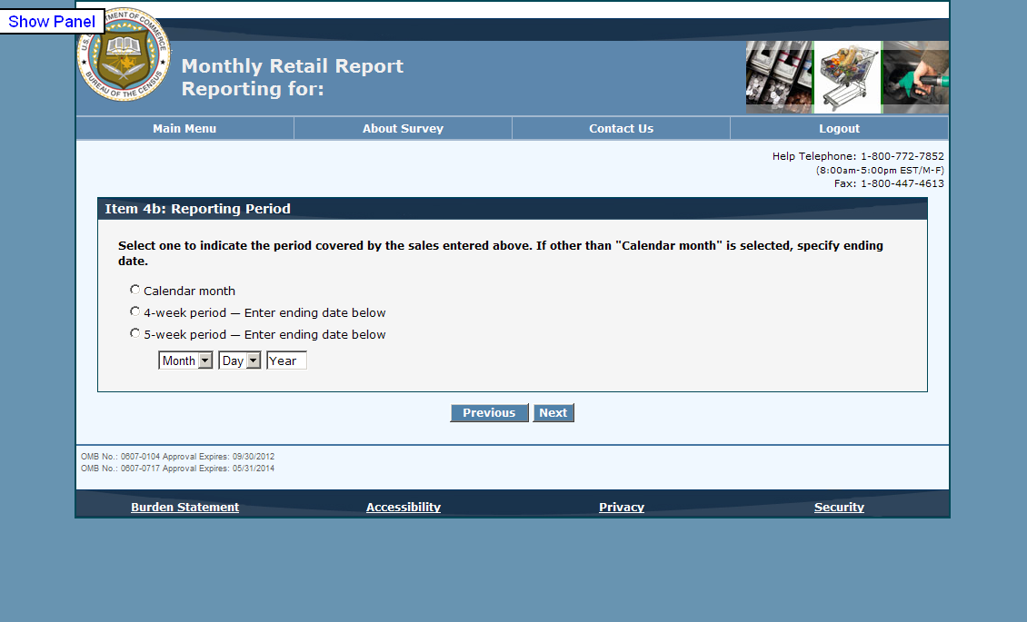

Review Screen (under construction)

