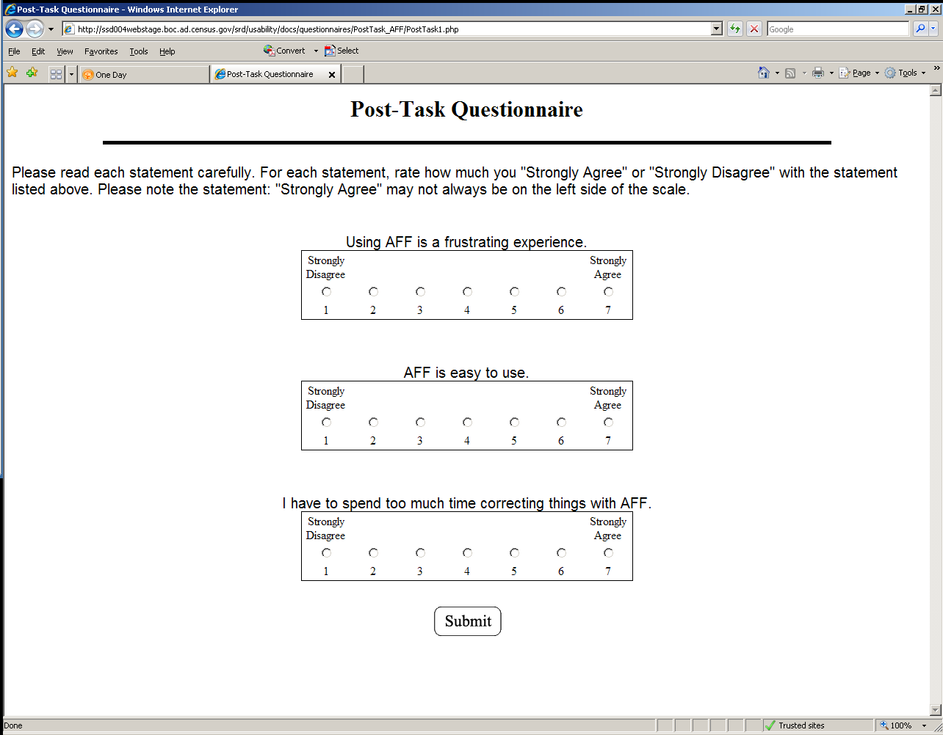

http://ssd004webstage.boc.ad.census.gov/srd/usability/docs/questionnaires/PostTask_AFF/PostTask1.php

