**2012 Census of Governments Survey of Local Government Finances**

**F-28: County, Municipal, and Township Screen Shots**

Login Screen 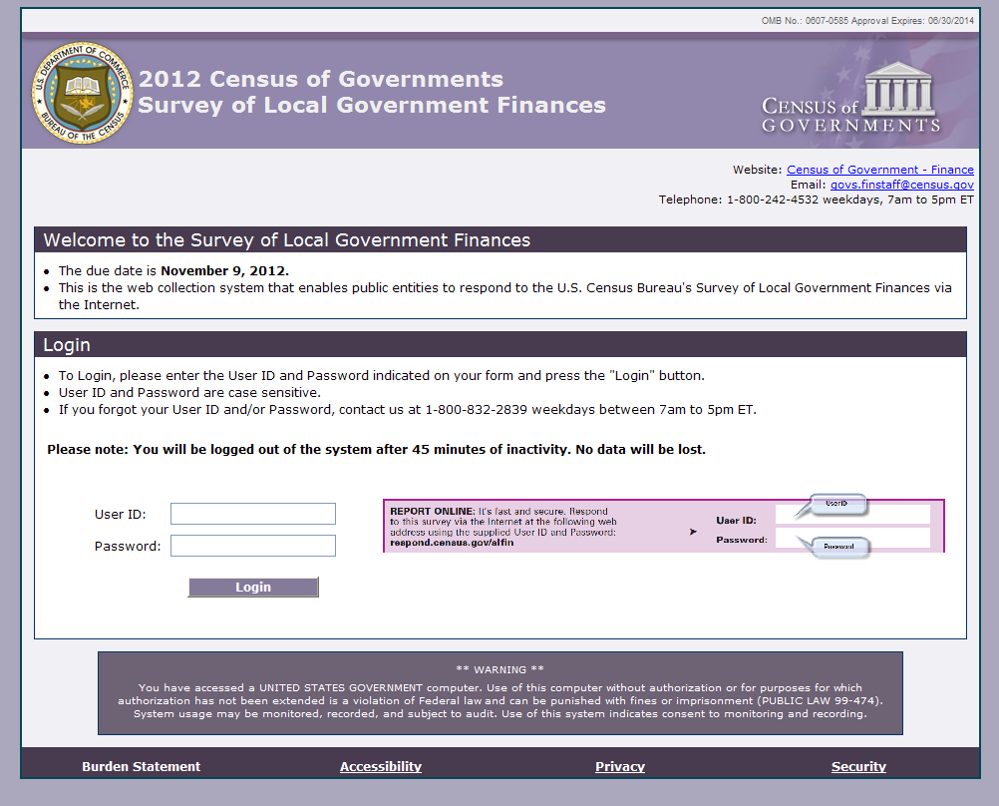

Main Menu screen (under construction)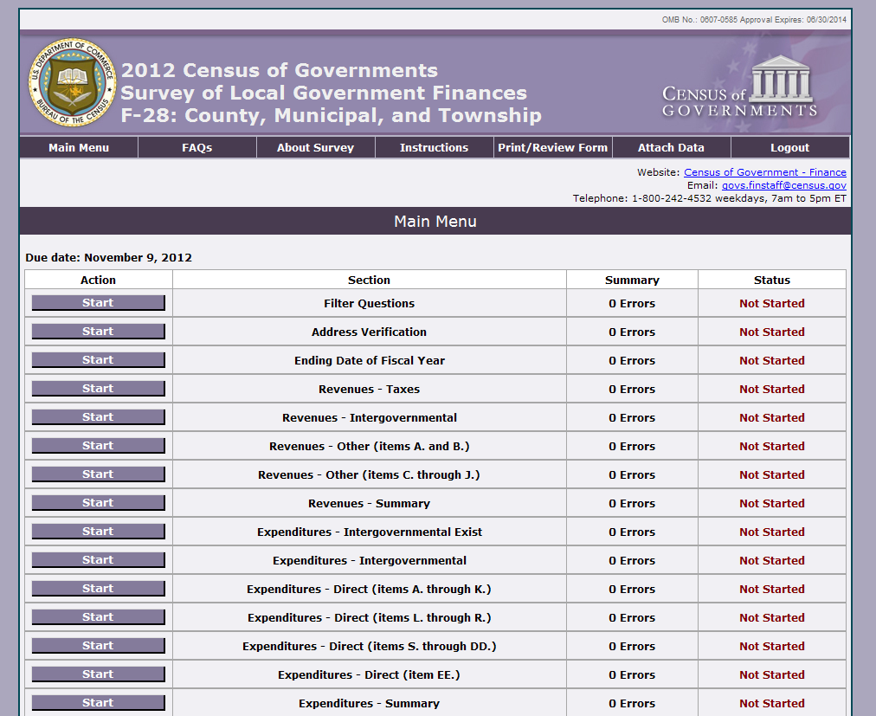 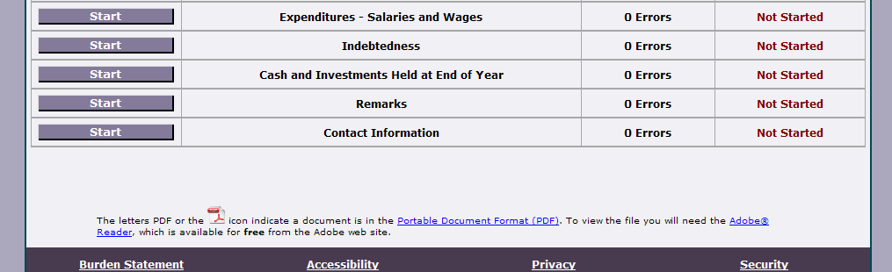

Filter Question

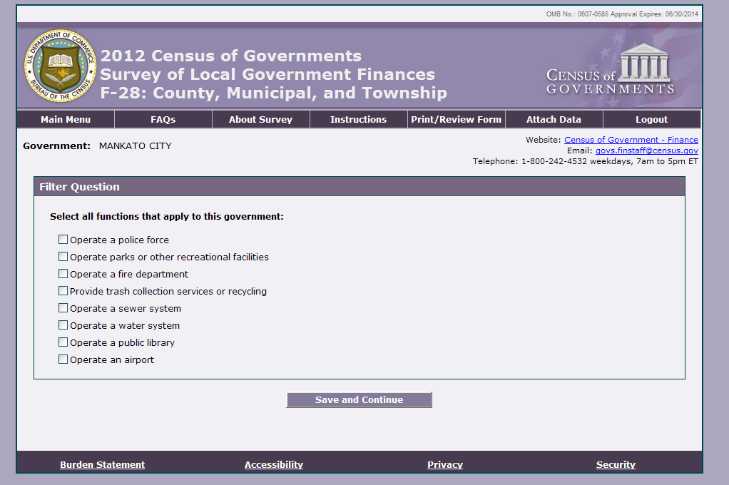

Address Verification Screen 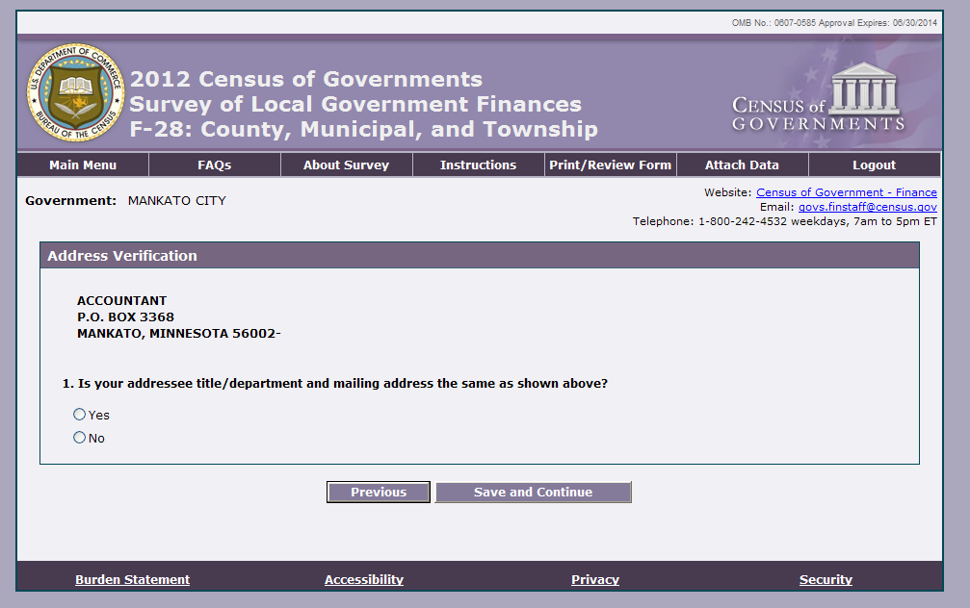

Ending Date of Fiscal Year Item

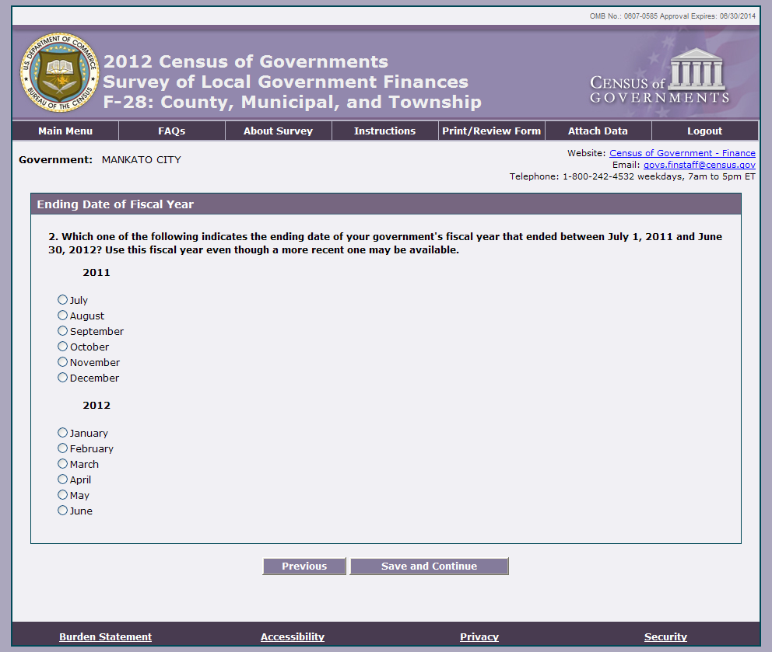

Intergovernmental Revenues Item 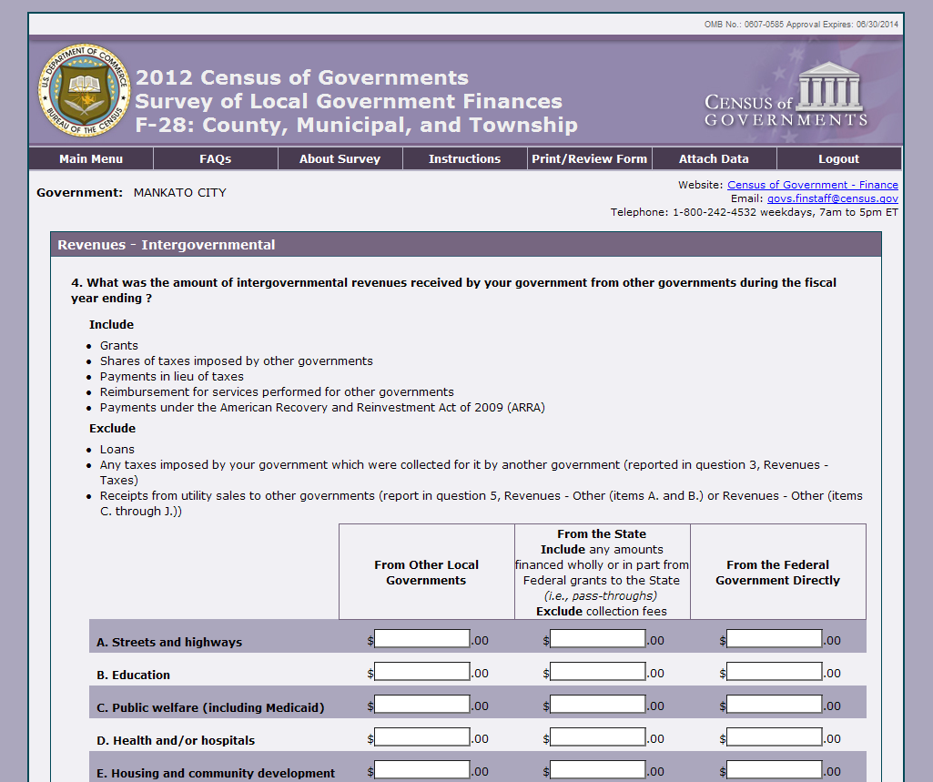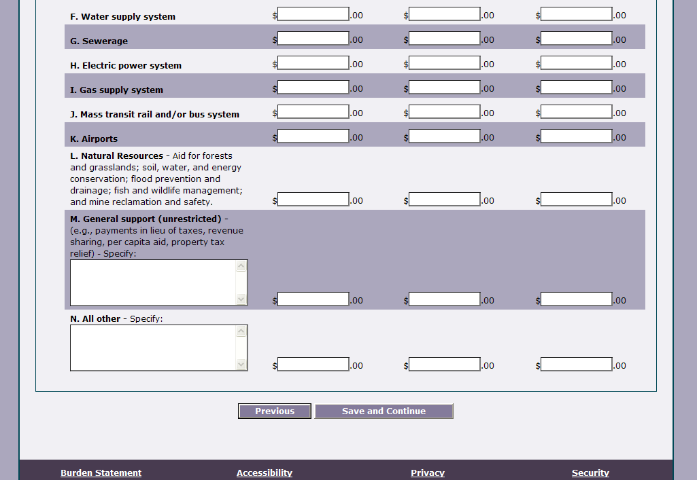

Intergovernmental Expenditures Item 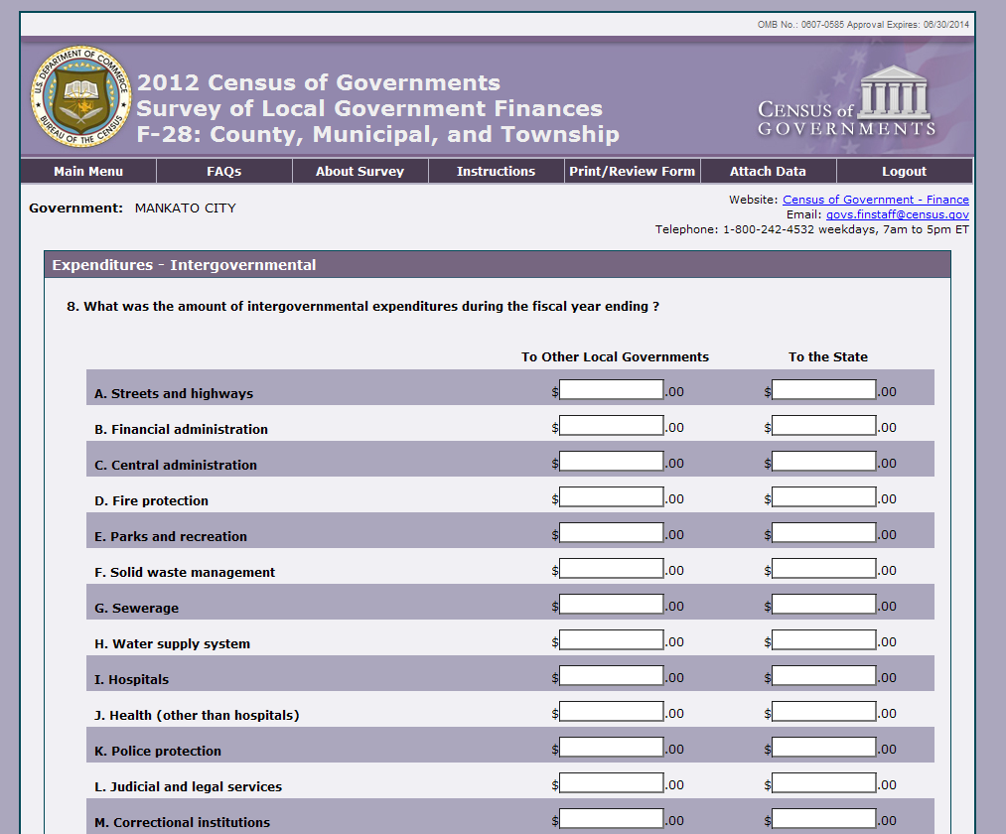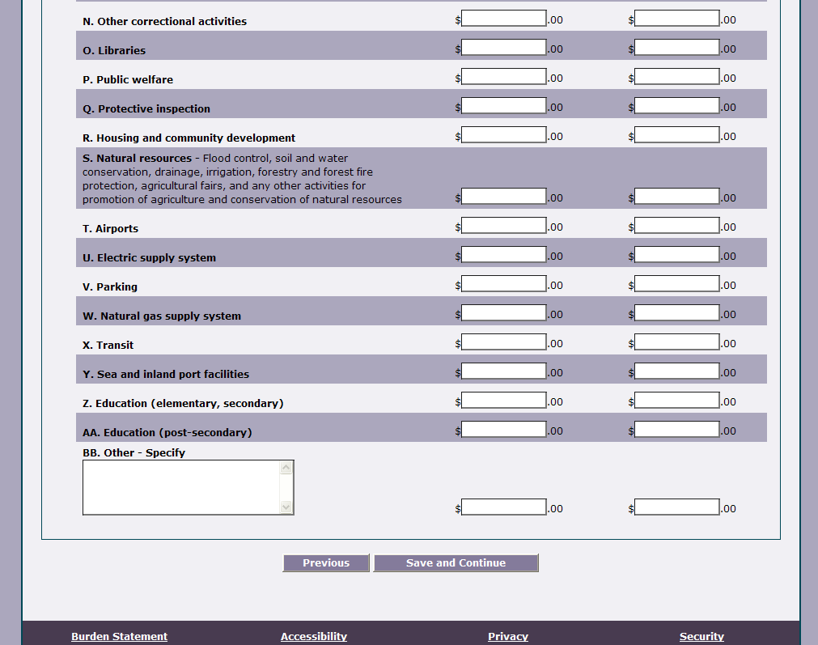

Salaries and Wages Item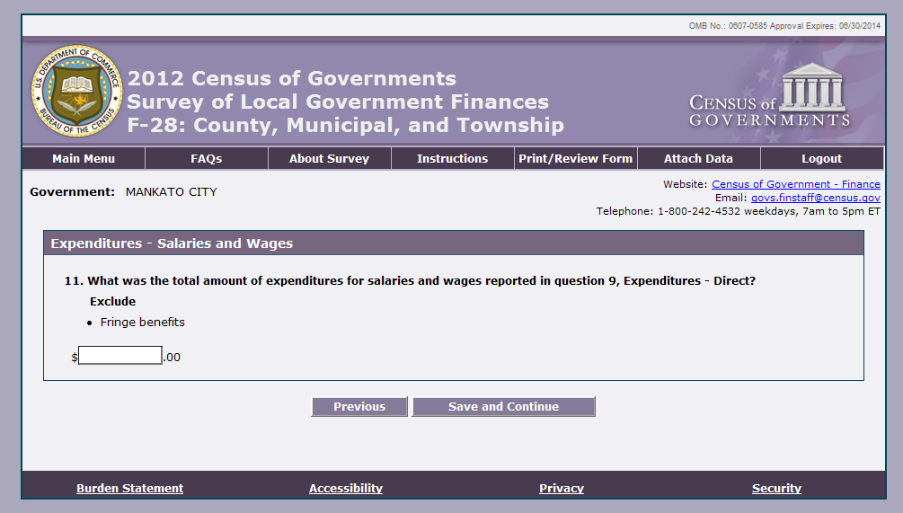

Indebtedness Item



Cash and Investments Held at End of Fiscal Year 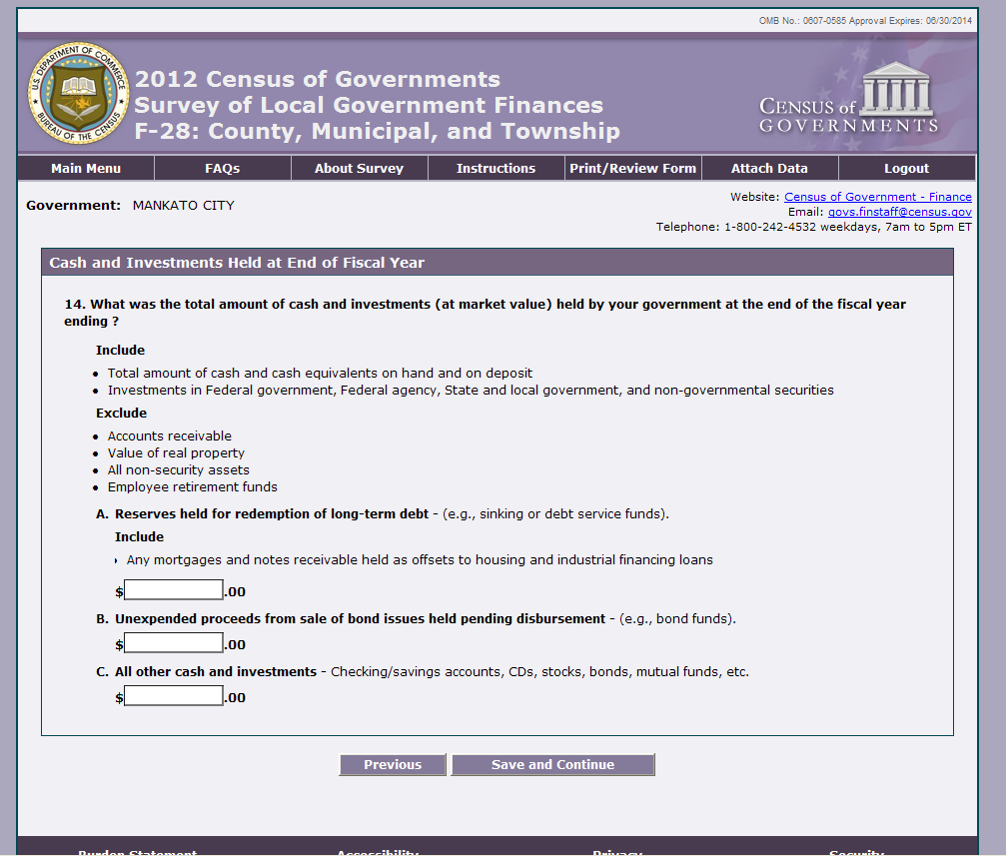

Certification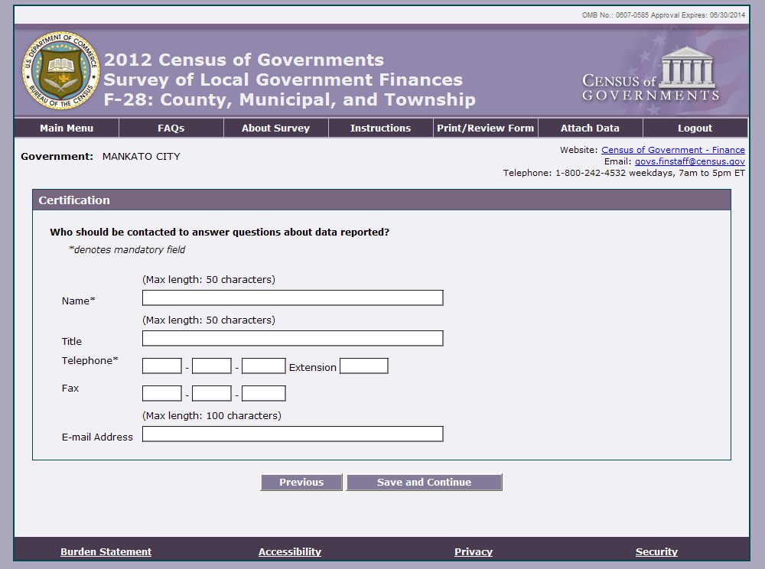

Review Screen (under construction)