Be Counted Form – Paper Protocol (Round 2)

INTERVIEW ID: ____________
INTERVIEW DATE: ____/____/____ START TIME: ______ AM / PM
Hello, my name is ___________. I work for RTI/RSS, a research company that has been hired by the Census Bureau to conduct research on the census forms. Thanks for agreeing to help us today. Let me start by telling you a little about what we will be doing. Every ten years the United States conducts a census, or count, of everyone who is living in the United States.
The form we’re working on today is the kind you might find in a post office or library, and pick up if you thought that you had not been counted in the census.
Permission to Record:
Because it would be hard to keep track of everything you say today, I would like to record this session. [HAND RESPONDENT THE CONSENT FORM.] Please read over this consent form and let me know if you have any questions. When you are ready, please sign the form. I want you to know that your responses will be kept strictly confidential and will only be seen by members of the project team and Census employees. Your participation in this study is completely voluntary and you can decline to answer any particular question. At the end of the study, we will delete any record of your responses from our machines. Your name will never be used in any reports.
Think-out-loud Instructions:
What I’ll ask you to do today is to fill the questionnaire out, just as you would if you received it at home.
So I can keep track of what you are doing, I’d like you to describe what you are doing and thinking as you go along. [The think aloud example is optional.] For example, I may ask you a question that seems relatively simple such as “How many cars do you have?” Instead of just providing a number, tell me what you were thinking when you answered it. For example, my response would be “Well I have an SUV that I drive every day and I also have an old truck. But the truck does not currently run. I assume that you mean working cars, so…one. I just have one car.” This kind of response will help me understand how you understood and interpreted the question so that we can see what each question means to you. I may remind you to think aloud as we go along.
When you’re done, I will ask you some additional questions about your answers to the Census. Some of these questions may sound a little strange. For example, I might ask you what a certain word means to you or how you came up with your answer. Again, the reason for this is to see how people understand each question. Even though some of these questions may sound like I am giving you a test, there are no right or wrong answers. We are interested in how these questions work for you.
Do you have any questions before we begin?
[HAND FORM TO PARTICIPANT AND ASK THEM TO COMPLETE IT]

General Observations

- NOTE HOW THE PARTICIPANT USES THE INSTRUCTIONS:
  - note evidence of reading instructions, Where the R starts, Whether R reads both sets of bullets, etc
  - Note if R fillS out q1 prior to reading instructions or if r makeS any changes to the person counts in q1 or q2?

- USE THIS SPACE TO WRITE NOTES FOR A NARRATIVE ON HOW THE RESPONDENT READS/USES PAGE 1.
- INCLUDE ANY COMMENTS, QUESTIONS, OR DISCUSSIONS WHICH OCCUR DURING THE INITIAL FILLING OF THE FORM.
- NOTE ANY CHANGES WHICH ARE SPONTANEOUSLY MADE DURING THE INITIAL FILLING OF THE QUESTIONNAIRE: WHAT WAS CHANGED? WHEN DID THE CHANGE OCCUR? DID R EXPLAIN THE CHANGES.

- DESCRIBE ANY ISSUES WITH COMPLETING THE PERSON PAGES:
- note whether r appears to read instructions
- Note if questions are not filled out in order or R jumps back and forth
- Note whether addresses are listed correctly? any fields missing?

- USE THIS SPACE TO WRITE NOTES FOR A NARRATIVE ON HOW THE R READS/USES THE PERSON PAGES.
- INCLUDE ANY COMMENTS, QUESTIONS, OR DISCUSSIONS WHICH OCCUR DURING THE INITIAL FILLING OF THE FORM.
- NOTE ANY CHANGES WHICH ARE SPONTANEOUSLY MADE DURING THE INITIAL FILLING OF THE QUESTIONNAIRE: WHAT WAS CHANGED? WHEN DID THE CHANGE OCCUR? DID R EXPLAIN THE CHANGES.

When R is finished with the form, review the form and note any problems to follow-up on during retrospective probing.
Page 1

GIVE the PAPER FORM BACK TO THE R AND ADMINISTER RETROSPEctive Probes. Note any changes to the written answers which are made during probing. What change was made? When was it made? What comments did the respondent make to explain the changes? if the change was made during probing for a different question than the one that was changed, note which question or probes elicited the change.

General Instructions
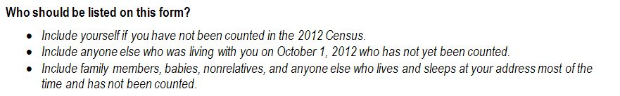
- What was the first thing you saw on this page? Where did you start to read? How much of these instructions did you read?

- What is the first set of instructions telling you? Who is it telling you to put on the form/not put on the form?

- In the second bullet, what does “not yet been counted” mean to you in these instructions?

- In the third bullet, what does “lives and sleeps at your address most of the time” mean? IF NECESSARY: What does “most of the time” mean here?

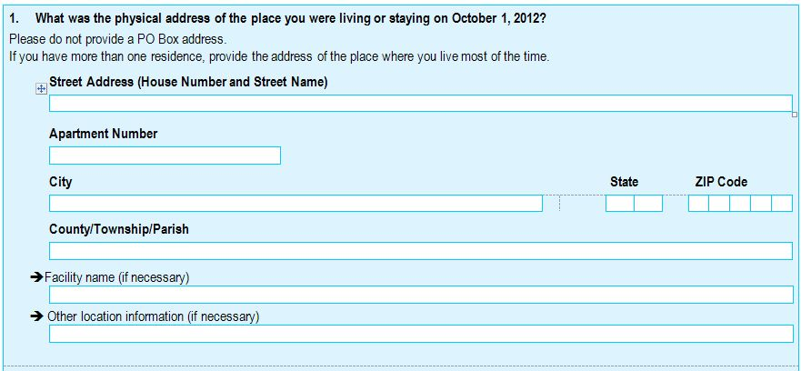
Question 1:
- NOTE ANY BLANK OR INCORRECT FIELDS AND PROBE AS NECESSARY. INDICATE WHICH FIELDS WERE FILLED SPONTANEOUSLY PRIOR TO THE BEGINNING OF PROBING. INDICATE WHAT CHANGES OR ADDITIONS WERE MADE SUBSEQUENTLY.

- What are the instructions over the address telling you to do?

- What does “physical address” mean as used in this question? Post Office box address?

- What kind of information is the line saying “other location information” asking for? What kind of information might someone put in there? IF NECESSARY: Why did you choose to write _____ in there?

- What kind of information is the line saying “facility name” asking for? IF NECESSARY: Why did you choose to write ____ in there?

- IF R HAS MORE THAN ONE RES: How did you decide which residence to list here?

- Please tell me about the address you wrote in here. What kind of place is it? Why did you choose this address?

- How long have you lived there? OR: How often do you stay there?

Question 2
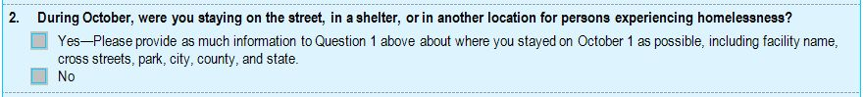

- What is this question asking? What does “experiencing homelessness” mean to you?

- You said YES/NO. Why did you choose that answer?

Question 3:
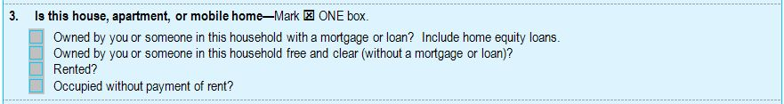

- Why did you choose [ANSWER]?

- Are these answer choices okay or did you want to provide a different answer? IF YES: What did you want to answer?

Question 4:

NO SCRIPTED PROBES

Question 5a:

- Why did you choose that answer?

- IF YES: which people were you thinking of? How are the other people living at this address connected to you? Are they friends, relatives, or what?

Question 5b:
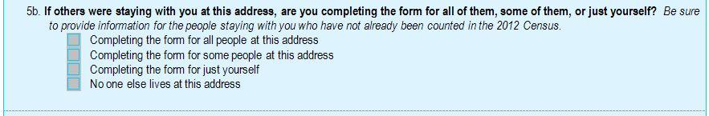

- What is this question asking you?

- Why did you choose that answer? If “some of the people,” how did you decide which people you were going to answer for?

Person 1

Question 6:
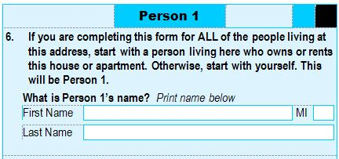

- NOTE WHETHER FULL NAME IS PROVIDED AND IF IT IS FORMATTED CORRECTLY.

- In your own words, what is this question asking? [IF NECESSARY: What is the instruction above the name telling you?]

- IF MORE THAN ONE PERSON: How did you choose who to start with?

- IF MORE THAN ONE PERSON: This question asks you to start with a person who “owns or rents” this place. What did that mean in your situation?

Demographic Questions 7-10

- no probes: if they have an objection, let them comment and go on.

Question 11:
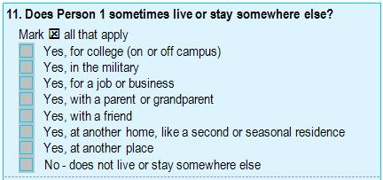

- What does “sometimes live or stay somewhere else” mean to you in this question? IF NECESSARY: What does “sometimes” mean here?

- FOR EACH YES RESPONSE: Why did you choose that answer? Can you tell me more about that place?
  - [IF ADDRESS IS SOMEONE ELSE’S HOME: Whose place is/was that? Is this a place you stay frequently? How often? When were you there last?]
  - [IF ADDRESS REPRESENTS A MOVE: When did you move?]
  - [If address is a facility: What kind of place is that? When were you there last? How long did you stay that time?]

- Were there any places that you were unsure whether you should select or not? IF YES: Can you tell me more about that? IF NECESSARY: Did you notice earlier where it says “mark all that apply?”

- What does “With a friend” mean? What kind of situations were you thinking of?

- What does “at another home, like a second or seasonal home” mean in this question? What were you thinking of?

- What kind of places might be included with “another place” here?

Question 12:
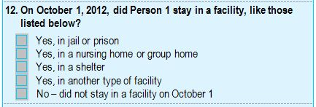

- FOR EACH YES: Can you tell me more about that? Why did you choose that answer?
- [IF ADDRESS REPRESENTS A MOVE: When did you move?]
- [If address is a facility: What kind of place is that? When were you there last? How long did you stay that time?]

- Were there any places that you were unsure whether you should select or not? IF YES: Can you tell me more about that?

- What kind of places might be included with “another place” here?

- IF NECESSARY: Is this question asking the same thing as the previous one, or is it different to you? If different: How is it different?

Question 13:
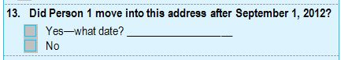

- IF YES: Tell me about that move. Where did [you/he/she] move from? Why did [you/he/she] move?

- IF YES: How certain are you of the date of that move?

Question 14:
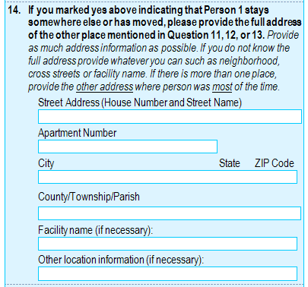
- NOTE WHETHER R CORRECTLY ANSWERED THIS QUESTION BASED ON SKIP LOGIC. DETAIL HOW THE ADDRESS FIELDS ARE FILLED. INCLUDE SPONTANEOUS COMMENTS INDICATING THAT R KNOWS AN ADDRESS IS REQUIRED OR NOT REQUIRED BASED ON PREVIOUS ANSWERS. INDICATE WHICH FIELDS WERE SPONTANEOUSLY FILLED OUT PRIOR TO THE BEGINNING OF PROBING.

- What does the phrase “the other place” mean to you in this context?

- IF MORE THAN ONE YES IN Q. 11, 12 and 13: How easy or difficult was it to determine which address to provide in Question 14? IF NECESSARY: How did you choose which address to provide?

- IF PARTIAL INFORMATION IS PROVIDED: Can you tell me why you left some fields blank here? NOTE: IF R ADDS INFORMATION OR CHANGES A RESPONSE DURING PROBING, FLAG WHICH INFORMATION IS ADDED OR CHANGED

- If Q14 is blank after a yes answer: Can you tell me why you chose not to write an address in Question 14?

- Did you see the sentence in italics? What kind of information is it asking for? IF NECESSARY: Would you be able to provide information like that?

Question 15:
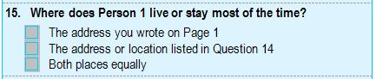
- How did you determine where PERSON 1 lives or stays most of the time? NOTE WHETHER THIS RESPONSE MATCHES THE INTERVIEWER’S UNDERSTANDING OF R’S LIVING SITUATION.

- IF NECESSARY: What does “most of the time” mean in this question?

- Around October 1, 2012, where did Person 1 live and sleep most of the time?

Question 16:
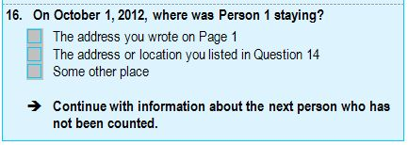
- How did you choose your answer to Question 16?

- IF “SOME OTHER PLACE”: Can you tell me a little about that place?

- Is Question 16 the same as Question 15 or is it different? IF DIFFERENT: How is it different?

Person 2
Question 1:
1. What is Person 2’s name? Print name below
First name ______________________________ MI ____
Last name _______________________________________
P25. NOTE WHETHER FULL NAME IS PROVIDED AND IF IT IS FORMATTED CORRECTLY.

Question 7:
7. Does Person 2 sometimes live or stay somewhere else?
P30. FOR EACH YES RESPONSE: Can you tell me more about that. Why did you choose that answer?
- [IF ADDRESS IS SOMEONE ELSE’S HOME: Whose place is/was that? Is this a place you stay frequently? How often? When were you there last?]
- [IF ADDRESS REPRESENTS A MOVE: When did you move?]
- [If address is a facility: What kind of place is that? When were you there last? How long did you stay that time?]

Question 8:
8. On October 1, 2012, did Person 2 stay in a facility, like those listed below?
P35. FOR EACH YES: Can you tell me more about that? Why did you choose that answer?
- [IF ADDRESS REPRESENTS A MOVE: When did you move?]
- [If address is a facility: What kind of place is that? When were you there last? How long did you stay that time?]

Question 9:
9. Did Person 2 move into this address after September 1, 2012?
Yes – What date?_________________________
No
P39. IF YES: Tell me about that move. Where did [you/he/she] move from? Why did [you/he/she] move?

P40. IF YES: How certain are you of the date of that move?

Question 10:
- If you marked yes above indicating that Person 2 stays somewhere else or has moved, please provide the full address of the other place mentioned in Question 7, 8 or 9 Provide as much address information as possible (such as neighborhood, cross streets, or facility name), if you do not know the address. If there is more than one place, provide the other address where person was most of the time.

P41. NOTE WHETHER R CORRECTLY ANSWERED THIS QUESTION BASED ON SKIP LOGIC. DETAIL HOW THE ADDRESS FIELDS ARE FILLED. INCLUDE SPONTANEOUS COMMENTS INDICATING THAT R KNOWS AN ADDRESS IS REQUIRED OR NOT REQUIRED BASED ON PREVIOUS ANSWERS. INDICATE WHICH FIELDS WERE SPONTANEOUSLY FILLED OUT.

P44. IF PARTIAL INFORMATION IS PROVIDED: Can you tell me why you left some fields blank here? NOTE IF R ADDS INFORMATION OR CHANGES A RESPONSE DURING PROBING.

P45. If Q10 is blank after a yes answer: Can you tell me why you chose not to write an address in Question 10?

Question 11:
- Where does Person 2 live and sleep most of the time?

P47. How did you determine where Person 2 lives and sleeps most of the time?

P49. Around October 1, 2012, where did Person 2 live and sleep most of the time?

Question 12:
- On October 1, 2012, where was Person 2 staying?

P50. How did you come up with your answer to Question 12?

P51. IF “SOME OTHER PLACE”: Can you tell me a little about that place?

Person 3
Question 1:
1. What is Person 3’s name? Print name below
First name ______________________________ MI ____
Last name _______________________________________
P25. NOTE WHETHER FULL NAME IS PROVIDED AND IF IT IS FORMATTED CORRECTLY.

Question 7:
7. Does Person 3 sometimes live or stay somewhere else?
P30. FOR EACH YES RESPONSE: Can you tell me more about that. Why did you choose that answer?
- [IF ADDRESS IS SOMEONE ELSE’S HOME: Whose place is/was that? Is this a place you stay frequently? How often? When were you there last?]
- [IF ADDRESS REPRESENTS A MOVE: When did you move?]
- [If address is a facility: What kind of place is that? When were you there last? How long did you stay that time?]

Question 8:
8. On October 1, 2012, did Person 3 stay in a facility, like those listed below?
P35. FOR EACH YES: Can you tell me more about that? Why did you choose that answer?
- [IF ADDRESS REPRESENTS A MOVE: When did you move?]
- [If address is a facility: What kind of place is that? When were you there last? How long did you stay that time?]

Question 9:
9. Did Person 3 move into this address after September 1, 2012?
Yes – What date?_________________________
No
P39. IF YES: Tell me about that move. Where did [you/he/she] move from? Why did [you/he/she] move?

P40. IF YES: How certain are you of the date of that move?

Question 10:
- If you marked yes above indicating that Person 3 stays somewhere else or has moved, please provide the full address of the other place mentioned in Question 7, 8 or 9 Provide as much address information as possible (such as neighborhood, cross streets, or facility name), if you do not know the address. If there is more than one place, provide the other address where person was most of the time.

P41. NOTE WHETHER R CORRECTLY ANSWERED THIS QUESTION BASED ON SKIP LOGIC. DETAIL HOW THE ADDRESS FIELDS ARE FILLED. INCLUDE SPONTANEOUS COMMENTS INDICATING THAT R KNOWS AN ADDRESS IS REQUIRED OR NOT REQUIRED BASED ON PREVIOUS ANSWERS. INDICATE WHICH FIELDS WERE SPONTANEOUSLY FILLED OUT.

P44. IF PARTIAL INFORMATION IS PROVIDED: Can you tell me why you left some fields blank here? NOTE IF R ADDS INFORMATION OR CHANGES A RESPONSE DURING PROBING.

P45. If Q10 is blank after a yes answer: Can you tell me why you chose not to write an address in Question 10?

Question 11:
- Where does Person 3 live and sleep most of the time?

P47. How did you determine where Person 3 lives and sleeps most of the time?

P49. Around October 1, 2012, where did Person 3 live and sleep most of the time?

Question 12:
- On October 1, 2012, where was Person 3 staying?

P50. How did you come up with your answer to Question 12?

P51. IF “SOME OTHER PLACE”: Can you tell me a little about that place?

Person 4
Question 1:
1. What is Person 4’s name? Print name below
First name ______________________________ MI ____
Last name _______________________________________
P25. NOTE WHETHER FULL NAME IS PROVIDED AND IF IT IS FORMATTED CORRECTLY.

Question 7:
7. Does Person 4 sometimes live or stay somewhere else?
P30. FOR EACH YES RESPONSE: Can you tell me more about that. Why did you choose that answer?
- [IF ADDRESS IS SOMEONE ELSE’S HOME: Whose place is/was that? Is this a place you stay frequently? How often? When were you there last?]
- [IF ADDRESS REPRESENTS A MOVE: When did you move?]
- [If address is a facility: What kind of place is that? When were you there last? How long did you stay that time?]

Question 8:
8. On October 1, 2012, did Person 4 stay in a facility, like those listed below?
P35. FOR EACH YES: Can you tell me more about that? Why did you choose that answer?
- [IF ADDRESS REPRESENTS A MOVE: When did you move?]
- [If address is a facility: What kind of place is that? When were you there last? How long did you stay that time?]

Question 9:
9. Did Person 4 move into this address after September 1, 2012?
Yes – What date?_________________________
No
P39. IF YES: Tell me about that move. Where did [you/he/she] move from? Why did [you/he/she] move?

P40. IF YES: How certain are you of the date of that move?

Question 10:
- If you marked yes above indicating that Person 4 stays somewhere else or has moved, please provide the full address of the other place mentioned in Question 7, 8 or 9 Provide as much address information as possible (such as neighborhood, cross streets, or facility name), if you do not know the address. If there is more than one place, provide the other address where person was most of the time.

P41. NOTE WHETHER R CORRECTLY ANSWERED THIS QUESTION BASED ON SKIP LOGIC. DETAIL HOW THE ADDRESS FIELDS ARE FILLED. INCLUDE SPONTANEOUS COMMENTS INDICATING THAT R KNOWS AN ADDRESS IS REQUIRED OR NOT REQUIRED BASED ON PREVIOUS ANSWERS. INDICATE WHICH FIELDS WERE SPONTANEOUSLY FILLED OUT.

P44. IF PARTIAL INFORMATION IS PROVIDED: Can you tell me why you left some fields blank here? NOTE IF R ADDS INFORMATION OR CHANGES A RESPONSE DURING PROBING.

P45. If Q10 is blank after a yes answer: Can you tell me why you chose not to write an address in Question 10?

Question 11:
- Where does Person 4 live and sleep most of the time?

P47. How did you determine where Person 4 lives and sleeps most of the time?

P49. Around October 1, 2012, where did Person 4 live and sleep most of the time?

Question 12:
- On October 1, 2012, where was Person 4 staying?

P50. How did you come up with your answer to Question 12?

P51. IF “SOME OTHER PLACE”: Can you tell me a little about that place?

Person 5
Question 1:
1. What is Person 5’s name? Print name below
First name ______________________________ MI ____
Last name _______________________________________
P25. NOTE WHETHER FULL NAME IS PROVIDED AND IF IT IS FORMATTED CORRECTLY.

Question 7:
7. Does Person 5 sometimes live or stay somewhere else?
P30. FOR EACH YES RESPONSE: Can you tell me more about that. Why did you choose that answer?
- [IF ADDRESS IS SOMEONE ELSE’S HOME: Whose place is/was that? Is this a place you stay frequently? How often? When were you there last?]
- [IF ADDRESS REPRESENTS A MOVE: When did you move?]
- [If address is a facility: What kind of place is that? When were you there last? How long did you stay that time?]

Question 8:
8. On October 1, 2012, did Person 5 stay in a facility, like those listed below?
P35. FOR EACH YES: Can you tell me more about that? Why did you choose that answer?
- [IF ADDRESS REPRESENTS A MOVE: When did you move?]
- [If address is a facility: What kind of place is that? When were you there last? How long did you stay that time?]

Question 9:
9. Did Person 5 move into this address after September 1, 2012?
Yes – What date?_________________________
No
P39. IF YES: Tell me about that move. Where did [you/he/she] move from? Why did [you/he/she] move?

P40. IF YES: How certain are you of the date of that move?

Question 10:
- If you marked yes above indicating that Person 5 stays somewhere else or has moved, please provide the full address of the other place mentioned in Question 7, 8 or 9 Provide as much address information as possible (such as neighborhood, cross streets, or facility name), if you do not know the address. If there is more than one place, provide the other address where person was most of the time.

P41. NOTE WHETHER R CORRECTLY ANSWERED THIS QUESTION BASED ON SKIP LOGIC. DETAIL HOW THE ADDRESS FIELDS ARE FILLED. INCLUDE SPONTANEOUS COMMENTS INDICATING THAT R KNOWS AN ADDRESS IS REQUIRED OR NOT REQUIRED BASED ON PREVIOUS ANSWERS. INDICATE WHICH FIELDS WERE SPONTANEOUSLY FILLED OUT.

P44. IF PARTIAL INFORMATION IS PROVIDED: Can you tell me why you left some fields blank here? NOTE IF R ADDS INFORMATION OR CHANGES A RESPONSE DURING PROBING.

P45. If Q10 is blank after a yes answer: Can you tell me why you chose not to write an address in Question 10?

Question 11:
- Where does Person 5 live and sleep most of the time?

P47. How did you determine where Person 5 lives and sleeps most of the time?

P49. Around October 1, 2012, where did Person 5 live and sleep most of the time?

Question 12:
- On October 1, 2012, where was Person 5 staying?

P50. How did you come up with your answer to Question 12?

P51. IF “SOME OTHER PLACE”: Can you tell me a little about that place?

Person 6
Question 1:
1. What is Person 6’s name? Print name below
First name ______________________________ MI ____
Last name _______________________________________
P25. NOTE WHETHER FULL NAME IS PROVIDED AND IF IT IS FORMATTED CORRECTLY.

Question 7:
7. Does Person 6 sometimes live or stay somewhere else?
P30. FOR EACH YES RESPONSE: Can you tell me more about that. Why did you choose that answer?
- [IF ADDRESS IS SOMEONE ELSE’S HOME: Whose place is/was that? Is this a place you stay frequently? How often? When were you there last?]
- [IF ADDRESS REPRESENTS A MOVE: When did you move?]
- [If address is a facility: What kind of place is that? When were you there last? How long did you stay that time?]

Question 8:
8. On October 1, 2012, did Person 6 stay in a facility, like those listed below?
P35. FOR EACH YES: Can you tell me more about that? Why did you choose that answer?
- [IF ADDRESS REPRESENTS A MOVE: When did you move?]
- [If address is a facility: What kind of place is that? When were you there last? How long did you stay that time?]

Question 9:
9. Did Person 6 move into this address after September 1, 2012?
Yes – What date?_________________________
No
P39. IF YES: Tell me about that move. Where did [you/he/she] move from? Why did [you/he/she] move?

P40. IF YES: How certain are you of the date of that move?

Question 10:
- If you marked yes above indicating that Person 6 stays somewhere else or has moved, please provide the full address of the other place mentioned in Question 7, 8 or 9 Provide as much address information as possible (such as neighborhood, cross streets, or facility name), if you do not know the address. If there is more than one place, provide the other address where person was most of the time.

P41. NOTE WHETHER R CORRECTLY ANSWERED THIS QUESTION BASED ON SKIP LOGIC. DETAIL HOW THE ADDRESS FIELDS ARE FILLED. INCLUDE SPONTANEOUS COMMENTS INDICATING THAT R KNOWS AN ADDRESS IS REQUIRED OR NOT REQUIRED BASED ON PREVIOUS ANSWERS. INDICATE WHICH FIELDS WERE SPONTANEOUSLY FILLED OUT.

P44. IF PARTIAL INFORMATION IS PROVIDED: Can you tell me why you left some fields blank here? NOTE IF R ADDS INFORMATION OR CHANGES A RESPONSE DURING PROBING.

P45. If Q10 is blank after a yes answer: Can you tell me why you chose not to write an address in Question 10?

Question 11:
- Where does Person 6 live and sleep most of the time?

P47. How did you determine where Person 6 lives and sleeps most of the time?

P49. Around October 1, 2012, where did Person 6 live and sleep most of the time?

Question 12:
- On October 1, 2012, where was Person 6 staying?

P50. How did you come up with your answer to Question 12?

P51. IF “SOME OTHER PLACE”: Can you tell me a little about that place?

Final Debriefing

Thanks, we’re almost finished. I have just a few more questions for you.

- I see that you [HHD: typed/NRFU: provided] ________________ as your name. Would you ever use a different version of your name on a form like this?
  - IF YES: How else might you list your name? NOTE DIFFERENCES WITHOUT USING PII.
  - IF YES: How do you decide which way to write it on different forms?
- [IF NEEDED:] Is __________ your full name or another form of your name such as a nickname? NOTE DIFFERENCES WITHOUT USING PII.
- [IF MI FILLED]: Would you prefer to write out your whole middle name or just provide an initial on a form of this type?
- IF MI BLANK: Did you see the box marked MI? Do you have a middle name? How did you decide to leave it blank?
- Do any of the other people you listed sometimes use a different version of their name on forms like this? NOTE DIFFERENCES WITHOUT USING PII. How did you decide how to list their name?
- Do you have any other opinions about the format of the name question on this form?

- Was there anything in these questions that you found sensitive or uncomfortable to answer?

- Was there any information for yourself or others that you would be hesitant to provide on the census form?

- Aside from the things we’ve talked about, were there any questions or instructions that you find confusing or difficult to answer?

- Did you find parts of the survey form repetitive? If so, what parts?

- If you were going to answer your census questionnaire on your own, without an interviewer, how would you prefer to do it: CHECK ALL THAT APPLY
____ On a smartphone? (What kind:____________________________________________)
____ On a tablet? (What kind:____________________________________________)
____ On a laptop or desktop?
____ On a paper form?

FOR EACH ANSWER CHOSEN, ASK: Why?

- If you don’t answer the census on your own, an interviewer might be sent to your home to get your census information. How would you feel about the interviewer using….. CHECK ALL THAT APPLY.
____ a smartphone to do the interview?
____ a tablet, like an iPad?
____ a laptop computer?
____ a paper form?

Which do you prefer and why?

End Time:________ THANK YOU

