October 9, 2012
[Address block for recipient]
Dear [Sir/Madam or Name if available],
We are writing to ask for your help with an important study we are conducting for the U.S. Census Bureau. The U.S. Census Bureau is doing research about how people respond to the Decennial Census. They will use this information to improve the materials used in the 2020 Census.
Part of this research will involve interviewing workers (or their families) who live away from home for months at a time for work, such as oil rig workers, combine operators or [other appropriate group]. We have enclosed flyers about the study that we hoped you might post, email or provide to your [colleagues/associates/employees] who may be working away from home. Interviews are being conducted in Chicago, San Diego and Raleigh/Durham so if you or a worker you know has family in one of those areas please encourage someone from that household to call.
The in-person interview takes about an hour and can be conducted at a place and time convenient to respondents. Anyone who participates in the study will receive $40 in cash at the end of the interview as a token of our appreciation.
The study is being conducted by RTI International (a nonprofit research organization) and Research Support Services, Inc. (a contract research firm). The Census Bureau has contracted with us to conduct this research. We have assisted the Census Bureau with a number of research studies over the past several years. The study and all information collected by our research staff are confidential and protected under US Code Title 13. Anyone working at RTI or RSS, Inc., including the interviewers, can be sent to jail or have to pay a fine of up to $250,000 if we divulge any information about the interviews to anyone not directly working on the project.
Participation is voluntary and we would very much appreciate your cooperation with distributing the flyers to your residents.
Please feel free to contact our area recruiter [name TBD] at 1-800-xxx-xxxx if you have any questions or would like more information about the project.
Thank you in advance for your cooperation in our efforts.
Sincerely,
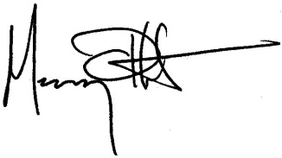
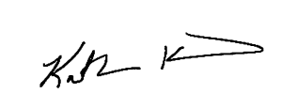

Murrey G. Olmsted, Ph.D. Katherine Kenward.
Project Director Recruitment Coordinator

RTI International Research Support Services, Inc.
3040 Cornwallis Road 906 Ridge Ave.
Research Triangle Park, NC 27709-2194 Evanston, IL 60202-1720
Phone: (919) 485-5506 Phone: (847) 864-5677
Email: molmsted@rti.org Email: katherine@researchsupportservices.com

