2012 Census of Governments Survey of Local Government Finances
F-28: County, Municipal, and Township Screen Shots
Login Screen 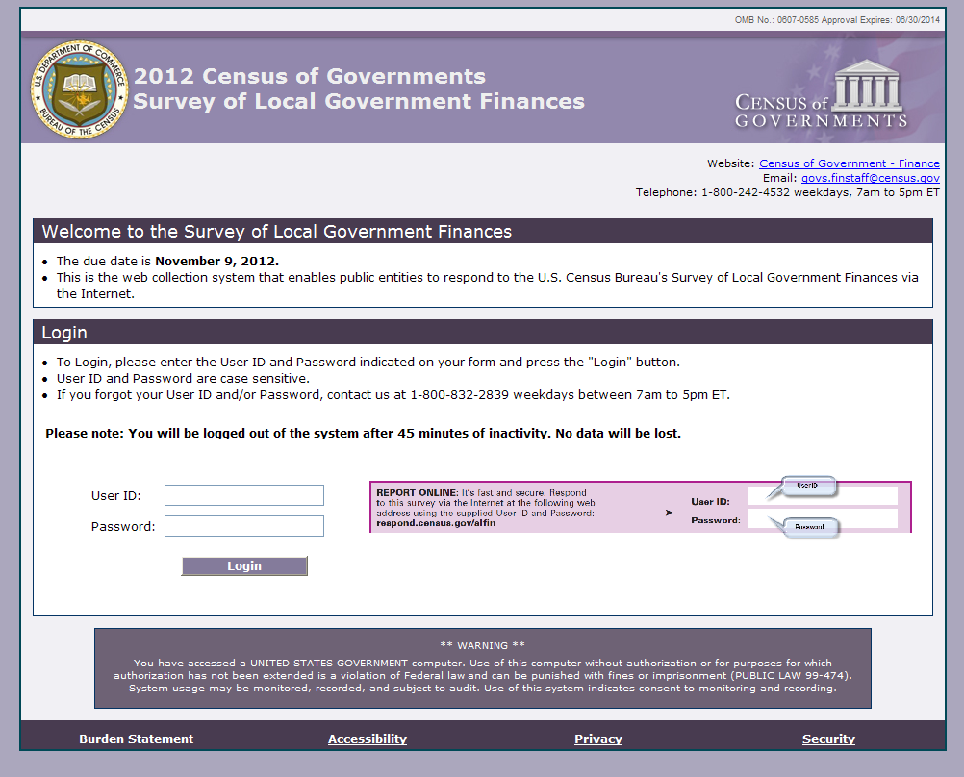
Main Menu screen (under construction)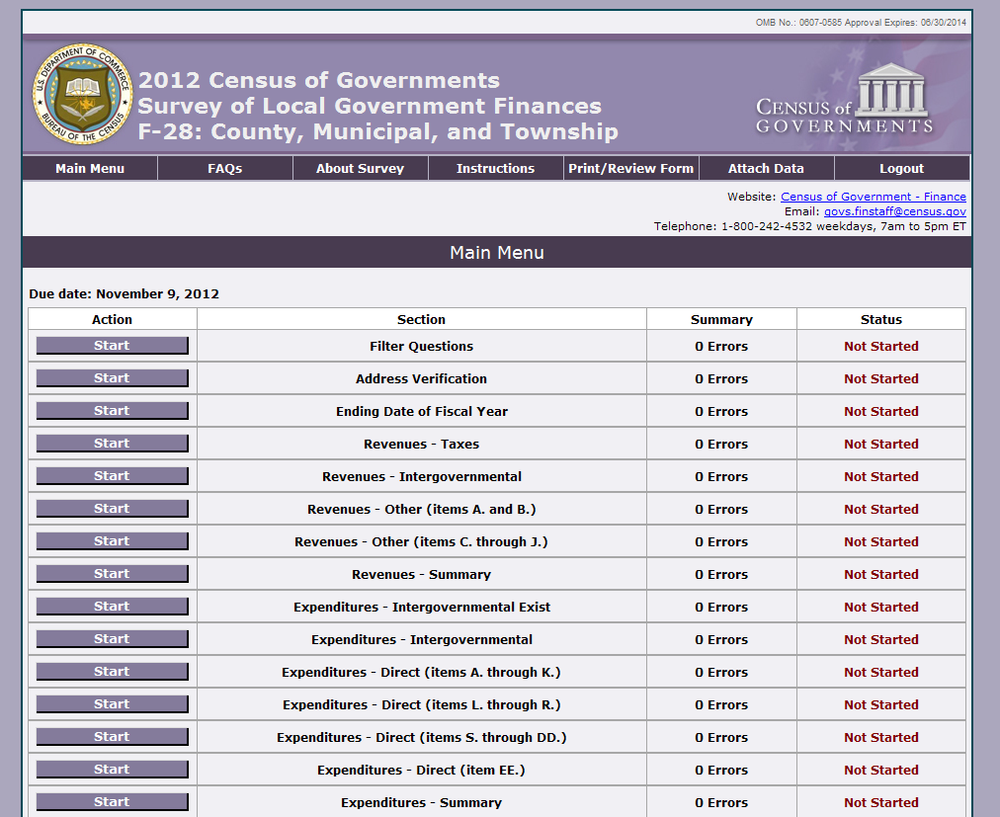 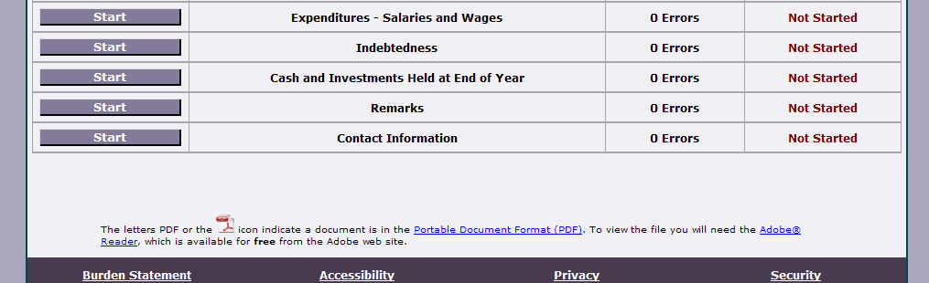

Filter Question
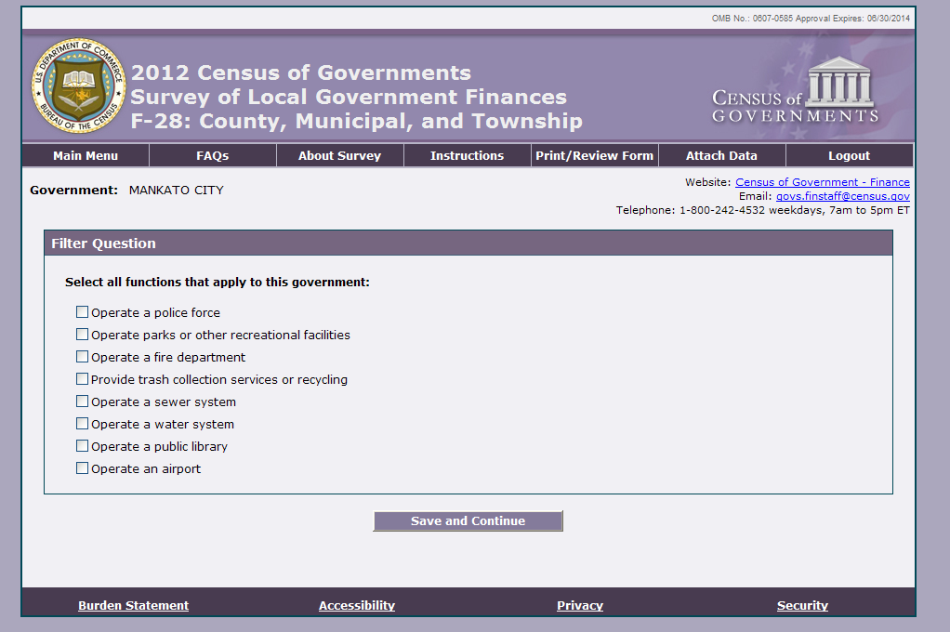

Address Verification Screen 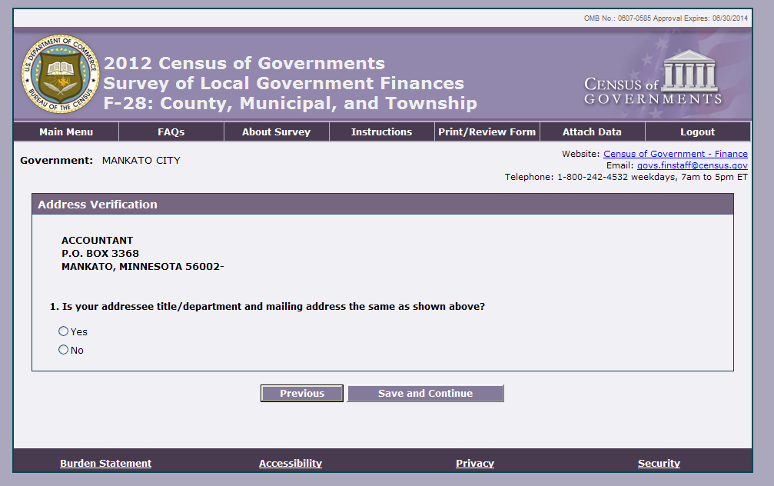

Ending Date of Fiscal Year Item
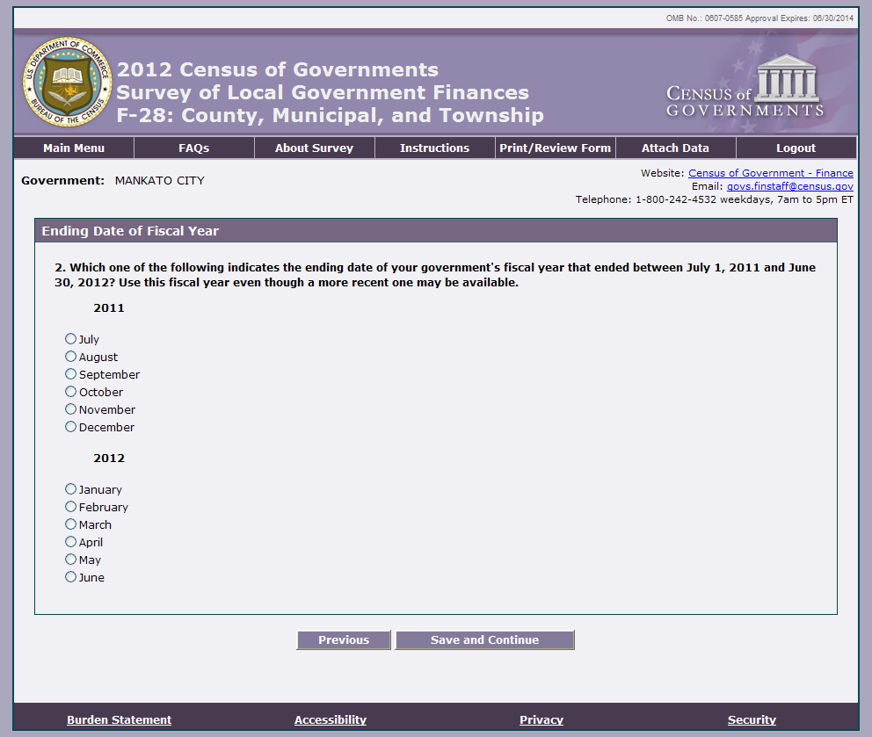
Intergovernmental Revenues Item 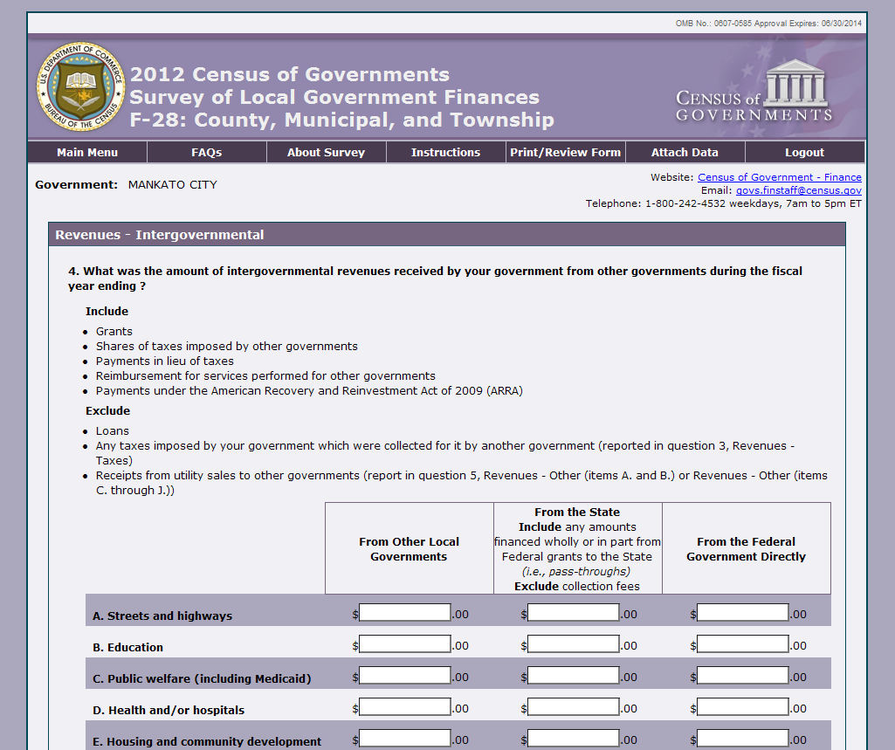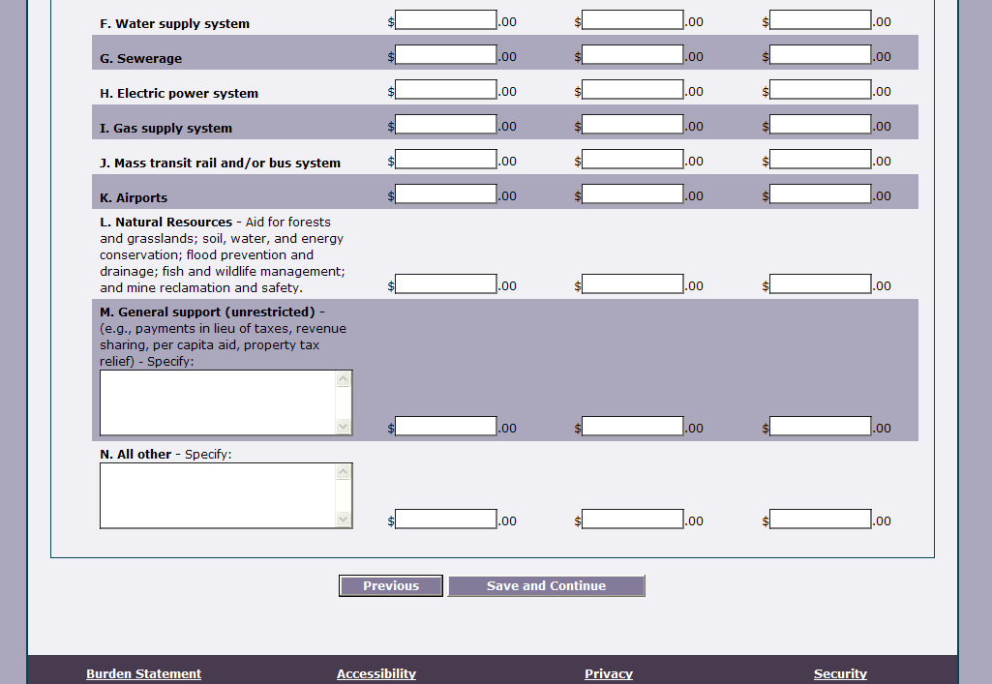
Intergovernmental Expenditures Item 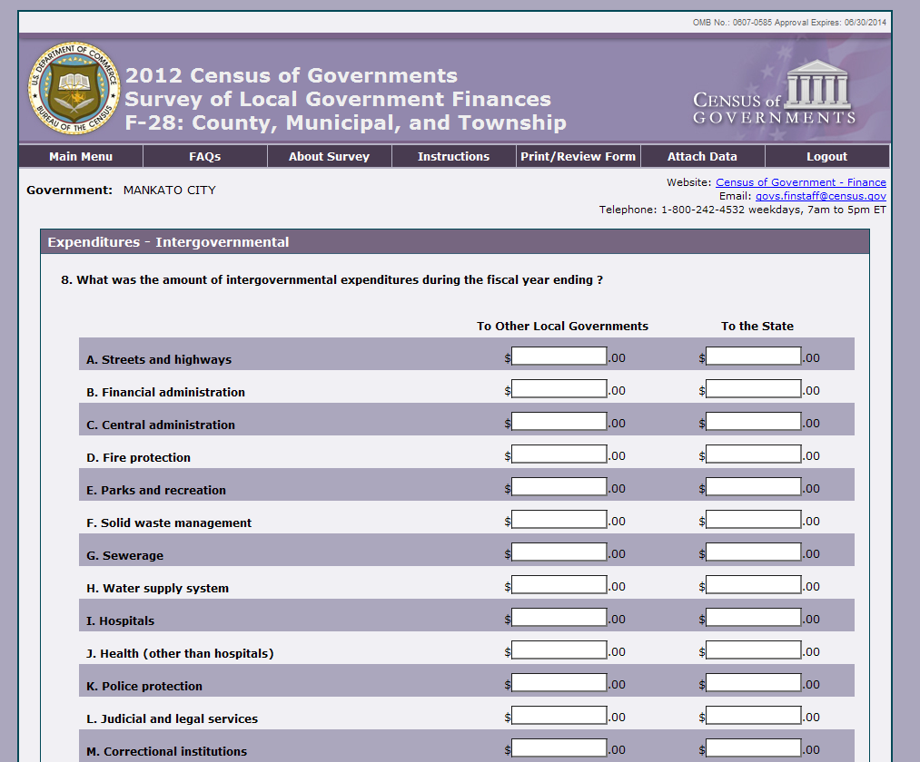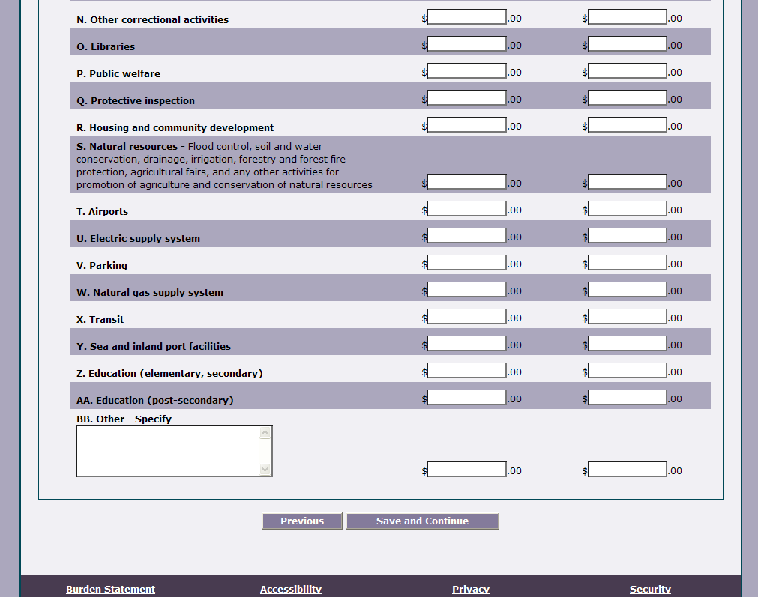
Salaries and Wages Item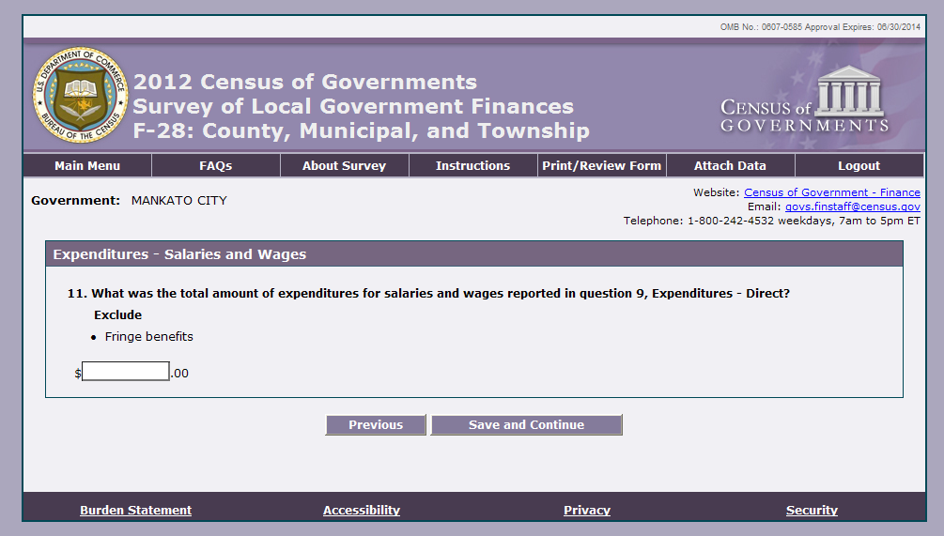

Indebtedness Item
Cash and Investments Held at End of Fiscal Year 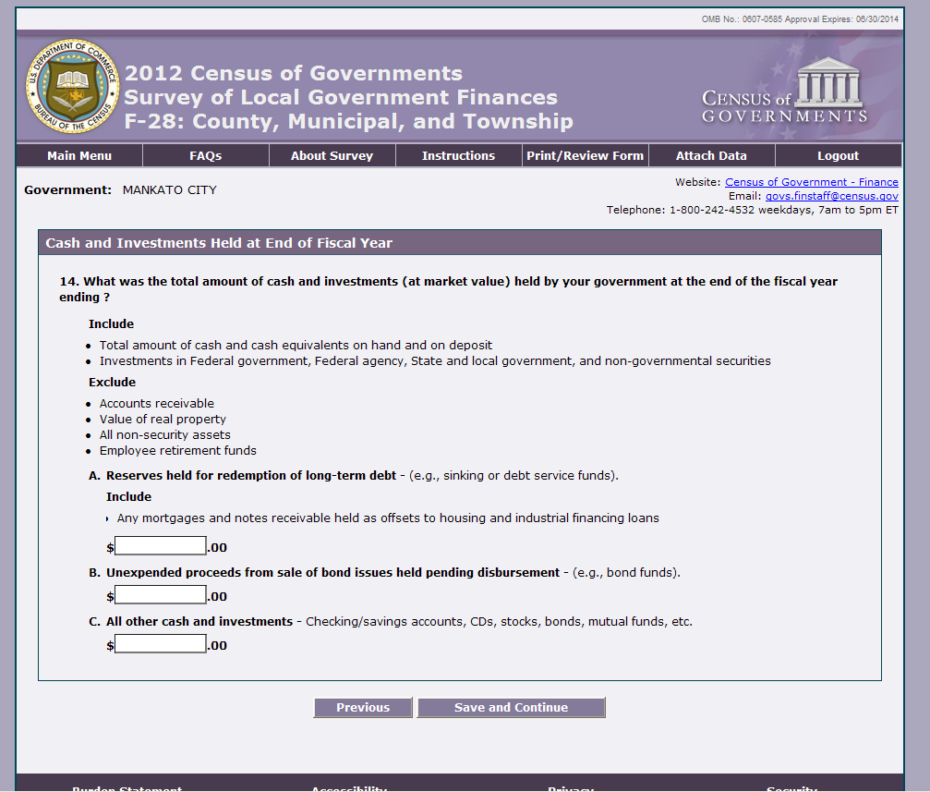
Certification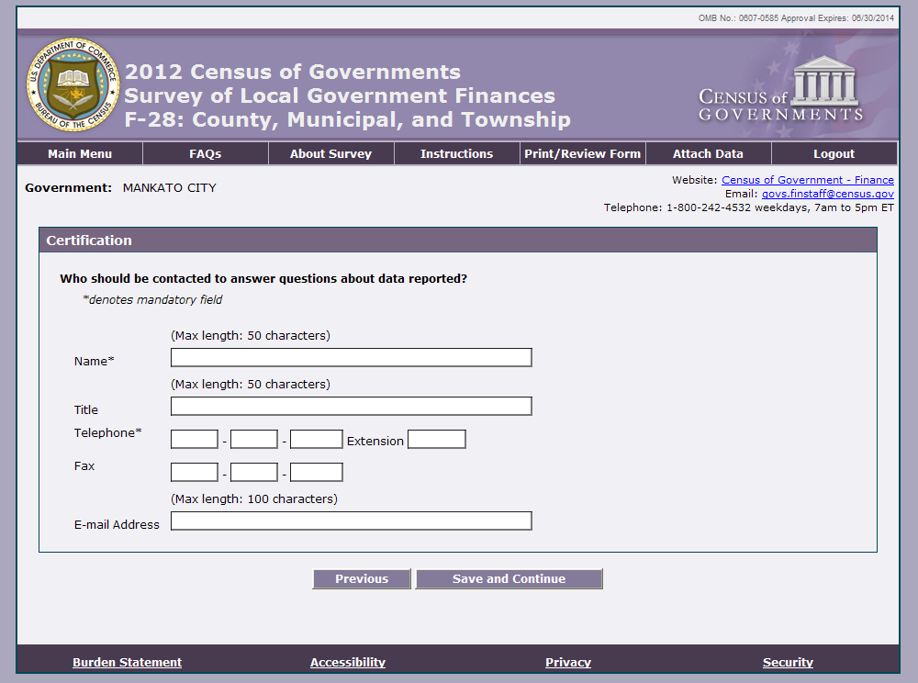

Review Screen (under construction)

