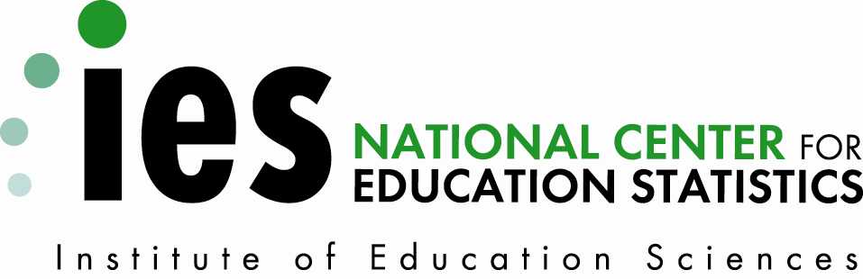

U.S. Department of Education
Institute of Education Sciences
Common Core
of Data - Teacher Compensation Survey

REQUEST FOR OMB REVIEW

Supporting Statement Part B

Prepared by:

National Center for Education Statistics
U.S. Department of Education
Washington, DC

May 26, 2010
Part B. Collections of Information Employing Statistical Methods

The Teacher Compensation Survey (TCS) does not collect sample data. The TCS removes sampling error and self-reporting bias through the use of an integrated dataset that contains universe data at the teacher level for multiple states. The survey is intended to provide statistical information about total compensation, teacher status, and demographic data about individual teachers from multiple states.

Although the personnel from state education agencies compiling the administrative records are experts, there are opportunities for potential error, either through technical mishap or misinterpretation of the intent of a data item. NCES staff members have developed a series of checks designed to flag these errors for review by the state agencies providing the administrative records. These checks also lead to action by NCES and Census Bureau staff. These edits rely on internal logic checks; consistency within specified tolerances over time; and consistency within a given jurisdiction and type of unit. Items reported as missing or not applicable are confirmed with SEAs and the responses may be changed accordingly.

1. Respondent Universe

The prospective universe includes the SEAs for the 50 states and the District of Columbia. It is anticipated that up to 35 SEAs (on average 31 annually) will participate in the TCS and provide data for school years 2009-2010 through 2011-2012.

B.2 Procedures for Collection of Information

None of the procedures described under this item (stratification, estimation, etc.) are used in the TCS collection.

B.3 Maximizing Response Rates

With approximately 33 percent of teachers in the nation included in the current participants’ dataset, the TCS already covers a substantial number of teachers. In 2010, the TCS expanded to 24 volunteer SEAs. In 2011-2013 the TCS is expected to expand up to 35 SEAs. NCES will continue to recruit new SEAs to the survey and ultimately build a complete universe of teacher compensation data. In accomplishing this goal, NCES will work with SEAs to ensure accuracy and comparability, as well as confidentiality of personally sensitive data. As new SEAs participate in the collection, the TCS will grow from a cross-sectional to a longitudinal dataset, expanding the possibilities for longitudinal and time series research. NCES anticipates that compensation data related to benefits, which currently remain elusive, will become increasingly available as SEAs continue to coordinate their data systems. When there is item non-response, the item is imputed and identified as such on the files and in reports.

B.4 Tests of Procedures

No such tests will be undertaken. Items are not added to the TCS unless a substantial majority (usually two-thirds or more) of respondents say that they can provide the item within 1 year of its introduction. This information is gathered during CCD Coordinator training sponsored by the U.S. Department of Education and at Education Information Management Advisory Consortium (EIMAC) meetings sponsored by the Council of Chief State School Officers (CCSSO). State CCD Coordinators also have the opportunity to respond on-line to proposals for new items.

B.5 Individuals Consulted on Statistical Design

There are no statistical aspects to the design of the TCS collections and thus no individuals were contacted.

