INFORMATION COLLECTION SUPPORTING STATEMENT

Automatic Dependent Surveillance – Broadcast (ADS-B) Out Performance Requirements to Support Air Traffic Control (ATC) Service

Final Rule

2120-AI92

- Explain the circumstances that make the collection of information necessary. Identify any legal or administrative requirements that necessitate the collection. Attach a copy of the appropriate section of each statue and regulation mandating or authorizing the collection of information. (Annotate the CFR parts/sections affected).

Title 49 of the United States Code, Subtitle VII, Aviation Programs, described in detail the scope of the agency’s authority. This rulemaking is promulgated under the authority described Subtitle VII, Part A, Subpart I, Section 40103, Sovereignty and use of the Airspace, and Subpart III, Section 44701, General requirements.

Under Section 40103, the FAA is charged with prescribing regulations on the flight of aircraft, including regulations on safe altitudes, navigating, protecting, and identifying aircraft, and the safe and efficient use of the navigable airspace. Under Section 44701, the FAA is charged with promoting safe flight of civil aircraft in air commerce by prescribing regulations for practices, methods and procedures the Administrator finds necessary for safety in air commerce.

This project is in direct support of the Department of Transportation’s Strategic Plan – Strategic Goal – CAPACITY; i.e., to increase capacity to meet projected demand and reduce congestion. This rulemaking amends 14 CFR part 91 to add performance requirements for certain avionics equipment on aircraft operating in specified airspace within the United States National Airspace System (NAS). The rule will facilitate the use of ADS-B for aircraft surveillance by FAA air traffic controllers and allow the NAS to expand to meet future demand. The rule will also provide aircraft operators with a platform for additional fight applications and services.

- Indicate how, by whom, and for what purpose the information is to be used. Except for a new collection, indicate the actual use the agency has made of the information received from the current collection.

The rule will support the information needs of the FAA by requiring avionics equipment that continuously transmits aircraft information to be received by the FAA, via automation, for use in providing air traffic surveillance services.

- Describe whether, and to what extent, the collection of information involves the use of automated, electronic, mechanical, or other technological collection techniques or other forms of information technology, e.g., permitting electronic submission of responses, and the basis for the decision for adopting this means of collection. Also describe any consideration of using information technology to reduce burden. [Effective 03/22/01, your response must SPECIFICALLY reference the Government Paperwork Elimination Act (GPEA), which addresses electronic filing and recordkeeping, and what you are doing to adhere to it. You must explain how you will provide a fully electronic reporting option by October 2003, or an explanation of why this is not practicable.]

This rule supports the Government Paperwork Elimination Act (GPEA). One hundred percent (100%) of the rule involves electronic collection of broadcast information from an aircraft to an automated receiver on the ground.

- Describe efforts to identify duplication. Show specifically why any similar information already available cannot be used or modified for use for the purpose(s) described in Item 2 above.

We have reviewed other FAA public-use reports and find no duplication. Also, the FAA knows of no other agency collecting the same information. The information sought is specific to aircraft being operated in the NAS. The information is available from that aircraft only, not from any other source.

- If the collection of information has a significant impact on a substantial number of small businesses or other small entities (Item 5 of the Paperwork Reduction Act submission form), describe the methods used to minimize burden.

The FAA has determined that a substantial number of small entities will be significantly affected by the rule and minimized the burden by considering the following alternatives:

Alternative One
The status quo alternative has compliance costs to continue the operation and commissioning of radar sites. The FAA rejected this status quo alternative because it is becoming operationally obsolete to use ground-based radars to track congested airways and pass information among control centers for the duration of flights. The current system is not able to upgrade to the NextGen capabilities, nor accommodate the estimated increases in air traffic, which would result in mounting delays or limitations in service for many areas.

Alternative Two
Alternative Two would employ a technology called multilateration. Multilateration is a separate type of secondary surveillance system that is not radar-based and has limited deployment in the U.S. At a minimum, multilateration requires at least four ground stations to deliver the same volume of coverage and integrity of information as ADS–B, because of the need to "triangulate" the aircraft's position.
Multilateration is a process that determines aircraft position by using the difference in time of arrival of a signal from an aircraft at a series of receivers on the ground. Multilateration meets the need for accurate surveillance and is less costly than ADS–B (however, more costly than radar), but cannot achieve the same level of benefits as ADS–B, such as system capacity and environmental improvements. Multilateration would provide the same benefits as radar, but the FAA estimates that the cost of providing multilateration (including the cost to sustain radar until multilateration is operational), would exceed the cost to continue full radar surveillance.

Alternative Three
Alternative Three would provide relief by having the FAA provide an exemption to small air carriers from all requirements of this rule. This alternative would mean that small air carriers would rely on the status quo ground-based radars to track their flights and pass information among control centers for the duration of the flights.
As discussed previously, ADS-B Out cannot be used effectively as the primary surveillance system if certain categories of airspace users are subject to separate surveillance systems. The small air carriers operate in the same airspace as the larger carriers and general aviation. Such an exemption would require two primary surveillance systems, which adds the cost of an additional surveillance system without improving the existing benefits. Thus, this alternative is not considered to be acceptable.

Alternative Four
Alternative Four exempts small-piston engine GA operators from the requirements of this final rule. This final rule provides minimal benefits to small-piston engine GA operators, while adding significant costs by mandating these operators to retrofit and equip about 150,000 small piston engine GA airplanes with ADS–B Out. Even though the FAA determined that the percentage of small piston engine GA airplanes operating at the top Operational Evolution Plan 35 airports is less than 5%, the number of GA operations within a 30-nautical-mile radius of these airports is significant. This alternative was not considered acceptable because ADS-B equipage for all aircraft operating in the airspace subject to this rule is essential to gaining the overall stated ADS-B benefits, realizing savings associated with radar decommissioning, and the expansion of potential future benefits.

Alternative Five
This alternative is the final ADS–B rule. ADS–B does not employ different classes of receiving equipment or provide different information based on its location. Therefore, controllers will not have to account for transitions between surveillance solutions as an aircraft moves closer to or farther away from an airport. To address congestion and delay, fuel consumption, emissions, and future demand for air travel without significant delays or denial of service, the FAA found ADS–B to be the most cost-effective solution to maintain a viable air transportation system. ADS–B provides a wider range of services to aircraft users and could enable applications that are not available with multilateration or radar.

- Describe the consequence to Federal program or policy activities if the collection is not conducted or is conducted less frequently, as well as any technical or legal obstacles to reducing burden.

Without this rulemaking, the transition to the Next Generation Air Transportation System (NextGen), which will provide more efficient service for aircraft operating in the NAS and meet the growing demands on the air traffic control system, will not be possible. (See Question 5, discussion of Alternative 5.)

- Explain any special circumstances that require the collection to be conducted in a manner inconsistent with the general information collection guidelines in 5 CFR 1320.5(d)(2).

The rule requires operators to equip aircraft operating in specified airspace within the NAS with ADS-B avionics that will continually transmit aircraft information (in “real time”) to FAA ground receivers. The information will be used for air traffic control surveillance of those operations.

- Describe efforts to consult persons outside the agency to obtain their views on the availability of data, frequency of collection, the clarity of instructions and recordkeeping, disclosure, or reporting format (if any), and on the data elements to be recorded, disclosed, or reported. If applicable, provide a copy and identify the date and page number of publication in the Federal Register of the agency’s notice, required by 5 CFR 1320.8(d) soliciting comments on the information collection prior to submission to OMB. Summarize public comments received in response to that notice and describe actions taken by the agency in response to these comments. Specifically address comments received on cost and hour burden.

This proposal was published in the Federal Register on October 5, 2007 (72 FR 56947).
While the FAA received comments on the proposed performance requirements for ADS–B Out aircraft equipment, the agency received no comments specifically on the burden associated with collecting aircraft transmissions from the ADS–B Out equipment required by this rule.

- Explain any decision to provide any payment or gift to respondents, other than remuneration of contractors or grantees.

There will be no monetary considerations for this collection of information.

- Describe any assurance of confidentiality provided to respondents and the basis for the assurance in statute, regulation, or agency policy.

The respondents will not be given assurance of confidentiality.

- Provide additional justification for any questions of sensitive nature, such as sexual behavior and attitudes, religious beliefs, and other matters that are commonly considered private.

There are no questions of a sensitive nature.

- Provide estimates of hour burden of the collection of information.

This information is collected electronically without input from the human operator. Old information is overwritten on a continuous basis. A 1-hour burden is submitted to allow entry in the OMB database.

The following table shows the number of respondents who would install ADS-B Out equipment.

The following table shows the number of aircraft that will be equipped each year until 2035. The average number of aircraft that will be equipped annually for the first three years is 577.

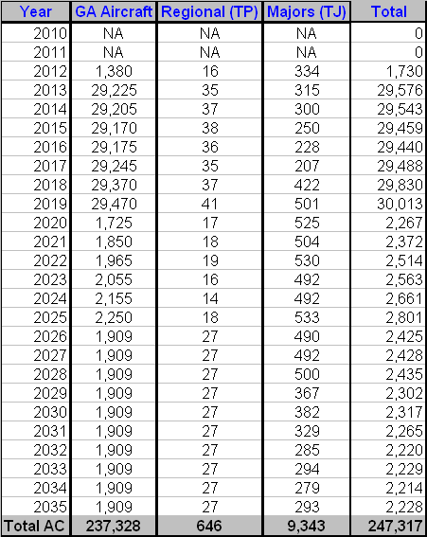

- Provide an estimate of the total annual cost burden to respondents or recordkeepers resulting from the collection of information.

The follow table shows the range of total costs for a ADS-B Out-compliant transponder. These costs include the sum of the unit, maintenance, installation and certification costs. These costs do not include the cost of upgrades for future navigational aides such as ADS-B In.

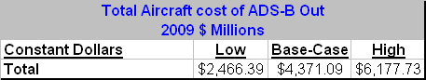

- Provide estimates of annualized cost to the Federal Government. Also, provide a description of the method used to estimate cost, and other expenses that would not have been incurred without this collection of information.

The Federal government will incur costs to provide ADS-B surveillance uplink and downlink services, TIS-B and FIS-B services. Since these costs are incurred in order to provide data on aircraft they are all considered data collection costs.

Total government costs to provide these services are estimated at $1.8 billion over 27 years, or about $68 million per year. Total costs discounted by 7% are $1.1 billion as presented below. To annualize these costs over 27 years we multiply $1.074 billion by .08343 to derive $89.6 million annualized cost.

Costs in thousands of 2009 dollars
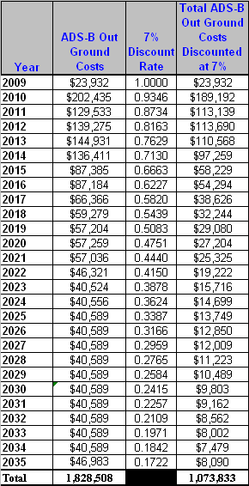
- Explain the reasons for any program changes or adjustments reported in Items 13 or 14 of the OMB Form 83-I.

This is a new collection, therefore it is a program change.

- For collections of information whose results will be published, outline plans for tabulation and publication. Address any complex analytical techniques that will be used. Provide the time schedule for the entire project, including beginning and ending dates of the collection of information, completion of report, publication dates, and other actions.

There is no plan for tabulation or publication.

- If seeking approval to not display the expiration date for OMB approval of the information collection, explain the reasons that display would be inappropriate.

No such approval is being sought.

- Explain each exception to the certification statement identified in Item 19, “Certification for Paperwork Reduction Act Submissions,” of OMB Form 83-I.

There are no exceptions.

