DBIDS SWAsia

Person Registration
- Demographics Screen
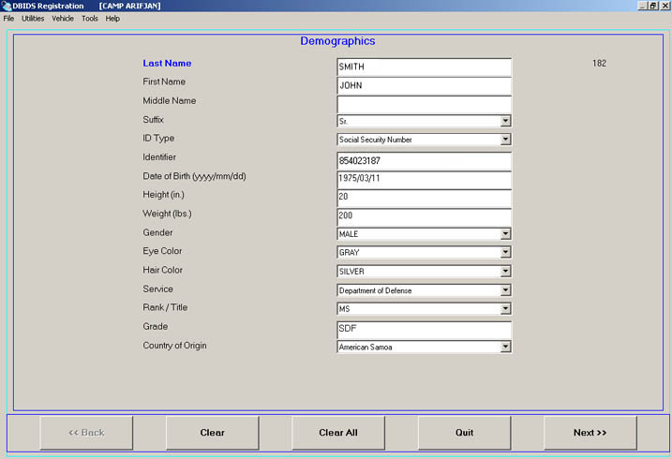

- Authorization Profile Screen
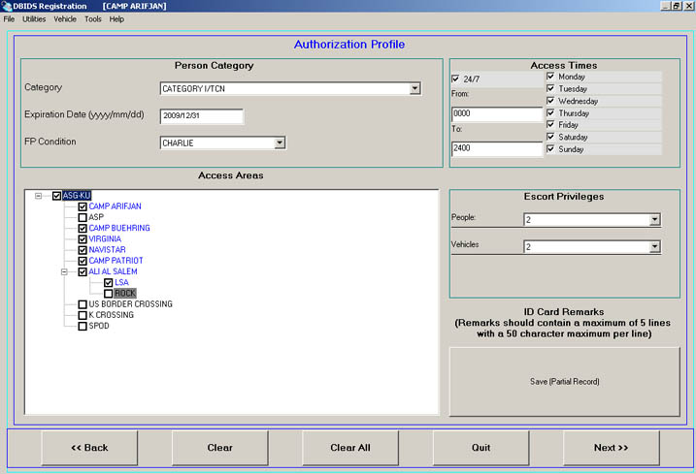

- Capture Photo Screen
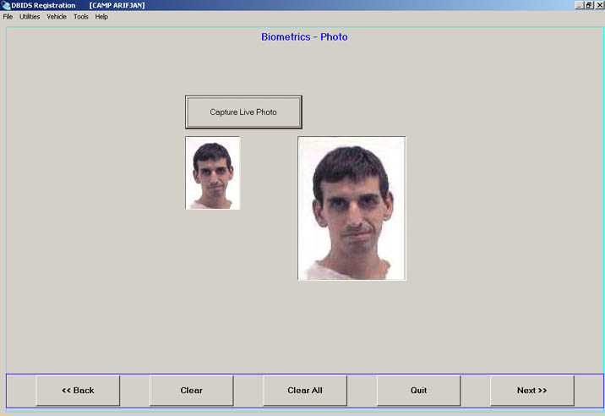

- Access Control Reader: Placing Fingers Against Alignment Pins
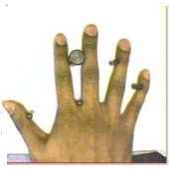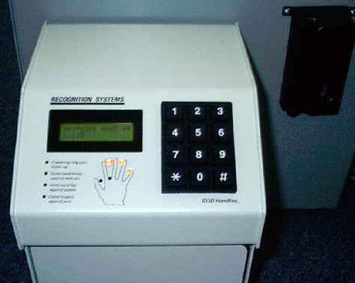
Place fingers against alignment pins and hold fingers and palm flat.
When positioned correctly, all finger position indicator lights turn off. A red light indicates incorrect position. When a red light turns on, move the finger toward the indicated alignment pin until the light turns off.

- Completed Fingerprint Screen
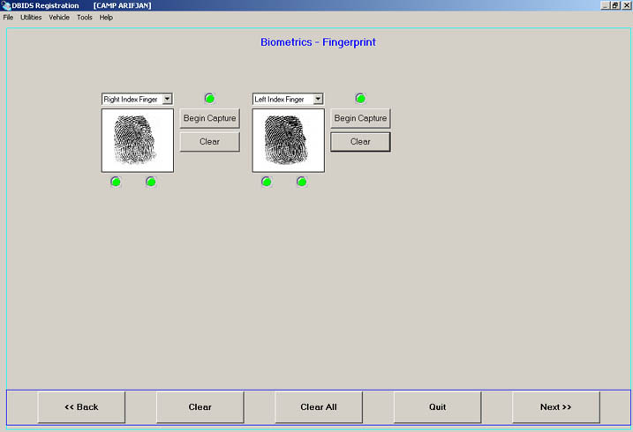

- Successful ID Card Verification Screen
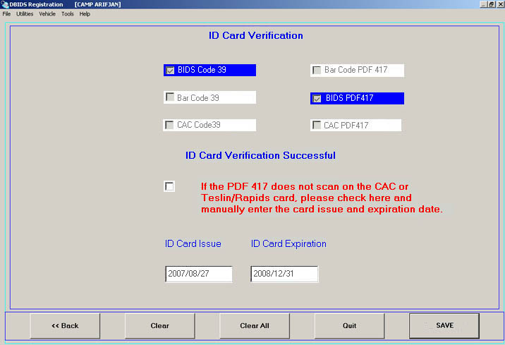

- Screening Demographic Info Screen
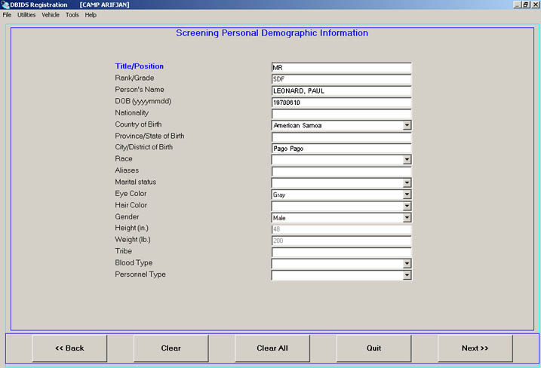
- Ten Print Images Complete Screen
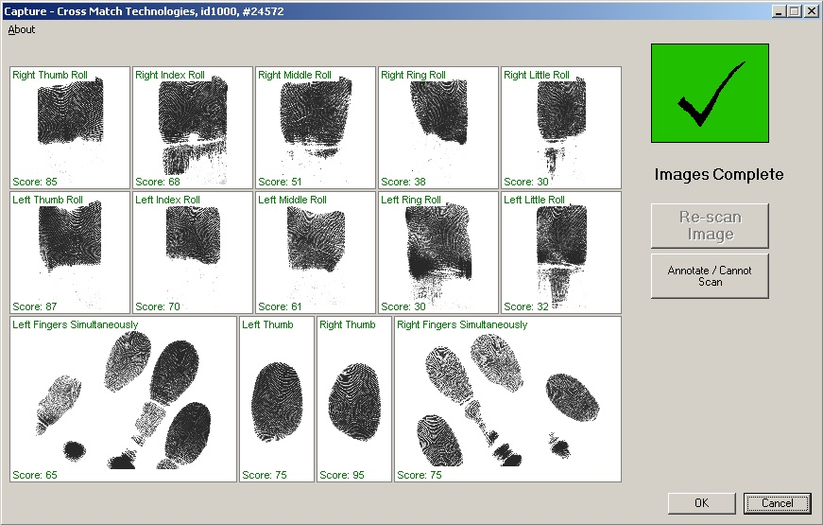

- Biometrics – Completed Mugshot Screen
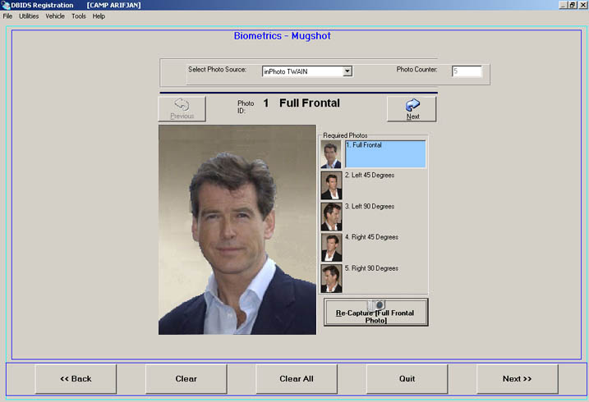
- Completed DBIDS Iris Capture Screen
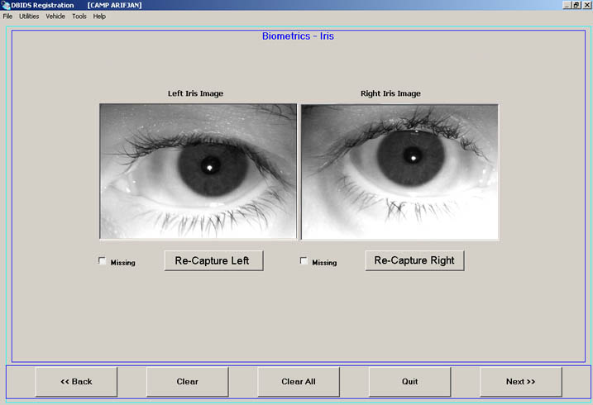

- Screening Family Information Screen
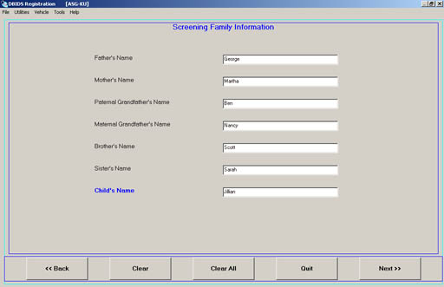
- Screening Identification Information Screen
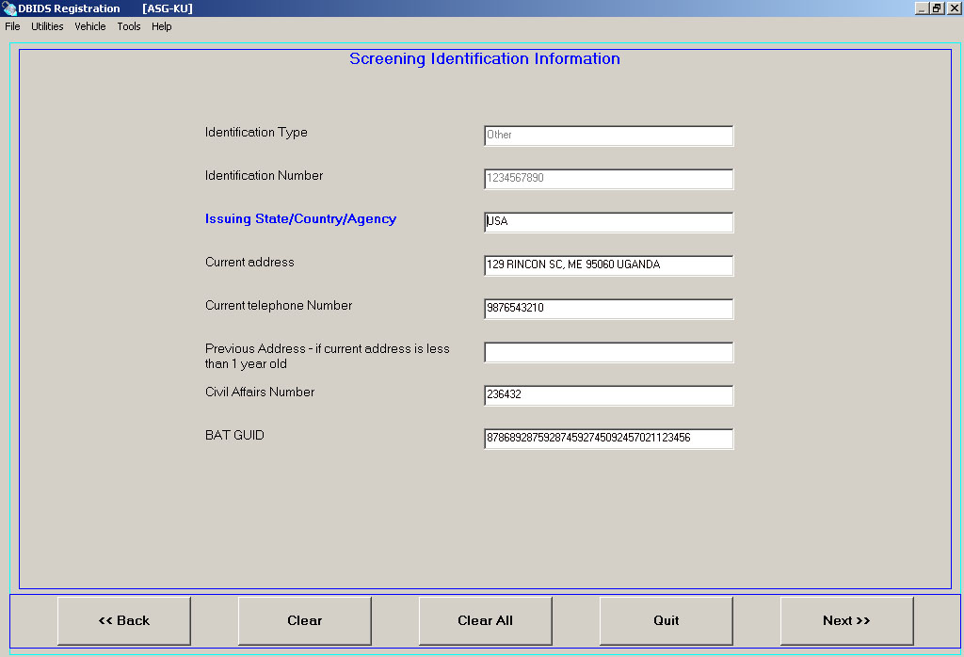
- Screening Employer Information Screen
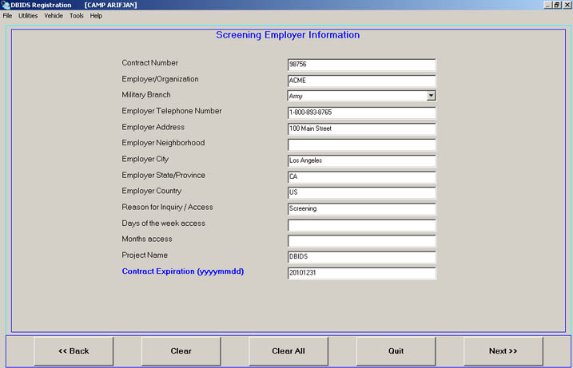
- Screening Sponsor Information Screen
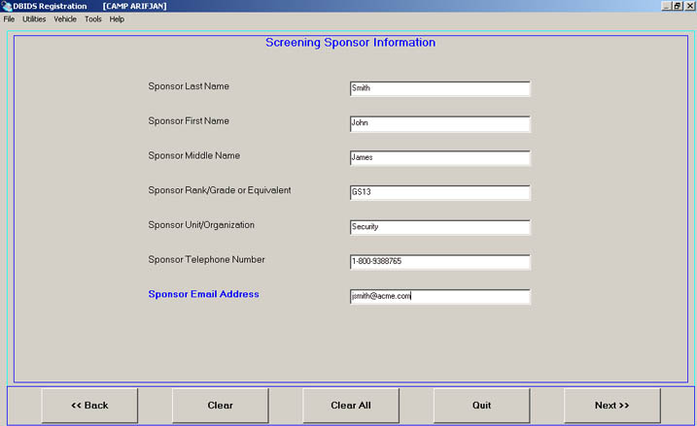
- Screening Requesting Authority Information Screen
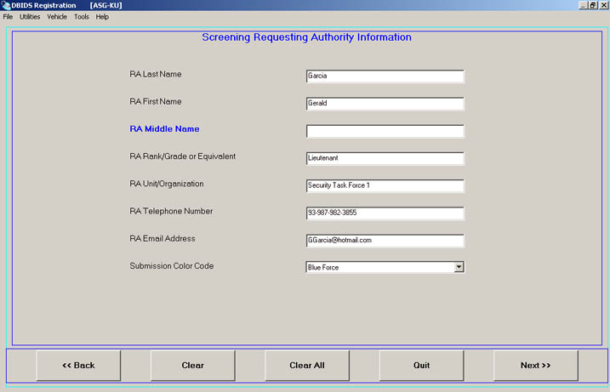
- Screening Approval Authority Information
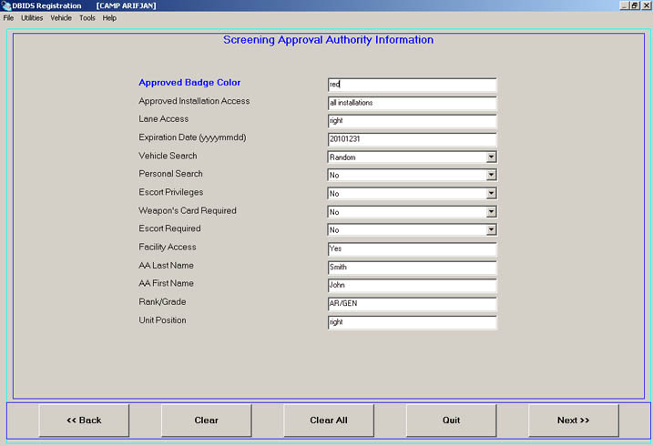
- Screening Enrollment Personnel Information Screen
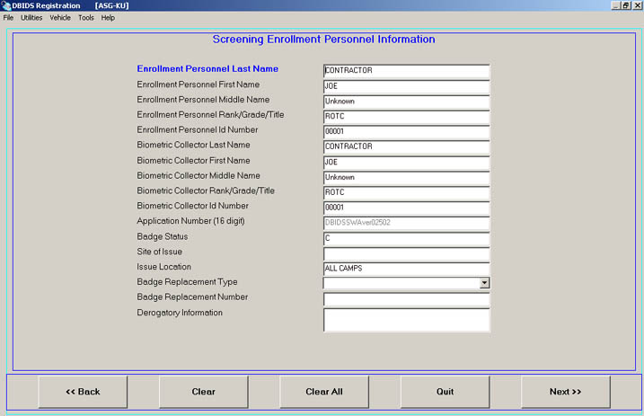
- Completed Vehicle Information Screen
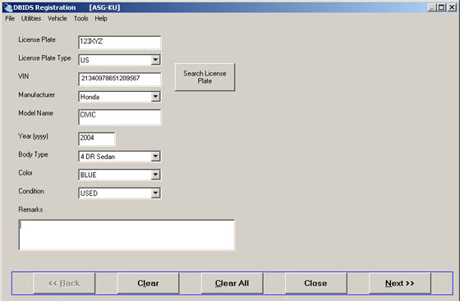
- Vehicle Access Authorization Screen
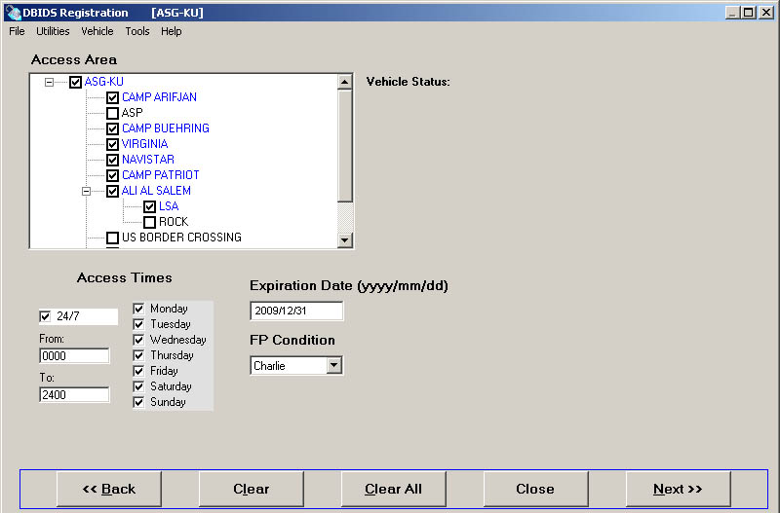
- Vehicle Associations Screen
