NPHPSP Reporting System – Main Screen
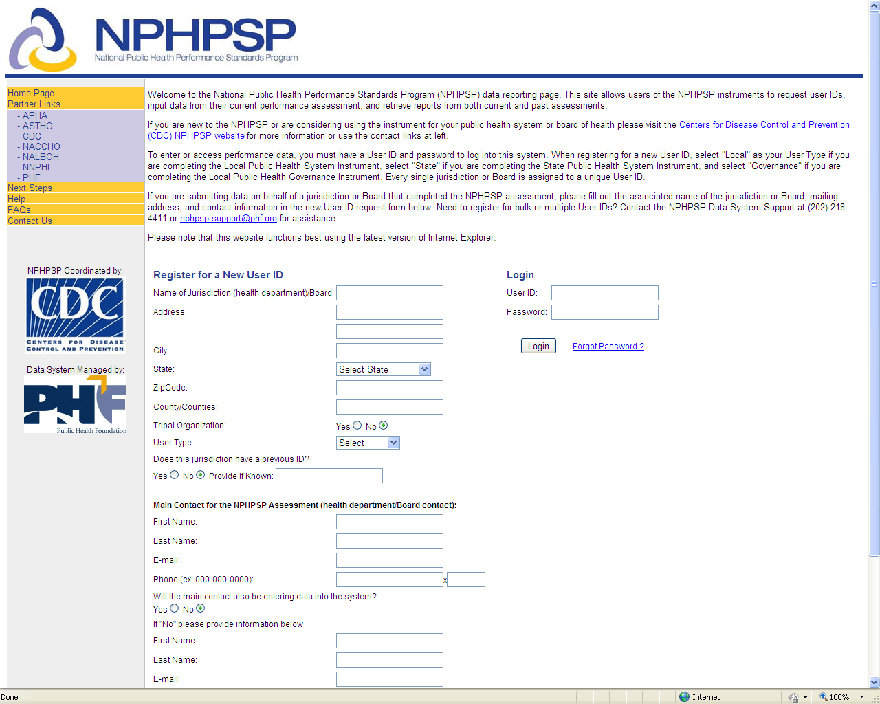

NPHPSP Reporting System – Next Steps Page
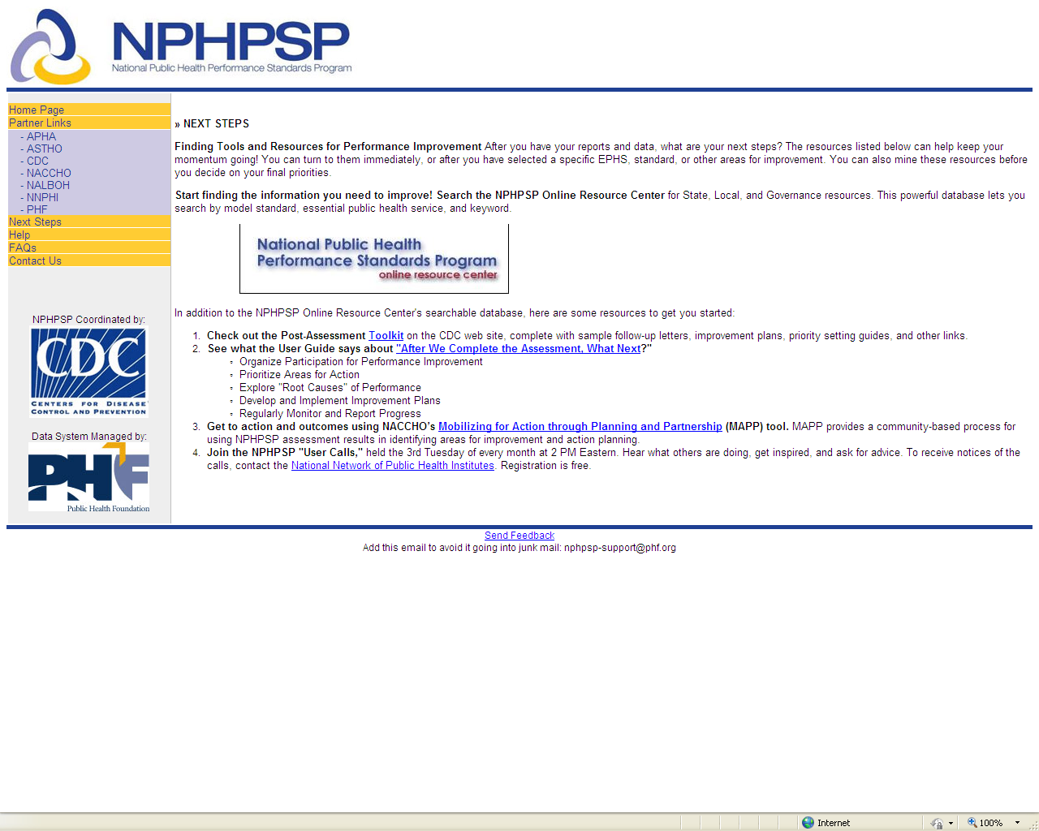

NPHPSP Reporting System – Help Page 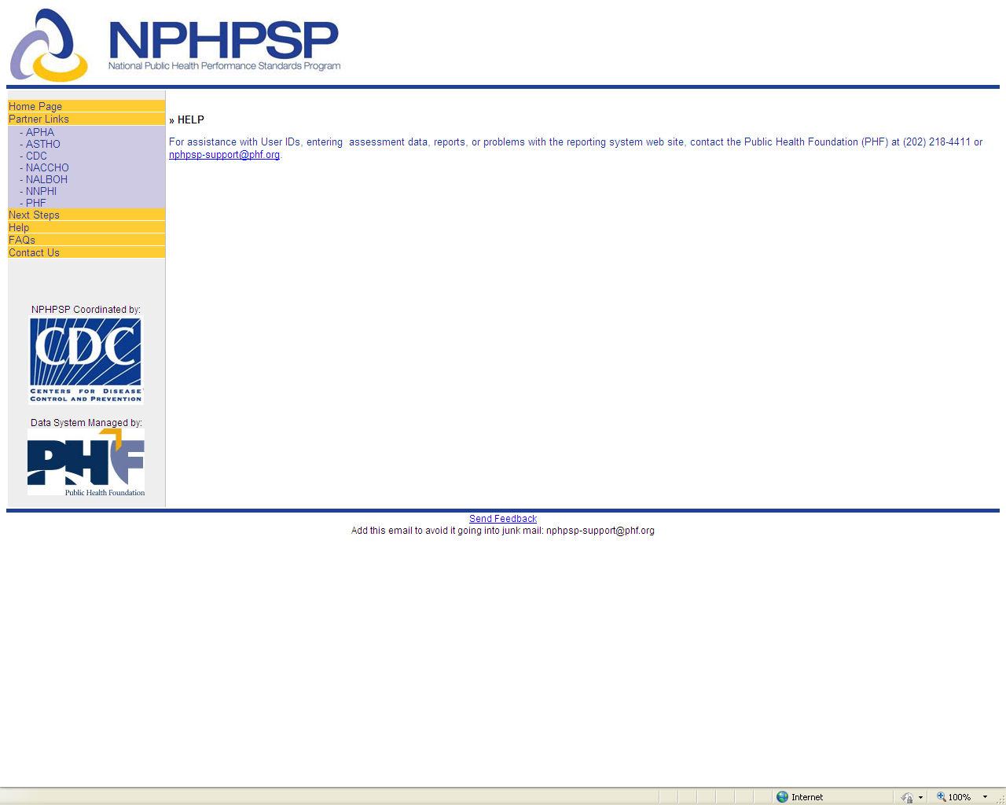 NPHPSP Reporting System – Frequently Asked Questions Guidance 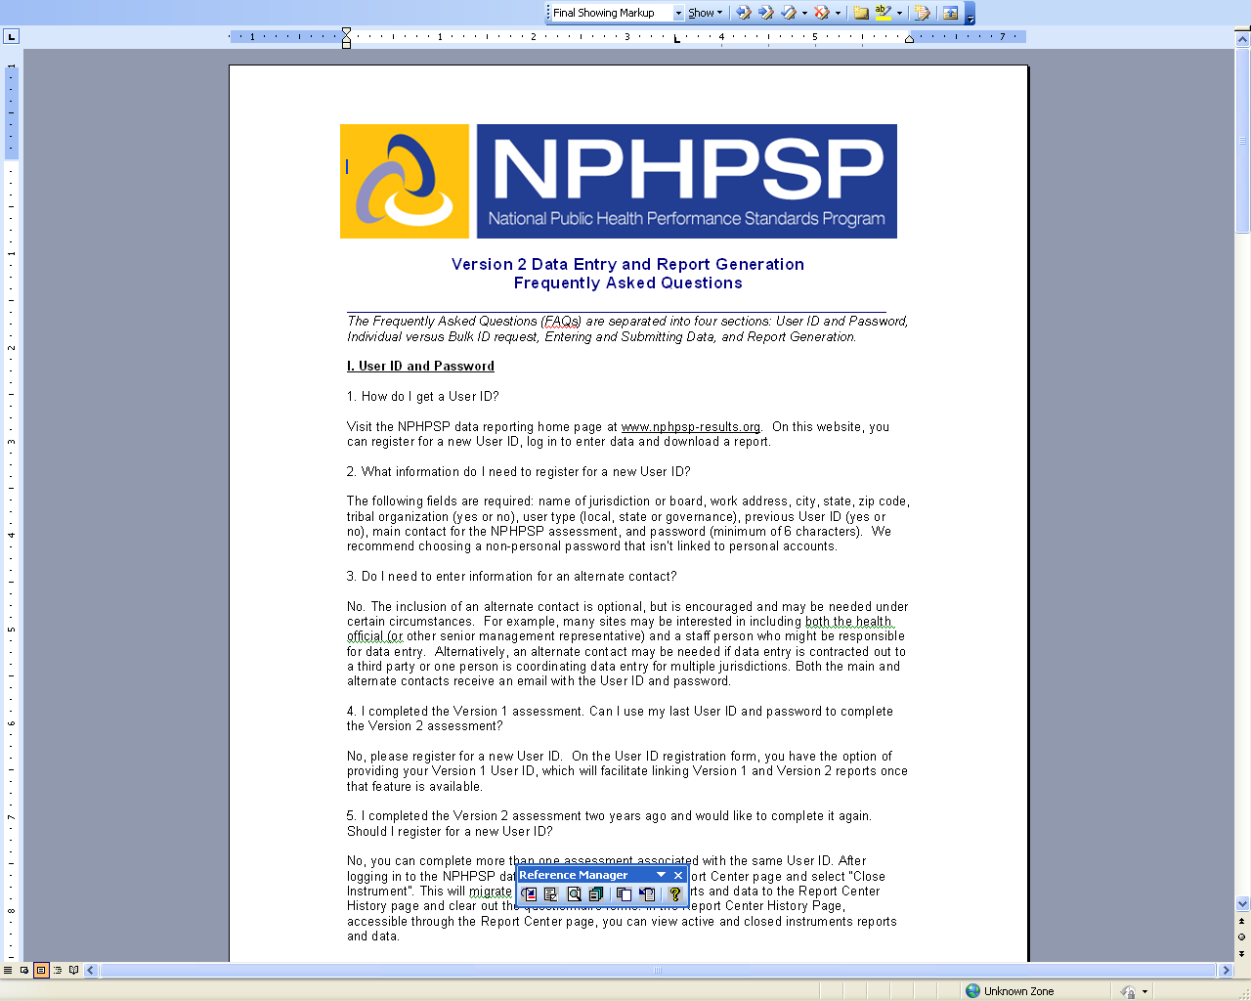

NPHPSP Reporting System – Contact Us Page
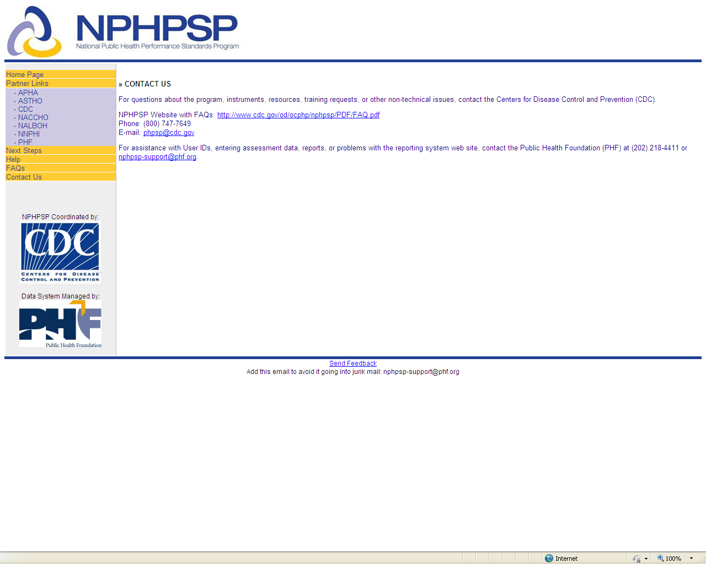

NPHPSP Reporting System – New User ID Registration and User Log-In
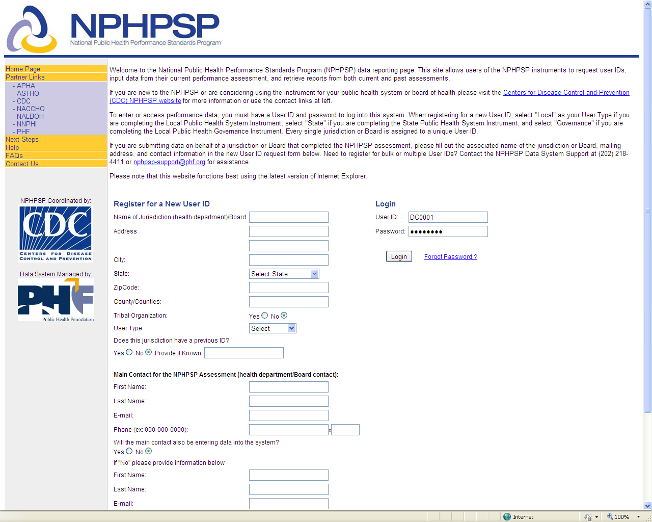

NPHPSP Reporting System – Welcome User Page after Secure Log-in
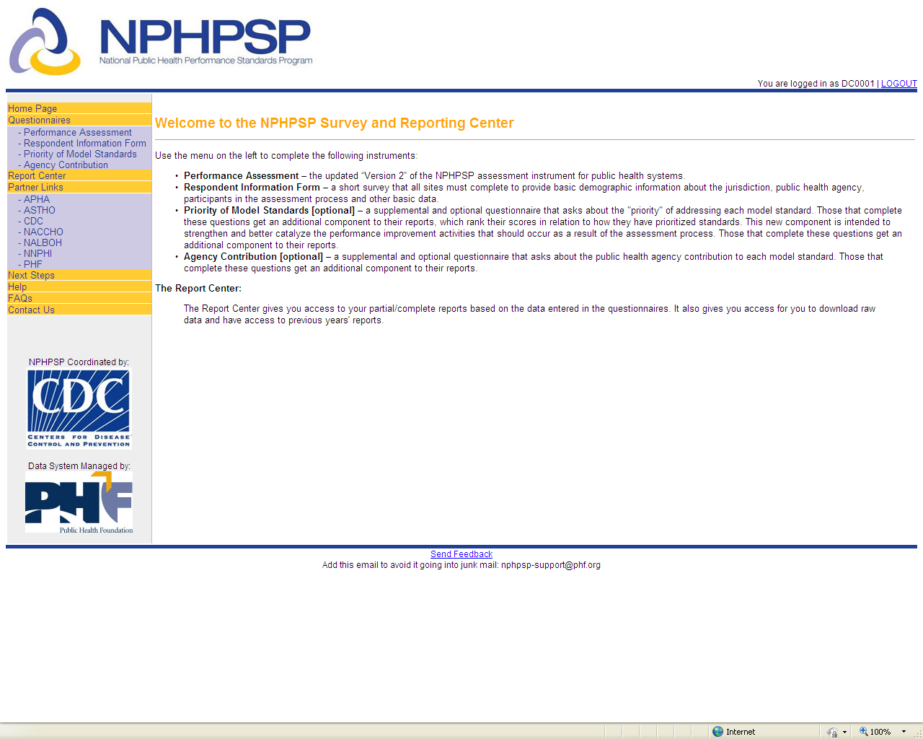

NPHPSP Reporting System – Performance Assessment Questionnaire Page
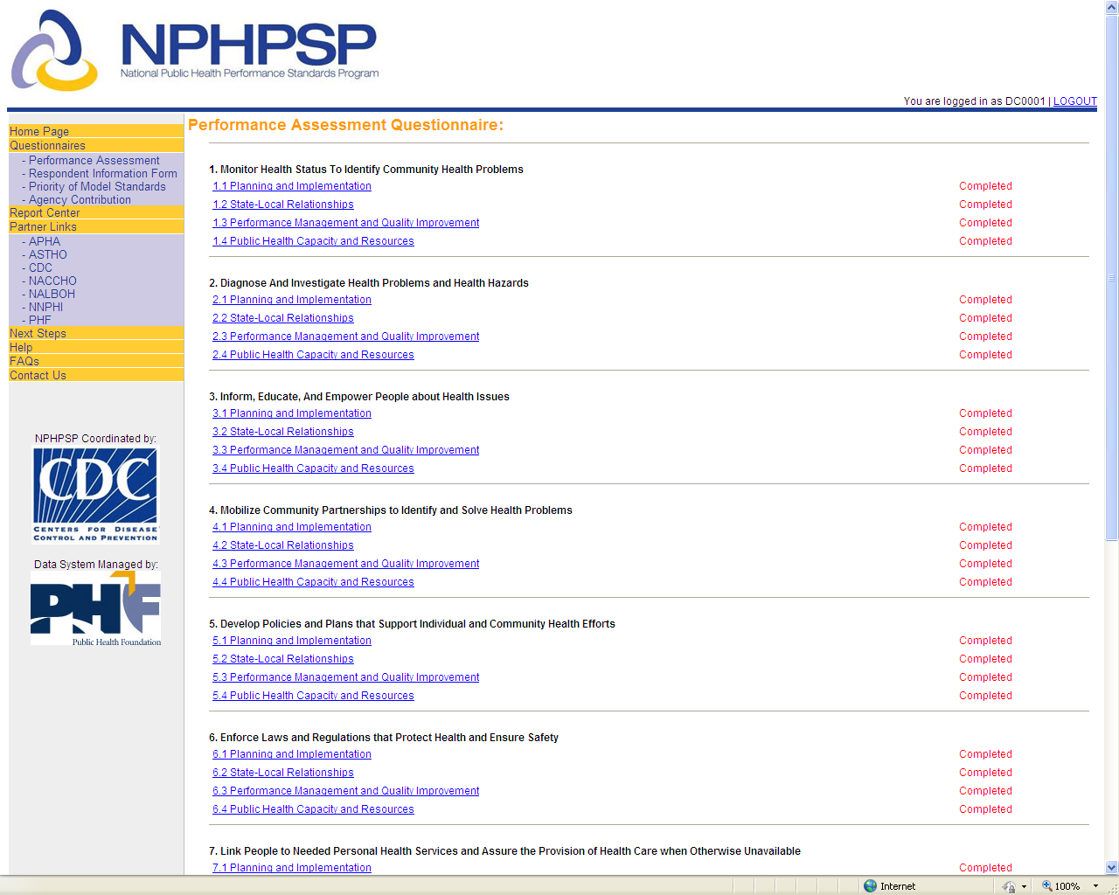

NPHPSP Reporting System – Performance Assessment Questionnaire Detail Page
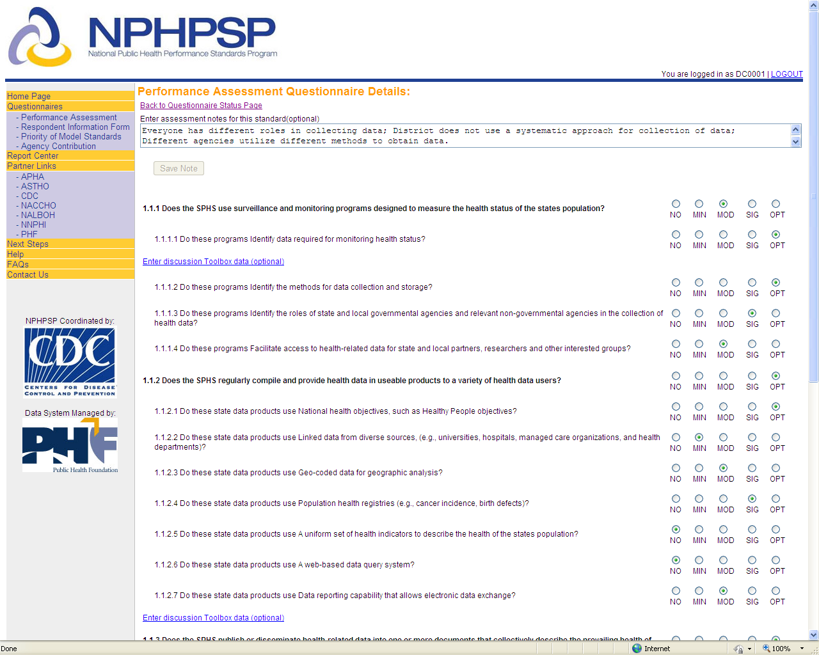

NPHPSP Reporting System – Respondent Information Form Questionnaire Page
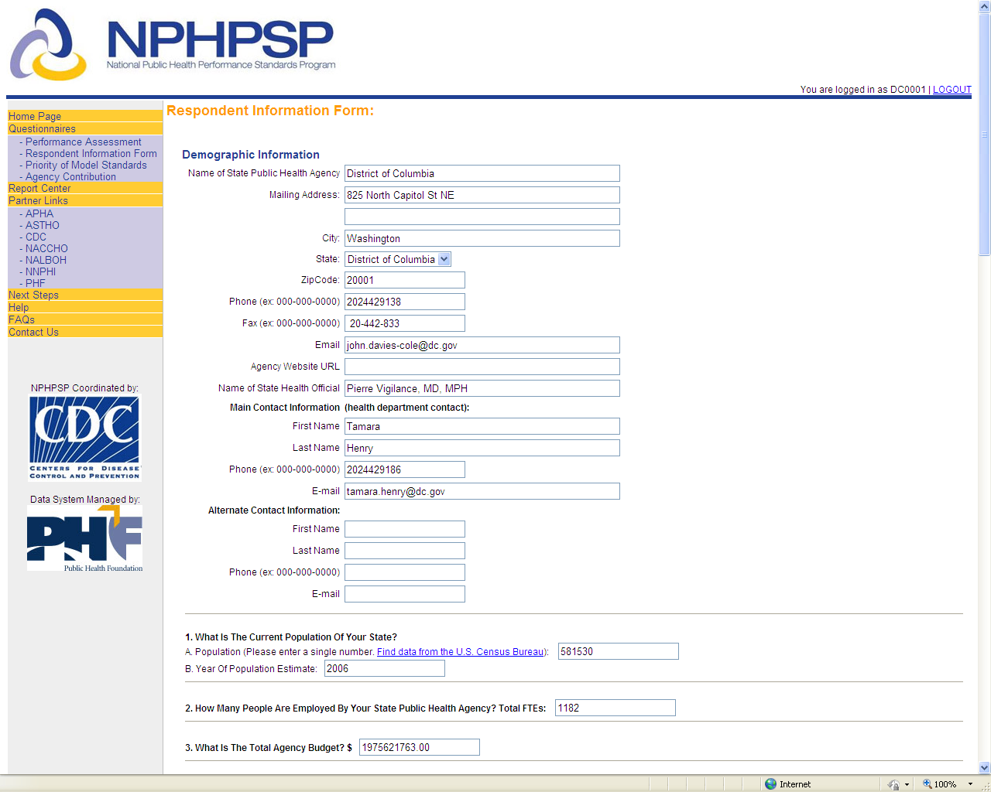

NPHPSP Reporting System – Priority of Model Standards (Optional Questionnaire) Page
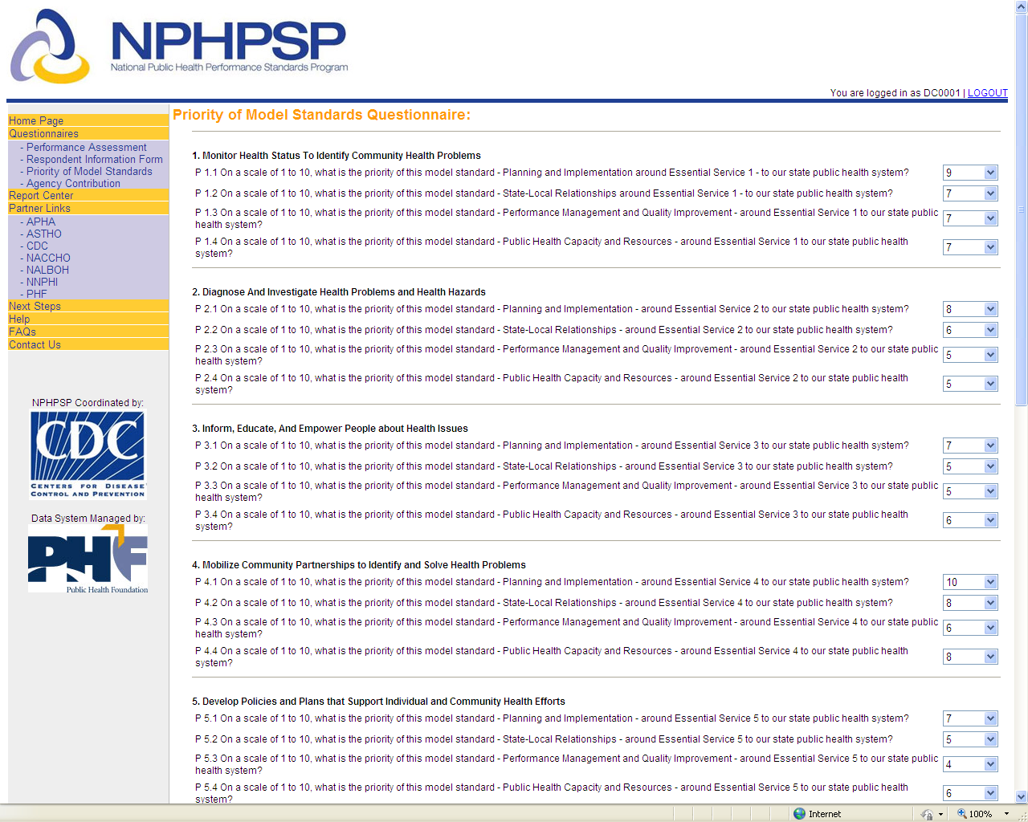

NPHPSP Reporting System – Agency Contribution (Optional Questionnaire) Page
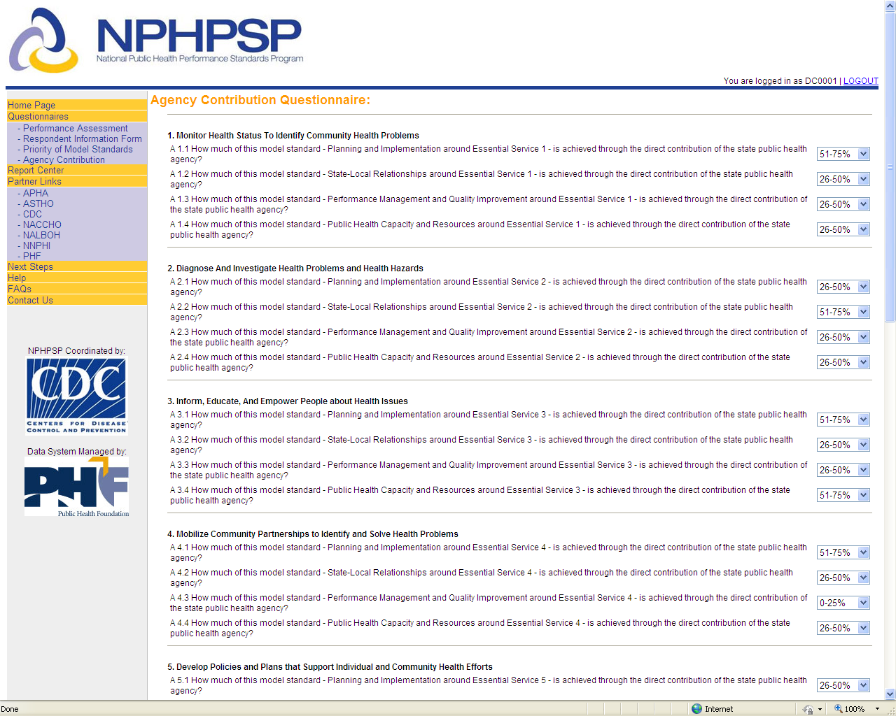

NPHPSP Reporting System – Report Center Page
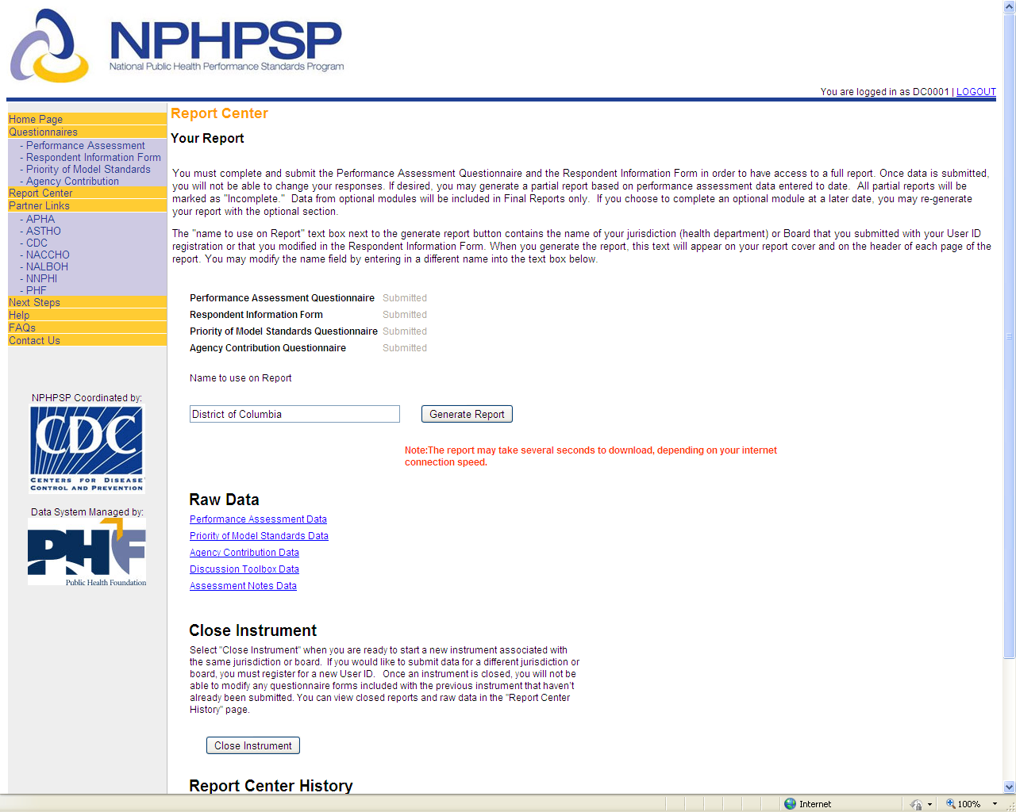

NPHPSP Reporting System – Report of Results Download
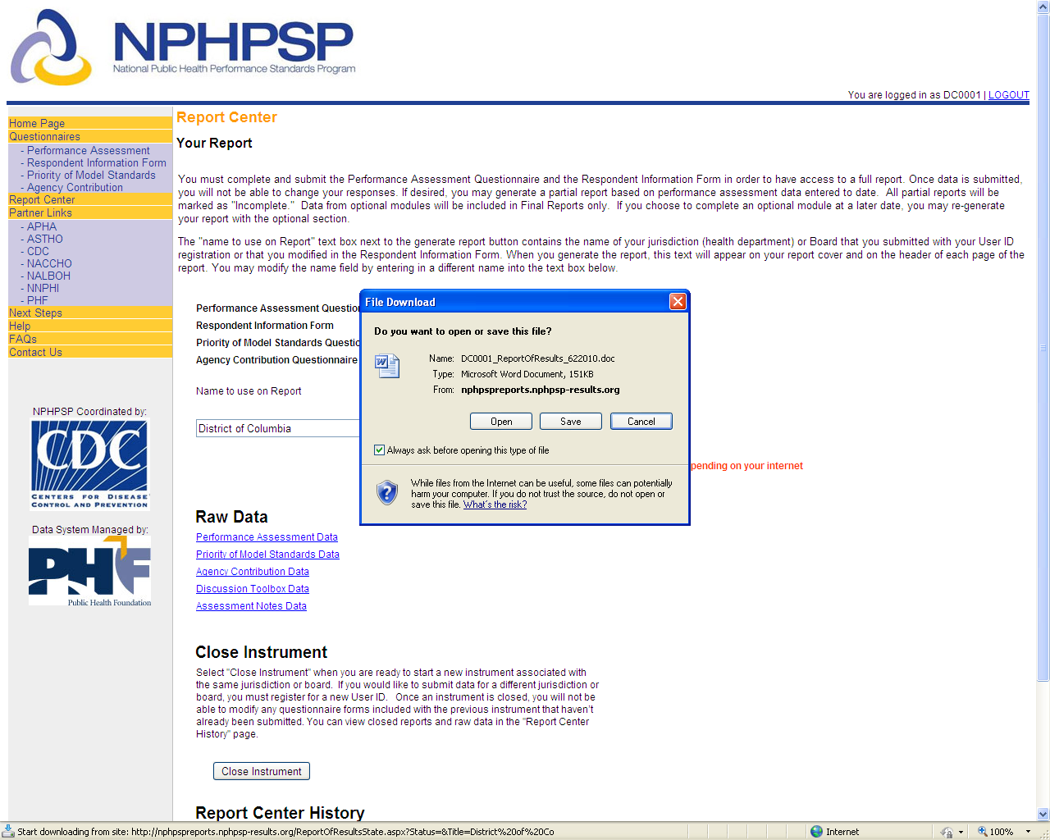

NPHPSP Reporting System – Report of Results Cover Page
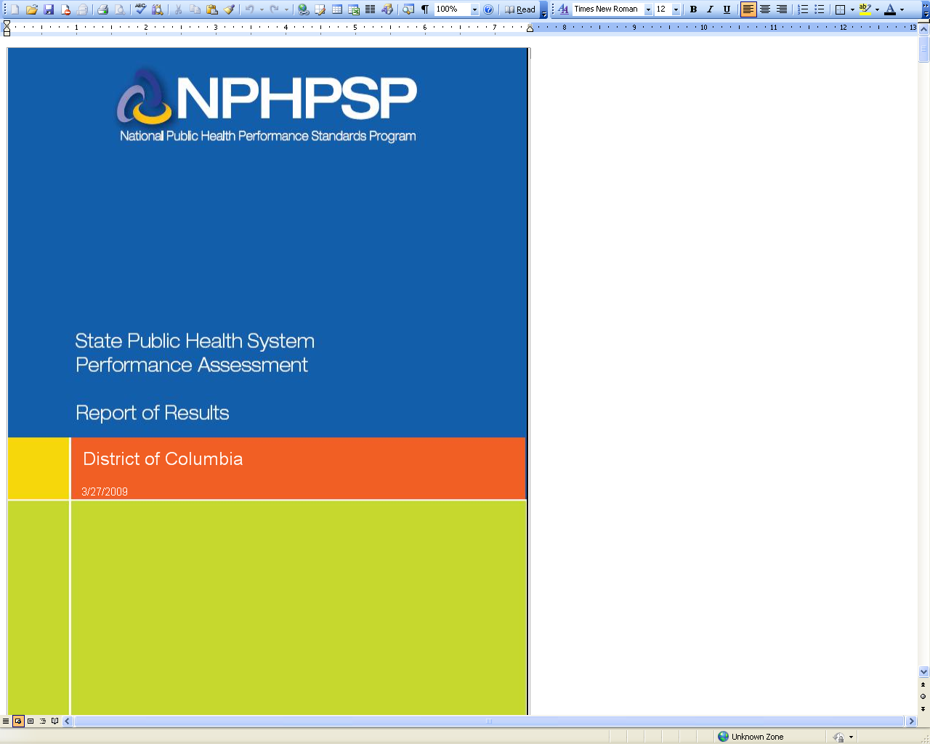

NPHPSP Reporting System – Report of Results Tables & Figures
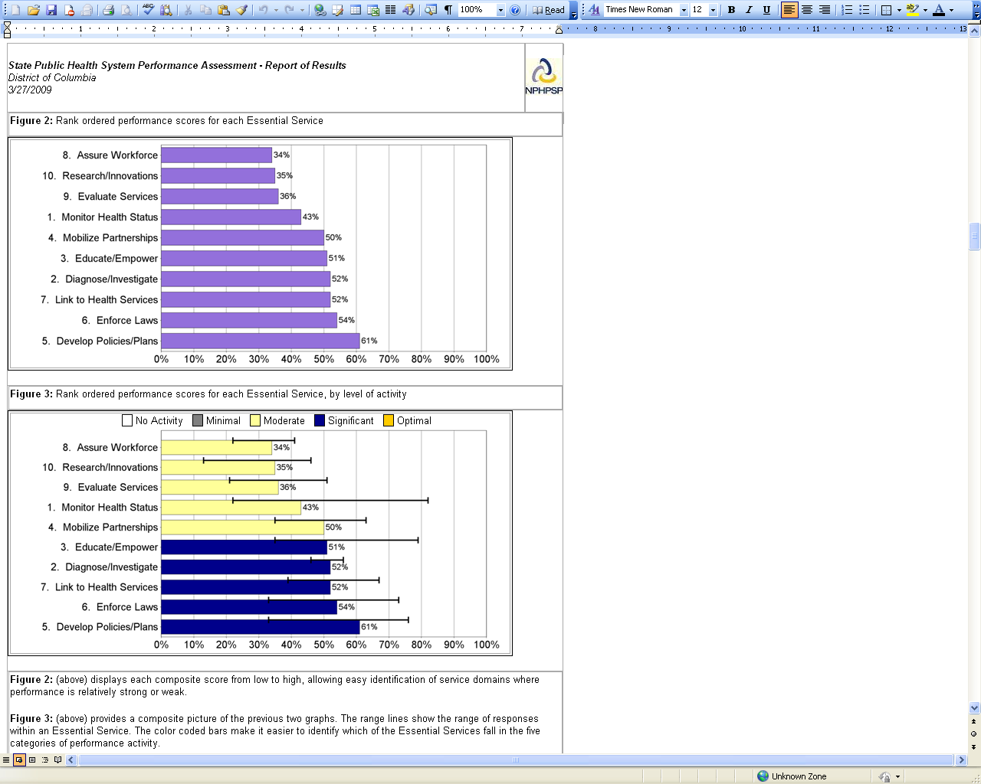

NPHPSP Reporting System – Report of Results Tables & Figures
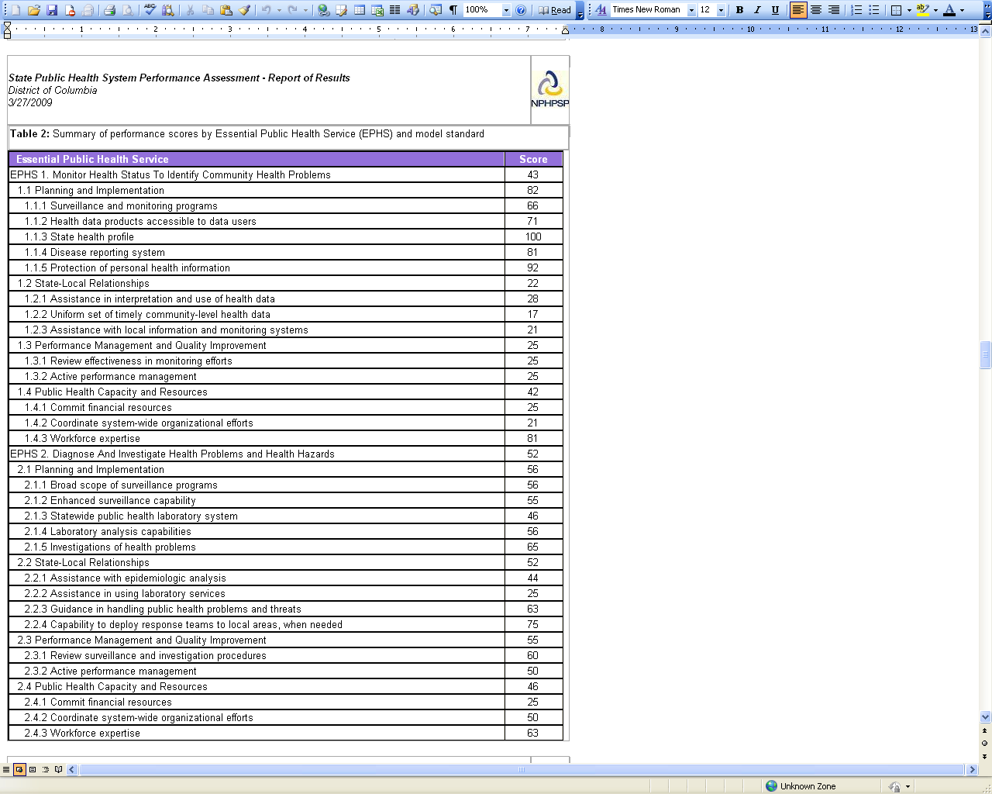

NPHPSP Reporting System – Report of Results Tables & Figures
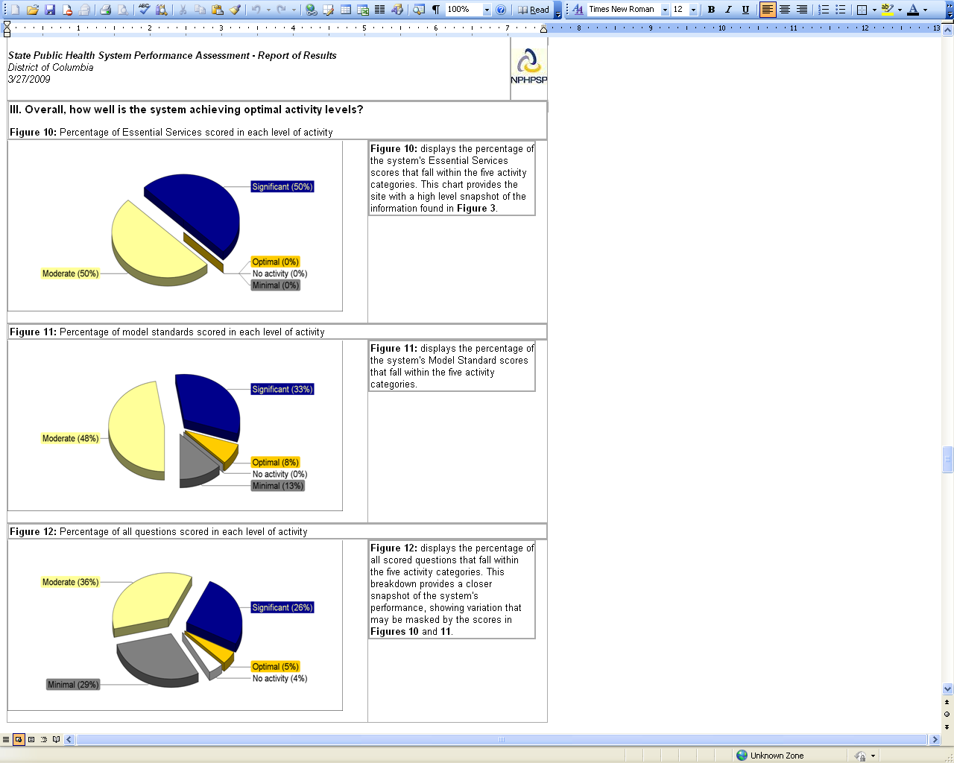

NPHPSP Reporting System – Report of Results Tables & Figures
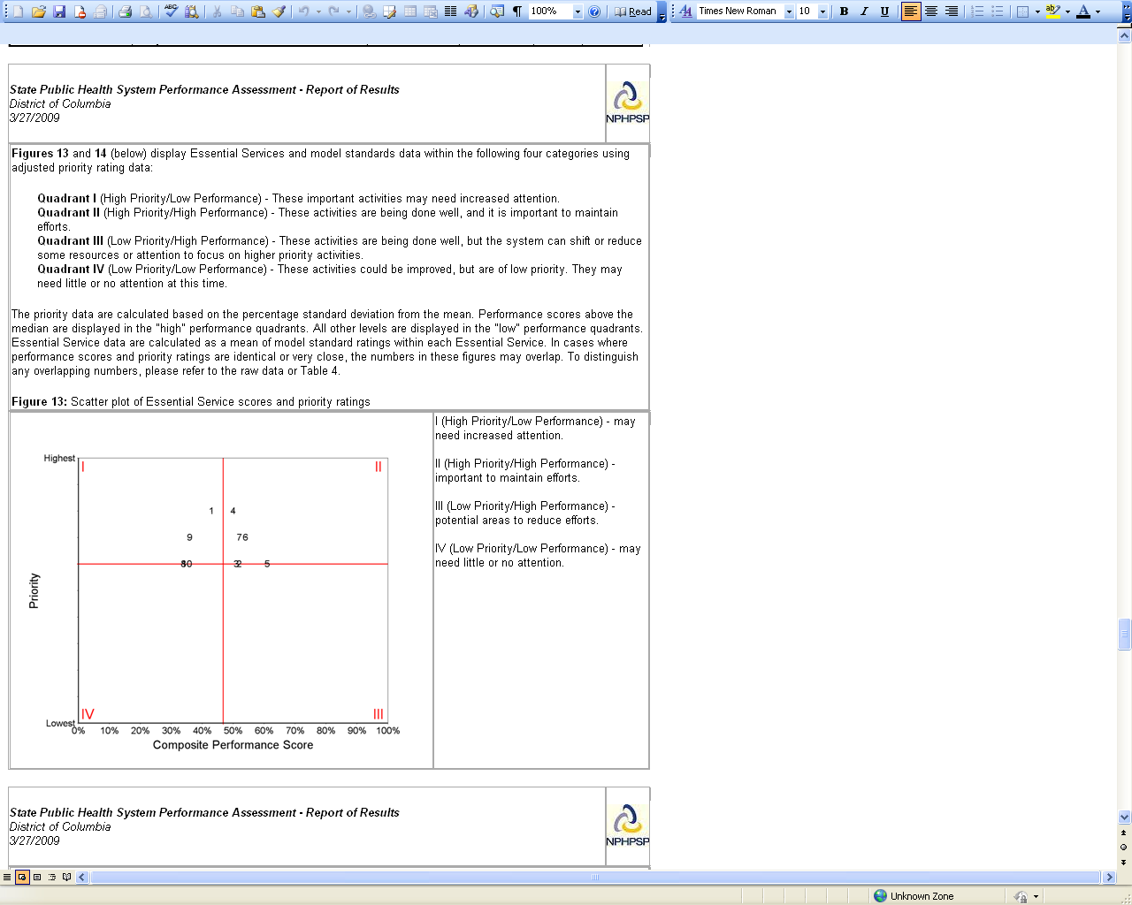

NPHPSP Reporting System – Performance Assessment Data Excel Spreadsheet Download
