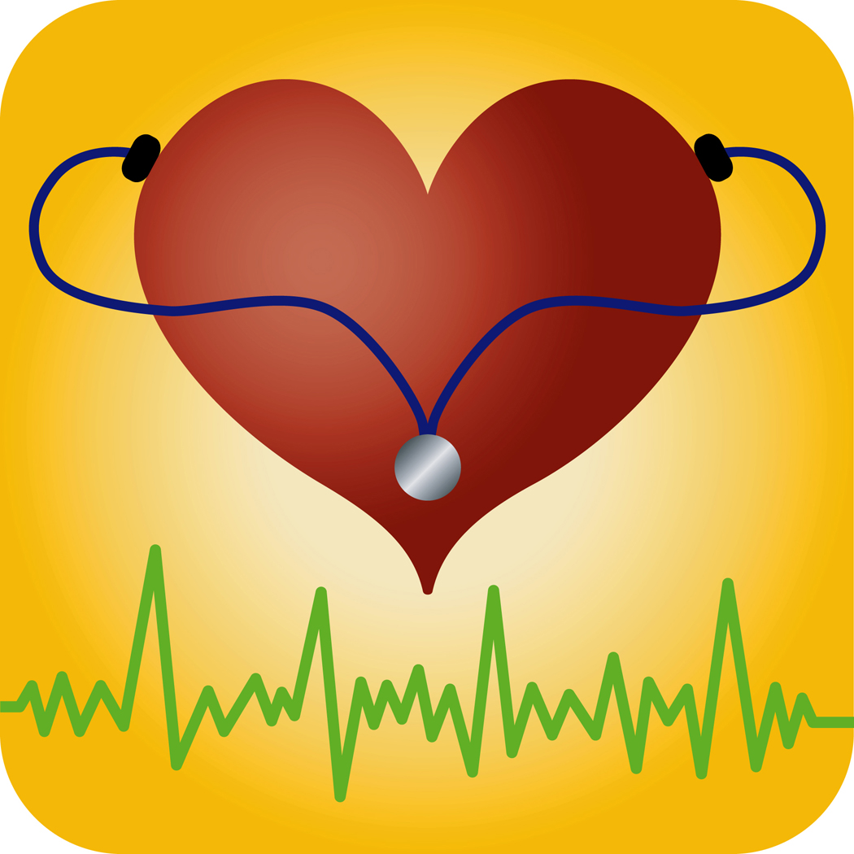

Family Medical
History Questionnaire



Instructions

Please complete the Family Medical History questionnaire as best as you can. If you don’t know the answer to one or more questions or have the information you need to complete the questionnaire, please don’t guess. Instead, please contact your biological mother, father, or full brothers and sisters and ask them to help you complete the questionnaire. If you need help or have questions while completing this questionnaire, please call XXX-XXX-XXXX.

The following questions are about your parents and siblings, not your children.

1. Were you raised by your biological parent or parents, adoptive parents, foster parents, or other relatives? (MARK ALL THAT APPLY.)

  - Biological parent(s) ➔ Q3
  - Adoptive parent(s)
  - Foster parent(s)
  - Other relatives, specify: ______________________________
  - Don’t know

2. Do you know anything about the health conditions of your biological relatives?

  - Yes
  - No ➔ END
  - Don’t know

3. How many full siblings do you have? By full sibling, we mean brothers or sisters you have with the same biological mother and father.

|___|___|
NUMBER OF FULL SIBLINGS

  - No siblings
  - Don’t know

4. Is your biological mother still living?

  - Yes ➔ Q7
  - No
  - Don’t know ➔ Q7

5. What was the cause of her death?

____________________________________
MOTHER’S CAUSE OF DEATH

  - Don’t know

6. How old was she when she died? If you aren’t sure how old she was when she died, please guess as closely as you can.

|___|___|___|
AGE

  - Don’t know

7. Is your biological father still living?

  - Yes ➔ Q10
  - No
  - Don’t know ➔ Q10

8. What was the cause of his death?

____________________________________
FATHER’S CAUSE OF DEATH

  - Don’t know

9. How old was he when he died? If you aren’t sure how old he was when he died, please guess as closely as you can.

|___|___|___|
AGE

  - Don’t know
Please answer the following questions about your biological mother and father, as well as any full brothers and/or sisters you have.

 | Mother | Father | Full Brother/Sister # 1
Heart attack? | - Yes  - No  - Don’t know  Did she have a heart  attack before age 55?  - Yes  - No  - Don’t know | - Yes  - No  - Don’t know  Did he have a heart  attack before age 55?  - Yes  - No  - Don’t know | - Yes  - No  - Don’t know  Did s/he have a heart  attack before age 55?  - Yes  - No  - Don’t know
Angioplasty or coronary bypass surgery? | - Yes  - No  - Don’t know  Did she have angioplasty  or coronary bypass  surgery before age 55?  - Yes  - No  - Don’t know | - Yes  - No  - Don’t know  Did he have angioplasty  or coronary bypass  surgery before age 55?  - Yes  - No  - Don’t know | - Yes  - No  - Don’t know  Did s/he have angioplasty  or coronary bypass  surgery before age 55?  - Yes  - No  - Don’t know
Asthma? | - Yes  - No  - Don’t know | - Yes  - No  - Don’t know | - Yes  - No  - Don’t know
Eczema or atopic dermatitis? | - Yes  - No  - Don’t know | - Yes  - No  - Don’t know | - Yes  - No  - Don’t know
Allergies? | - Yes  - No  - Don’t know | - Yes  - No  - Don’t know | - Yes  - No  - Don’t know
High blood pressure? | - Yes  - No  - Don’t know | - Yes  - No  - Don’t know | - Yes  - No  - Don’t know

 | Mother | Father | Full Brother/Sister # 1
Attention deficit disorder (ADD) or attention deficit hyperactivity disorder (ADHD)? | - Yes  - No  - Don’t know | - Yes  - No  - Don’t know | - Yes  - No  - Don’t know
Autism, Asperger syndrome or other autism spectrum disorder? | - Yes  - No  - Don’t know | - Yes  - No  - Don’t know | - Yes  - No  - Don’t know
An eating disorder such as anorexia or bulimia? | - Yes  - No  - Don’t know | - Yes  - No  - Don’t know | - Yes  - No  - Don’t know
Alcoholism? | - Yes  - No  - Don’t know | - Yes  - No  - Don’t know | - Yes  - No  - Don’t know
Bipolar disorder? | - Yes  - No  - Don’t know | - Yes  - No  - Don’t know | - Yes  - No  - Don’t know
Depression other than bipolar disorder? | - Yes  - No  - Don’t know | - Yes  - No  - Don’t know | - Yes  - No  - Don’t know
Schizophrenia? | - Yes  - No  - Don’t know | - Yes  - No  - Don’t know | - Yes  - No  - Don’t know
Anxiety disorder such as generalized anxiety disorder (GAD)  or obsessive compulsive disorder (OCD)? | - Yes  - No  - Don’t know  What type of  anxiety disorder  was she diagnosed with:  ________________________ | - Yes  - No  - Don’t know  What type of  anxiety disorder  was he diagnosed with:  ________________________ | - Yes  - No  - Don’t know  What type of  anxiety disorder  was s/he diagnosed with:  ________________________
Mental retardation? | - Yes  - No  - Don’t know | - Yes  - No  - Don’t know | - Yes  - No  - Don’t know

 | Full Brother/Sister # 2 | Full Brother/Sister # 3 | Full Brother/Sister # 4
Attention deficit disorder (ADD) or attention deficit hyperactivity disorder (ADHD)? | - Yes  - No  - Don’t know | - Yes  - No  - Don’t know | - Yes  - No  - Don’t know
Autism, Asperger syndrome or other autism spectrum disorder? | - Yes  - No  - Don’t know | - Yes  - No  - Don’t know | - Yes  - No  - Don’t know
An eating disorder such as anorexia or bulimia? | - Yes  - No  - Don’t know | - Yes  - No  - Don’t know | - Yes  - No  - Don’t know
Alcoholism? | - Yes  - No  - Don’t know | - Yes  - No  - Don’t know | - Yes  - No  - Don’t know
Bipolar disorder? | - Yes  - No  - Don’t know | - Yes  - No  - Don’t know | - Yes  - No  - Don’t know
Depression other than bipolar disorder? | - Yes  - No  - Don’t know | - Yes  - No  - Don’t know | - Yes  - No  - Don’t know
Schizophrenia? | - Yes  - No  - Don’t know | - Yes  - No  - Don’t know | - Yes  - No  - Don’t know
Anxiety disorder such as generalized anxiety disorder (GAD)  or obsessive compulsive disorder (OCD)? | - Yes  - No  - Don’t know  What type of  anxiety disorder  was s/he diagnosed with:  ________________________ | - Yes  - No  - Don’t know  What type of  anxiety disorder  was s/he diagnosed with:  ________________________ | - Yes  - No  - Don’t know  What type of  anxiety disorder  was s/he diagnosed with:  ________________________
Mental retardation? | - Yes  - No  - Don’t know | - Yes  - No  - Don’t know | - Yes  - No  - Don’t know

