
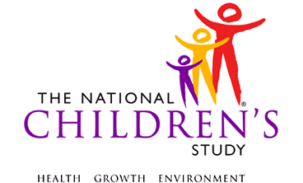
Infant Medical
Care Log

Infant Medical Care Log

The Infant Medical Care Log will help keep track of visits to doctors and other medical providers for your infant through 24 months of age. We will ask you about these visits during upcoming interviews. The log has two parts. The first part is for Routine / Well Visits and the other part is for Sick Visits. Please include visits to doctor’s offices, hospital emergency rooms and outpatient clinics, and any hospitalizations. Bring this Medical Care Log with you to each of your infant’s visits. If you forget to bring it with you to a visit, please complete the log as soon as possible afterwards.

Instructions for Completing Routine / Well Visits Log  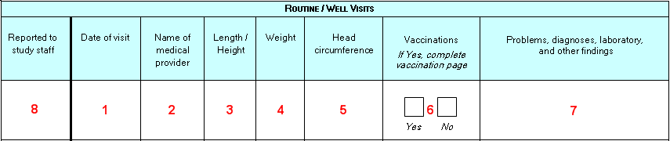  - Write in the visit date (month/day/year).  - Write in the name of the medical provider. For example, if your infant was examined by a pediatrician by the name of John Smith, write “Dr. John Smith” in the space provided.  - Write in your infant’s length / height. For example, if your infant is 32 inches tall at his 15 month well visit, write “32 inches” in the space provided.  - Write in your infant’s weight. For example, if your infant is 8 pounds, 4 ounces at his one month well visit, “8 pounds, 4 ounces” in the space provided.  - Write in your infant’s head circumference. For example, if your infant’s head circumference is 18.5 inches at his 15 month well visit, write “18.5 inches” in the space provided.  - If your infant received a vaccination (or vaccinations) during his/her well visit, put a √ in the space provided for “Yes”. You will record the type of vaccines he/she received in the Vaccinations section of this Medical Care Log.  - Write in any problems, diagnoses, laboratory or other findings that the medical provider may have noted or that you discussed with the medical provider. For example, if your child had dry, irritated skin that the provider thinks may be eczema, write “eczema” in the space provided.  - After you have finished telling NCS Staff about the routine/well visit, put a √ in the space provided.  IF YOU NEED HELP OR HAVE QUESTIONS PLEASE CALL  XXX-XXX-XXXX | Instructions for Completing Sick Visits Log  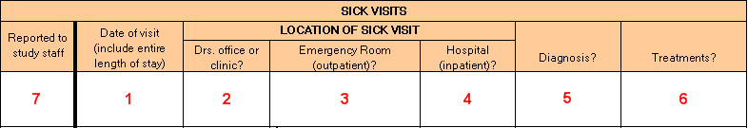  - Write in the visit date (month/day/year). If the visit lasts longer than a day, write in the entire length of the visit (i.e., 10/2/2008 – 10/4/2008).  - If you took your infant to a doctor’s office or clinic, put a √ in the space provided.  - If you took your infant to a hospital emergency room and he/she was seen as an outpatient, put a √ in the space provided.  - If you took your infant to the hospital and he/she was seen as an in-patient, put a √ in the space provided. [You may put a √ in both the emergency room (outpatient) box and the hospital (in-patient) box if your infant was first seen in a hospital emergency room and was later admitted to the hospital].  - If your infant received a diagnosis, put a √ in the space provided and fill in what the diagnosis was.  - If your infant received any treatments, put a √ in the space provided and write what the treatments were.  - After you have finished telling NCS Staff about the sick visit, put a √ in the space provided.  Affix label with VC info here

Infant Medical Care Log

Instructions for Completing Vaccination section of Vaccination Log

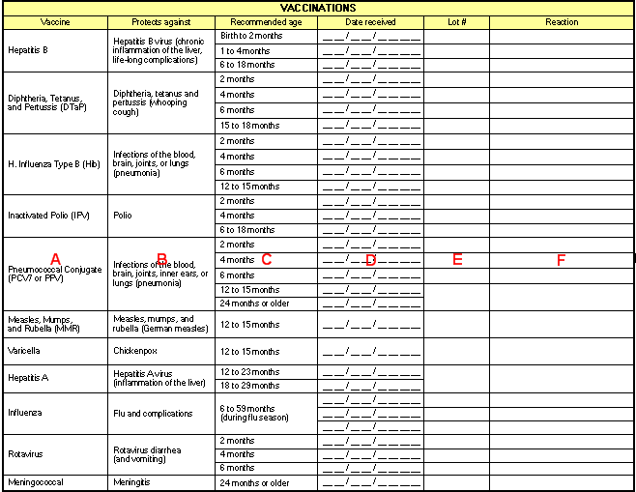 | You had noted in the Routine/Well Visit section of this log that your infant received a vaccination (or vaccinations) during his/her well visit and you had put a √ in the space provided for “Yes”. We also need the following information.  - Write in the date the vaccine (or vaccines) were received in the space provided in column D. For example, if your infant received her H. Influenza Type B, or Hib vaccine on October 10, 2008, write 10/02/2008 in the space provided. It is common for infant’s to receive multiple vaccines during a doctor’s visit.  - Ask your infant’s medical provider to provide you with the vaccine lot # and write it in the space provided in column E.  - If your infant had a reaction to a vaccine, write the symptoms he/she had in the space provided. For example, if he received the Varicella (chickenpox) vaccine and developed a small case of chickenpox, write this information in column F.

Routine / Well Visits
Reported to study staff | Date of visit | Name of medical provider | Length / Height | Weight | Head circumference | Vaccinations  If Yes, complete vaccination page | Problems, diagnoses, laboratory,  and other findings
 |  |  |  |  |  | Yes No
 |  |  |  |  |  | Yes No
 |  |  |  |  |  | Yes No
 |  |  |  |  |  | Yes No
 |  |  |  |  |  | Yes No
 |  |  |  |  |  | Yes No
 |  |  |  |  |  | Yes No

SICK VISITS
Reported to study staff | Date of visit (include entire length of stay) | LOCATION OF SICK VISIT
Reported to study staff | Date of visit (include entire length of stay) | Drs. office or clinic? | Emergency Room (outpatient)? | Hospital  (inpatient)? | Diagnosis? | Treatments?

VACCINATIONS
Vaccine | Protects against | Recommended age | Date received | Lot # | Reaction
Hepatitis B | Hepatitis B virus (chronic inflammation of the liver, life-long complications) | Birth to 2 months | __ __ / __ __ / __ __ __ __
Hepatitis B |  | 1 to 4 months | __ __ / __ __ / __ __ __ __
Hepatitis B |  | 6 to 18 months | __ __ / __ __ / __ __ __ __
Diphtheria, Tetanus,  and Pertussis (DTaP) | Diphtheria, tetanus and pertussis (whooping cough) | 2 months | __ __ / __ __ / __ __ __ __
Diphtheria, Tetanus,  and Pertussis (DTaP) | Diphtheria, tetanus and pertussis (whooping cough) | 4 months | __ __ / __ __ / __ __ __ __
Diphtheria, Tetanus,  and Pertussis (DTaP) | Diphtheria, tetanus and pertussis (whooping cough) | 6 months | __ __ / __ __ / __ __ __ __
Diphtheria, Tetanus,  and Pertussis (DTaP) | Diphtheria, tetanus and pertussis (whooping cough) | 15 to 18 months | __ __ / __ __ / __ __ __ __
H. Influenza Type B (Hib) | Infections of the blood, brain, joints, or lungs (pneumonia) | 2 months | __ __ / __ __ / __ __ __ __
H. Influenza Type B (Hib) | Infections of the blood, brain, joints, or lungs (pneumonia) | 4 months | __ __ / __ __ / __ __ __ __
H. Influenza Type B (Hib) | Infections of the blood, brain, joints, or lungs (pneumonia) | 6 months | __ __ / __ __ / __ __ __ __
H. Influenza Type B (Hib) | Infections of the blood, brain, joints, or lungs (pneumonia) | 12 to 15 months | __ __ / __ __ / __ __ __ __
Inactivated Polio (IPV) | Polio | 2 months | __ __ / __ __ / __ __ __ __
Inactivated Polio (IPV) | Polio | 4 months | __ __ / __ __ / __ __ __ __
Inactivated Polio (IPV) | Polio | 6 to 18 months | __ __ / __ __ / __ __ __ __
Pneumococcal Conjugate (PCV7 or PPV) | Infections of the blood, brain, joints, inner ears, or lungs (pneumonia) | 2 months | __ __ / __ __ / __ __ __ __
Pneumococcal Conjugate (PCV7 or PPV) |  | 4 months | __ __ / __ __ / __ __ __ __
Pneumococcal Conjugate (PCV7 or PPV) |  | 6 months | __ __ / __ __ / __ __ __ __
Pneumococcal Conjugate (PCV7 or PPV) |  | 12 to 15 months | __ __ / __ __ / __ __ __ __
Pneumococcal Conjugate (PCV7 or PPV) |  | 24 months or older | __ __ / __ __ / __ __ __ __
Measles, Mumps,  and Rubella (MMR) | Measles, mumps, and rubella (German measles) | 12 to 15 months | __ __ / __ __ / __ __ __ __
Varicella | Chickenpox | 12 to 15 months | __ __ / __ __ / __ __ __ __
Hepatitis A | Hepatitis A virus (inflammation of the liver) | 12 to 23 months | __ __ / __ __ / __ __ __ __
Hepatitis A | Hepatitis A virus (inflammation of the liver) | 18 to 29 months | __ __ / __ __ / __ __ __ __
Influenza | Flu and complications | 6 to 59 months (during flu season) | __ __ / __ __ / __ __ __ __
Influenza | Flu and complications | 6 to 59 months (during flu season) | __ __ / __ __ / __ __ __ __
Influenza | Flu and complications | 6 to 59 months (during flu season) | __ __ / __ __ / __ __ __ __
Rotavirus | Rotavirus diarrhea (and vomiting) | 2 months | __ __ / __ __ / __ __ __ __
Rotavirus | Rotavirus diarrhea (and vomiting) | 4 months | __ __ / __ __ / __ __ __ __
Rotavirus | Rotavirus diarrhea (and vomiting) | 6 months | __ __ / __ __ / __ __ __ __
Meningococcal | Meningitis | 24 months or older | __ __ / __ __ / __ __ __ __

