Restoring a U.S. River Basin: What Is Your Opinion?

Across the United States, many river systems are under stress from population growth, pollution, and competing demands for water. This survey focuses on one river system in particular: the Klamath River Basin.
The federal government is considering plans for restoring this river basin and its fish populations. Understanding the views of households like yours will help the government choose the best option.

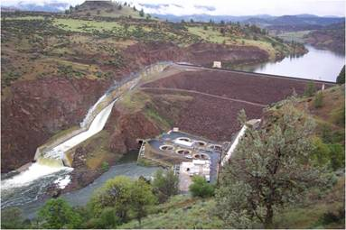
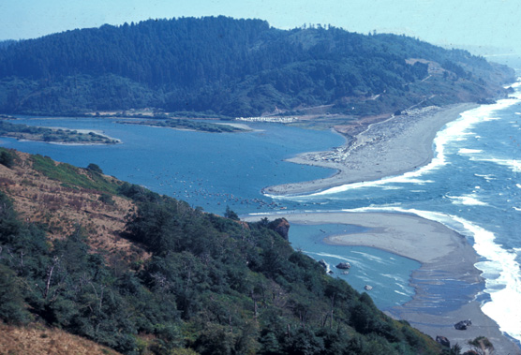
Upper Klamath Basin (Oregon)

Iron Gate Dam on the
Klamath River

Klamath River Estuary at the
Pacific Ocean (California)

Your participation in this survey is voluntary. The reports prepared for this study will summarize findings across the sample and will not associate responses with a specific individual. We will not provide information that identifies you to anyone outside the study team, except as required by law. Your responses will be stored separately from your name and address, and when analysis of the questionnaire is completed, all name and address files will be destroyed.

A Federal agency may not conduct or sponsor, and a person is not required to respond to, a collection of information unless it displays a currently valid OMB control number.

Burden estimate statement: Public reporting for this form is estimated to average 5 minutes per
response. Direct comments regarding the burden estimate or any other aspect of this form to:
Ben Simon, MS3530-MIB, 1849 C Street N.W., Washington, DC 20240 or Benjamin_Simon@ios.doi.gov.

OMB Control #1090-0010
Expiration Date:

Cover photos courtesy of the U.S. Fish and Wildlife Service (FWS)

About the Klamath River Basin
- The basin occupies over 10 million acres (the area outlined in brown in the map). It is twice the size of Massachusetts. About 125,000 people live in the basin, including 14,000 members of Indian tribes. Klamath Falls, Oregon, is the largest city, with a population of roughly 20,000.
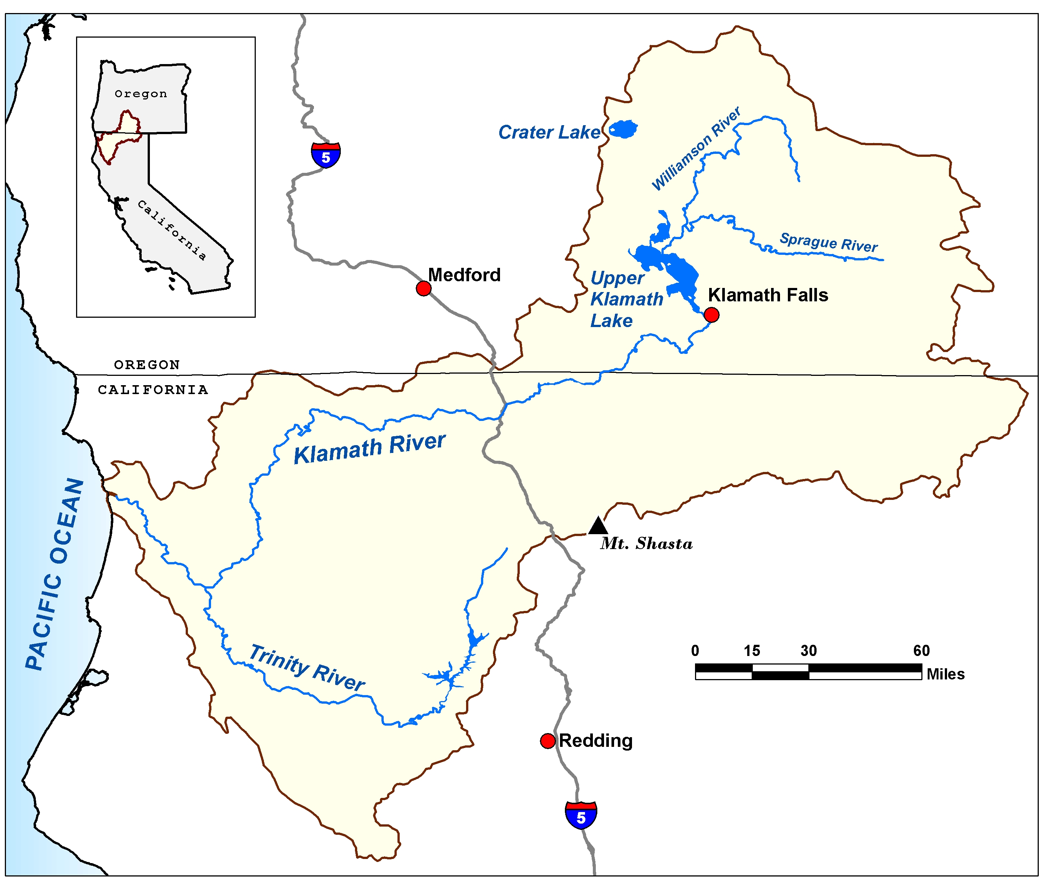
- Before you started this survey, had you ever heard of the Klamath River Basin?
- Yes
- No
- I don’t know
- Have you ever visited the Klamath River Basin?
- Yes
- No
- I don’t know

- How many recreation trips did you make to the Klamath River Basin in the past 12 months?
______ trips

Competing Demands for Klamath River Basin Water
Some of the main uses of the Klamath River and its tributaries are:
- Commercial fishing
- Farmland irrigation
- Hydroelectric power
- Recreation and tourism
- Tribal cultural practices
The Klamath River Basin is important to many people and industries, but there is not always enough water for everyone, especially in drought years. Competing demands for water have been a source of conflict in the basin.

The River Basin Restoration Plan
The federal government must decide whether to support a plan that would remove several hydroelectric dams on the Klamath River and change the way water is managed in the basin. The plan would
- Improve conditions for fish
- improve water quality in the Klamath River
- create more natural free-flowing river conditions along most of the Klamath River

The agreement would also
- cost millions of dollars to remove the dams and for projects that restore fish habitat and improve water quality
- limit the amount of water available for irrigation

- People often have different views about plans like this one. Please rate how much you agree or disagree with each of the following statements. (Circle the number that matches your answer. If you have no opinion, check the box in the No Opinion column.)
 | 1  Strongly Agree | 2  Agree | 3  See Both Sides | 4  Disagree | 5  Strongly Disagree | No Opinion
Some decrease in environmental quality is inevitable if we are going to continue to improve our standard of living | 1 | 2 | 3 | 4 | 5
When humans interfere with nature, it often produces disastrous results | 1 | 2 | 3 | 4 | 5
Humans should modify the natural environment to suit their needs | 1 | 2 | 3 | 4 | 5
The balance of nature is very delicate and easily upset | 1 | 2 | 3 | 4 | 5
The decision to develop natural resources should be based more on economic grounds than on environmental grounds | 1 | 2 | 3 | 4 | 5
It is important to use rivers as a source of electric power | 1 | 2 | 3 | 4 | 5
It is important for rivers to provide places for recreation | 1 | 2 | 3 | 4 | 5
It is important for rivers to provide healthy habitat for fish | 1 | 2 | 3 | 4 | 5
It is important to use rivers as a source of water for irrigation | 1 | 2 | 3 | 4 | 5
It is important for rivers to provide Indian tribes with traditional fishing areas | 1 | 2 | 3 | 4 | 5
It is important for rivers to support commercial fishing | 1 | 2 | 3 | 4 | 5

About You and Your Household
Finally, we would like to ask you a few questions about you and your household. Responses to these questions will be used only for statistical purposes and to compare respondents to this survey with the U.S. population as a whole. The reports prepared for this study will summarize findings across the sample and will not associate responses with an individual. Your answers will not be saved or stored in a way that can be associated with your name or address.
- Are you male or female?
- Male
- Female
- What is your age?
_________

- What is your current marital status?
- Single, never married
- Married or living with a long-term partner
- Separated or divorced
- Widowed
- How many children under age 18 are living at your home?
____________ children
- What is the highest degree or level of school you have completed?
- No high school diploma
- High school diploma or GED
- Some college credit or college degree
- Some graduate school or professional school credit or a graduate or professional degree

Thank you very much for your time.

