Request for Emergency Clearance
Summer of Innovation (SoI) Pilot Website Registrations

About the Summer of Innovation

As part of the President’s “Educate to Innovate” campaign to improve the science and mathematics achievement of American students, President Obama announced several new and innovative partnerships involving major companies, universities, foundations, non-profit organizations, and government agencies. These partnerships to attract, develop, reward, and retain outstanding educators in science, technology, engineering, and mathematics (STEM) will build upon initiatives already announced by the President in November 2009 at the launch of the “Educate to Innovate” campaign to motivate and inspire students to excel in STEM subjects.

In response to the President’s “Educate to Innovate” campaign, NASA developed the Summer of Innovation Project, the Administrator’s top education priority for the Agency. The Summer of Innovation pilot project will engage thousands of middle school teachers and students by providing intensive, stimulating mathematics and science-based experiences during the summer of 2010. The Agency’s intent is that the 2010 pilot program will demonstrate success of the concept and utilize the best practices to implement future Summer of Innovation on a national scale. NASA is the first Federal Agency to invest resources in intensive STEM education for the summer that will go beyond inspiration to result in demonstrable improvements in teaching and learning.

Circumstances Requiring the Collection of Data

The Space Act 1958 --- The National Aeronautics and Space Act http://www.nasa.gov/offices/ogc/about/space_act1.html#NASA established NASA. NASA Office of Education manages several national NASA education projects including Summer of Innovation.

One of the several activities under the Summer of Innovation Pilot is an Open Call for Participation. This national call for participation will be announced on June 10, 2010 to invite all STEM Stakeholders interested in incorporating NASA content into existing Non-NASA summer learning experiences to become part of the NASA Summer of Innovation. Those stakeholders (organizations and families) interested in participating will be asked to register on the Summer of Innovation Website. Organizations that register will then be provided the options to register an event and submit event data (total participant numbers for students, teachers, and families) and to access special features on the SoI website. Families that register will then be provided the option to access special features on the SoI website. The special features include access to a NASA Summer of Innovation Certificate of Participation and the ability to share a photo and Summer of Innovation story.

Driving collaboration and partnership development is key to the success of the Summer of Innovation Pilot. The Open Call will be one of the entry points for STEM Stakeholders to participate in the NASA Summer of Innovation providing them the opportunity to become STEM Collaborators. Technology will be the delivery mechanism through the Summer of Innovation website with accessible NASA content, electronic professional development resources, certificate of completion and interactive educational experiences (flash content and user generated content).

Purposes and Uses of the Data

The purpose of registering Summer of Innovation participant organizations and families is for the following purposes:

Organizations
- to register organizations that participate in the Summer of Innovation in response to the Open Call
- to provide the opportunity to registrants to submit an event for posting on the Summer of Innovation interactive calendar and map
- to collect participant data (total numbers) on registered Summer of Innovation events
- to provide access to special features of the Summer of Innovation website
- to provide future collaboration opportunities with NASA

Families
- to register family locations that participate in the Summer of Innovation in response to the Open Call for interactive map
- to provide access to special features of the Summer of Innovation website
- to provide future collaboration opportunities with NASA

Data collected by registration form from organizations will be used to gain permission and produce a calendar of events (with event details and organization contact information) and an interactive map displaying events (with event details and organization contact information) scheduled across the nation. Data collected by registration form from a family will be used to also gain permission and produce an interactive map displaying Summer of Innovation Participant Family locations across the nation. Although the information in the registration form varies for organizations and families, both will gain access to website special features after registering. The following highlights the registration process for both organizations and families.

Organizations
- Register Organization and Organization contact information
  - Option to Submit an SoI Activity/Event (with Event Information) for Calendar and Map
  - Submit SoI Activity/Event Participant Data (Name of Activity/Event, Total Students, Teachers and Families)
    - Gain Access to optional web features (Certificate and Share Your Story)
Families
- Register Family Contact Information
  - Submit SoI Activity/Event Participant Data (Name of Activity/Event, Total Students, Teachers and Families)
  - Gain Access to optional web features (Certificate and Share Your Story)

Screenshots of the Summer of Innovation background pages; family, educator and organization pages along with the online registration form for organizations and families can be seen in Appendices A, B, C and D. Additionally, screenshots of the special features (certificate generation and share your story) can be seen in Appendix E.

Estimates of Response Burden
The total burden on the public for this data collection is 916.66 hours. The estimated burden to collect information from organizations and families is highlighted in the table below:

Table. Number of Respondents, Frequency of Response, and Annual Hour Burden

 | Customer | Collection  Instruments | Frequency | Estimated  Number of Respondents | Expected Response Rate | Completion Time (Minutes) | Total Estimated Burden Hours
1 | Organizations who participate in the Summer of Innovation (SoI) pilot | Organization Registration Form and Optional Event Submission | One time (Starts in July 2010) | 1250 Participants | 100% | 10 minutes (.16 hours) | 208.33 hours
2 | Families who participate in the SoI pilot | Family Registration Form | One-time. (Starts in July 2010) | 250 Participants | 100% | 5 minutes  (.083 hours) | 20.83 hours
3 | Organizations and Families who participate in the SoI pilot and register on the SoI Website | Optional Special Feature Forms (Certificate Generation and Share Your Story) | One-time. (Starts in July 2010) | 1500 Participants (Note: these participants are the same participants in 1 and 2) | 100% | 5 minutes  (.083 hours) | 125.00 hours
 |  |  | Total Number of Respondents | 1500 Participants |  | Total Hours | 354.16 Hours

Hour Burden Estimates by Each Form and Aggregate Hour Burdens
There is no cost to respondents other than the time it takes to respond to the survey.
The hourly rate for private nonfarm sector and private-sector production and non-supervisory payrolls are used as the average hourly rate for an American family. The hourly rates are taken from the Bureau of Labor Statistics Employment Situation Summary of the Economic New Releases (USDL-10-0748 - June 4, 2010).

Average hourly earnings of all employees in the private nonfarm sector increased by 7 cents, or 0.3 percent, to $22.57 in May. Over the past 12 months, average hourly earnings have increased by 1.9 percent. In May, average hourly earnings of private-sector production and non-supervisory employees increased by 4 cents, or 0.2 percent, to $18.99.
The average hourly rate of $20.78 was determined by taking the average of the hourly rates for the private nonfarm sector and private-sector production and non-supervisory payrolls above. The average hourly rate was then multiplied by the number of estimated burden hours for families registering to determine estimated costs for families registering on the website indicated in the table below:

Costs for Estimated Family Registration | ($20.78/hour x 20.83 hours) | $432.85
Costs for Estimate Family Special Features | ($20.78/hour x 20.83 hours) | $432.85

The hourly rate for educators is being used as an average hourly rate for organization representing STEM stakeholder organizations. The hourly rate for educators was established by using the Bureau of Labor Statistic's May 2006 National Occupational Employment and Wage Estimates, which estimates the mean annual wage for those in Education, Training, and Library Occupations to be $45,320. This average annual wages was then divided by the number of standard annual work hours (2,080) to determine an average hourly rate. The rates and the total costs are indicated in the table below:

Costs for Estimated Educator/Organization Registration | ($22/hour x 208.33 hours) | $4,583.26
Costs for Estimated Educator/Organization Special Features | ($22/hour x 104.16 hours) | $2,291.52

Estimates of Costs to the Federal Government

This data collection effort will occur primarily during the summer of 2010. It is anticipated that intermittent data collections will occur during the thirty-six month period of performance for NASA Summer of Innovation Pilot. There are no annualized costs to the Federal government.

Names and Telephone Numbers of Individuals Consulted

Agency Unit

Brenda Maxwell, Paper Work Reduction Act Lead, NASA HQ 202-358-4616
Dovie Lacy, NASA Summer of Innovation Project Manager, NASA HQ, 202-358-7229
Brian Yoder, Evaluation Manager, Office of Education, NASA HQ 202-358-7338
Shelley Canright, Outcome Manager, Informal Education, NASA HQ 202-358-1021
Bernice Alston, Deputy Associate Administrator for Planning, Evaluation and Policy Development, NASA HQ 202-358-0103
James Stofan, Acting Associate Administrator for Education, NASA HQ 202-358-1885

Appendix A: Summer of Innovation (Home and About Pages)

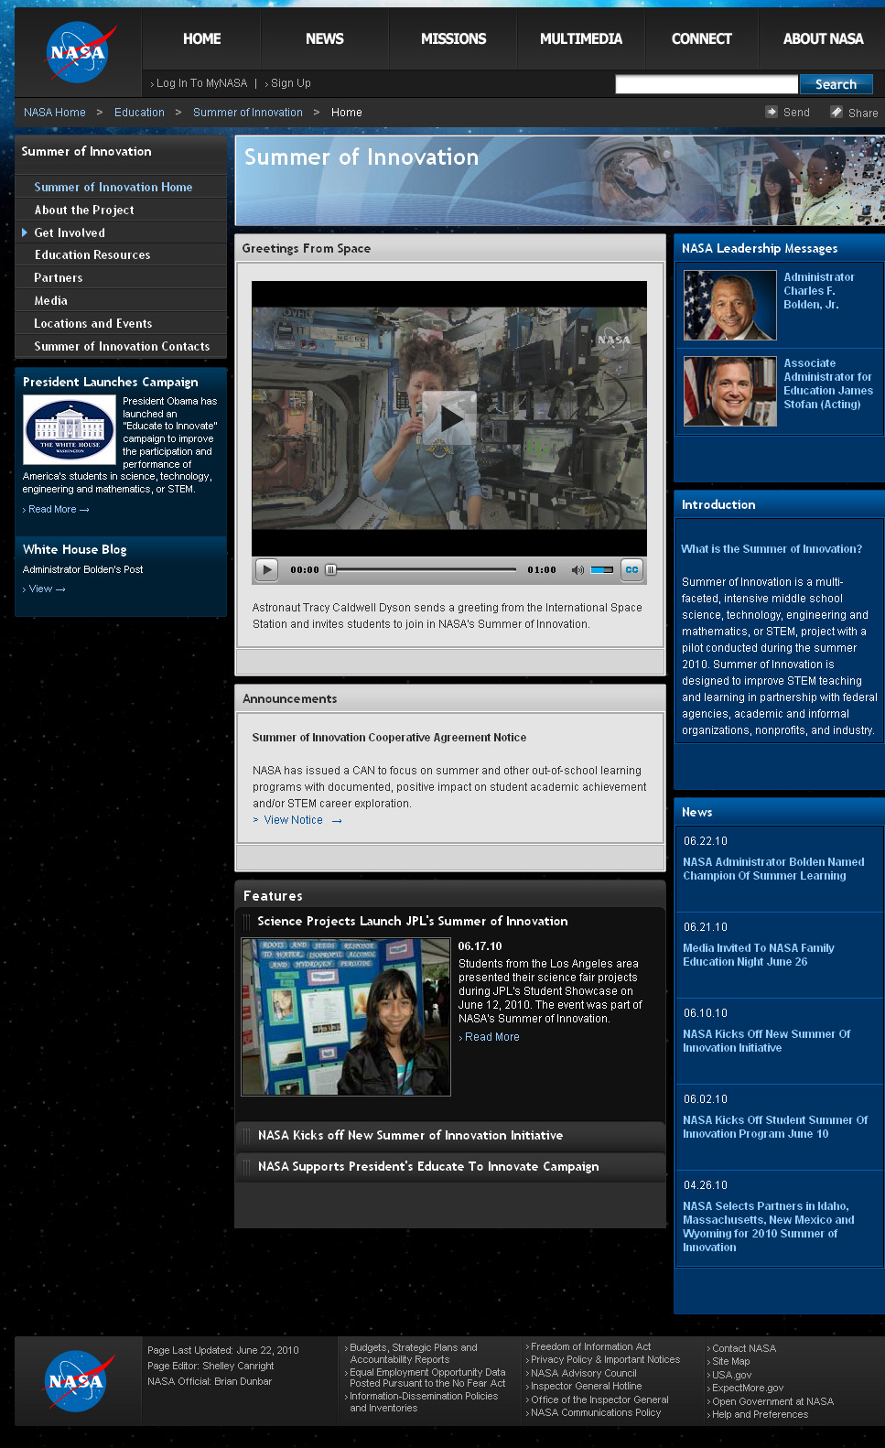
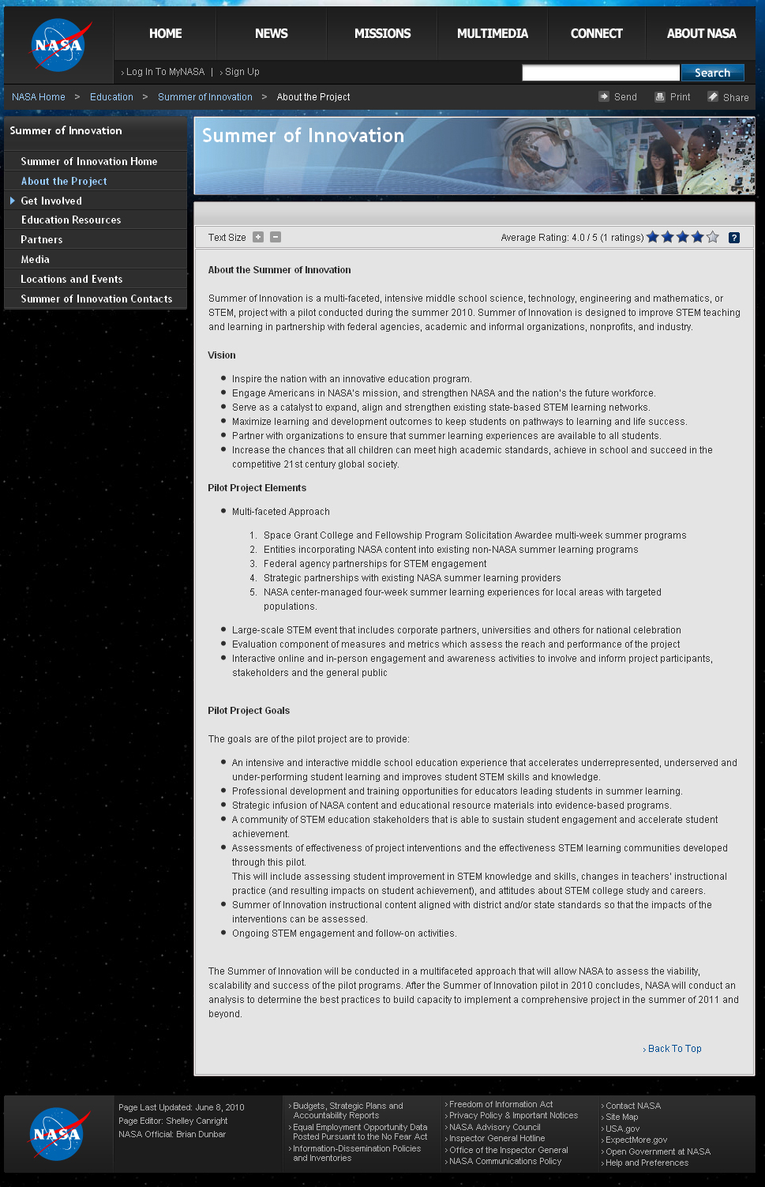

Appendix B: Family, Educator and Organization Pages

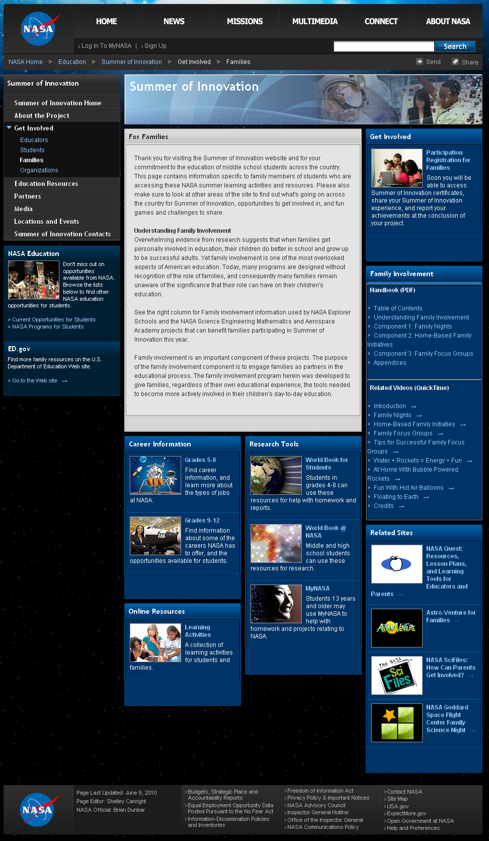
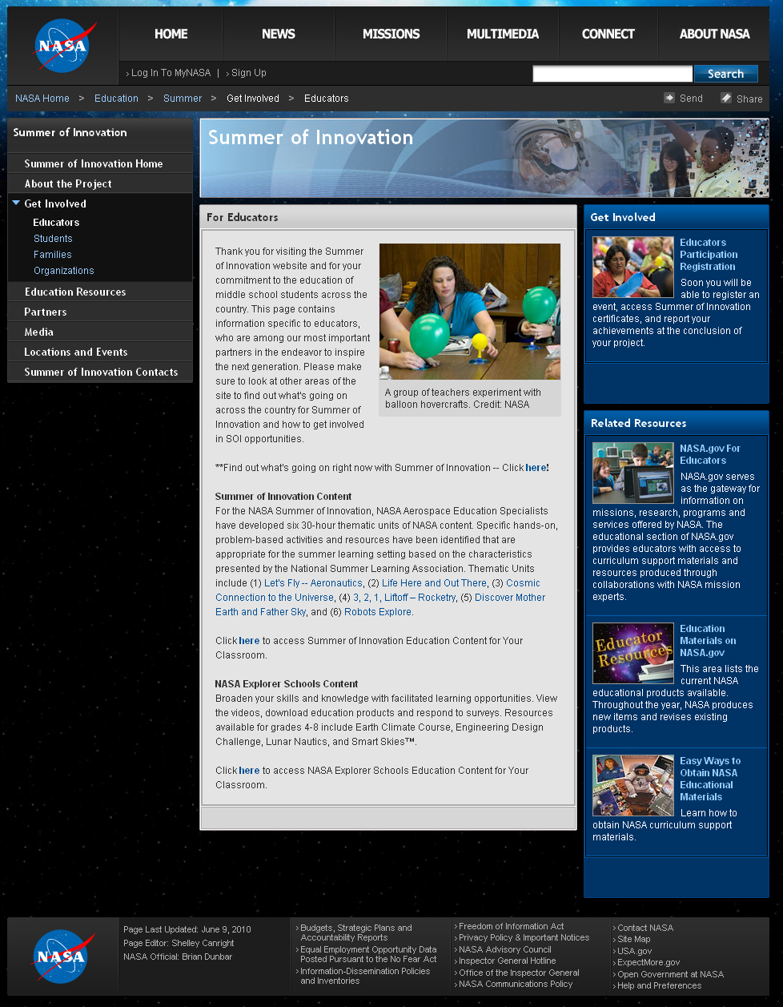

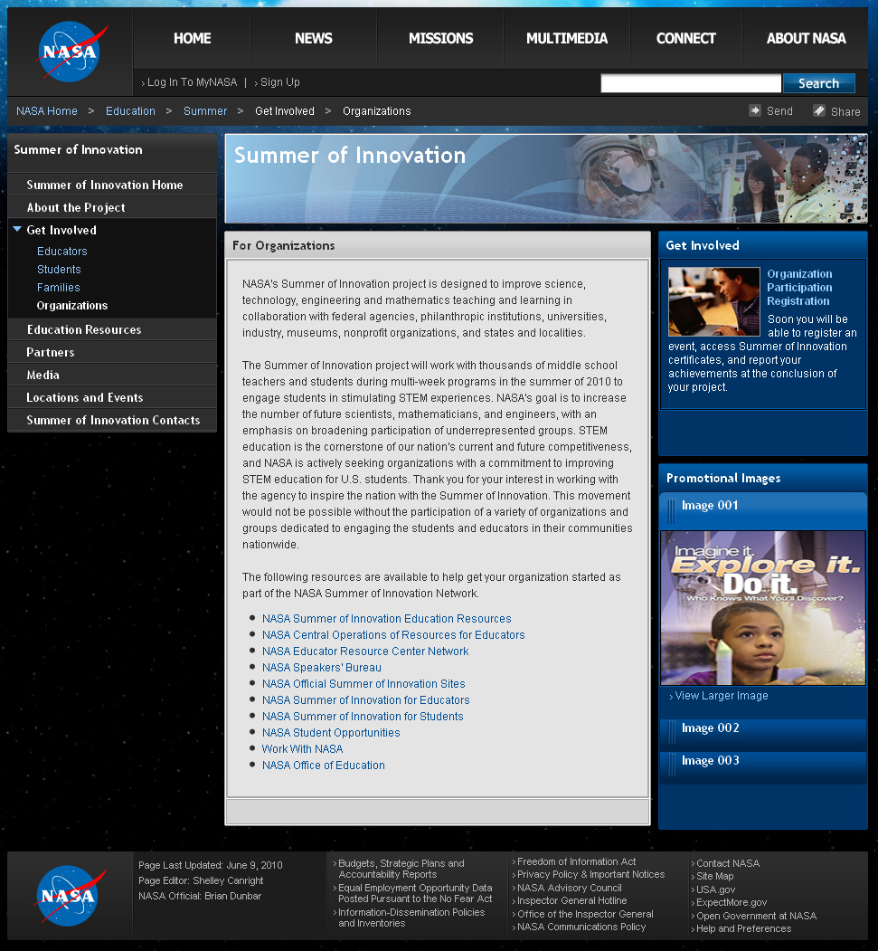

Appendix C: Organization Registration and Event Registration

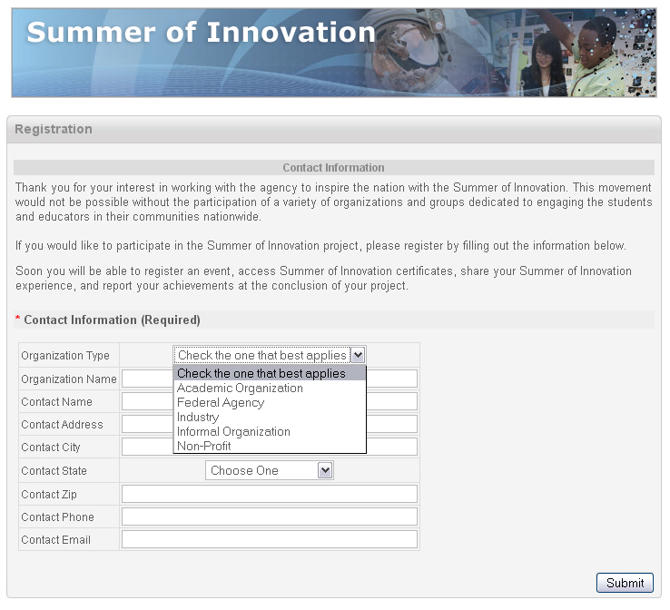

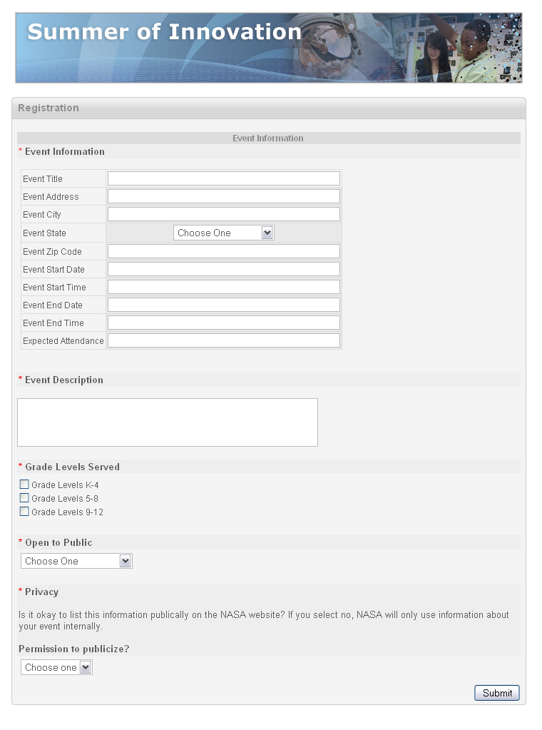

Appendix D: Family Registration

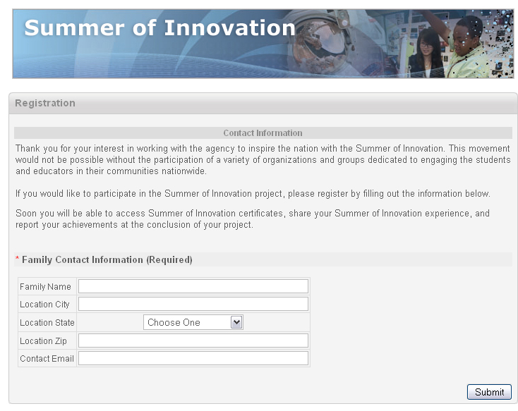

Appendix E: Special Features (Certificate Generation and Share Your Story)

