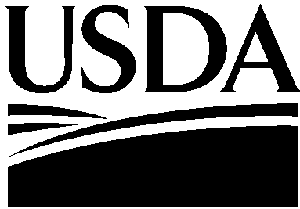

USDA is an Equal Opportunity Employer

United States Department of Agriculture

Farm and Foreign
Agricultural
Services

Farm Service Agency

1400 Independence Avenue, SW
Stop 0572
Washington, DC
20250-0572

August 13, 2010

TO: Drew Perraut
Office of Management and Budget Desk Officer

THROUGH: Ruth Brown
Department Clearance Officer

FROM: Brandon Willis
Deputy Administrator for Farm Programs

SUBJECT: Request for Emergency Approval for a New Information Collection Package—Ammonia Nurse Tank Additive Program

The Farm Service Agency (FSA), in partnership with the Agricultural Marketing Service (AMS), has been tasked with implementing the Ammonia Nurse Tank Additive Program (ANTAP). This program is authorized by Section 14203 of the Food, Conservation, and Energy Act of 2008 (Pub. L. 110-246, the 2008 Farm Bill). Section 735 of the Agriculture, Rural Development, Food and Drug Administration, and Related Agencies Appropriations Act, 2010 (Pub. L. 111-80) provides $1 million for the purpose of adding a substance to anhydrous ammonia fertilizer nurse tanks that would reduce the amount of methamphetamine (meth) that could be illegally produced from the ammonia, in order to discourage thefts.

ANTAP funding needs to be obligated by September 30, 2010, for up to five eligible entities, based on approved work plans, standard forms, and grant agreements.

The Notice of Funds Availability (NOFA) to Announce Funding for the Ammonia Nurse Tank Additive Program will be published in the Federal Register to notify the eligible entities, as well as outreach to trade associations for producers, cooperatives, and agricultural chemical retailers.

Eligible entities are defined as: (1) a producer of agricultural commodities; (2) cooperative associations, a majority of the members of which produce or process agricultural commodities; and (3) persons in the trade or business of: (a) selling an agricultural product (including an agricultural chemical) at retail, predominantly to farmers and ranchers; or (b) aerial and ground application of an agricultural chemical.

FSA needs to collect the following:

- ANTAP work plans and standard forms in order to select up to five eligible entities for funding.

- Standard forms and grant agreements to obligate and transfer the funds on or before September 30, 2010.

- ANTAP progress reports to summarize progress or delays, upcoming work, and financial status.

- ANTAP final reports and standard forms to document results, accomplishments, and financial status.

We are requesting emergency approval of a new information collection package by August 30, 2010, as the fall harvest season and the end of the fiscal year approach.

If there are any questions or concerns, please call Deirdre Holder at 202-205-5851 or Mary Ann Ball at 202-720-4283.

