OMB BURDEN STATEMENT: According to the Paperwork Reduction Act of 1995, no persons are required to respond to a collection of information unless it displays a valid OMB control number. The valid OMB control number for this information collection is 0584-0524. The time to complete this information collection is estimated to average 60 minutes per response, including the time for reviewing instructions, searching existing data sources, gathering and maintaining the data needed, and completing and reviewing the collection of information.

USDA/FNS: Communications Tools Testing – Evaluative Round (July 2011)
Mini Group Moderator’s Guide (Middle School Students)
60 Minutes

i. WELCOME AND GROUND RULES (5 minutes)

[OMB Statement read to parents and children before groups begin]

- First of all, I want to thank you for coming in today. My name is and I am very excited that you could all join us, and we should have a fun discussion. The group discussion will last only one hour. Do any of you need anything before we start? If you need to go to the bathroom during the next hour just let me know and a co-worker will show you where it is.

- Have any of you ever been to a group discussion like this before? Moderator to review and explain to the kids the details of the room.

Well, I want to tell you a few things before we begin. There are microphones in the room that are recording what is said. I have to write a report after I am done today, and it makes it easy for me to be able to go back and listen to everything we talked about.

Behind me is a one-way mirror, which means there are a few people behind the mirror watching. A few other people working on this project with me are observing this discussion and taking notes since I can’t write down everything you say.

Because we are taping, it is important that you try to speak one at a time. It is my only “rule” of the day. So if everyone can be polite and try not to talk over each other I would appreciate it. It will also help the people taking notes to not hear everyone talking one at a time!

- Before we start I want everyone to know that there are no wrong answers. We just want to hear your most honest thoughts, so don’t worry if you have different ideas or opinions than someone else in the group. The more thoughts you can share the better! I know you all have great thoughts to share and I can’t wait to hear them.

II. INTRODUCTION (5 minutes)

- Ok, so now that I have told you all about the room, let’s take a minute before we start to introduce ourselves. Moderator to go first by saying name again and fun fact about herself – for example favorite thing to do in her free time.

- Ok, so now that you know a little bit about me, I would love to hear all about you! Let’s go around the room and everyone can just say their first name, age and grade as well as their favorite activity.

III. WARM UP/HELPING CHILDREN STAY HEALTHY (5 minutes)

- Let’s begin our discussion by discussing how you stay healthy.
  - In general, what are some things that you do to stay healthy? [WRITE ON EASEL. IF NOT MENTIONED, PROBE NUTRITION/PHYSICAL ACTIVITY]
  - Of the items we have on this list, which are the easiest for you? Which are harder to do?
  - What about making sure you eat right and get exercise? How easy or hard is that for you? What makes you say that?

- Now let’s talk a little bit more about nutrition and getting exercise during a regular day at school.
  - How important is it to get exercise while at school? What makes you say that?
  - How important is it to eat healthy foods while at school? What makes you say that?
  - How good of a job do you think you and your friends do when it comes to getting exercise and eating healthy foods while at school? What makes you say that? What do you think you can do better?
  - What are some things you and your friends could do to get people to get more exercise and eat healthier while at school?

[NOTE TO MODERATOR: ROTATE ORDER OF TESTING TOOLS.]
[NOTE TO MODERATOR: Ask all of the tool-specific questions for the tool presented first. For the tool presented second, spend less time on reaction to content areas (since the content for both tools is similar)]

IV. Communication Tool: HANDOUT (20 minutes)

1. Thank you for that information. Now, we are going to do something a bit different. A lot of what we are going to talk about is how to get students like you to play a part in making your school a healthier place to be, in terms of nutrition and physical activity. Now, we are going to read a handout that was written to try to convince you to do just that.

Before we start, I want to let you know that I did not write the handout you are going to see today, so don’t worry if there’s something you don’t like about it. I want to hear what you like and dislike.

[HANDOUT IS A 1-PAGE TWO-SIDED COLOR AND BLACK-AND-WHITE DOCUMENT (SEE APPENDIX A). THE HANDOUT WILL PRESENT THE MESSAGES AND SUPPORTING CONTENT AND ENSURE THAT THEY MATCH THE MESSAGE TONE, STYLE AND LITERACY LEVEL OF OUR TARGET AUDIENCE.]
- What are the first words/phrases that came to your mind when you first saw the handout?
- What do you think of it? [Get general reaction (interest, boredom, etc. before asking next set of questions)]
  - What is the handout trying to tell you?
  - What do you think about how the handout looks? Does it grab your attention?
  - What, if anything, do you like about the handout? What makes you say that?
  - What is the most interesting part of the handout? Why is that interesting to you?
  - Let’s look at the other side of the coin. What, if anything, do you dislike? What makes you say that?
  - Is there anything on the handout that seems confusing? What is it?
- Who do you think this handout is made for? People like you? Older? Younger? Boys? Girls? Both? What makes you say that?
- Does this handout get you interested in playing a part to make your school a healthier place? What makes you say that?
  - What would you be most likely to try?
  - What do you think you would never try?
- How do you think you would use this handout (PROBE: use it to start a conversation with friends, show your parents, etc.)?
- How likely are you to look for or share ideas with other schools? What makes you say that?

V. Communication Tool: VIDEO CLIP (15 minutes)

Now, we are going to take a look at another way to share this type of information. Eventually, it will become a video designed to help convince middle school students to get involved in making their school a healthier environment in terms of nutrition and physical activity.
We are not going to see a finished video. Instead, we are going to see draft pictures that represent parts of the video while you hear the script (See Appendix B for video script). It will give you a sense of what the video will be like when it is finished.
Before we start, I want to let you know that I did not make the video clip you are going to see today, so don’t worry if there’s something you don’t like about it. I want to hear what you like and dislike.
[VIDEO ANMATIC WILL BE 1 MINUTE IN LENGTH AND WILL COMMUNICATE THE KEY MESSAGES]

Before we talk about what you just saw, please note that the final version will be fully animated in the style you have just seen, instead of just seeing a few screen shots

- What are the first words/phrases that came to your mind when you first saw the video?
- What do you think of it? [Get general reaction (interest, boredom, etc. before asking next set of questions)]
  - What is the video trying to tell you?
- Now we are going to watch the video again. What do you think about how the video looks? Does it grab your attention?
  - Does it seem like something that you would watch? When do you think would you watch this video?
  - What, if anything, do you like about the video? What makes you say that?
  - What is the most interesting part of the video? Why is that interesting to you?
  - Let’s look at the other side of the coin. What, if anything, do you dislike? What makes you say that?
  - Is there anything on the video that seems confusing? What is it?
- Who do you think this video is made for? People like you? Older? Younger? Boys? Girls? Both? What makes you say that?
- Does this video get you interested in playing a part to make your school a healthier place? What makes you say that?
  - What would you be most likely to try?
  - What do you think you would never try?
- If you got this video or the link to it in through e-mail, do you think you would forward it to any of your friends? What about your parents? What makes you say that?
- How likely are you to look for or share ideas with other schools? What makes you say that?

VI. SUMMARY (5 minutes)

- Let’s think about everything we saw, heard, and read today.
  - What is the most important piece of information you saw/read/heard?
  - Which tip or idea are you most likely to try? What makes you say that?
  - Where do you think you would be most likely to see the handout? Who do you think would give it to you?
  - Where do you think you would be most likely to see the video? Who do you think would show/forward it to you?

VII. FALSE CLOSE (5 minutes)

- While I step out of the room for a moment to see if I need to cover any additional information, please answer the questions on Handout A (See Appendix C). [DISTRIBUTE HANDOUT A.] The questions on this handout read, “Is it important for middle school students to play a part in making their middle school a healthier place in terms of nutrition and physical activity? Why or why not?”

Thank you very much for your participation! Have a great day/evening!

Appendix A: Handout (Front)

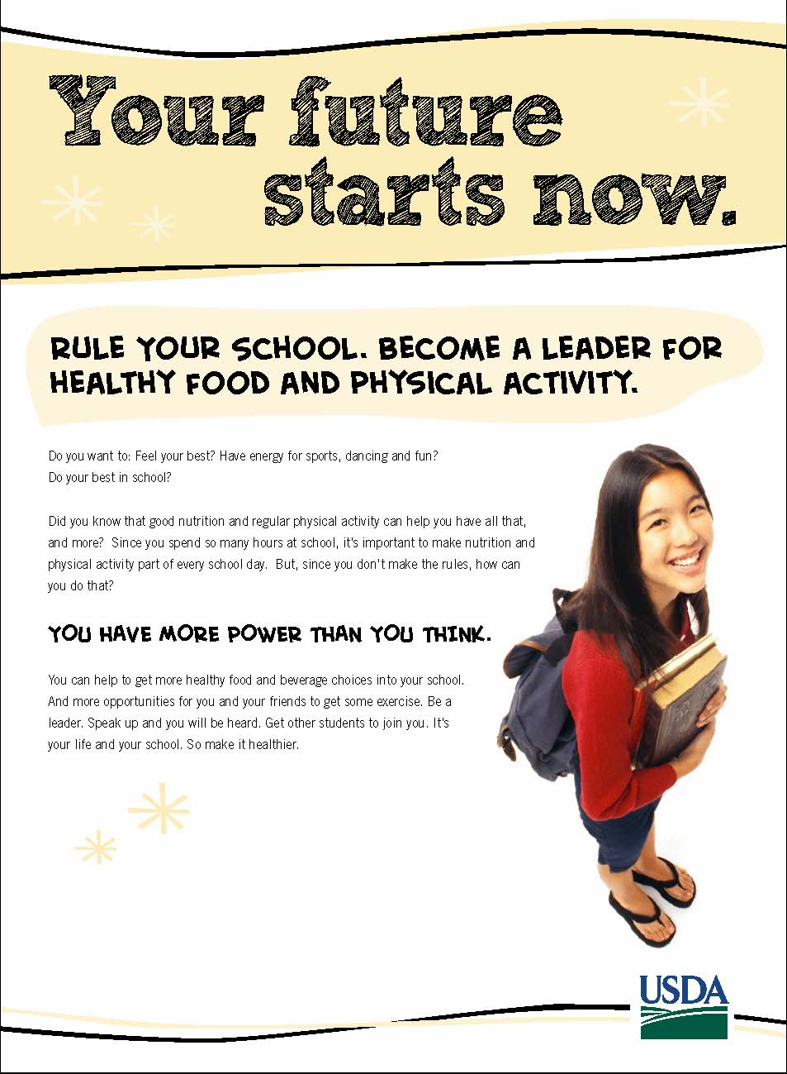

Appendix A: Handout (Back)
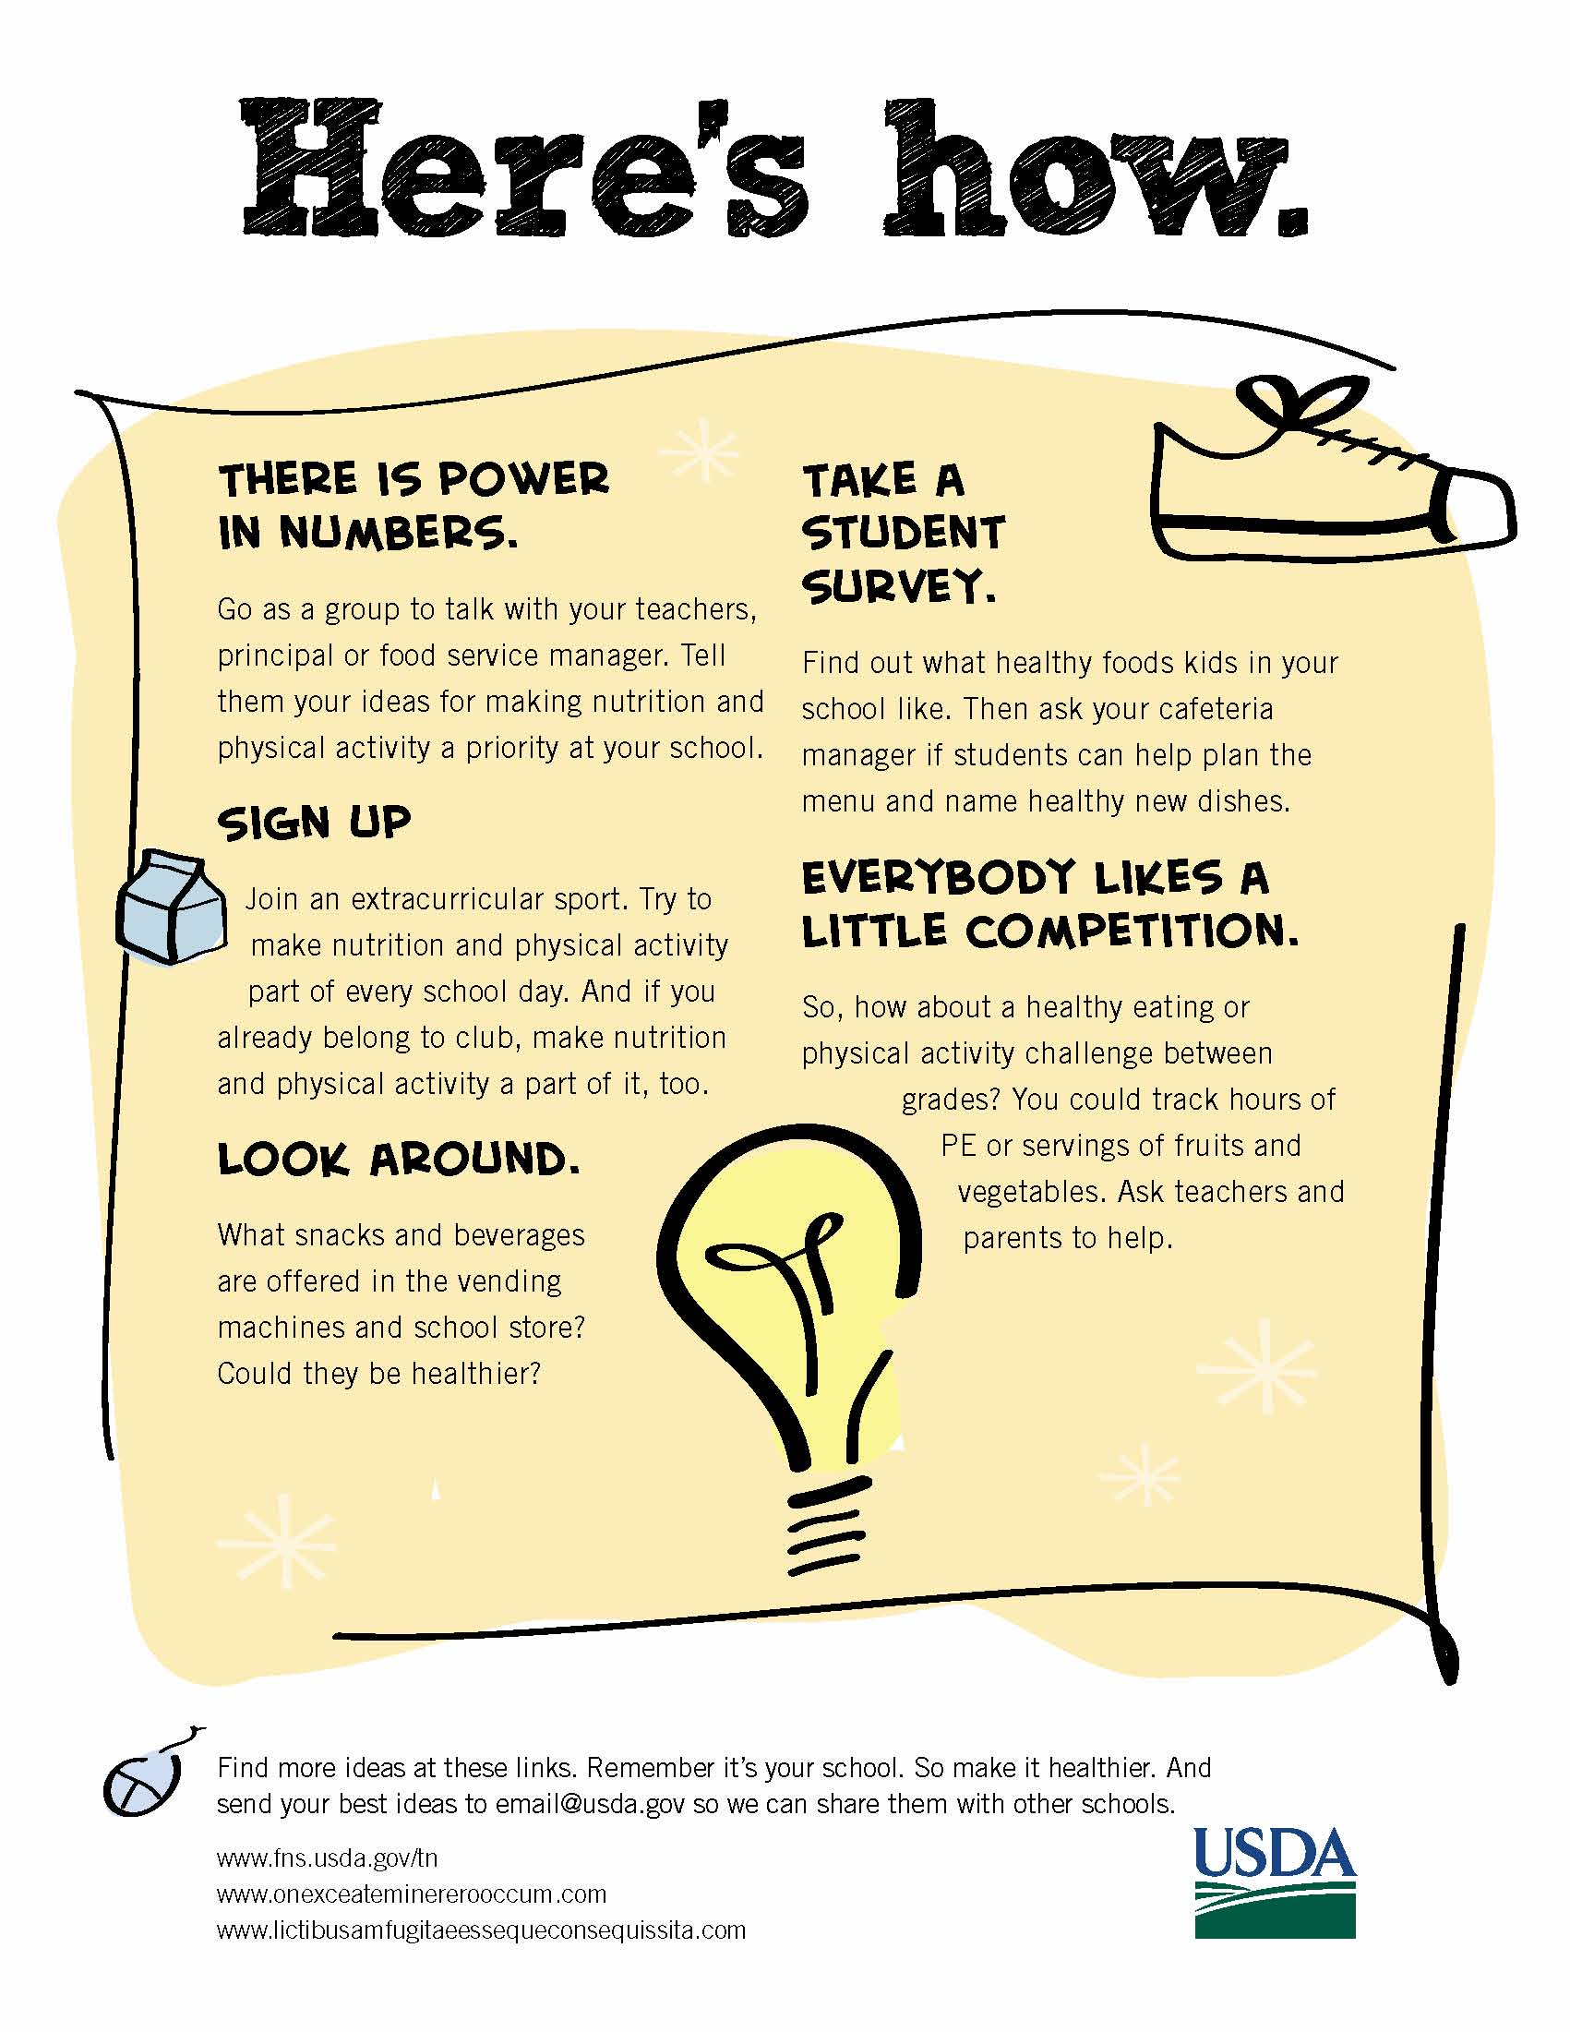

Appendix B. Video Script

VIDEO  MIDDLE SCHOOL BOY IN FRONT OF SCHOOL HALLWAY SCENE WITH LOCKERS. A THOUGHT BUBBLE APPEARS AND GROWS WITH IMAGES REPRESENTING MANY ACTIVITIES AND CHOICES—SOCCERBALL, A+ PAPER, STACK OF BOOKS/HOMEWORK; FRIENDS. TWO SCHOOLMATES—A GIRL AND A BOY—APPEAR IN THIS SCENE.  BOY IN FRONT OF SCHOOL SOCCER FIELD SCENE IS WEARING A SOCCER UNIFORM. THERE ARE OTHER KIDS IN SCENE.  BOY IN CAFETERIA. HEALTHY FOODS POP UP HERE AND THERE ON FOOD LINE.  BOY IN INTERIOR SCHOOL SETTING. OTHER KIDS APPEAR IN THE SCENE. THEY ARE HOLDING CLIPBOARDS.  CLASSROOM AFTER SCHOOL. KIDS ARE HAVING AN ENVIRONMENT CLUB MEETING.  THEY ARE PLANNING A HIKE. YOU CAN SEE A TRAIL MAP ON THE WALL. THE KIDS ARE CHOOSING HEALTHY FOODS TO TAKE ON THE HIKE.  KIDS WITH ADULT STAKEHOLDERS IN CAFETERIA. MORE HEALTHY FOODS APPEAR.  TYPE TREATMENT OF THEME LINE APPEARS.  IT CONTAINS AN IDEA ICON THAT REAPPEARS WITH EACH NEW TIP/IDEA PRESENTED.  KIDS AT VENDING MACHINES OR SCHOOL STORE.  KIDS IN CAFETERIA. MENU BOARD GETS NEW FOOD NAMES.  KIDS IN A PHYSICAL ACTIVITY.  CLASSROOM WHERE COMPETITION BETWEEN GRADES IS BEING CHARTED. SHOW KID POSTING PROGRESS, AND HAPPY TEACHER.  KID GETTING AWARD/TROPHY.  ON CAMERA BOY KICKS SOCCER BALL. IT BOUNCES TO END CARD WITH LINKS. | AUDIO  MUSIC UP AND UNDER THROUGHOUT  BOY: Middle school. There’s so much going on. So many more choices to make. Clubs. Schoolwork. Grades.  I want to look my best, and have the energy to do my best. I know that choosing….  ….healthy foods can help with all that. But, it’s not always easy finding them at school, or at least ones that taste good.  We can change that. We’re not little kids anymore. Each day, we are in charge of deciding what we eat and how much physical activity we get, right? So why not get more of these healthy choices in school where we spend a lot of our time? If we work together, we can help to make our schools healthier for everyone.  Be a leader, and ask your friends to join you. Maybe you can all sign up for an after school sport or club, then make nutrition and being active a part of it.  BOY: Go as a group to talk with your teachers, cafeteria staff, your parents, coach or principal about getting healthier choices in more places at school.  Here are more ways you and your friends can step up. Our future starts now. Here’s how.  Take a look around. How many places have healthy food choices? Could things be better? Take your ideas to your student council, principal or cafeteria manager.  What healthy foods do kids in your school like most? Take a student survey. Then ask your cafeteria manager if students can help plan the menu. Create fun names for new menu items.  Ask your gym teacher to help you start a before or after school physical activity club.  Everybody likes a little competition. So, how about a healthy eating or physical activity challenge between grades? You could track hours of physical activity or how many fruits and vegetables you eat. Ask teachers and parents to help.  Find more ideas at these links. Remember it’s your school. So make it healthier. And thanks for watching

Appendix C: Handout A

OMB Control # 0584-0524
Expiration Date: 03/31/2013

Public reporting burden for this collection of information is estimated to average 2 minutes per response, including the time for reviewing instructions, searching existing data sources, gathering and maintaining the data needed, and completing and reviewing the collection of information. An agency may not conduct or sponsor, and a person is not required to respond to, a collection of information unless it displays a currently valid OMB control number. Send comments regarding this burden estimate or any other aspect of this collection of information, including suggestions for reducing this burden, to: U.S. Department of Agriculture, Food and Nutrition Services, Office of Research, Nutrition and Analysis, Alexandria, VA 22302 (0584-0524). Do not return the completed form to this address.
First Name: ______________
Session #: _____

Handout A

- Is it important for middle school students to play a part in making their middle school a healthier place in terms of nutrition and physical activity? Why or why not?

_______________________________________________________________________

_______________________________________________________________________

_______________________________________________________________________

_______________________________________________________________________

