OMB BURDEN STATEMENT: According to the Paperwork Reduction Act of 1995, no persons are required to respond to a collection of information unless it displays a valid OMB control number. The valid OMB control number for this information collection is 0584-0524. The time to complete this information collection is estimated to average 120 minutes per response, including the time for reviewing instructions, searching existing data sources, gathering and maintaining the data needed, and completing and reviewing the collection of information.

USDA/FNS: Communications Tools Testing – Evaluative Round (July 2011)
Mini Group Moderator’s Guide (Parents of Middle School Students)
120 Minutes

I. WELCOME AND GROUND RULES (5 minutes)

Welcome everyone. My name is _______. I am an independent marketing researcher. Thank you for coming for this discussion. Before we begin, I’d like to explain a few things about the discussion.

- First of all, I want everyone to know there are no wrong answers. (We want to know your opinions and those opinions might differ. This is fine. We want to know what each of you thinks about the topics we will be discussing.)
- You have probably noticed the microphones in the room. They are here because we are audiotaping the discussion. Afterwards, I have to write a report. I want to give you my full attention and not have to take a lot of notes. Also, because we are taping, it is important that you try to speak one at a time. I may occasionally interrupt you when two or more people are talking at once in order to be sure everyone gets a chance to talk and that responses are accurately recorded.
- Behind me is a one-way mirror. Some of the people working on this project are observing this discussion so that they can hear your opinions directly from you. However, your identity and anything you personally say here will remain secure, to the extent permitted by law. When I write my report, I will not refer to anyone by name.
- Please turn off your beepers & cell phones. The group will last only 120 minutes. Should you need to go to the restroom during the discussion, please feel free to leave, but we’d appreciate it if you would go one at a time.
- Feel free to say what is on your mind. If you have something negative to say, it is all right. Remember, there are no right or wrong answers. We just want to hear your opinions.

II. INTRODUCTION (10 minutes)

- Now, first let’s spend a little time getting to know one another. Let’s go around the table and introduce each of ourselves. Please tell me:
- First name, and
- What local area you live in,
- Who you live with (ages of children), pets, plants, etc. and
- A little bit about yourself—such as what you do for a living or a favorite hobby

[MODERATOR: Instruct respondents that when questions in the guide refer to children, they should think of their middle school age child(ren), even if they have another child in a different age range. REMIND THEM OF THIS THROUGHOUT THE SESSION]

III. WARM UP/HELPING CHILDREN STAY HEALTHY (10 minutes)

- Let’s begin our discussion this evening by discussing how we help our middle school children be healthy.
  - In general, what are some things that you do to help your middle school-aged child stay healthy? [WRITE ON EASEL. IF NOT MENTIONED, PROBE NUTRITION/PHYSICAL ACTIVITY]
  - Of the items we have on this list, which are the easiest to do as a parent for your middle school-aged child(ren)? Which are more challenging?

- How much do you think about nutrition and physical activity when it comes to your middle school-aged child/children? In other words, where does this rank on your list of priorities as a parent?
- As a parent, to what degree do you feel you can help make your children eat healthier and get regular physical activity while at school?
  - What are the biggest challenges to helping your children eat healthier and get regular physical activity while they are at school?
  - How much responsibility falls on your shoulders as opposed to your child/children? What about other school officials (e.g., teachers, principals, food service staff) What makes you say that?
- With which other members of your community (e.g., other parents, the school principal, teachers, food service staff), if any, do you work with to help make sure your children eat healthfully and get regular physical activity while at school?

[NOTE TO MODERATOR: ROTATE ORDER OF TESTING TOOLS.]
[NOTE TO MODERATOR: Ask all of the tool-specific questions for the tool presented first. For the tool presented second, spend less time on reaction to content areas (since the content for both tools is similar)]

IV. Communication Tool: HANDOUT (35 minutes)

We just discussed a little bit about the challenges of getting your middle school children to eat healthfully and get regular physical activity while at school. Now, we are going to look a handout that is designed to help convince parents to get involved in making their child’s middle school a healthier environment in terms of nutrition and physical activity.
Before we start, I want to let you know that I did not write the handout you are going to see today, so don’t worry if there’s something you don’t like about it. I want to hear what you like and dislike.

[HANDOUT IS A 1-PAGE TWO-SIDED COLOR AND BLACK-AND-WHITE DOCUMENT (SEE APPENDIX A). THE HANDOUT WILL PRESENT THE MESSAGES AND SUPPORTING CONTENT AND ENSURE THEY MATCH THE MESSAGE TONE, STYLE AND LITERACY LEVEL OF OUR TARGET AUDIENCE.]

- What are your first impressions about this handout? [Get general reaction (interest, boredom, etc. before asking next set of questions)]
  - In your own words, what is the handout trying to tell you? How do you know?
  - [IF NOT ALREADY MENTIONED:] What is the handout trying to encourage you to do?
  - What, if anything, did you like about the handout? What makes you say that?
  - What is the most interesting piece of information on the handout? What makes you say that?
  - What is the most important piece of information on the handout? What makes you say that?
  - Let’s look at the other side of the coin. What, if anything, do you dislike? What makes you say that?
  - What, if anything, was confusing to you? What was difficult to understand?
- Does this handout seem like it was made for someone like you? What makes you say that?
  - Does this handout remind you of anything you’ve seen or used before? What does it remind you of? How are they similar?
  - Does this handout sound like something you would use? What makes you say that?
    - When do you think you would use this handout?
    - How do you think you would use the information in this handout?
  - How likely would you be to share this handout with others? What makes you say that?
  - Where would you expect to receive this handout? How do you think would you get it? [PROBE: online, in the mail, etc.]
- Specific Content Review – Handout
  - What was the first piece that grabbed your attention? Where did you look, first?
  - What did you think about the language that talked about bringing “together parents and other in the community to help”? Is that important? Realistic? What makes you say that?
  - What did you think about the tips and suggestions?
    - Of all tips and suggestions the handout provided, which are the most realistic to implement? What makes you say that?
    - Which, if any, would you be most likely to try? What makes you say that?
    - Which is the most challenging for you to do? What makes you say that?
  - What about when it said “our kids need to see that we walk our talk at home and school”? How did that section make you feel? Is it appropriate? What makes you say that?
  - What did you think about the links included on the handout?
    - How likely would you be to go to the links to get new ideas?
    - How likely would you be to share your own ideas on these sites?
  - What, if anything, do you think about the way this handout looks?
    - What do you think about the headlines? Do they interest you? How well do they introduce the information that follows them?
    - What do you think about the pictures?
      - How well do they grab your attention?
      - How well do they “match” with the language on the handout? What makes you say that?
      - To what extent, if at all, do they make you interested in what the handout is saying?

V. Communication Tool: VIDEO CLIP (35 minutes)

Now, we are going to take a look at another way to share this type of information. Eventually, it will become a video designed to help convince parents to get involved in making their school a healthier environment in terms of nutrition and physical activity.
We are not going to see a finished video. Instead, we are going to see draft pictures that represent parts of the video while you hear the script (See Appendix B for video scripts). It will give you a sense of what the video will be like when it is finished.
Before we start, I want to let you know that I did not make the video clip you are going to see today, so don’t worry if there’s something you don’t like about it. I want to hear what you like and dislike.

[[VIDEO ANMATIC WILL BE 1 MINUTE IN LENGTH AND WILL COMMUNICATE THE KEY MESSAGES]

Before we talk about what you just saw, please note that the final version will be fully animated in the style you have just seen, instead of just seeing a few screen shots.

- What are your first impressions? [Get general reaction (interest, boredom, etc. before asking next set of questions)]
  - In your own words, what was it trying to tell you? How do you know?
  - [IF NOT ALREADY MENTIONED:] What is it trying to encourage you to do?
- Now, watch the video again, and I’ll ask you some other questions about it.
  - What, if anything, do you like about the clip? What makes you say that?
  - What is the most interesting piece of information you gleaned from the clip? What makes you say that?
  - What is the most important piece of information? What makes you say that?
  - Let’s look at the other side of the coin. What, if anything, do you dislike? What makes you say that?
  - What, if anything, was confusing to you? What was difficult to understand?
- Does this clip seem like it was made for someone like you? What makes you say that?
- Once it is finished, do you think it is something you would watch? What makes you say that?
- How likely do you think you would be to share this video with others? With whom would you share it?
- Does what you have just watch seem like it is a video from the government? What makes you say that? Is that good or bad? Why?
- Specific Content Review – Video Clip
  - It has been a few minutes since we watched the clip? What do you remember the most? What image or phrase sticks out in your mind?
  - What did you think about the tips and suggestions?
    - Of all tips and suggestions the handout provided, which are the most realistic to implement? What makes you say that?
    - Which, if any, would you be most likely to try? What makes you say that?
    - Which is the most challenging for you to do? What makes you say that?
  - What did you think about the links mentioned?
    - How likely would you be to go to the links to get new ideas?
  - What do you think about the people/images who are sharing information in the clip? Do they seem credible to you? What makes you say that?
  - How important do you think it is to share this information with other parents? What makes you say that?

VI. SUMMARY (20 minutes)

- We have seen two different ways to convince you to help make your middle school a healthier environment in terms of nutrition and physical activity.
  - Thinking about all the information we discussed, which piece of information is most convincing to get you to try to help make your school a healthier environment?
  - Is some information better shared on one tool over the other?
    - In other words, what, if anything, did the video communicate better than the handout? What makes you say that?
    - What, if anything, did the handout communicate better than the video? What makes you say that?
  - If you saw one of these tools/or saw information about one of these tools at [TBD locations: at school, online, etc], which of the two would you be most likely to notice? What makes you say that?

- [IF NOT PREVIOIUSLY MENTIONED:] Do you find it believable that at schools where successful changes have been made, parents are often instrumental in getting things like more physical education and healthier food choices?
- [IF NOT PREVIOIUSLY MENTIONED:] How do you feel about asking your children and/or their teachers about what they are eating in school and how much physical activity they are getting? What about reinforcing what your child is learning about food and nutrition in school when they are at home?
- [IF NOT PREVIOIUSLY MENTIONED:] On a related note, how do you feel about suggesting healthier food choices for fundraisers or classroom celebrations?

VII. FALSE CLOSE (5 minutes)

- While I step out of the room for a moment to see if I need to cover any additional information, please answer the questions on Handout A (See Appendix C). [DISTRIBUTE HANDOUT A.] The question on this handout reads, “What is the most useful tip you heard/read to help you make your child’s school a healthier environment in terms of nutrition and physical activity”?

Thank you very much for your participation! Have a great day/evening!

Appendix A: Handout (Front)

Appendix A: Handout (Back)
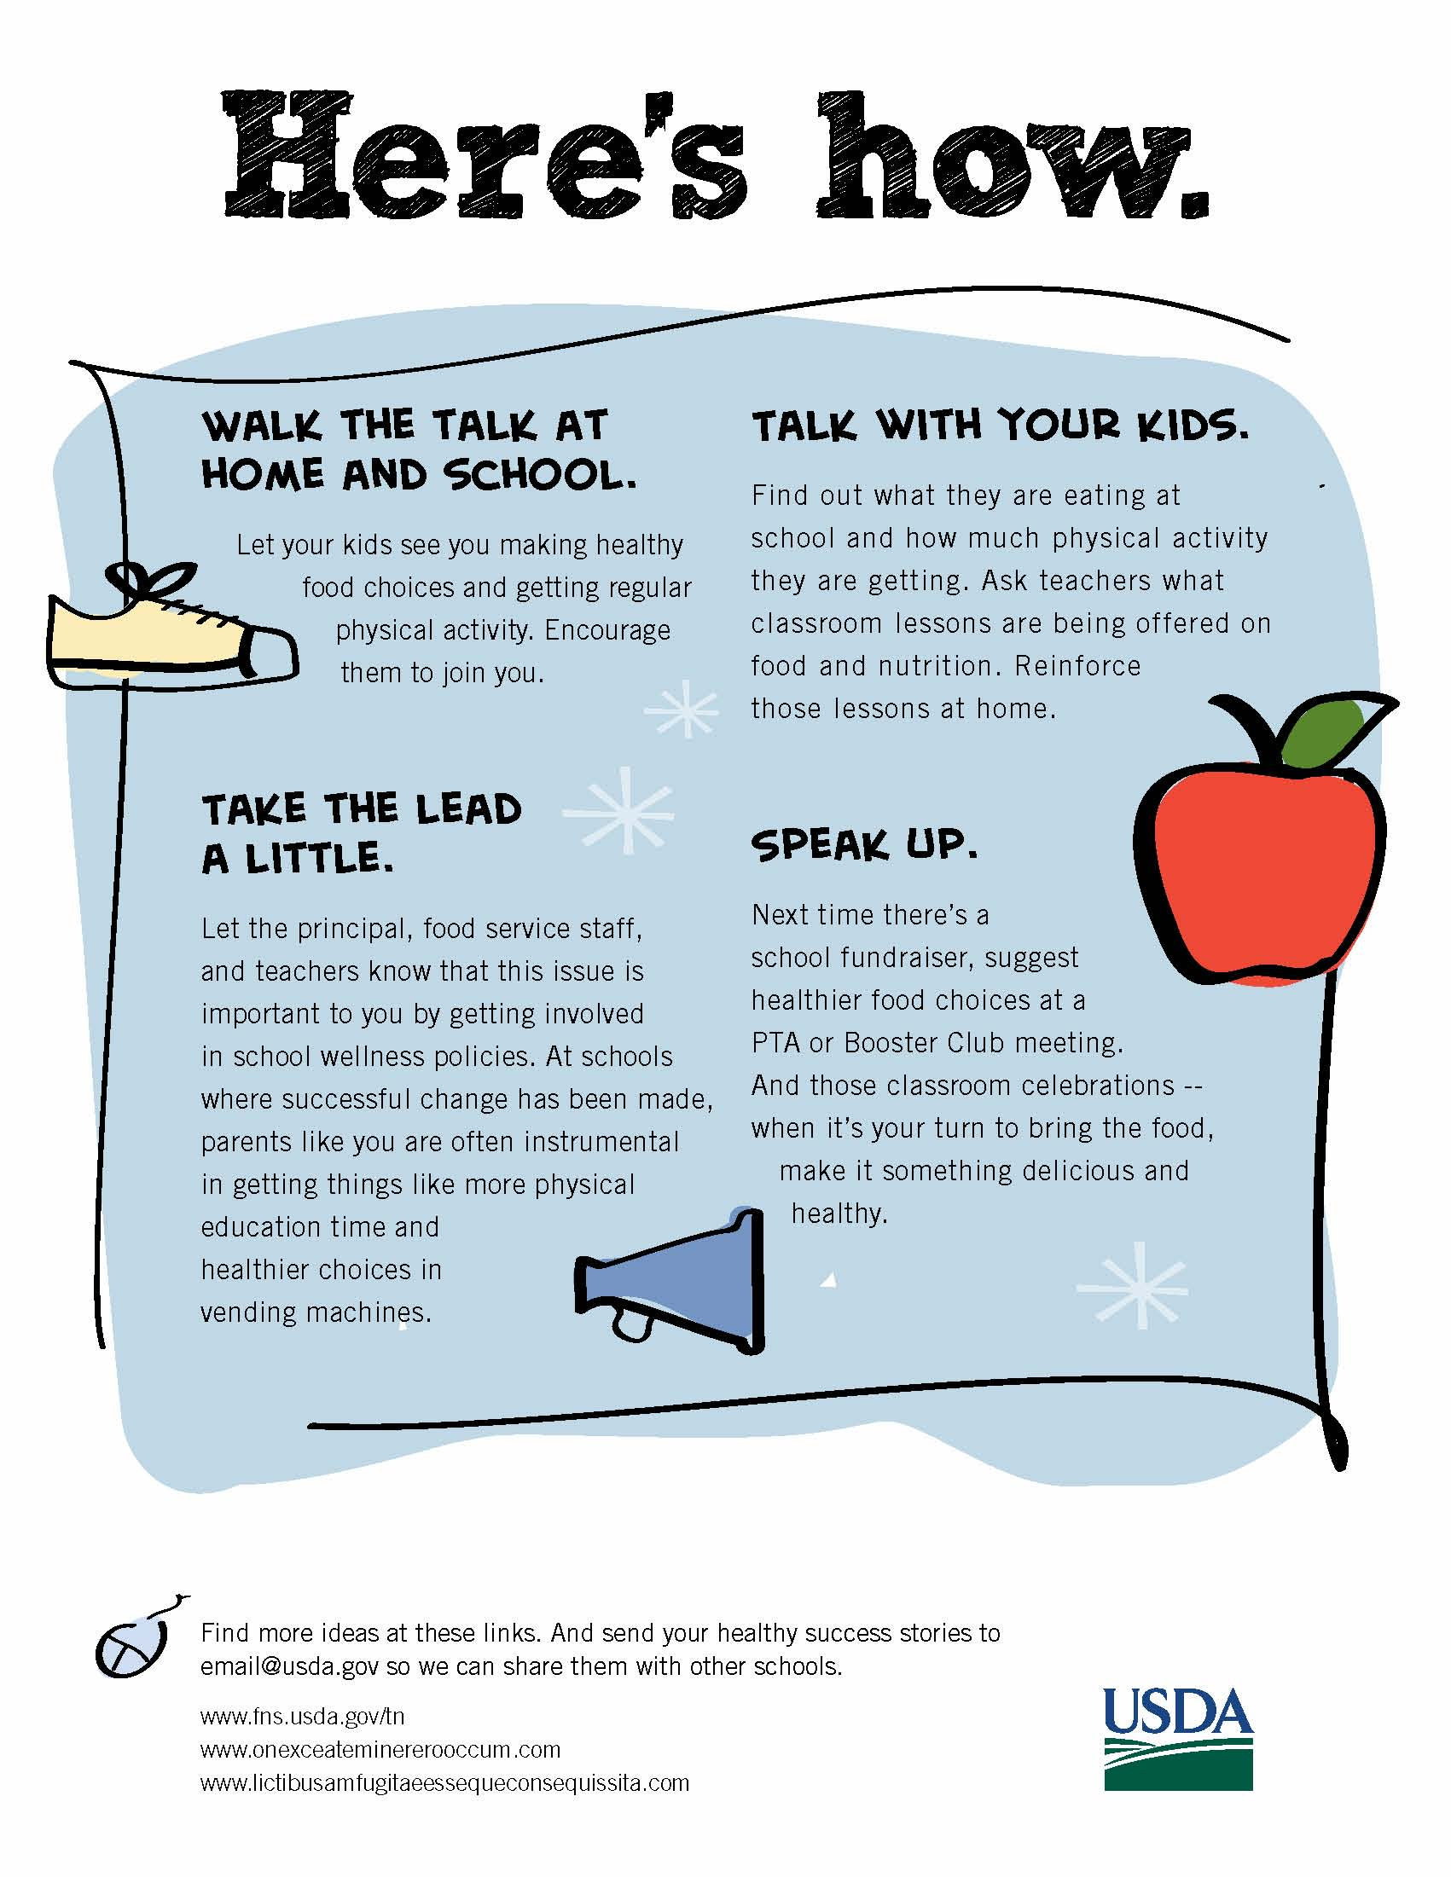

Appendix B: Video Script

VIDEO  MOM IN FRONT OF A TYPICAL OUTDOOR SUBURBAN SCENE. AS SHE REMINISCES, WE SEE A PROGRESSION OF IMAGES DEPICTING HER DAUGHTER’S PROGRESSIVE STAGES—FROM BABY BLOCKS TO CELL PHONE.  HER DAUGHTER APPEARS IN THE BACKGROUND. HER WARDROBE  CHANGES TO INDICATE EVOLVING MATURITY. MOM SLIDES OF SCREEN AND DAUGHTER MOVES TO FOREGROUND AS BACKGROUND CHANGES TO CLASSROOM. A THOUGHT BUBBLE APPEARS ABOVE HER HEAD WITH CAFETERIA TRAY HEALTHY MEAL AND MILK.  CLASSROOM SCENE WITH KIDS HAPPILY LEARNING.  MOM IN FRONT OF HOME KITCHEN SCENE WHERE A HEALTHY DINNER IS ON THE TABLE.  OUTDOOR IMAGE OF MIDDLE SCHOOL.  ANIMATED SUN RISES AND SETS OVER SCHOOL.  INSIDE SCHOOL, A MEETING TAKES PLACE  OF STAKEHOLDERS.  TYPE TREATMENT OF THEIR FUTURE STARTS NOW HERE’S HOW WITH LIGHTBULB ICON.  MOM IN JOGGING SUIT AT SCHOOLYARD WHERE KIDS ARE BEING ACTIVE. MOM NODS HER APPROVAL, THEN CONTINUES TALKING TO CAMERA.  PRINCIPAL AND TEACHER APPEAR ON SCENE WITH MOM. A THOUGHT BUBBLE OVER MOM’S HEAD HAS IMAGES OF THINGS SHE WANTS TO DISCUSS WITH THEM.  AS MOM TALKS TO CAMERA, SCENE BEHIND HER CHANGES TO SHOW VENDING MACHINES.  SCENE OF FAMILY AT HOME DEPICTING SCHOOL MENU ON COMPUTER AND HEALTHY FOODS FOR DINNER.  PARENTS AT PTA MEETING. THEY VOTE FOR CHOICES OF NON-JUNK FOOD FUNDRAISERS SUCH AS CAR WASH, DANCE-A-THON, 5K, OR BOOK SALE.  AS PARENT TALKS TO US, LINKS ARE SUPERED | AUDIO  MUSIC UP AND UNDER THROUGHOUT  MOM: I’m a middle school parent.  And like you, I’ve seen my child go through a lot of changes lately. I’ve had to change the way I parent, just to keep up.  In a few years, they’ll be on their own. So middle school is the time for us to make sure our kids have good nutrition and physical activity habits for life.  Studies show that kids with healthier eating patterns also tend to have better academic performance. And kids who get regular physical activity may also concentrate better in class and have fewer behavioral problems.  You give them what they need at home, right? That’s because you’re there running the show.  But what about at school where they spend so much of their day? You’ve got to get the healthier food choices and regular physical activity there, too.  So what’s a parent to do?  First of all, realize you can’t do it alone.  Bring together parents and others in the community to help. You could form a parent’s committee on school nutrition and physical activity, or at least start a conversation between parents and school staff.  To get the conversation going, here are some other ideas middle school parents.  MOM: have used to make school a more nutritious and active place for kids. Their future starts now. Here’s how.  “Do as I say, not as I do” just doesn’t cut it for this age. Our kids need to see that we walk our talk at home and school.  So, let them see you making healthy choices. And at school, take the lead a little. Let the principal, food service staff, and  teachers know that this issue is important to you by getting involved in school wellness policies.  At schools where positive changes have been made, parents are often instrumental in things like getting more PE time and healthier vending machine choices.  Do you know what your kids are eating at school, or how much physical activity they are getting? Find out, and talk with your kids about what choices they are making. Also, ask your kids’ teachers what classroom lessons are being offered on food and nutrition. Reinforce those lessons at home.  Next time there’s a school fundraiser, suggest that it promote physical activity or involve the sale of a non-food item. Or, try focusing on healthier foods, like fruits and vegetables. Be sure to bring it up at the PTA or Booster Club.  These are just a few ideas. Find more at these links. The important thing is, work with others and get something started. Thanks for watching.

Appendix C: Handout A

OMB Control # 0584-0524
Expiration Date: 03/31/2013

Public reporting burden for this collection of information is estimated to average 2 minutes per response, including the time for reviewing instructions, searching existing data sources, gathering and maintaining the data needed, and completing and reviewing the collection of information. An agency may not conduct or sponsor, and a person is not required to respond to, a collection of information unless it displays a currently valid OMB control number. Send comments regarding this burden estimate or any other aspect of this collection of information, including suggestions for reducing this burden, to: U.S. Department of Agriculture, Food and Nutrition Services, Office of Research, Nutrition and Analysis, Alexandria, VA 22302 (0584-0524). Do not return the completed form to this address.
First Name: ______________
Session #: _____

Handout A

- What is the most useful tip you heard/read to help you make your child’s school a healthier environment in terms of nutrition and physical activity?

_______________________________________________________________________

_______________________________________________________________________

_______________________________________________________________________

_______________________________________________________________________

