OMB BURDEN STATEMENT: According to the Paperwork Reduction Act of 1995, no persons are required to respond to a collection of information unless it displays a valid OMB control number. The valid OMB control number for this information collection is 0584-0524. The time to complete this information collection is estimated to average 120 minutes per response, including the time for reviewing instructions, searching existing data sources, gathering and maintaining the data needed, and completing and reviewing the collection of information.

USDA/FNS: Communications Tools Testing – Evaluative Round (July 2011)
Focus Group Moderator’s Guide (Middle School Teachers)
120 Minutes

I. WELCOME AND GROUND RULES (5 minutes)

Welcome everyone. My name is _______. I am an independent marketing researcher. Thank you for coming for this discussion. Before we begin, I’d like to explain a few things about the discussion.

- First of all, I want everyone to know there are no wrong answers. (We want to know your opinions and those opinions might differ. This is fine. We want to know what each of you thinks about the topics we will be discussing.)
- You have probably noticed the microphones in the room. They are here because we are audiotaping the discussion. Afterwards, I have to write a report. I want to give you my full attention and not have to take a lot of notes. Also, because we are taping, it is important that you try to speak one at a time. I may occasionally interrupt you when two or more people are talking at once in order to be sure everyone gets a chance to talk and that responses are accurately recorded.
- Behind me is a one-way mirror. Some of the people working on this project are observing this discussion so that they can hear your opinions directly from you. However, your identity and anything you personally say here will remain secure, to the extent permitted by law. When I write my report, I will not refer to anyone by name.
- Please turn off your beepers & cell phones. The group will last only 120 minutes. Should you need to go to the restroom during the discussion, please feel free to leave, but we’d appreciate it if you would go one at a time.
- Feel free to say what is on your mind. If you have something negative to say, it is all right. Remember, there are no right or wrong answers. We just want to hear your opinions.

II. INTRODUCTION (10 minutes)

- Now, first let’s spend a little time getting to know one another. Let’s go around the table and introduce each of ourselves. Please tell me:
- First name,
- What grade you teach,
- How long you’ve been teaching, and
- A little bit about yourself—such as a favorite hobby

III. WARM UP/HELPING CHILDREN STAY HEALTHY (10 minutes)

- Let’s begin our discussion this evening by discussing how we help middle school children be healthy.
  - In general, what are some things that your school does to help the students stay healthy? [WRITE ON EASEL. IF NOT MENTIONED, PROBE NUTRITION/PHYSICAL ACTIVITY]
- How much do you think about nutrition and physical activity when it comes to your students and your school? In other words, where does this rank on your list of priorities as a teacher?
- Now let’s talk a little bit more about nutrition and physical activity.
  - To what extent do you think it is your responsibility, as a teacher, to do what you can to make sure your students eat healthfully and get physical activity?
  - How much responsibility falls on your shoulders as opposed to your students or their parents? What about other school officials (e.g., principals) What makes you say that?

[NOTE TO MODERATOR: ROTATE ORDER OF TESTING TOOLS.]
[NOTE TO MODERATOR: Ask all of the tool-specific questions for the tool presented first. For the tool presented second, spend less time on reaction to content areas (since the content for both tools is similar)]

IV. Communication Tool: HANDOUT (35 minutes)

We just discussed a little bit about the challenges of getting your students to eat healthfully and get regular physical activity while at school. Now, we are going to look a handout that is designed to help convince teachers to get involved in making their school a healthier environment in terms of nutrition and physical activity.
Before we start, I want to let you know that I did not write the handout you are going to see today, so don’t worry if there’s something you don’t like about it. I want to hear what you like and dislike.

[HANDOUT IS A 1-PAGE TWO-SIDED COLOR AND BLACK-AND-WHITE DOCUMENT (SEE APPENDIX A). THE HANDOUT WILL PRESENT THE MESSAGES AND SUPPORTING CONTENT AND ENSURE THEY MATCH THE MESSAGE TONE, STYLE AND LITERACY LEVEL OF OUR TARGET AUDIENCE.]

- What are your first impressions about this handout? [Get general reaction (interest, boredom, etc. before asking next set of questions)]
  - In your own words, what is the handout trying to tell you? How do you know?
  - [IF NOT ALREADY MENTIONED:] What is the handout trying to encourage you to do?
  - What, if anything, did you like about the handout? What makes you say that?
  - What is the most interesting piece of information on the handout? What makes you say that?
  - What is the most important piece of information on the handout? What makes you say that?
  - Let’s look at the other side of the coin. What, if anything, do you dislike? What makes you say that?
  - What, if anything, was confusing to you? What was difficult to understand?
- Does this handout seem like it was made for someone like you? What makes you say that?
  - Does this handout remind you of anything you’ve seen or used before? What does it remind you of? How are they similar?
  - Does this handout sound like something you would use? What makes you say that?
    - When do you think you would use this handout?
    - How do you think you would use the information in this handout?
  - How likely would you be to share this handout with others? What makes you say that?
  - Where would you expect to receive this handout? How do you think would you get it? [PROBE: conferences, meetings, online, from a supervisor or peers, etc.]
- Specific Content Review – Handout
  - What was the first piece that grabbed your attention? Where did you look, first?
  - What did you think about the language that talked about “a communitywide effort”? Is that important? Realistic? What makes you say that?
  - What did you think about the tips and suggestions?
    - Of all tips and suggestions the handout provided, which are the most realistic to implement? What makes you say that?
    - Which, if any, would you be most likely to try? What makes you say that?
    - Which is the most challenging for you to do? What makes you say that?
  - What about “Walk the Talk”? How did that section make you feel? Is it appropriate? What makes you say that?
  - What did you think about the links included on the handout?
    - How likely would you be to go to the links to get new ideas?
    - How likely would you be to share your own ideas on these sites?
  - What, if anything, do you think about the way this handout looks?
    - What do you think about the headlines? Do they interest you? How well do they introduce the information that follows them?
    - What do you think about the pictures?
      - How well do they grab your attention?
      - How well do they “match” with the language on the handout? What makes you say that?
      - To what extent, if at all, do they make you interested in what the handout is saying?
V. Communication Tool: VIDEO CLIP (35 minutes)

Now, we are going to take a look at another way to share this type of information. Eventually, it will become a video designed to help convince teachers to get involved in making their school a healthier environment in terms of nutrition and physical activity.
We are not going to see a finished video. Instead, we are going to see draft pictures that represent parts of the video while you hear the script (See Appendix B for video scripts). It will give you a sense of what the video will be like when it is finished.
Before we start, I want to let you know that I did not make the video clip you are going to see today, so don’t worry if there’s something you don’t like about it. I want to hear what you like and dislike.
[VIDEO ANMATIC WILL BE 1 MINUTE IN LENGTH AND WILL COMMUNICATE THE KEY MESSAGES]

Before we talk about what you just saw, please note that the final version will be fully animated in the style you have just seen, instead of just seeing a few screen shots.

- What are your first impressions? [Get general reaction (interest, boredom, etc. before asking next set of questions)]
  - In your own words, what was it trying to tell you? How do you know?
  - [IF NOT ALREADY MENTIONED:] What is it trying to encourage you to do?
- Now, watch the video again, and I’ll ask you some other questions about it.
  - What, if anything, do you like about the clip? What makes you say that?
  - What is the most interesting piece of information you gleaned from the clip? What makes you say that?
  - What is the most important piece of information? What makes you say that?
  - Let’s look at the other side of the coin. What, if anything, do you dislike? What makes you say that?
  - What, if anything, was confusing to you? What was difficult to understand?
- Does this clip seem like it was made for someone like you? What makes you say that?
- Once it is finished, do you think it is something you would watch? What makes you say that?
- How likely do you think you would be to share this video with others? With whom would you share it?
- Does what you have just watch seem like it is a video from the government? What makes you say that? Is that good or bad? Why?
- Specific Content Review – Video Clip
  - It has been a few minutes since we watched the clip? What do you remember the most? What image or phrase sticks out in your mind?
  - What did you think about the tips and suggestions?
    - Of all tips and suggestions the handout provided, which are the most realistic to implement? What makes you say that?
    - Which, if any, would you be most likely to try? What makes you say that?
    - Which is the most challenging for you to do? What makes you say that?
  - What did you think about the links mentioned?
    - How likely would you be to go to the links to get new ideas?
    - How likely would you be to share your own ideas on these sites?
  - What do you think about the people/images who are sharing information in the clip? Do they seem credible to you? What makes you say that?
  - How important do you think it is to share this information with other teachers? What makes you say that?

VI. SUMMARY (20 minutes)

- We have seen two different ways to convince you to help make your middle school a healthier environment in terms of nutrition and physical activity.
  - Thinking about all the information we discussed, which piece of information is most convincing to get you to try to help make your school a healthier environment?
  - Is some information better shared on one tool over the other?
    - In other words, what, if anything, did the video communicate better than the handout? What makes you say that?
    - What, if anything, did the handout communicate better than the video? What makes you say that?
  - If you saw one of these tools/or saw information about one of these tools at [TBD locations: at school, online, etc], which of the two would you be most likely to notice? What makes you say that?

- Do you feel that your classroom practices can affect what your students eat?
- [IF NOT PREVIOIUSLY MENTIONED:] How do you feel about the idea of NOT using food to reward students? For example, not giving out candy for correct answers or holding contests where candy or fast food is the prize.
- [IF NOT PREVIOIUSLY MENTIONED:] On a related note, how do you feel about making celebratory events such as birthdays and other holiday-related parties healthier by serving more nutritious foods or incorporating physical activity?
- Do you currently incorporate nutrition education into your regular classroom instruction?
  - If so, what resources do you use to do this?
  - Do you use Team Nutrition or Eat Smart Play Hard materials?
  - If not, where do you go for resources?
  - Where do you go for educational resources in general?
- Do teachers eat with the students in the cafeteria? Or do you they eat in a teacher lounge? Where do you typically have your lunch?
- Have you ever heard of the Healthier US Schools Challenge (HUSSC)?
  - If so, do you think your school would be capable of getting an award?

VII. FALSE CLOSE (5 minutes)

- While I step out of the room for a moment to see if I need to cover any additional information, please answer the questions on Handout A (See Appendix C). [DISTRIBUTE HANDOUT A.] The question on this handout reads, “What is the most useful tip you heard/read to help you make your school a healthier school environment in terms of nutrition and physical activity”?

Thank you very much for your participation! Have a great day/evening!

Appendix A: Handout (front)

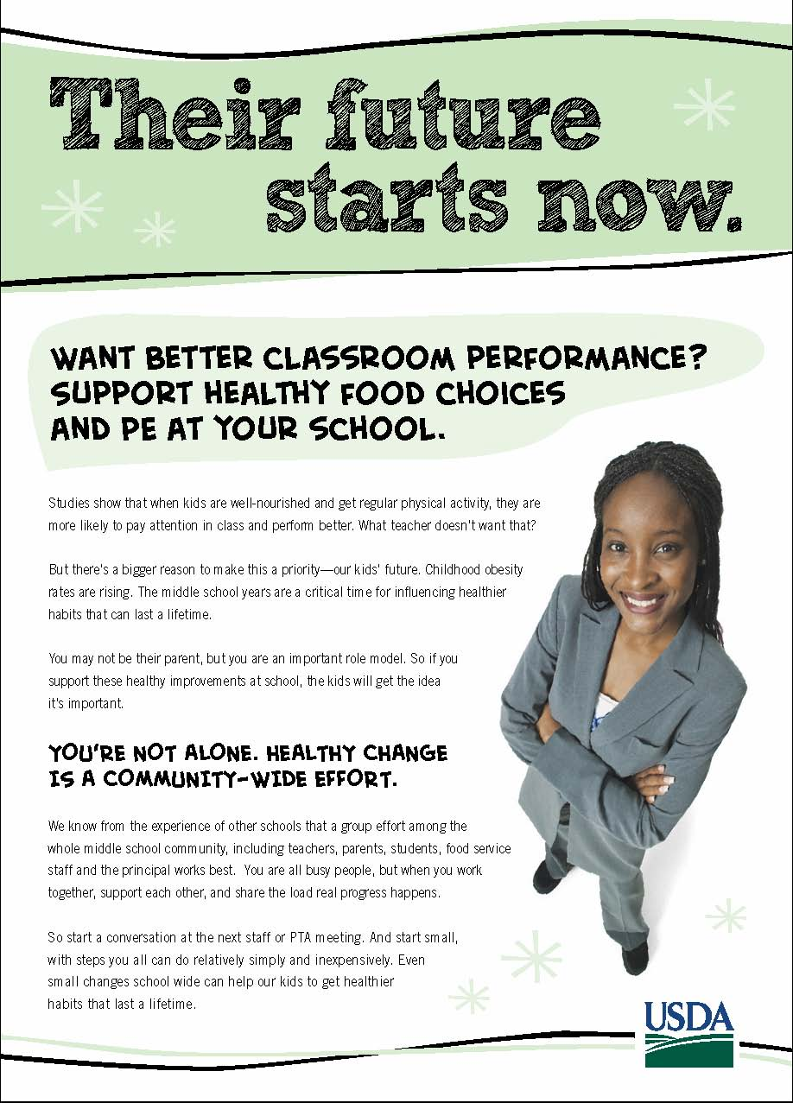

Appendix A: Handout (Back)

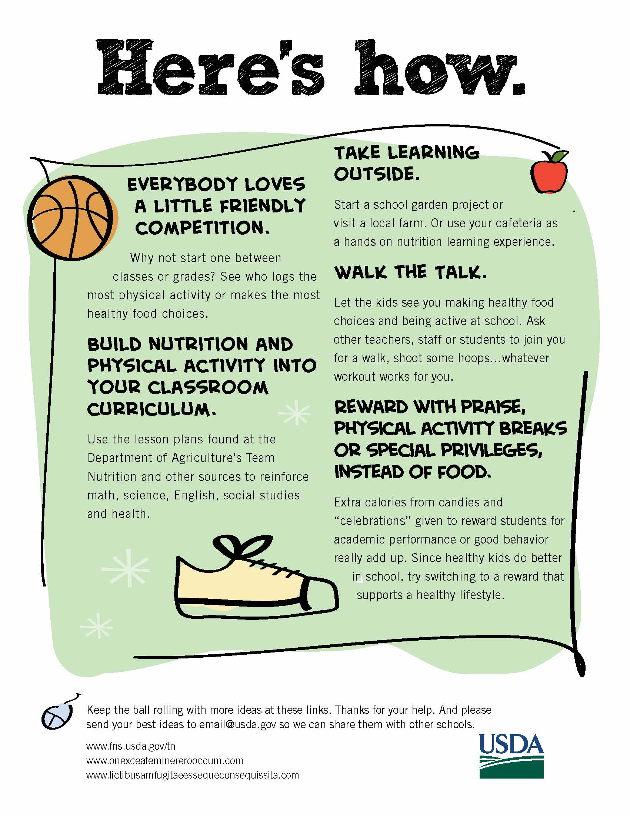

Appendix B: Video Script

VIDEO  TEACHER LEANS AGAINST ILLUSTRATED DESK IN DRAWN CLASSROOM. IMAGES OF WHAT MAKES HER DAY BUSY APPEAR ON CHALKBOARD: FULL INBOX; TUTORING; COACHING WHISTLE AND HAT.  CHILDHOOD OBESITY IN BIG FAT LETTERS ON CHALKBOARD GETS REDUCED.  TEACHER IN FRONT OF CAFETERIA SCENE  WHERE SOME KIDS ARE NEAR SOME HEALTHY FOODS.  CLASSROOM WHERE KIDS ARE WORKING COOPERATIVELY ON A GROUP PROJECT AND TEACHER IS SMILING.  TEACHER BEING ACTIVE IN FRONT OF OR BESIDE GYM BACKGROUND WHERE KIDS ARE BEING ACTIVE.  CUT TO TEACHER ALONE. SHE IS JOINED BY STAKEHOLDERS. SCENE CHANGES TO ALL OF THEM HAVING A MEETING. THE GROUP GETS AN IDEA ABOUT FRUITS & VEGGIES.  FRUITS & VEGGIES POP UP IN DIFFERENT PLACES IN SCHOOL, SUCH AS IN VENDING MACHINES, SCHOOL STORE, SCHOOL GARDEN, CLASSROOM ACTIVITY, OR  FUNDRAISER. (some, but not all of these will be portrayed).  TYPE TREATMENT OF THIS LINE  BECOMES AN IDEA SYMBOL  WHICH REAPPEARS AT THE BEGINNING OF EACH OF THE IDEAS PORTRAYED  TEACHER IN FRONT OF A CLASSROOM SCENE WITH A CHART/BAR GRAPH DEPICTING TWO GRADES OR TEAMS INCREASING PHYSICAL ACTIVITY OR HEALTHY FOOD CHOICES. KID MARKS THE CHART. CHART INCREASES.  TEACHER IN FRONT OF DIFFERENT CLASSROOM WHERE THERE IS A “HOW TO READ A FOOD LABEL” POSTER. THE  TEAM NUTRITION URL & GRAPHIC COME UP.  KIDS OUTSIDE WITH SCHOOL GARDEN OR INSIDE WITH SCHOOL CAFETERIA  TEACHER EATING ONE HEALTHY FOOD IN FRONT OF CAFETERIA SCENE OF KIDS WITH  HEALTHY FOODS.  TEACHER ON CAMERA WITH SOCCER BALL. BALL ROLLS AND LEADS TO END CARD WITH LINKS. | AUDIO  MUSIC UP AND UNDER THROUGHOUT  TEACHER: If you want something done, ask a busy person, right?  So, here’s the ask. To lower childhood obesity, we need your help making some changes in our schools.  Kids need more healthy food choices and more physical activity in school, where they spend so much of their day.  Studies show that kids with healthier eating patterns also tend to have better academic performance. Kids who get regular physical activity also concentrate better in class and have fewer behavioral problems. What teacher doesn’t want that?  We also know that our students notice what we do. We’re not their parents, but we are role models. So, what we say and do influences them. If we support these healthy improvements at school, the kids will get the idea it’s important.  So what does “support” mean? Not doing it alone, but working with others. A group effort works best, so start or join a conversation with your principal, fellow teachers, food service staff, students and parents.  And start small, with steps you all can do relatively simply and inexpensively. Even small changes school wide can help our kids to get healthier habits that last a lifetime.  TEACHER: Their future starts now. Here’s how.  Everybody loves a little friendly competition. Why not start one between classes or grades? See what group spends the most time being physically active, or eats the most vegetables at lunch. Don’t use food as incentives or rewards. Try giving extra credit, prize points, pencils, homework passes, or privileges like a chance to listen to music in the classroom.  Build nutrition and physical activity into your classroom curriculum. Could be math, science, English, social studies or health. Get ideas and lesson plans at the Department of Agriculture’s Team Nutrition web site.  Take learning outside to a school garden project or local farm visit. Or use your cafeteria as a hands-on nutrition learning lab.  Oh, and that role modeling I mentioned earlier? Let your students see you making healthy food choices and being active at school. Ask other teachers, staff or students to join you for a walk, shoot some hoops…whatever activity works for you.  Keep the ball rolling with more ideas at these links. Thanks for your help.

Appendix C: Handout A
OMB Control # 0584-0524
Expiration Date: 03/31/2013

Public reporting burden for this collection of information is estimated to average 2 minutes per response, including the time for reviewing instructions, searching existing data sources, gathering and maintaining the data needed, and completing and reviewing the collection of information. An agency may not conduct or sponsor, and a person is not required to respond to, a collection of information unless it displays a currently valid OMB control number. Send comments regarding this burden estimate or any other aspect of this collection of information, including suggestions for reducing this burden, to: U.S. Department of Agriculture, Food and Nutrition Services, Office of Research, Nutrition and Analysis, Alexandria, VA 22302 (0584-0524). Do not return the completed form to this address.
First Name: ______________
Session #: _____

Handout A

- What is the most useful tip you heard/read to help you make your child’s school a healthier environment in terms of nutrition and physical activity?

_______________________________________________________________________

_______________________________________________________________________

_______________________________________________________________________

_______________________________________________________________________

