OMB BURDEN STATEMENT: According to the Paperwork Reduction Act of 1995, no persons are required to respond to a collection of information unless it displays a valid OMB control number. The valid OMB control number for this information collection is 0584-0524. The time to complete this information collection is estimated to average 90 minutes per response, including the time for reviewing instructions, searching existing data sources, gathering and maintaining the data needed, and completing and reviewing the collection of information.

USDA/FNS: Communications Tools Testing – Evaluative Round (July 2011)
Telephone Focus Group Moderator’s Guide (Middle School Principals)
90 Minutes

I. WELCOME AND GROUND RULES (5 minutes)

Welcome everyone. My name is _______. I am an independent marketing researcher. Thank you for coming for this discussion. Before we begin, I’d like to explain a few things about the discussion.

- First of all, I want everyone to know there are no wrong answers. (We want to know your opinions and those opinions might differ. This is fine. We want to know what each of you thinks about the topics we will be discussing.)
- We are audiotaping the discussion. Afterwards, I have to write a report. I want to give you my full attention and not have to take a lot of notes. Also, because we are taping, it is important that you try to speak one at a time. I may occasionally interrupt you when two or more people are talking at once in order to be sure everyone gets a chance to talk and that responses are accurately recorded.
- Some colleagues are listening to the discussion with me. They want to hear your opinions directly from you. They will not participate in the discussion in any way except they might ask me to go over a topic or notify me if I skipped something we need to discuss.
- One of the great things about doing groups over the phone is that it adds a layer of anonymity to the discussion. Your identity and contact information will remain secure, to the extent permitted by law. When I write my report, I will not refer to anyone by name. During the discussion, we will only use first names.
- The discussion group will last only 90 minutes.
- Finally, you were mailed and e-mailed an information packet prior to the discussion. As was mentioned when you were recruited, this packet contains materials that we’ll be discussing today. Please be sure you are near a computer so you can take a look at the material when instructed to do so. However, please do not open it or look at the materials until I prompt you to.

II. INTRODUCTION (5 minutes)

- Now, first let’s spend a little time getting to know one another. Let’s each take turns introducing ourselves. Please tell me:
- First name, and
- What local area you live in,
- What school you are a principal at, and
- A little bit about yourself—such as a favorite hobby

III. WARM UP/HELPING CHILDREN STAY HEALTHY (10 minutes)

- Let’s begin our discussion this evening by discussing how we help our middle school children be healthy.
  - In general, what are some things that your school does to help the students stay healthy? [WRITE ON EASEL. IF NOT MENTIONED, PROBE NUTRITION/PHYSICAL ACTIVITY]
  - Of the items we have on this list, which are the easiest to do as a principal for your middle students? Which are more challenging?
  - How much do you think about nutrition and physical activity when it comes to your students and your school? In other words, where does this rank on your list of priorities as a principal?
  - If you had to rate the health of your school environment when it comes to nutrition and physical activity on a scale from 1-10, where 1 = no focus on nutrition and 10 = nutrition is a major priority in the school, what would you say? What makes you say that?

- As a principal, to what degree do you feel you can help make your students eat healthier and get regular physical activity while at school?
  - What are the biggest challenges to helping your students eat healthier and get regular physical activity while they are at school?
  - What kinds of things do you need or do you feel could be done to help encourage students to choose healthy items in the cafeteria?

- With which other school officials, if any, do you work to help make sure the students in your school eat as healthfully as possible? To what extent, if at all, do you get support from officials in your middle school?

[NOTE TO MODERATOR: ROTATE ORDER OF TESTING TOOLS.]
[NOTE TO MODERATOR: Ask all of the tool-specific questions for the tool presented first. For the tool presented second, spend less time on reaction to content areas (since the content for both tools is similar)]

IV. Communication Tool: HANDOUT (30 minutes)

We just discussed a little bit about the challenges of getting middle school students to eat healthfully and get regular physical activity. Now, we are going to look a handout that is designed to help convince principals to make their school a healthier environment in terms of nutrition and physical activity. Please open the envelope in your packet labeled “A.” Take a moment to read through it.
Before we start, I want to let you know that I did not write the handout you are going to see today, so don’t worry if there’s something you don’t like about it. I want to hear what you like and dislike.

[HANDOUT IS A 1-PAGE TWO-SIDED COLOR AND BLACK-AND-WHITE DOCUMENT (SEE APPENDIX A). THE HANDOUT WILL PRESENT THE MESSAGES AND SUPPORTING CONTENT AND ENSURE THEY MATCH THE MESSAGE TONE, STYLE AND LITERACY LEVEL OF OUR TARGET AUDIENCE.]
- What are your first impressions about this handout? [Get general reaction (interest, boredom, etc. before asking next set of questions)]
  - In your own words, what is the handout trying to tell you? How do you know?
  - [IF NOT ALREADY MENTIONED:] What is the handout trying to encourage you to do?
  - What, if anything, did you like about the handout? What makes you say that?
  - What is the most interesting piece of information on the handout? What makes you say that?
  - What is the most important piece of information on the handout? What makes you say that?
  - Let’s look at the other side of the coin. What, if anything, do you dislike? What makes you say that?
  - What, if anything, was confusing to you? What was difficult to understand?
- Does this handout seem like it was made for someone like you? What makes you say that?
  - Does this handout remind you of anything you’ve seen or used before? What does it remind you of? How are they similar?
  - Does this handout sound like something you would use? What makes you say that?
    - When do you think you would use this handout?
    - How do you think you would use the information in this handout?
  - How likely would you be to share this handout with others? What makes you say that?
  - Where would you expect to receive this handout? How do you think would you get it? [PROBE: conferences, meetings, online, from a supervisor or peers, etc.]
- Specific Content Review – Handout
  - What was the first piece that grabbed your attention? Where did you look, first?
  - What did you think about the language that talked about working with students, teachers, food service staff and parents?
  - What did you think about the tips and suggestions?
    - Of all tips and suggestions the handout provided, which are the most realistic to implement? What makes you say that?
    - Which, if any, would you be most likely to try? What makes you say that?
    - Which is the most challenging for you to do? What makes you say that?
  - What about “Walk the Talk”? How did that section make you feel? Is it appropriate? What makes you say that?
  - What about enrolling your school in the Healthier US Schools Challenge (HUSSC)?
    - Have you ever heard of this program?
    - If so, do you think your school would be capable of getting an award?
  - What did you think about the links included on the handout?
    - How likely would you be to go to the links to get new ideas?
    - How likely would you be to share your own ideas on these sites?
  - What, if anything, do you think about the way this handout looks?
    - What do you think about the headlines? Do they interest you? How well do they introduce the information that follows them?
    - What do you think about the pictures?
      - How well do they grab your attention?
      - How well do they “match” with the language on the handout? What makes you say that?
      - To what extent, if at all, do they make you interested in what the handout is saying?

V. Communication Tool: VIDEO CLIP (30 minutes)

Now, we are going to take a look at another way to share this type of information. Eventually, it will become a video designed to help convince principals to make their school a healthier environment in terms of nutrition and physical activity.
A link to the video was provided in the welcome email we sent prior to the group. Before you click on the link, let me explain that you are not going to see a finished video. Instead, you are going to see draft pictures from the video while you hear the script. It will give you a sense of what the video will be like when it is finished.
Before we start, I want to let you know that I did not make the video clip you are going to see today, so don’t worry if there’s something you don’t like about it. I want to hear what you like and dislike.
Please click on the link now and watch it (See Appendix B for video script). Let me know if you are having any problems accessing the link.

[VIDEO ANMATIC WILL BE 1 MINUTE IN LENGTH AND WILL COMMUNICATE THE KEY MESSAGES]

Before we talk about what you just saw, please note that the final version will be fully animated in the style you have just seen, instead of just seeing a few screen shots

- What are your first impressions? [Get general reaction (interest, boredom, etc. before asking next set of questions)]
  - In your own words, what was it trying to tell you? How do you know?
  - [IF NOT ALREADY MENTIONED:] What is it trying to encourage you to do?
- Now, watch the video again, and I’ll ask you some other questions about it.
  - What, if anything, do you like about the clip? What makes you say that?
  - What is the most interesting piece of information you gleaned from the clip? What makes you say that?
  - What is the most important piece of information? What makes you say that?
  - Let’s look at the other side of the coin. What, if anything, do you dislike? What makes you say that?
  - What, if anything, was confusing to you? What was difficult to understand?
- Does this clip seem like it was made for someone like you? What makes you say that?
- Once it is finished, do you think it is something you would watch? What makes you say that?
- How likely do you think you would be to share this video with others? With whom would you share it?
- Specific Content Review – Video Clip
  - It has been a few minutes since we watched the clip? What do you remember the most? What image or phrase sticks out in your mind?
  - What did you think about the tips and suggestions?
    - Of all tips and suggestions the handout provided, which are the most realistic to implement? What makes you say that?
    - Which, if any, would you be most likely to try? What makes you say that?
    - Which is the most challenging for you to do? What makes you say that?
  - What did you think about the links mentioned?
    - How likely would you be to go to the links to get new ideas?
- What do you think about the people/images who are sharing information in the clip? Do they seem credible to you? What makes you say that?

VI. SUMMARY (5 minutes)

- We have seen two different ways to convince you to help make your middle school a healthier environment in terms of nutrition and physical activity.
  - Thinking about all the information we discussed, which piece of information is most convincing to get you to try to help make your school a healthier environment?
  - Is some information better shared on one tool over the other?
    - In other words, what, if anything, did the video communicate better than the handout? What makes you say that?
    - What, if anything, did the handout communicate better than the video? What makes you say that?
  - If you saw one of these tools/or saw information about one of these tools at [TBD locations: at school, online, etc], which of the two would you be most likely to notice? What makes you say that?

VII. FALSE CLOSE (5 minutes)

- [While I step out of the room for a moment to see if I need to cover any additional information, please answer the questions on Handout A (See Appendix C). [DISTRIBUTE HANDOUT A.] The question on this handout reads, “What is the most useful tip you heard/read to help you make your school a healthier environment in terms of nutrition and physical activity”?
- Please take a moment to put all of the materials and your Handout A into the self-addressed stamped envelope we have provided for you and mail back to us. Thank you very much for your participation! Have a great day/evening!

Appendix A: Handout (Front)
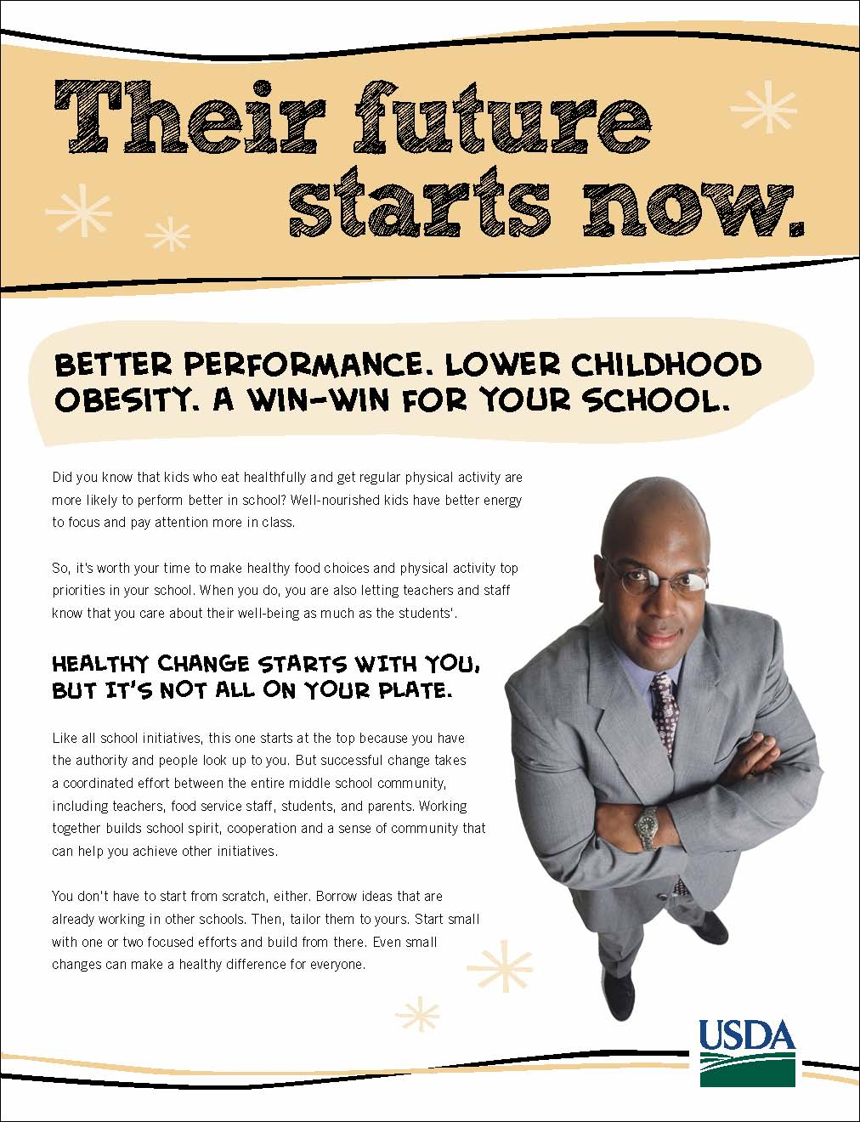

Appendix A: Handout (Back)
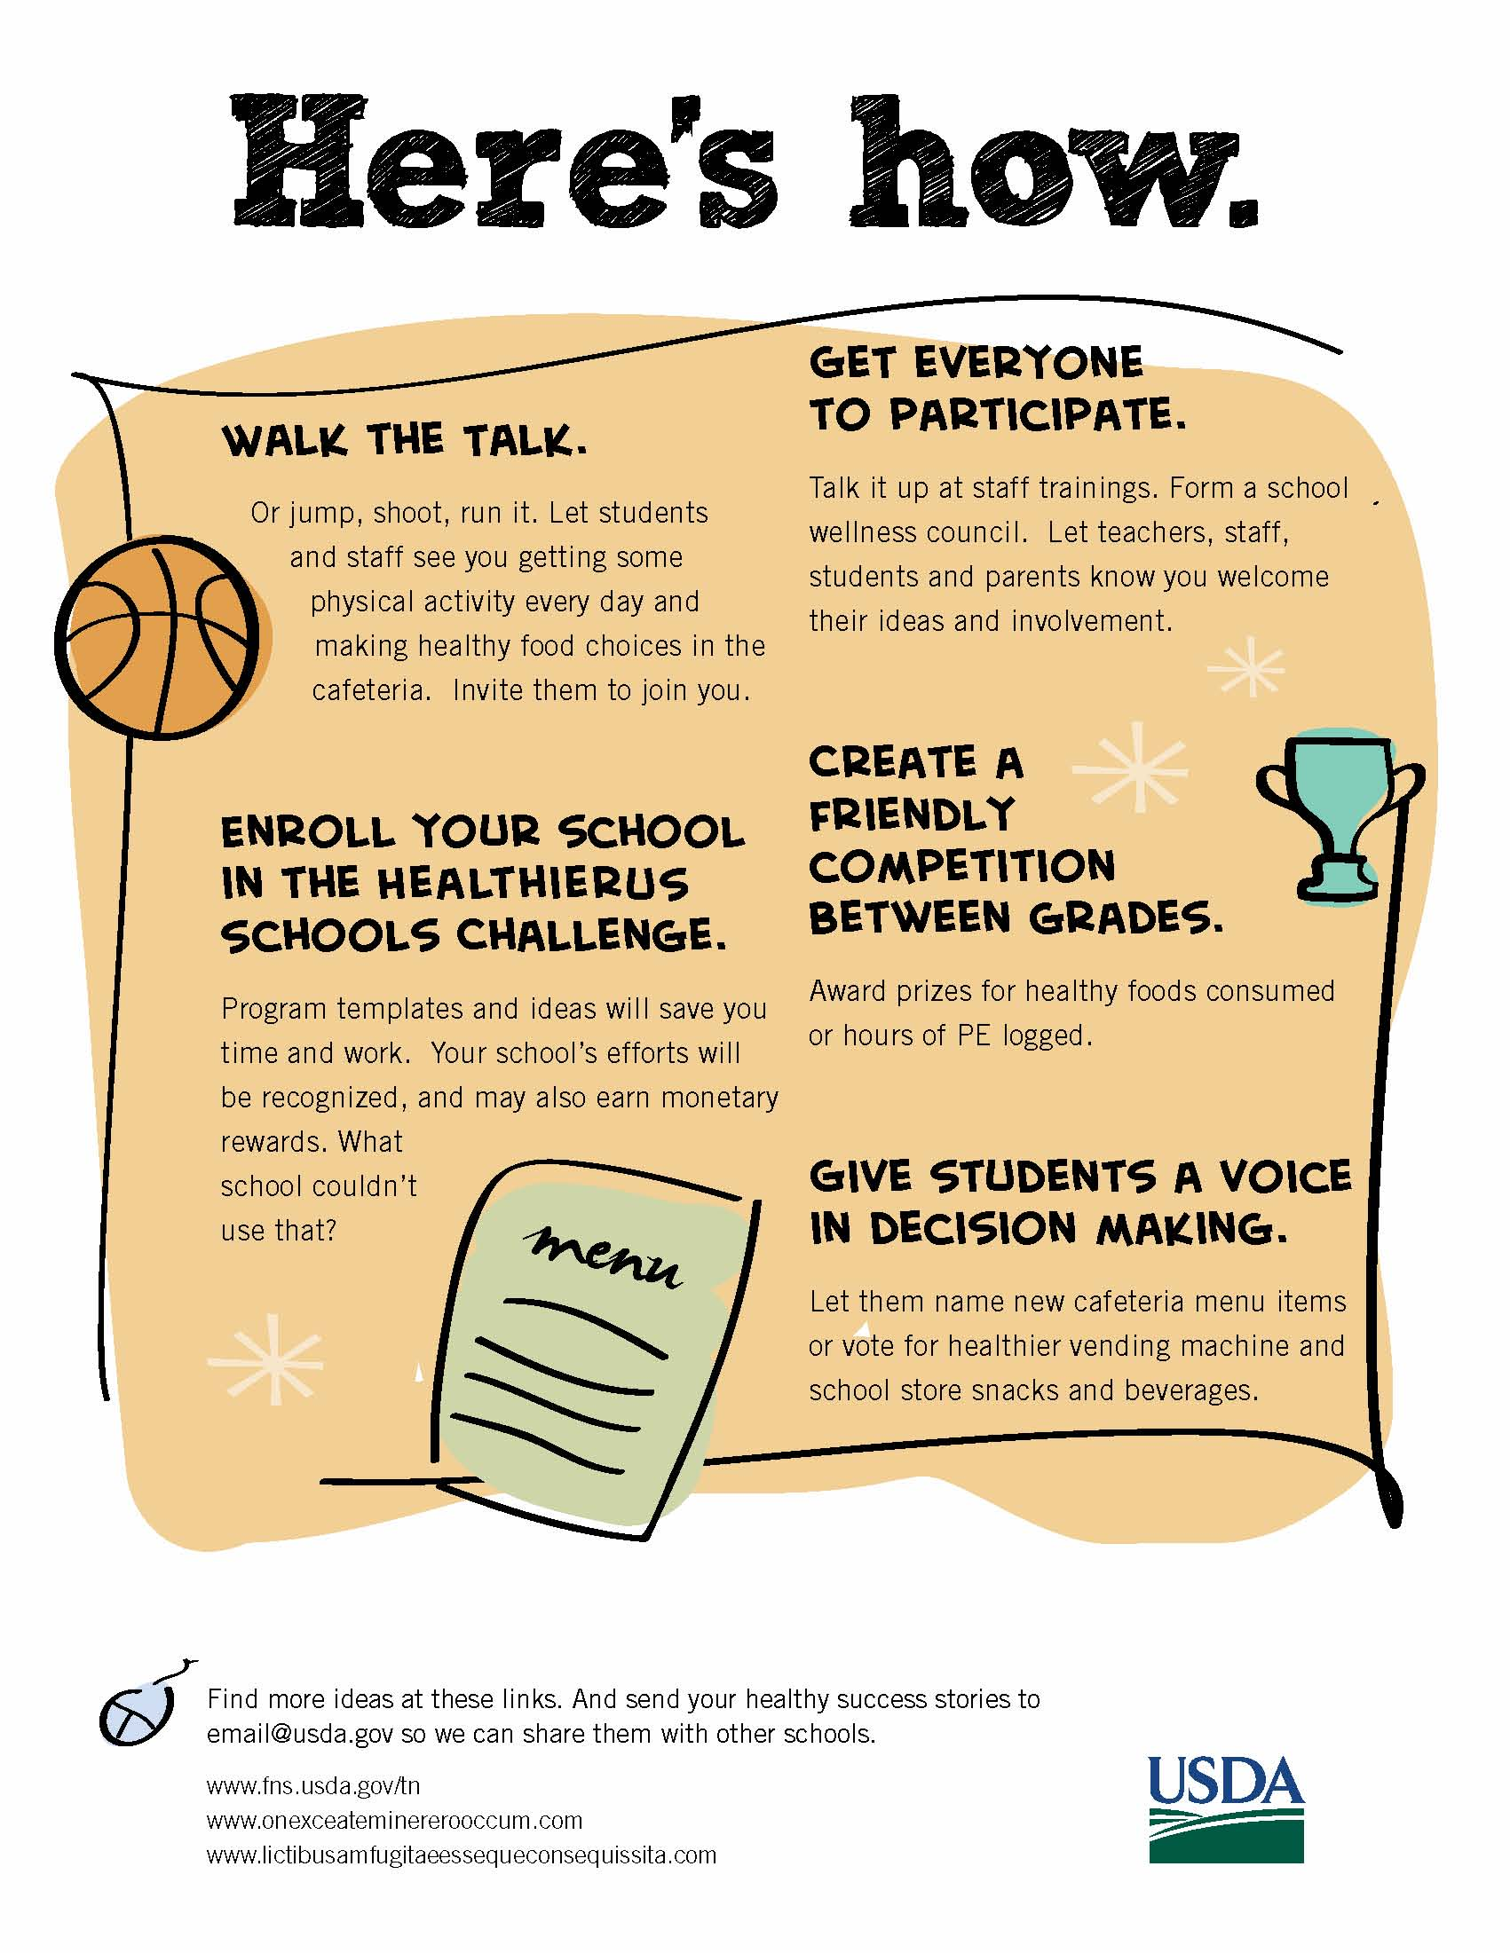

Appendix B: Video Script
VIDEO  PRINCIPAL IN FRONT OF SCENE OF A CLASSROOM WHERE KIDS ARE LEARNING.  THE BACKGROUND CHANGES TO CAFETERIA AND THEN TO GYM AS PRINCIPAL TALKS.  CUT TO TV SCREEN IN A CLASSROOM WHERE MORNING SCHOOL ANNOUNCEMENTS ARE MADE SYMBOLIZING HEALTHY FOOD AND FUN GROUP PHYSICAL ACTIVITY. THEN WE SEE THE SCHOOL OFFICE STAFF TAKING NOTE OF THE NEWS, TOO.  PRINCIPAL TALKS TO US ON CAMERA.  ICONS APPEAR AS NEEDED TO COVER WHAT HE IS SAYING AND KEEP INTEREST.  SCENE OF STAKEHOLDERS MEETING.  AROUND A TABLE IN THE LIBRARY OR A MEETING ROOM AT SCHOOL. ICONS OF IDEAS REPRESENTING HEALTHY FOODS AND PHYSICAL ACTIVITY RISE FROM STAKEHOLDERS.  WE SEE VARIOUS PLACES AROUND THE SCHOOL WHERE HEALTHIER FOODS, BEVERAGES AND PHYSICAL ACTIVITY OPPORTUNITIES ARE IN PLACE AND KIDS ARE ENJOYING THEM—THE VENDING MACHINES HAVE BETTER FOOD/DRINK CHOICES; THE CAFETERIA LINE HAS COLORFUL FRUITS, VEGGIES AND WHOLE GRAIN FOODS. THE GYM OR PLAYGROUND HAS A FUN GAME IN PROGRESS.  GRAPHIC TREATMENT OF THE LINE “THEIR FUTURE STARTS NOW. HERE’S HOW.” WITH IDEA ICON THAT REAPPEARS WITH EACH NEW IDEA MENTIONED.  OC PRINCIPAL OUTDOORS. HE MAKES A LONG BASKTBALL SHOT AND CELEBRATES. KIDS CHEER HIM.  EXTERIOR FRONT OF SCHOOL BUILDING WITH FLAGPOLE. FLAG IS RAISED WITH HEALTHIERUS SCHOOLS CHALLENGE LOGO ON IT.  CLASSROOM SCENE WHERE KIDS AND TEACHER ARE CHARTING COMPETITION.  OC PRINCIPAL WITH BALL.  SHOW LINKS TO INFO SOURCES. | AUDIO  MUSIC UP AND UNDER THROUGHOUT  PRINCIPAL: You and I both know how hard principals are working to meet academic goals and keep schools safe. But did you know that making our schools healthier can help us reach these goals? Research shows that kids who have healthful eating patterns and get regular physical activity are more likely to perform well academically.  When you make nutrition and physical activity a priority at your school, student concentration, behavior, attendance and self-esteem can all benefit. And you are also letting your teachers and staff know that you care about their well-being as much as the students’.  Then there’s the childhood obesity problem. Schools aren’t the only answer, but they do play a key role.  So, for all these reasons, increasing school wide access to healthier food choices and physical activity is worth your time and attention.  Like all school initiatives, this one starts at the top because you have the authority, and people look up to you.  But don’t worry. It’s not all on your plate. In fact, in schools where changes are being made most successfully, it’s a coordinated effort between the entire school community, including principals, teachers, food service staff, students and parents. You don’t have to start from scratch, either. You can take ideas that are already working in other schools. Then, tailor them to your budget, facility, etc.  Another best practice. Start small with one or two focused efforts and build from there.  The most important thing is to start somewhere this year. Even small changes can make a healthy difference.  With everybody involved, your school can be a place that supports children’s learning and has a stronger sense of community. All while helping kids to get healthier eating and physical activity habits for life.  Their future starts now. Here’s how.  PRINCIPAL: Start by walking the talk. Or jumping, shooting, running it.  Let students and staff see you making healthy food choices in the cafeteria and getting some physical activity every day. Invite them to join you.  Sign up your school for the HealthierUS School Challenge. Save time and effort by using the program checklist and ideas. Hey, why reinvent the wheel when you don’t have to? You’ll get recognized for all the hard work you do and you may earn cash awards, too. What school couldn’t use that?  Start a friendly competition between grades. And give students a voice in decision making.  Moves like these build school spirit and give everyone ownership in becoming healthier.  Well, that should get the ball rolling. For more great ideas, go here. And thanks for watching.

Appendix C: Handout A

OMB Control # 0584-0524
Expiration Date: 03/31/2013

Public reporting burden for this collection of information is estimated to average 2 minutes per response, including the time for reviewing instructions, searching existing data sources, gathering and maintaining the data needed, and completing and reviewing the collection of information. An agency may not conduct or sponsor, and a person is not required to respond to, a collection of information unless it displays a currently valid OMB control number. Send comments regarding this burden estimate or any other aspect of this collection of information, including suggestions for reducing this burden, to: U.S. Department of Agriculture, Food and Nutrition Services, Office of Research, Nutrition and Analysis, Alexandria, VA 22302 (0584-0524). Do not return the completed form to this address.
First Name: ______________
Session #: _____

Handout A

- What is the most useful tip you heard/read to help you make your school a healthier environment in terms of nutrition and physical activity?

_______________________________________________________________________

_______________________________________________________________________

_______________________________________________________________________

_______________________________________________________________________

