OMB BURDEN STATEMENT: According to the Paperwork Reduction Act of 1995, no persons are required to respond to a collection of information unless it displays a valid OMB control number. The valid OMB control number for this information collection is 0584-0524. The time to complete this information collection is estimated to average 90 minutes per response, including the time for reviewing instructions, searching existing data sources, gathering and maintaining the data needed, and completing and reviewing the collection of information.

USDA/FNS: Communications Tools Testing – Evaluative Round (July 2011)
Telephone Focus Group Moderator’s Guide (School Food Service Managers)
90 Minutes

I. WELCOME AND GROUND RULES (5 minutes)

Welcome everyone. My name is _______. I am an independent marketing researcher. Thank you for coming for this discussion. Before we begin, I’d like to explain a few things about the discussion.

- First of all, I want everyone to know there are no wrong answers. (We want to know your opinions and those opinions might differ. This is fine. We want to know what each of you thinks about the topics we will be discussing.)
- We are audiotaping the discussion. Afterwards, I have to write a report. I want to give you my full attention and not have to take a lot of notes. Also, because we are taping, it is important that you try to speak one at a time. I may occasionally interrupt you when two or more people are talking at once in order to be sure everyone gets a chance to talk and that responses are accurately recorded.
- Some colleagues are listening to the discussion with me. They want to hear your opinions directly from you. They will not participate in the discussion in any way except they might ask me to go over a topic or notify me if I skipped something we need to discuss.
- One of the great things about doing groups over the phone is that it adds a layer of anonymity to the discussion. Your identity and contact information will remain secure, to the extent permitted by law. When I write my report, I will not refer to anyone by name. During the discussion, we will only use first names.
- The discussion group will last only 90 minutes.
- Finally, you were mailed and e-mailed an information packet prior to the discussion. As was mentioned when you were recruited, this packet contains materials that we’ll be discussing today. Please be sure you are near a computer so you can take a look at the material when instructed to do so. However, please do not open it or look at the materials until I prompt you to.

II. INTRODUCTION (5 minutes)

- Now, first let’s spend a little time getting to know one another. Let’s each take turns introducing ourselves. Please tell me:
- First name, and
- What local area you live in,
- What school you work at, and
- A little bit about yourself—such as a favorite hobby

III. WARM UP/HELPING CHILDREN STAY HEALTHY (10 minutes)

- Let’s begin our discussion today by discussing how we help our middle school children be healthy.
  - In terms of nutrition, what are some things that your school does to help the students stay healthy? [WRITE ON EASEL. IF NOT MENTIONED, PROBE NUTRITION/PHYSICAL ACTIVITY]
  - What are some of the easiest things you do as a food service manager to help promote good nutrition for your middle students?
  - If you had to rate the health of your school environment when it comes to nutrition on a scale from 1-10, where 1 = no focus on nutrition and 10 = nutrition is a major priority in the school, what would you say? What makes you say that?
- As a food service manager, to what degree do you feel you can help make your students eat healthier while at school?
  - What are the biggest challenges to helping your students eat healthier while they are at school?
  - What kinds of things do you need or do you feel could be done to help encourage students to choose healthy items in the cafeteria?
- With which other school officials, if any, do you work to help make sure the students in your school eat as healthfully as possible?
  - To what extent, if at all, do you get support from officials in your middle school?
  - To what extent, if at all, do you get support from officials outside your middle school, such as District food service managers?

[NOTE TO MODERATOR: ROTATE ORDER OF TESTING TOOLS ACROSS GROUPS]
[NOTE TO MODERATOR: Ask all of the tool-specific questions for the tool presented first. For the tool presented second, spend less time on reaction to content areas (since the content for both tools is similar)]

IV. Communication Tool: HANDOUT (30 minutes)

We just discussed a little bit about the challenges of getting middle school students to eat healthfully. Now, we are going to look a handout that is designed to help convince food service managers to get involved in making their school a healthier environment in terms of nutrition. Please open the envelope in your packet labeled “A.” Take a moment to read through it.
Before we start, I want to let you know that I did not write the handout you are going to see today, so don’t worry if there’s something you don’t like about it. I want to hear what you like and dislike.

[HANDOUT IS A 1-PAGE TWO-SIDED COLOR AND BLACK-AND-WHITE DOCUMENT (SEE APPENDIX A). THE HANDOUT WILL PRESENT THE MESSAGES AND SUPPORTING CONTENT AND ENSURE THEY MATCH THE MESSAGE TONE, STYLE AND LITERACY LEVEL OF OUR TARGET AUDIENCE.]
- What are your first impressions about this handout? [Get general reaction (interest, boredom, etc. before asking next set of questions)]
  - In your own words, what is the handout trying to tell you? How do you know?
  - [IF NOT ALREADY MENTIONED:] What is the handout trying to encourage you to do?
  - What, if anything, did you like about the handout? What makes you say that?
  - What is the most interesting piece of information on the handout? What makes you say that?
  - What is the most important piece of information on the handout? What makes you say that?
  - Let’s look at the other side of the coin. What, if anything, do you dislike? What makes you say that?
  - What, if anything, was confusing to you? What was difficult to understand?
- Does this handout seem like it was made for someone like you? What makes you say that?
  - Does this handout remind you of anything you’ve seen or used before? What does it remind you of? How are they similar?
  - Does this handout sound like something you would use? What makes you say that?
    - When do you think you would use this handout?
    - How do you think you would use the information in this handout?
  - How likely would you be to share this handout with others? What makes you say that?
  - Where would you expect to receive this handout? How do you think would you get it? [PROBE: conferences, meetings, online, from supervisor or peers, etc.]
- Specific Content Review – Handout
  - What was the first piece that grabbed your attention? Where did you look, first?
  - What did you think about the language that talked about working with students, teachers, principals and parents?
  - What did you think about the tips and suggestions?
    - Of all tips and suggestions the handout provided, which are the most realistic to implement? What makes you say that?
    - Which, if any, would you be most likely to try? What makes you say that?
    - Which is the most challenging for you to do? What makes you say that?
  - What did you think about the links included on the handout?
    - How likely would you be to go to the links to get new ideas?
    - How likely would you be to share your own ideas on these sites?
  - What, if anything, do you think about the way this handout looks?
    - What do you think about the headlines? Do they interest you? How well do they introduce the information that follows them?
    - What do you think about the pictures?
      - How well do they grab your attention?
      - How well do they “match” with the language on the handout? What makes you say that?
      - To what extent, if at all, do they make you interested in what the handout is saying?

V. Communication Tool: VIDEO CLIP (30 minutes)

Now, we are going to take a look at another way to share this type of information. Eventually, it will become a video designed to help convince food service managers to get involved in making their school a healthier environment in terms of nutrition.
A link to the video was provided in the welcome email we sent prior to the group. Before you click on the link, let me explain that you are not going to see a finished video. Instead, you are going to see draft pictures from the video while you hear the script. It will give you a sense of what the video will be like when it is finished.
Before we start, I want to let you know that I did not make the video clip you are going to see today, so don’t worry if there’s something you don’t like about it. I want to hear what you like and dislike.
Please click on the link now and watch it (See Appendix B for video script). Let me know if you are having any problems accessing the link.

[VIDEO ANMATIC WILL BE 1 MINUTE IN LENGTH AND WILL COMMUNICATE THE KEY MESSAGES]

Before we talk about what you just saw, please note that the final version will be fully animated in the style you have just seen, instead of just seeing a few screen shots

- What are your first impressions? [Get general reaction (interest, boredom, etc. before asking next set of questions)]
  - In your own words, what was it trying to tell you? How do you know?
  - [IF NOT ALREADY MENTIONED:] What is it trying to encourage you to do?
- Now, watch the video again, and I’ll ask you some other questions about it.
  - What, if anything, do you like about the clip? What makes you say that?
  - What is the most interesting piece of information you gleaned from the clip? What makes you say that?
  - What is the most important piece of information? What makes you say that?
  - Let’s look at the other side of the coin. What, if anything, do you dislike? What makes you say that?
  - What, if anything, was confusing to you? What was difficult to understand?
- Does this clip seem like it was made for someone like you? What makes you say that?
- Once it is finished, do you think it is something you would watch? What makes you say that?
- How likely do you think you would be to share this video with others? With whom would you share it?
- Specific Content Review – Video Clip
  - It has been a few minutes since we watched the clip? What do you remember the most? What image or phrase sticks out in your mind?
  - What did you think about the tips and suggestions?
    - Of all tips and suggestions the handout provided, which are the most realistic to implement? What makes you say that?
    - Which, if any, would you be most likely to try? What makes you say that?
    - Which is the most challenging for you to do? What makes you say that?
  - What did you think about the links mentioned?
    - How likely would you be to go to the links to get new ideas?
  - What do you think about the people/images who are sharing information in the clip? Do they seem credible to you? What makes you say that?

VI. SUMMARY (5 minutes)

- We have seen two different ways to convince you to help make your middle school a healthier environment in terms of nutrition.
  - Thinking about all the information we discussed, which piece of information is most convincing to get you to try to help make your school a healthier environment?
  - Is some information better shared on one tool over the other?
    - In other words, what, if anything, did the video communicate better than the handout? What makes you say that?
    - What, if anything, did the handout communicate better than the video? What makes you say that?
  - If you saw one of these tools/or saw information about one of these tools at [TBD locations: at school, online, etc], which of the two would you be most likely to notice? What makes you say that?

VII. FALSE CLOSE (5 minutes)

- While I step out of the room for a moment to see if I need to cover any additional information, please answer the questions on Handout A. [DISTRIBUTE HANDOUT A.] The question on this handout reads, “What is the most useful tip you heard/read to help you make your school a healthier environment in terms of nutrition”?
- Please take a moment to put all of the materials and your Handout A (See Appendix C) into the self-addressed stamped envelope we have provided for you and mail back to us. Thank you very much for your participation! Have a great day/evening!

Appendix A: Handout (Front)
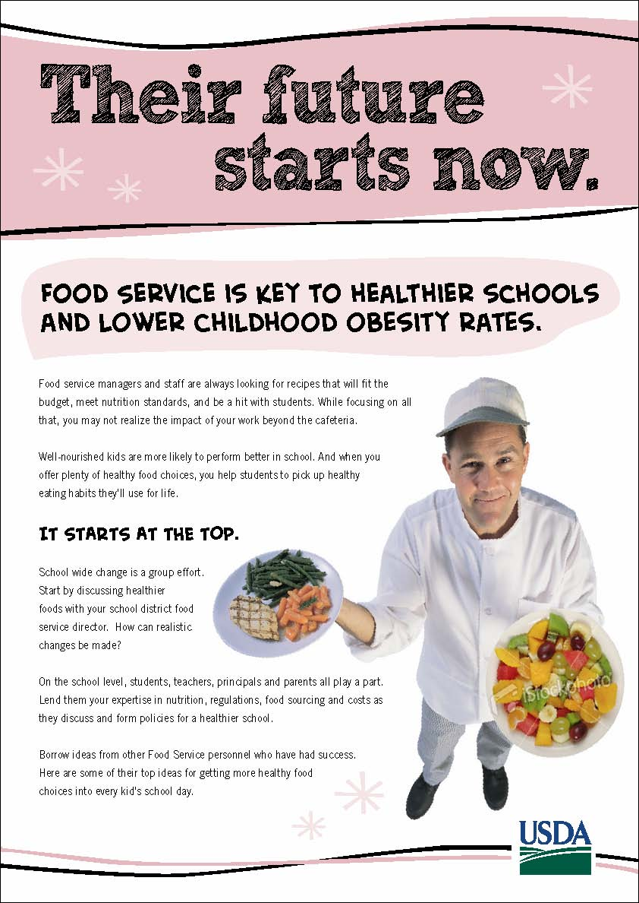

Appendix A: Handout (Back)
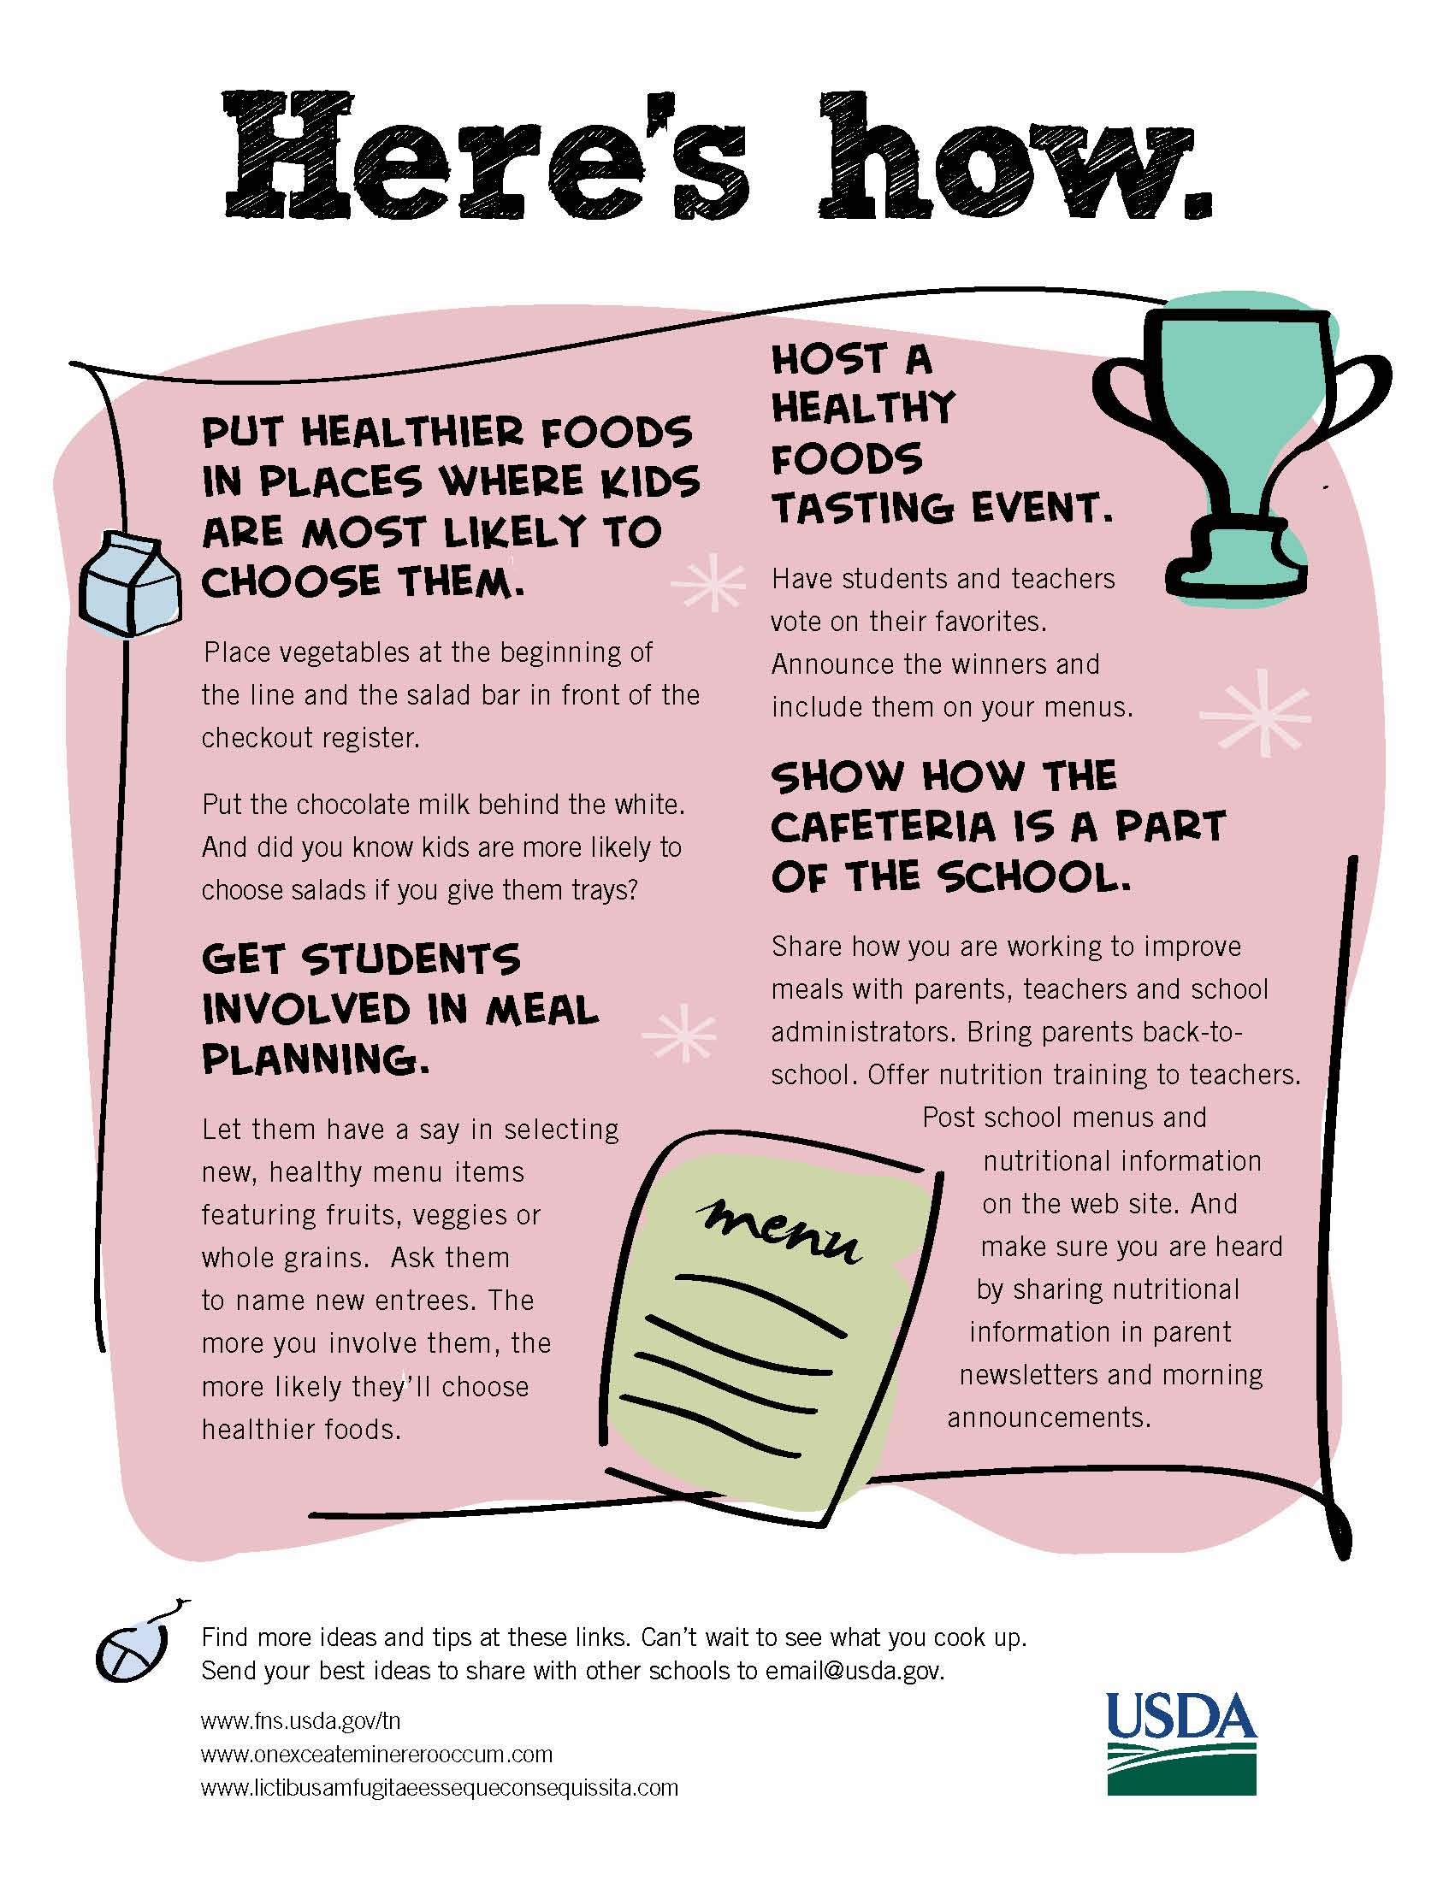

Appendix B: Video Script
VIDEO  OPEN ON FS MANAGER IN CAFETERIA KITCHEN. SHE IS HOLDING A LARGE SALAD BOWL. AS SHE SPEAKS , INGREDIENTS FALL INTO THE BOWL. A THOUGHT BUBBLE APPEARS OVER HER HEAD WITH IMAGES OF  CONSIDERATIONS IN IT. WE SEE TOP OF BOWL AS IT BECOMES A PIE CHART. WE SEE 1/3 BEGIN TO GET SMALLER.  WE SEE KIDS IN CAFETERIA, THEN AT HOME WITH HEALTHY FOODS. THEN WE SEE A CLASSROOM WITH KIDS HAPPILY LEARNING.  FS MANAGER IS JOINED BY IMAGES OF OTHER STAKEHOLDERS. SUDDENLY THEY ARE ALL IN THE SCHOOL LIBRARY SHARING INFORMATION AND IDEAS.  FS MANAGER TALKS TO CAMERA AS DRAWN IMAGES APPEAR WITH HER TO DEPICT WHAT IS BEING SAID.  ANIMATED TYPE TREATMENT FOR “THEIR FUTURE STARTS NOW. HERE’S HOW.” COMES UP. IDEA ICON BEGINS WITH FIRST IDEA AND REAPPEARS WITH EACH NEW IDEA PRESENTED.  CAFETERIA LINE WITH HEALTHIER CHOICES IN BEST PLACES. AS FSM TALKS, THE LINE SLIDES ALONG TO THE APPOINTED SPOT RELATED TO COPY.  KIDS IN CAFETERIA WITH FOOD SERVICE MANAGER.  KIDS AND TEACHERS AT TASTING EVENT.  FS MANAGER SPEAKS TO CAMERA.  LINKS APPEAR. | AUDIO  FS MANAGER: Food Service Managers are no strangers to recipes. You’re always looking for the ones that will keep you on budget, meet all the standards, and be a hit with the kids.  But we’re so busy with all that, sometimes we forget that the foods we create have an impact way beyond the cafeteria. Healthier food choices help reduce childhood obesity.  Well-nourished kids are more likely to perform better in school. And when you offer plenty of healthy food choices, you help middle schoolers pick up healthy eating habits they’ll use at home and for life.  So, how can you help to improve things at the schools you serve? First, enlist the help of many other interested people, starting with your school district food service director.  On the school level, students, teachers, principals and parents all play a part. And you are an important member of this team. By sharing what you know about meal requirements, food costs, and finding healthy foods kids will eat, you can help the team better understand the barriers  to change and find workable solutions. Most team members won’t be aware of all you do to improve school food offerings. So working with them may even help to build support for the meal program  You don’t need to invent an original recipe for this. Just borrow the best from what other food service managers say works for them. Here are some of their top ideas for getting more healthy food choices into every kid’s school day.  Their future starts now. Here’s how.  Before they’ll eat it, first they need to see it. Put healthier foods in places where kids are most likely to choose them. Vegetables at the beginning of the line. Salad bar in front of the check out register. Put the chocolate milk behind the unflavored. And did you know kids are more likely to choose salads if you give them trays?  Make kids part of meal planning. Involve students in selecting new, healthy menu items featuring dark green and orange veggies, beans and peas, or whole grains.  Host a tasting event where students and teachers can vote on their favorites. Announce the winners and include them on your menus. If they help create it, they’re more likely to eat it. And it’s easier than doing all the work yourself.  More ideas and tips are waiting for you at these links. Can’t wait to see what you cook up. Thanks for watching.

Appendix C: Handout A
OMB Control # 0584-0524
Expiration Date: 03/31/2013

Public reporting burden for this collection of information is estimated to average 2 minutes per response, including the time for reviewing instructions, searching existing data sources, gathering and maintaining the data needed, and completing and reviewing the collection of information. An agency may not conduct or sponsor, and a person is not required to respond to, a collection of information unless it displays a currently valid OMB control number. Send comments regarding this burden estimate or any other aspect of this collection of information, including suggestions for reducing this burden, to: U.S. Department of Agriculture, Food and Nutrition Services, Office of Research, Nutrition and Analysis, Alexandria, VA 22302 (0584-0524). Do not return the completed form to this address.
First Name: ______________
Session #: _____

Handout A

- What is the most useful tip you heard/read to help you make your school a healthier environment in terms of nutrition?

_______________________________________________________________________

_______________________________________________________________________

_______________________________________________________________________

_______________________________________________________________________

