The Supporting Statement for OMB 0596-NEW
Virtual Incident Procurement (VIPR) Existing Vendor User Survey
2010

Terms of Clearance
A. Justification
- Explain the circumstances that make the collection of information necessary. Identify any legal or administrative requirements that necessitate the collection. Attach a copy of the appropriate section of each statute and regulation mandating or authorizing the collection of information.
This collection of information is part of USDA Forest Service efforts to improve customer service pursuant to the 1993 President’s Executive Order 12862, which seeks to “ensure that the Federal Government provides the highest quality service possible to the American people.” Additionally, the Executive Order directs Federal agencies to change the way they do business, to reform their management practices, and to provide service to the public that matches or exceeds the best service available in the private sector. The proposed survey for OMB approval will provide the Forest Service with the necessary information to meet the terms of Executive Order 12862.
Virtual Incident Procurement (VIPR) is an acquisition system designed to solicit, award, and manage preseason incident agreements and contracts for equipment and services used by the Forest Service. Opinions and comments from existing VIPR vendor users are needed to evaluate the acquisition system leading to program improvements and to potential system functionality upgrades. For this reason, the Forest Service requests to question vendor users utilizing an online, electronic survey.
The information will be collected by the Forest Service Acquisition Management Systems Branch. The Forest Service will inquire and collect surveys from existing VIPR vendor users on their individual experiences with the acquisition system, customer service support, and other supporting tools. The information will be used to assist program management enhancements, identify potential system upgrades, and improve overall customer service and other support tools. Results from the information collection may be shared with other US Forest Service divisions, with agencies outside of the US Forest Service, and with the public.
- Indicate how, by whom, and for what purpose the information is to be used. Except for a new collection, indicate the actual use the agency has made of the information received from the current collection.
- What information will be collected - reported or recorded? (If there are pieces of information that are especially burdensome in the collection, a specific explanation should be provided.)
Virtual Incident Procurement (VIPR) is an acquisition system designed to solicit, award, and manage preseason incident agreements and contracts for equipment and services used by the Forest Service. Forest Service Acquisition Management Systems Branch will inquire and collect surveys from existing VIPR vendor users concerning their opinions and comments using the procurement system. Information collected will be used to evaluate the system and to make decisions on program and system improvements. Authority to collect vendor information comes from currently OMB-approved GSA acquisition collections.

- From whom will the information be collected? If there are different respondent categories (e.g., loan applicant versus a bank versus an appraiser), each should be described along with the type of collection activity that applies.
Respondents are existing VIPR vendor users who utilize the Forest Service’s Virtual Incident Procurement system. They are businesses that provided services to the Forest Service in support of emergency incident and fire safety activities.
- What will this information be used for - provide ALL uses?
Opinions and comments from existing VIPR vendor users will be used to evaluate the VIPR acquisition system leading to program improvements and to potential system functionality upgrades. The information will be used to assist program management enhancements, identify potential system upgrades, and improve overall customer service and other support tools. Results from the information collection may be used as a case study shared with other US Forest Service divisions, with agencies outside of the US Forest Service, and with the public.

Information Collected | Description | Information Provided to: | Prepared by
Online Survey | Questionnaire addressing user experiences with VIPR, customer service support and tools | Forest Service  Other Federal, State, and Local Governments  Public | Existing VIPR vendor users
- How will the information be collected (e.g., forms, non-forms, electronically, face-to-face, over the phone, over the Internet)? Does the respondent have multiple options for providing the information? If so, what are they?
The information will be collected utilizing an online, electronic survey. Since the VIPR system is electronic, the Forest Service is confident that the vendors have access to the necessary technology to complete an electronic survey. For this reason, the electronic survey will be the only mode of collection.
- How frequently will the information be collected?
The information will be collected once annually.
- Will the information be shared with any other organizations inside or outside USDA or the government?
Results from the survey may be shared with other US Forest Service divisions, with agencies outside of the US Forest Service, and with the public.
- If this is an ongoing collection, how have the collection requirements changed over time?
This would be the first time this data will be collected. The information collected will be used in evaluating existing VIPR vendor users’ experiences using the acquisition system.
- Describe whether, and to what extent, the collection of information involves the use of automated, electronic, mechanical, or other technological collection techniques or other forms of information technology, e.g. permitting electronic submission of responses, and the basis for the decision for adopting this means of collection. Also describe any consideration of using information technology to reduce burden.
As mentioned, the survey will be submitted via a web-based survey. The web-based survey tool is user-friendly, inexpensive, and easy to use and administer. The Forest Service is confident that VIPR users are comfortable with computer technology necessary to respond to the web-based survey. The electronic submission of responses will reduce both the time and cost burden on the public.
- Describe efforts to identify duplication. Show specifically why any similar information already available cannot be used or modified for use for the purposes described in Item 2 above.
This survey does not duplicate any other collection of information. Information collected is specific to the VIPR system and is not already available otherwise.
- If the collection of information impacts small businesses or other small entities, describe any methods used to minimize burden.
A majority of the respondents are small businesses. The information will be collected using a web-based survey tool. The web-based survey tool is user-friendly, inexpensive, and easy to use and administer. The survey is free to the respondent to use and it can be accessed from any computer connected to the Internet. Respondents will be able to obtain assistance with the survey by contacting the VIPR team via e-mail at vipr@fs.fed.us .
- Describe the consequence to Federal program or policy activities if the collection is not conducted or is conducted less frequently, as well as any technical or legal obstacles to reducing burden.
The VIPR vendor user group is the largest population using the system. Feedback regarding system performance and customer support from this group is essential to making effective and useful system enhancements. Without the collection of this information, the Forest Service Acquisition Management System Branch will miss the opportunity to learn valuable information from vendors on their utilizing the acquisition system.
- Explain any special circumstances that would cause an information collection to be conducted in a manner:
- Requiring respondents to report information to the agency more often than quarterly;
- Requiring respondents to prepare a written response to a collection of information in fewer than 30 days after receipt of it;
- Requiring respondents to submit more than an original and two copies of any document;
- Requiring respondents to retain records, other than health, medical, government contract, grant-in-aid, or tax records for more than three years;
- In connection with a statistical survey, that is not designed to produce valid and reliable results that can be generalized to the universe of study;
- Requiring the use of a statistical data classification that has not been reviewed and approved by OMB;
- That includes a pledge of confidentiality that is not supported by authority established in statute or regulation, that is not supported by disclosure and data security policies that are consistent with the pledge, or which unnecessarily impedes sharing of data with other agencies for compatible confidential use; or
- Requiring respondents to submit proprietary trade secret, or other confidential information unless the agency can demonstrate that it has instituted procedures to protect the information's confidentiality to the extent permitted by law.
There are no special circumstances. The collection of information is conducted in a manner consistent with the guidelines in 5 CFR 1320.6.
- If applicable, provide a copy and identify the date and page number of publication in the Federal Register of the agency's notice, required by 5 CFR 1320.8 (d), soliciting comments on the information collection prior to submission to OMB. Summarize public comments received in response to that notice and describe actions taken by the agency in response to these comments. Specifically address comments received on cost and hour burden.
The Federal Register 60-day Notice for the renewal of this information collection was published on June 15, 2010 (Vol. 75, No. 114, Page 33760). No comments were received.
Describe efforts to consult with persons outside the agency to obtain their views on the availability of data, frequency of collection, the clarity of instructions and record keeping, disclosure, or reporting format (if any), and on the data elements to be recorded, disclosed, or reported.
Consultation with representatives of those from whom information is to be obtained or those who must compile records should occur at least once every 3 years even if the collection of information activity is the same as in prior periods. There may be circumstances that may preclude consultation in a specific situation. These circumstances should be explained.
The test survey described in Section B4 of these supporting statements included questions regarding the pertinence, clarity, and burden associated with this information collection. The following vendors were selected at random to complete the test survey including providing feedback on the purpose of the information collection. In speaking with each of these company’s the general consensus was that they were agreeable to providing feedback and wanted to have the opportunity to provide feedback and suggestions regarding VIPR. They didn’t express any concerns regarding the estimated burden of the proposed information collection.
Vendor | Address | E-mail | Phone (Primary)
Northwest Timber Fallers, Inc. | 1630 Williams Hwy 142  Grants Pass, OR 97527-9753 | shari@nwtimberfallers.com | (541)  226-6266
Contract Water Wagons | 60519 Liberty Road,  Joseph, OR 97846-8196 | contractwaterwagons@gmail.com | (541)  432-3221
Curfman Showers & Potable Water LLC | 5194 E. Buffalo Soldier Trail,  Sierra Vista, AZ 85650 | curfmans@gmail.com | (520)  803-9294

- Explain any decision to provide any payment or gift to respondents, other than re-enumeration of contractors or grantees.
No gifts or payments will be provided to the respondents of this information collection.
- Describe any assurance of confidentiality provided to respondents and the basis for the assurance in statute, regulation, or agency policy.
No information covered by a Privacy Act System of Records, Personally Identifiable Information, or other confidential information covered by a statute, regulation, or Agency policy will be collected.

- Provide additional justification for any questions of a sensitive nature, such as sexual behavior or attitudes, religious beliefs, and other matters that are commonly considered private. This justification should include the reasons why the agency considers the questions necessary, the specific uses to be made of the information, the explanation to be given to persons from whom the information is requested, and any steps to be taken to obtain their consent.
There are no questions of a sensitive nature, such as those pertaining to sexual behavior, attitudes, religious beliefs, or other matters commonly considered private.
- Provide estimates of the hour burden of the collection of information. Indicate the number of respondents, frequency of response, annual hour burden, and an explanation of how the burden was estimated.
• Indicate the number of respondents, frequency of response, annual hour burden, and an explanation of how the burden was estimated. If this request for approval covers more than one form, provide separate hour burden estimates for each form.
a) Description of the collection activity
b) Corresponding form number (if applicable)
c) Number of respondents
d) Number of responses annually per respondent,
e) Total annual responses (columns c x d)
f) Estimated hours per response
g) Total annual burden hours (columns e x f)
Table 1
(a)  Description of the Collection Activity | (b)  Form Number | (c)  Number of Respondents | (d)  Number of responses annually per Respondent | (e)  Total annual responses  (c x d) | (f)  Estimate of Burden Hours per response | (g)  Total Annual Burden Hours  (e x f)
Web-based Survey | N/A | 3,000 | 1 | 3,000 | 20 Minutes | 1,000 Hours
Totals | --- | 3,000 | --- | 3,000 | --- | 1,000

This estimate was calculated by taking the annual average number of VIPR vendor users over the period of the information collection (3,000) multiplied by the average length of time it will take to respond to the survey (20 minutes) to come up with 1,000 hours as the total annual burden on the public.
- Record keeping burden should be addressed separately and should include columns for:
a) Description of record keeping activity: None
b) Number of record keepers: None
c) Annual hours per record keeper: None
d) Total annual record keeping hours (columns b x c): Zero
- Provide estimates of annualized cost to respondents for the hour burdens for collections of information, identifying and using appropriate wage rate categories.

Table 2
(a)  Description of the Collection Activity | (b)  Estimated Total Annual Burden on Respondents (Hours) | (c)*  Estimated Average Income per Hour | (d)  Estimated Cost to Respondents
SCA Wage Determination No. 1995-0221, Rev No. 25, Dated 06/15/2010  01000 Administrative Support and Clerical Occupations (*) – Data entry/response input | 1,000 | $17.84 | $17,840.00
Totals | 1,000 | --- | $17,840.00
* www.wdol.gov/sca.aspx#0

- Provide estimates of the total annual cost burden to respondents or record keepers resulting from the collection of information, (do not include the cost of any hour burden shown in items 12 and 14). The cost estimates should be split into two components: (a) a total capital and start-up cost component annualized over its expected useful life; and (b) a total operation and maintenance and purchase of services component.
There are no capital/start-up or ongoing operation/maintenance costs associated with this information collection.
- Provide estimates of annualized cost to the Federal government. Provide a description of the method used to estimate cost and any other expense that would not have been incurred without this collection of information.
The response to this question covers the actual costs the agency will incur as a result of implementing the information collection. The estimate should cover the entire life cycle of the collection and include costs, if applicable, for:
- Employee labor and materials for developing, printing, storing forms
- Employee labor and materials for developing computer systems, screens, or reports to support the collection
- Employee travel costs
- Cost of contractor services or other reimbursements to individuals or organizations assisting in the collection of information
- Employee labor and materials for collecting the information
- Employee labor and materials for analyzing, evaluating, summarizing, and/or reporting on the collected information

Table 3
(a)  Description of the Labor or Material | (b)  Estimated Total Annual Burden to Government (Hours) | (c)  Unit of Measure | (d)*  Estimated Average Cost per Hour | (e)  Estimated Cost to Government
Survey Monkey subscription | --- | Annually | $200.00 | $200.00
Information collection prep and administration (GS-12) * | 260 | Hours | $32.97 | $8,572.20
Information collection review approval (GS-13) * | 80 | Hours | $39.21 | $3,136.80
Information collection executive review (GS-14) * | 4 | Hours | $46.33 | $185.32
Totals | ---- |  | --- | $12,094.32
* http://www.opm.gov/oca/10tables/indexGS.asp

- Explain the reasons for any program changes or adjustments reported in items 13 or 14 of OMB form 83-I.
This is a new information collection.
- For collections of information whose results are planned to be published, outline plans for tabulation and publication.
This information may also be distributed to internal FS personnel and to external Federal, State, and Local Governments or to the public. This would most likely be accomplished via publishing of bar charts and/or graphs to the VIPR internal website for internal FS personnel; and to the VIPR external website to reach external partners and members of the public. The primary purpose for publication of the survey results would be to increase transparency to VIPR and the overall perception of the system among the vendor community.
The published information can then be used by VIPR management in decision-making regarding VIPR services (help desk, user guides, web sites, etc). For example, if a majority of vendors did not feel that the user guides were helpful, VIPR management would certainly look at ways to improve those guides.
The published results would include a date for when the survey was conducted, to provide some background to those viewing the results. As new surveys are conducted, the older results will be archived on the web sites so that they are available for comparison.
An example of a bar chart follows.
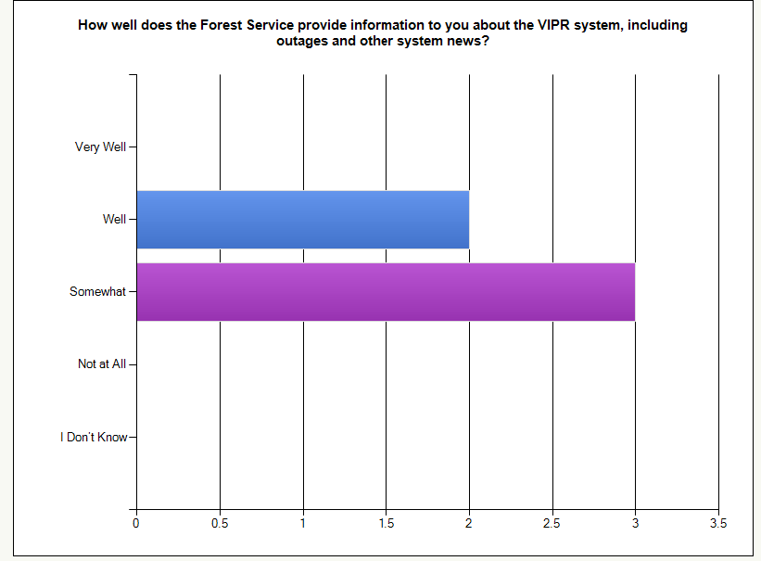
- If seeking approval to not display the expiration date for OMB approval of the information collection, explain the reasons that display would be inappropriate.
The Agency plans to display the expiration date for OMB approval of the information collection on all instruments.
- Explain each exception to the certification statement identified in item 19, "Certification Requirement for Paperwork Reduction Act."
The Agency is able to certify compliance with all provisions under item 19 of OMB Form 83-1.

