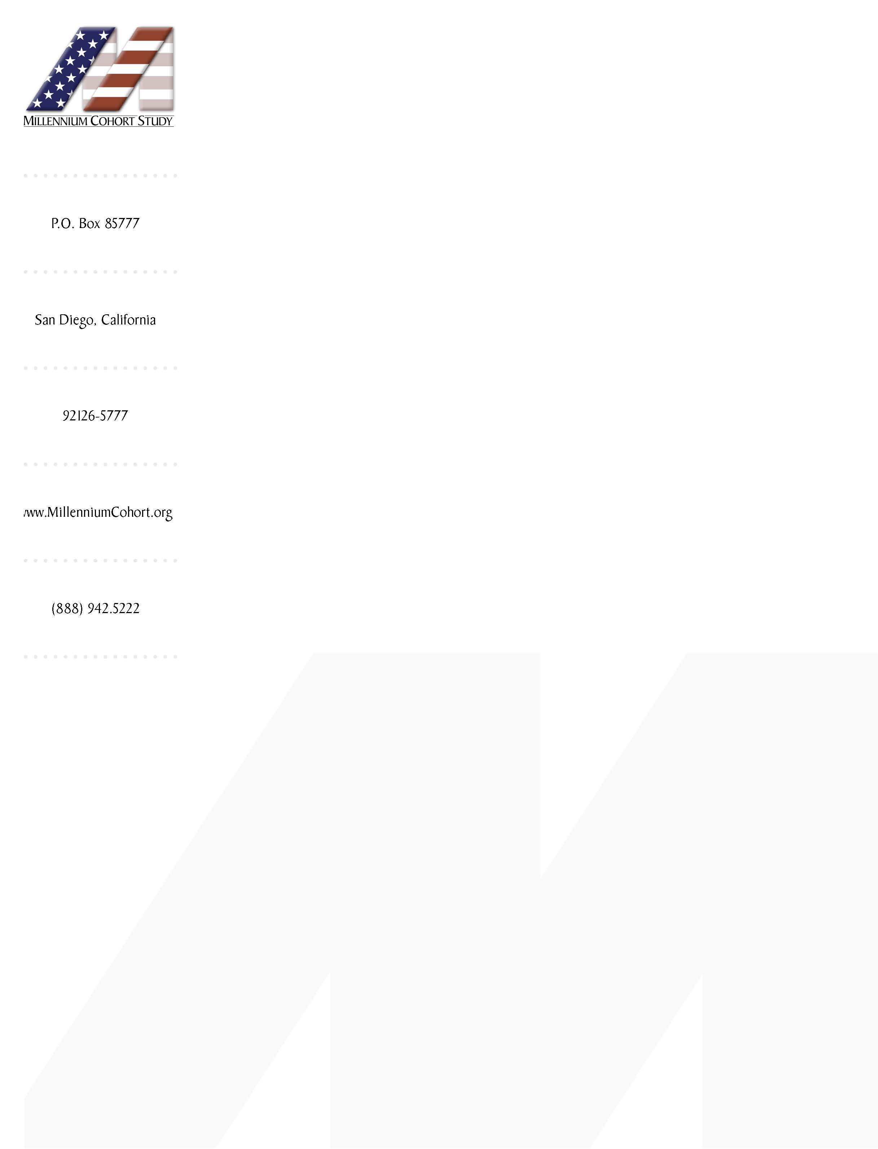

5 June 2010

Dear NAME,

Thank you for your past participation in the Millennium Cohort!

Recently, we sent you an invitation to complete a follow-up survey for the Millennium Cohort Study. By participating in this study, you are helping to determine the long-term health effects of military service, and you are helping future generations of service members.

Remember, even if you are retired or no longer in the military, your participation is essential!

Please complete the enclosed survey and return it in the postage-paid envelope. Or, to complete the survey online, please go to the website:

http://www.MillenniumCohort.org

To access the online survey, use your Subject ID number, located below the barcode on this envelope.

Completing online is faster and easier, and it saves a tremendous amount of resources. If you complete the survey online, you will receive your choice of a free gift: a Millennium Cohort coin, hat, or 60-minute phone card for domestic calls.

Remember that this is an authorized study supported by the highest levels of the Department of Defense. Note DMDC Reference #00-0019; DoD RCS #DD-HA(AR)2106; OMB approval #0720-0029.

If you have any questions, please contact the Millennium Cohort team at our toll-free number, 1-888-942-5222, or DSN 553-7465, or email info@millenniumcohort.org

If you have already completed your survey, please accept my thanks and disregard this request.

We look forward to hearing from you as one of our valued Millennium Cohort members!



Dr. Tyler C. Smith
Director, DoD Center for Deployment Health Research

P.S. Remember, every participant is vital! Please complete your survey online, or by mail, today.

