Form Approved
OMB No. 0920-XXXX
Exp. xx/xx/xxxx

Public reporting burden of this collection of information is estimated to average 6 hours per response, including the time for reviewing instructions, searching existing data sources, gathering and maintaining the data needed, and completing and reviewing the collection of information. An agency may not conduct or sponsor, and a person is not required to respond to a collection of information unless it displays a currently valid OMB control number. Send comments regarding this burden estimate or any other aspect of this collection of information, including suggestions for reducing this burden to CDC/ATSDR Reports Clearance Officer; 1600 Clifton Road NE, MS D-74, Atlanta, Georgia 30333; ATTN: PRA (0920-0479)

NCCDPHP MIS Proposed Screens

Program Information: Contact Information
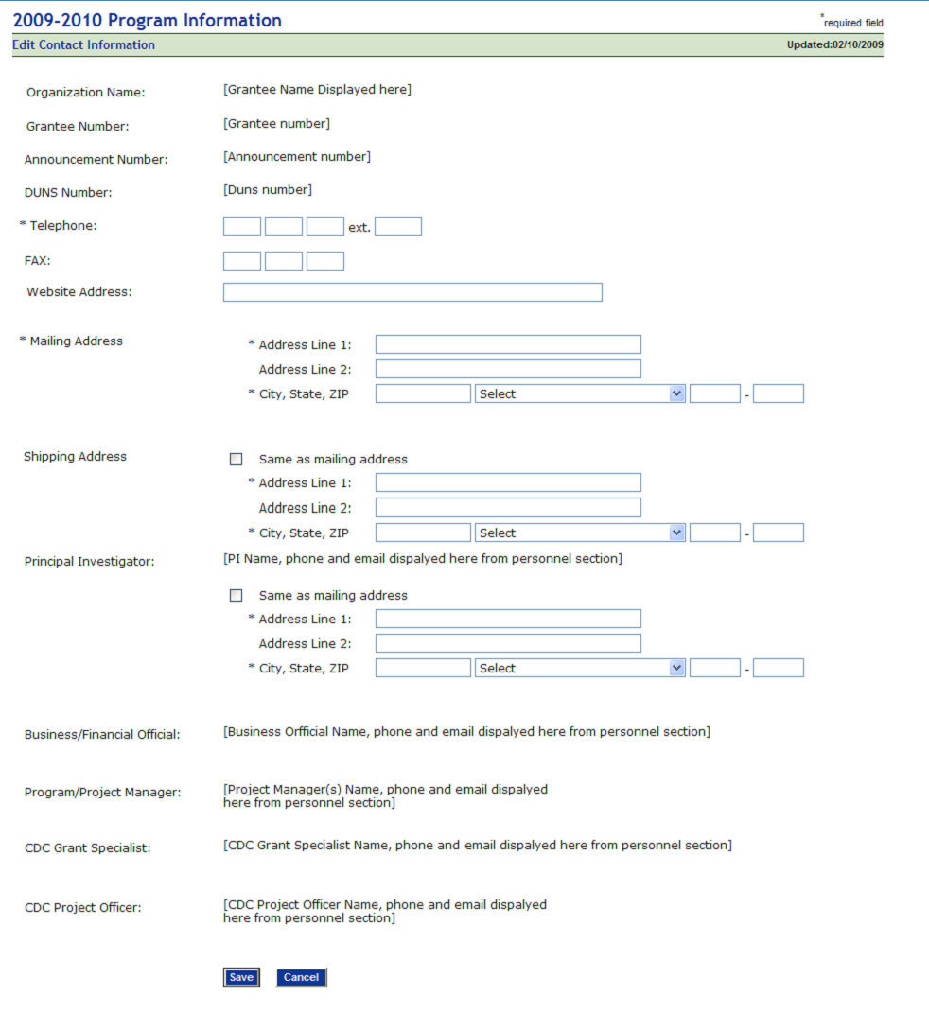
Program Information: Program Summary

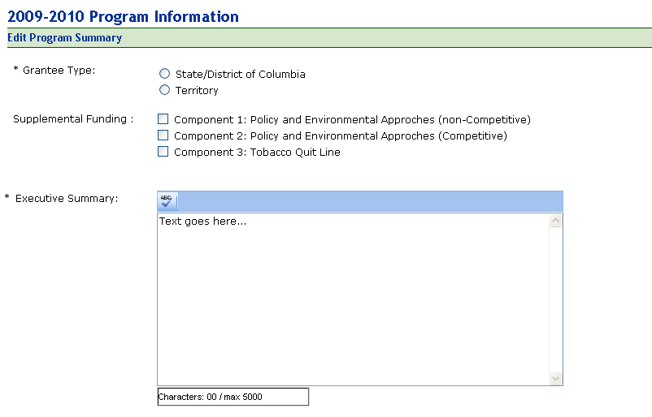

Resources: Personnel
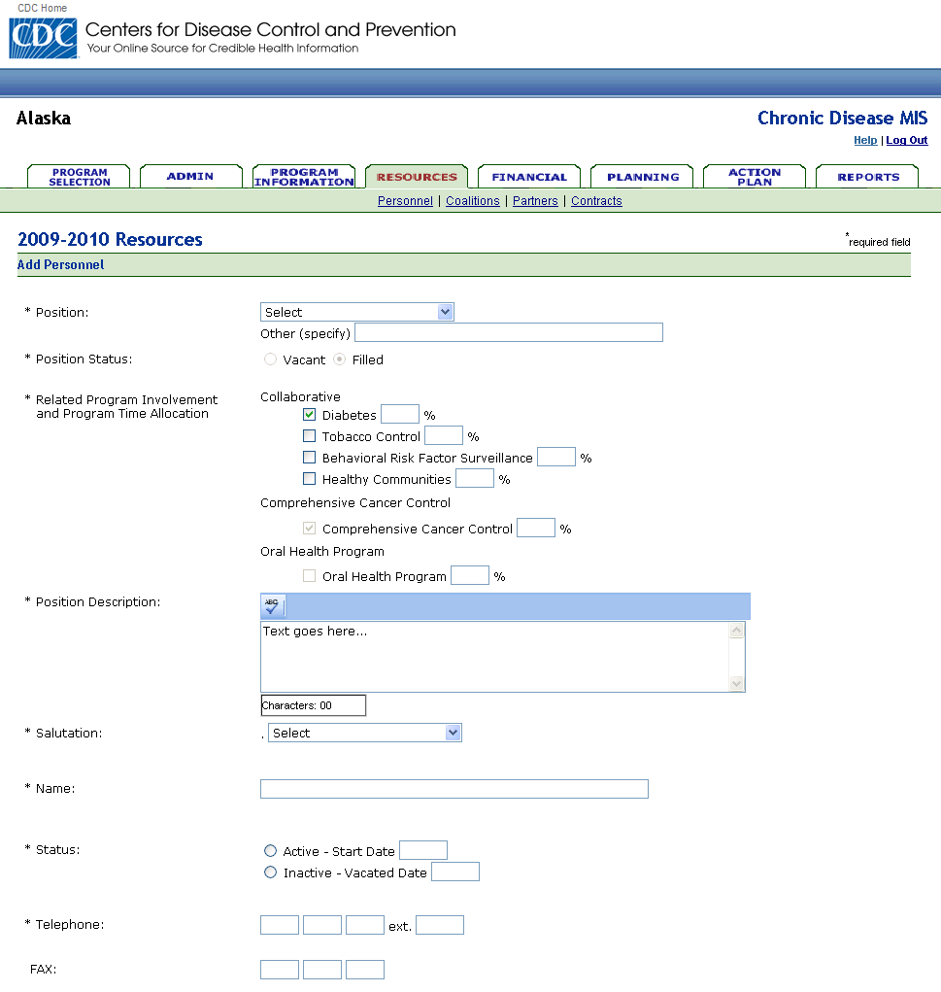

Personnel Continued:
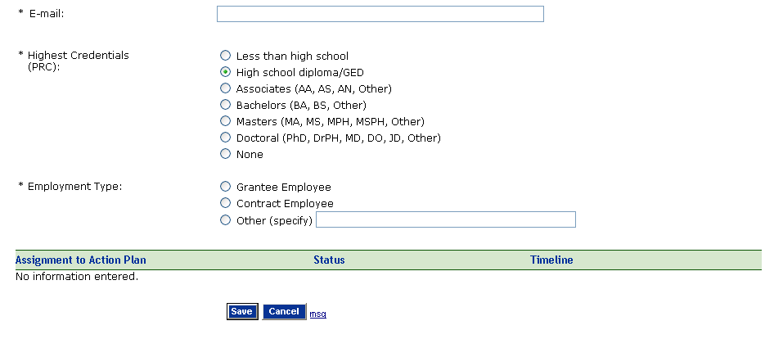
Partners:
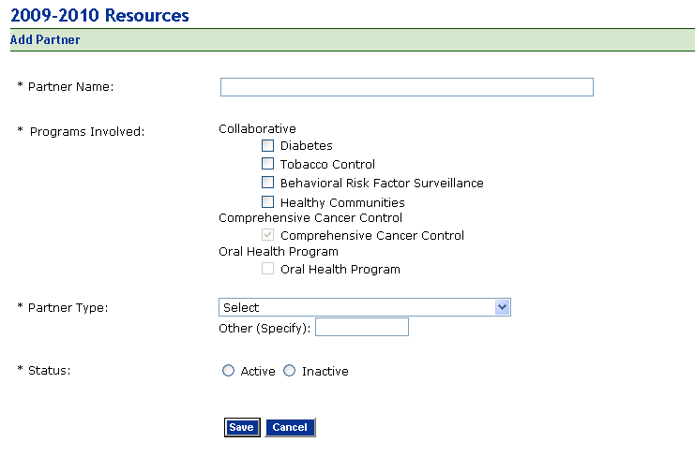

Standard Data Sources
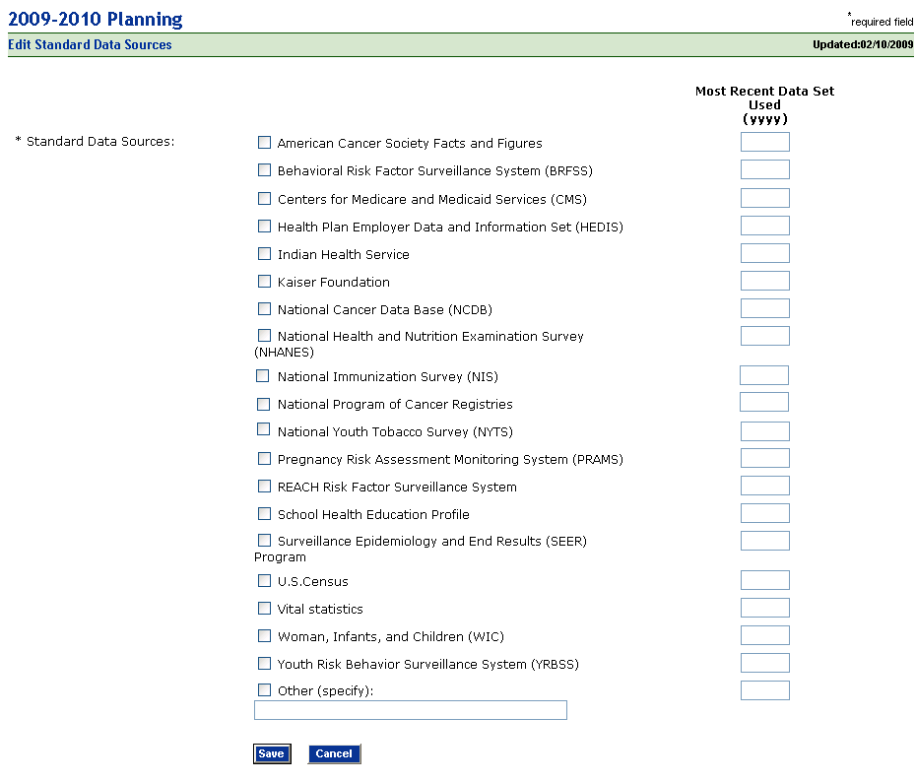

Other Data Sources
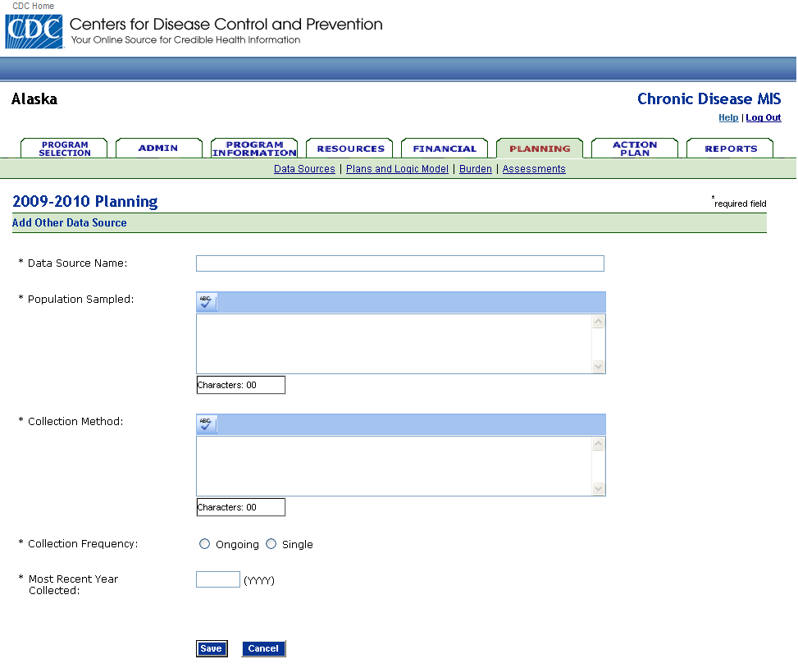

Plans and Logic Models
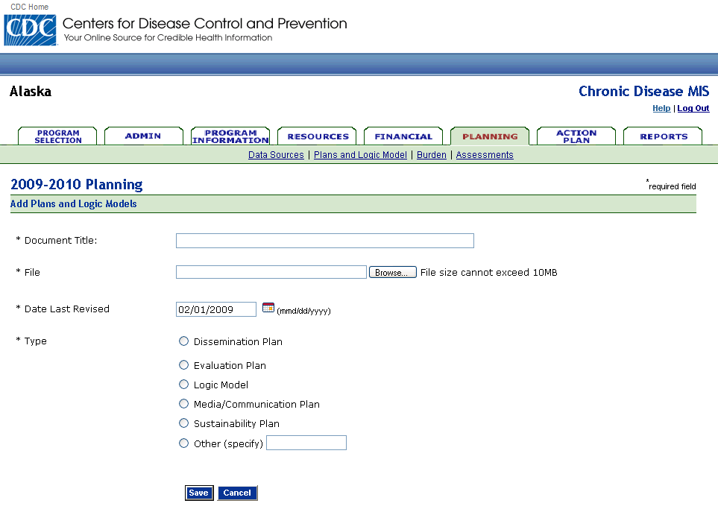

Action Plan: Project Period Objective
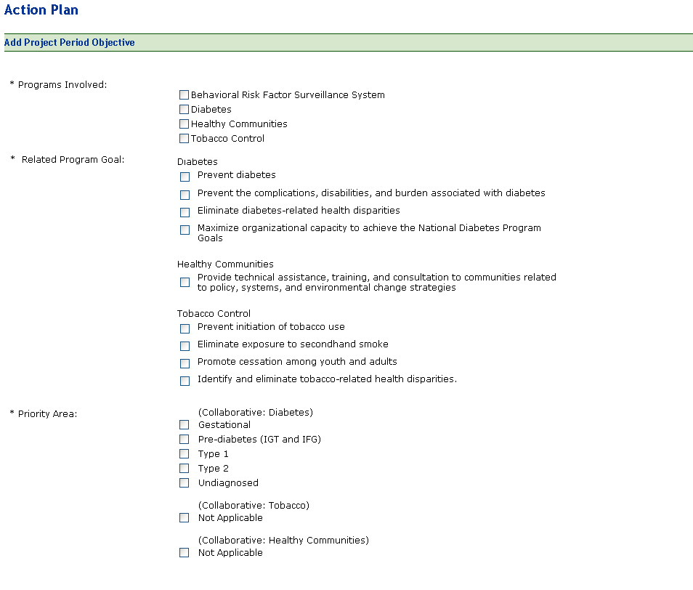

Action Plan: Project Period Objective (Continued)
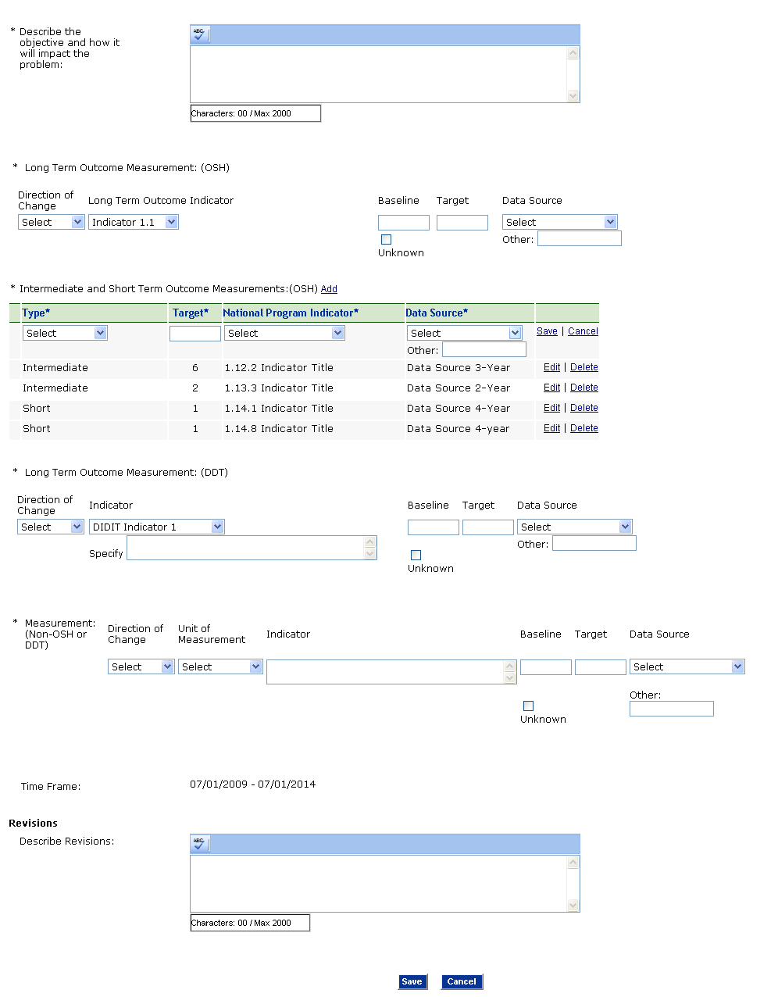

Action Plan: Annual Objective
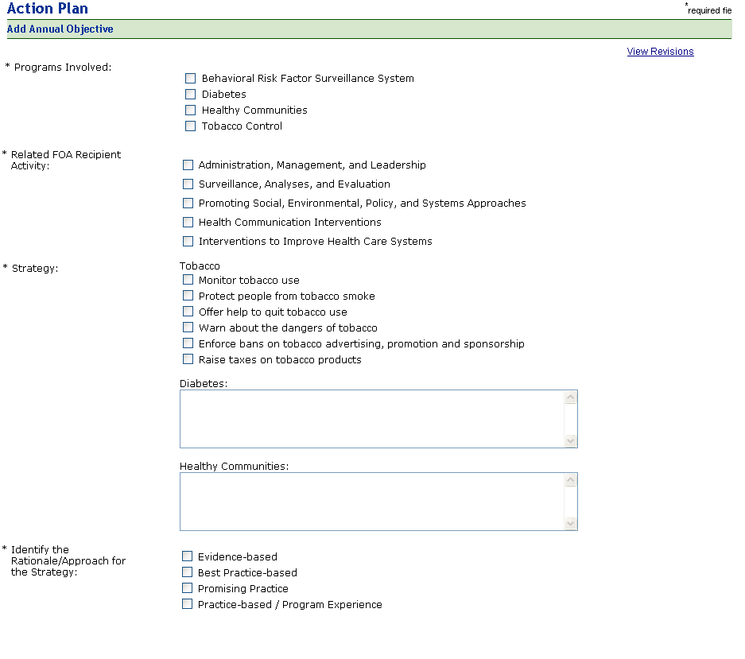

Action Plan: Annual Objective.

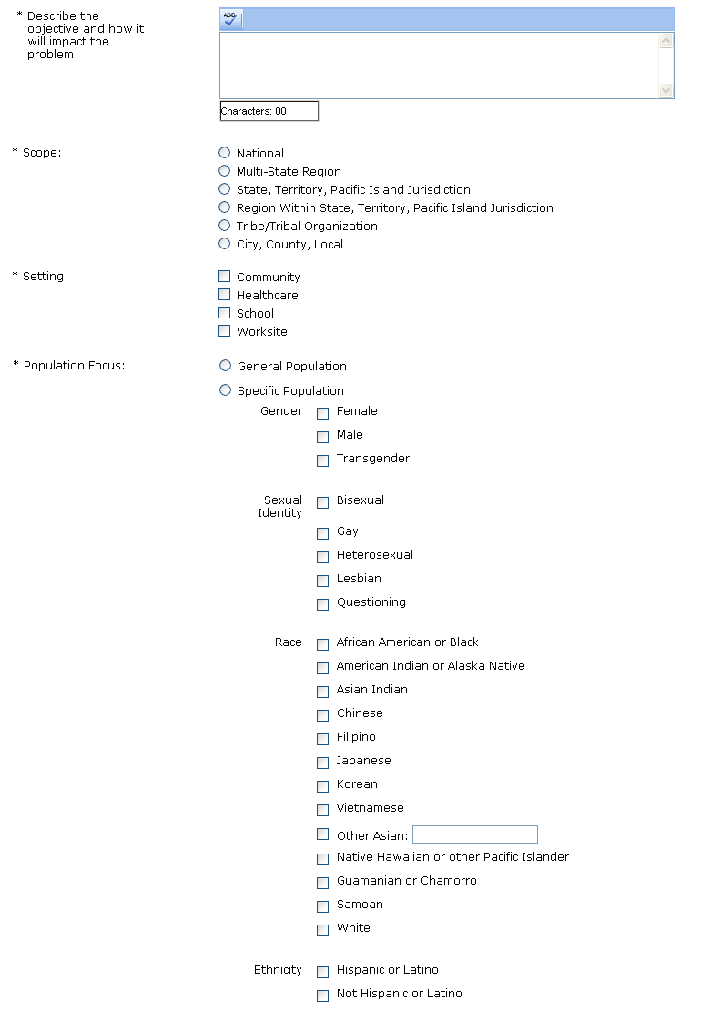

Action Plan: Annual Objective
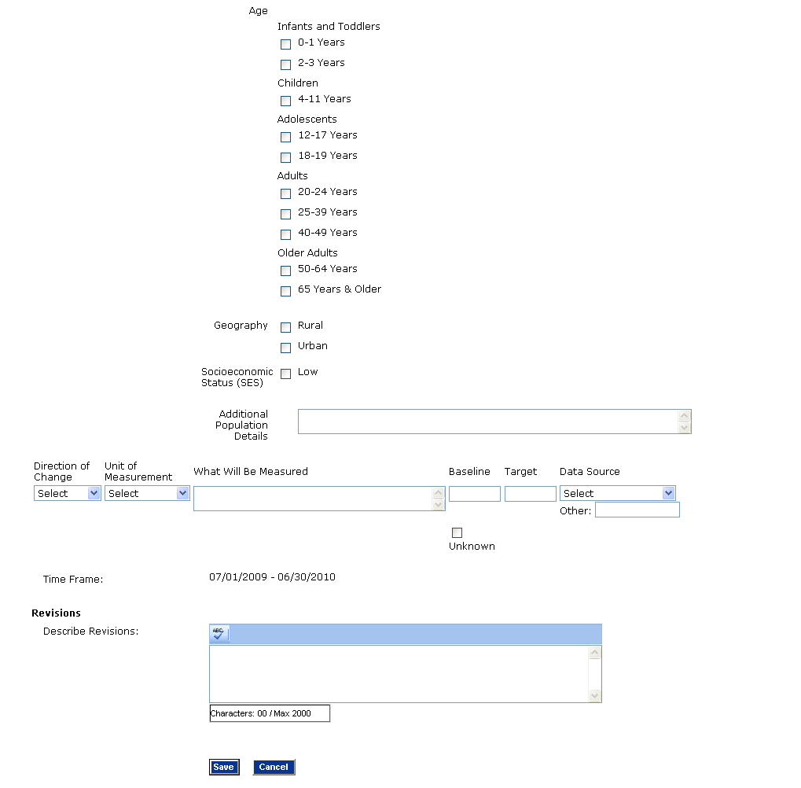

Action Plan: Annual Activity
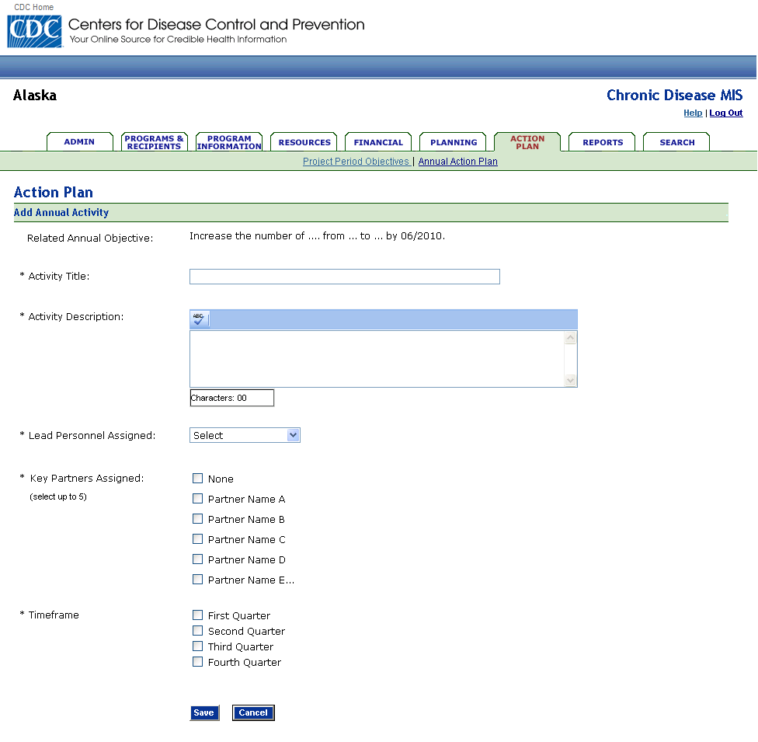

Action Plan: Objective Progress (for both Project Period and Annual objectives)
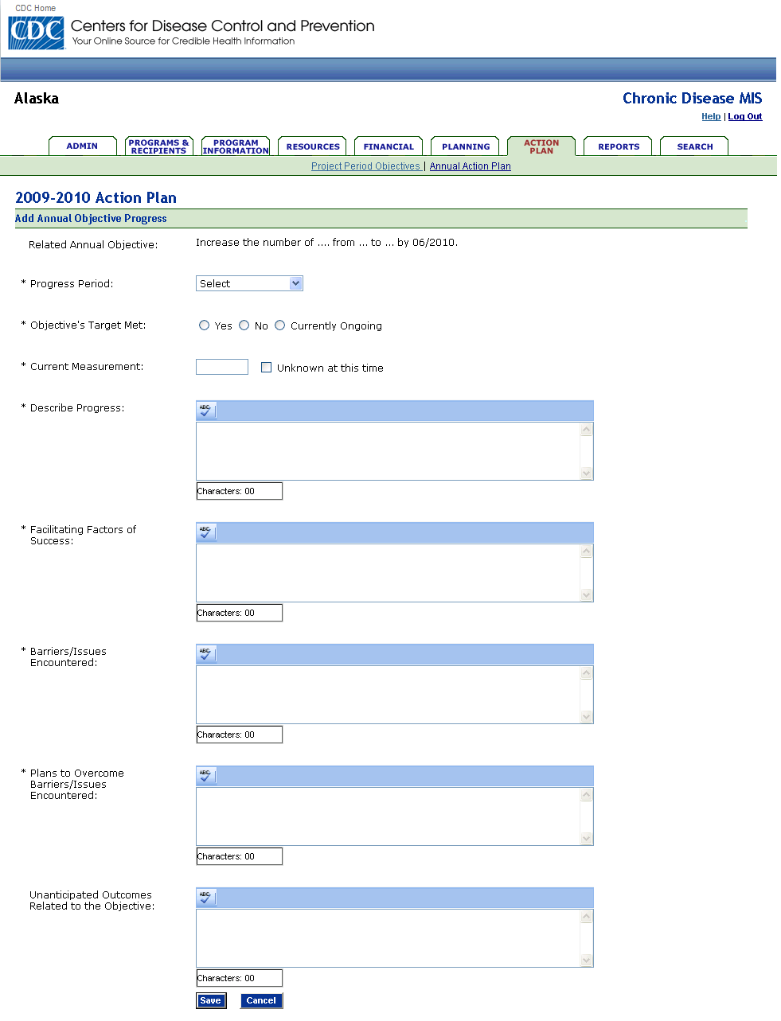

Action Plan: Products
