Attachment 2

Assessing Adoption and Use of the Living a Balanced Life with Diabetes Toolkit
Advance Notice Email to Potential Respondents

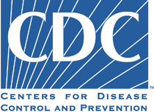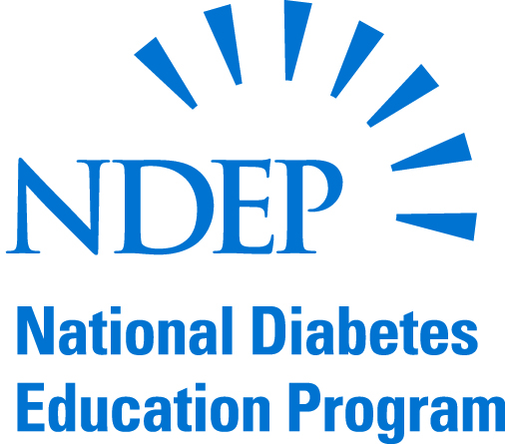

The American Indian/Alaska Native Stakeholder Group of the National Diabetes Education Program (NDEP) recently released a toolkit on diabetes and depression for health care professionals who serve American Indian and Alaska Native Peoples. The U.S. Centers for Disease Control and Prevention (CDC) would like to invite you to participate in a Web-based survey to gather your feedback and opinions on the usefulness of the Living a Balanced Life with Diabetes Toolkit (The Toolkit) for the populations that you serve. The purpose of the survey is to better understand how the Toolkit is currently being used by health care professionals and to help us improve the Toolkit. You will receive an e-mail in approximately one to two weeks inviting you to respond to this Web-based survey. Your participation in the survey is voluntary. Responses will be reported in aggregate form and will not contain any personal identifying information. The survey is designed to assess the usefulness of the Toolkit.
Thank you for in advance for your willingness to participate in this survey. Please contact Dr. Michelle Owens-Gary at MOwens1@cdc.gov, if you have questions about this survey.

