**Attachment 3**

**Assessing Adoption and Use of the Living a Balanced Life with Diabetes Toolkit**

**Follow-Up Reminder E-mail to Potential Respondents**

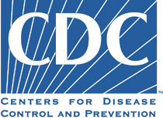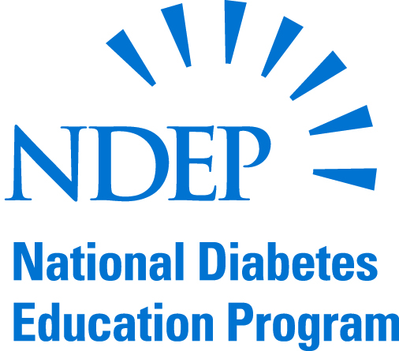

You recently received an invitation to participate in a voluntary, Web-based survey from the National Diabetes Education Program (NDEP) at the Centers for Disease Control and Prevention. NDEP has developed a survey to assess how the Living a Balanced Life with Diabetes Toolkit is being used by health care professionals who serve American Indian and Alaska Native Peoples.

Ifyou have not already done so, we are writing to remind you to complete our survey, which takes about 20 minutes of your time. Again, we thank you for your willingness to participate in this project.

To respond to this survey, please click the link below:

<https://www.surveymonkey.com/s/AIANTOOLKIT>

Please respond to this survey by September 30, 2013.

**If you have already completed this survey, we thank you for your participation and please disregard this request.**

Please contact Dr. Michelle Owens-Gary at [MOwens1@cdc.gov](mailto:MOwens1@cdc.gov), if you have questions about this survey.