How to Enter the NPHPSP Assessment Responses

- Go to www.NPHPSP-results.org and Login. If you do not have a User ID for NPHPSP “Version 2” instruments, please register for an ID and choose your own password (minimum 6 characters). Check that your computer meets system requirements. | SYSTEM REQUIREMENTS  - Operating System: Windows 95/98/2K/XP/Vista.  - Browsers (versions): Internet Explorer 6.0 and above, or Firefox 1.1 and above.  IMPORTANT!  - Save your data frequently. Save:  - When you complete a section  - Before you leave a page (i.e., before using the Back button)  - At minimum, every 20 minutes  - You have 20 minutes to save before the system automatically logs you out. Each time you save, you have another 20 minutes.
- Use links in the “Questionnaires” left menu to enter data for different sections of the NPHPSP, as listed below.

Questionnaires | Use To:
- Report Center  - Performance Assessment  - Respondent Information Form  - Priority Of Model Standards  - Agency Contribution | ─ Generate reports, download data  ─ Enter 10 EPHS data*  ─ Enter respondent information*  ─ Enter priority rating module  ─ Enter agency contribution module  *required to generate final report

- Tips on entering performance assessment data:

a. Use the “Questionnaire Status Page” to identify sections within the 10 EPHS that are completed or in progress. Click on any section title to view or enter data for that section.  - Click on the “Enter Discussion Toolbox Data” link to open or close the box with these optional questions.  - Click the “Save” button to save each page of assessment data.  - After saving data, click the “Enter assessment notes…” link to enter any text notes from your assessment. Entered comments will be included in an export file (not analyzed). Click the “Save” button below the box to save your notes. | 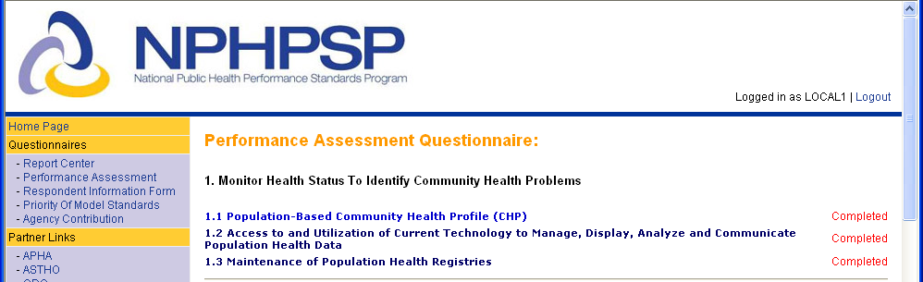  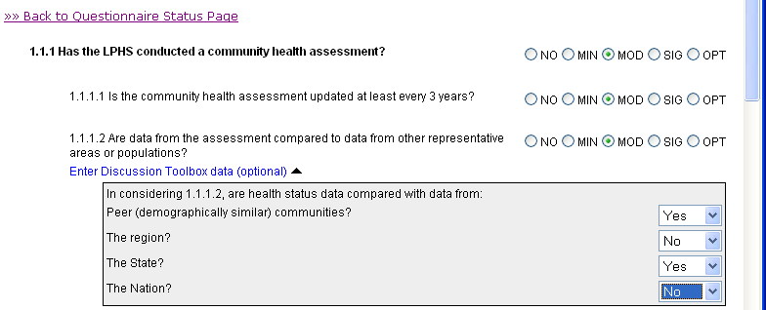  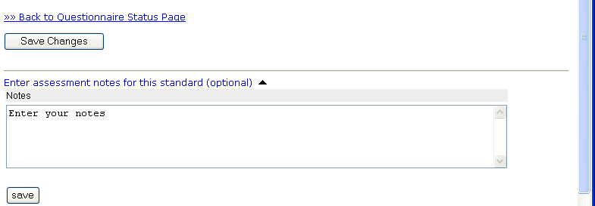

- For all sections:
  - Keep a hard copy of responses in front of you, which you transfer to the online system.
- You may print a copy for your records by using your browser’s print function.
How to Enter the NPHPSP Assessment Responses (Continued)
www.nphpsp-results.org

- Once you have completed all sections of the assessment, click “Submit Questionnaire.”  - Carefully review any error messages.  - Correct or complete responses as needed.  - Once you have submitted the performance assessment questionnaire, you may not change answers or enter additional data. | Access Your Report Files Anytime:  - Visit www.NPHPSP-results.org and login with your User ID and password.  - Click “Report Center” from the left menu.  - You will see a screen with options to download your report and data files. For repeat NPHPSP users, previous reports are also available as PDF files.
- To create a report, go to “Report Center” on the left menu, then click “Generate Report.” To receive a final NPHPSP report for your site, you must complete the following sections:
- Performance Assessment (EPHS sections 1-10)
- Respondent Information Form

You will see a screen with options to download your report and data files.

- The optional “Priority of Model Standards” and “Agency Contributions” may be completed with the Performance Assessment or it may be returned to AFTER completing the entire Assessment. If entering this data after completion of the Assessment, click on “Generate Reports” to get updated reports.

Special Reports:
- You may generate a partial report at any time with data for all EPHS sections completed to date. To do so, you may click “Generate Report” without submitting the full questionnaire. Partial reports are indicated as such in the report header.
- To receive a statewide aggregate report or other special reports, contact the Public Health Foundation using the information below.

Need help?
Help Desk—NPHPSP Online Data System:
NPHPSP-support@phf.org
202-218-4411

