Attachment 4

Letters and Scripts
NOTE: All letters will be available in Spanish, Chinese, Korean, Vietnamese and English versions.

Pre-Advance letter postcard

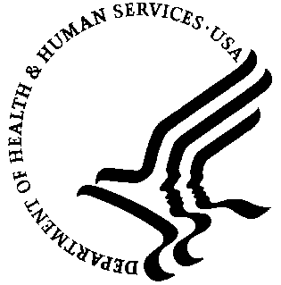
The National Center for Health Statistics (NCHS), part of the Centers for Disease Control and Prevention (CDC) is conducting the National Health and Nutrition Examination Survey (NHANES) in your neighborhood. For more than 40 years, information from this survey has been used to solve health problems, develop health programs and improve the quality of health care in the United States. You may have the opportunity to participate in NHANES when a representative of the NCHS/CDC calls at your home. Thank you.

For more information visit the NHANES web site at http://www.cdc.gov/nhanes.

Please watch for your letter to arrive soon. Please participate if you are contacted.

Advance Letter

You or a member of your family may have a chance to take part in an important national health survey.

The National Center for Health Statistics, a part of the Centers for Disease Control and Prevention, is responsible for this survey—the National Health and Nutrition Examination Survey. This survey teaches us about the health and diet of people in the United States. Over the years, this survey has led to changes in the foods we eat and the health care we receive.

In the next few weeks, one of our health representatives may visit your home. She or he will show you official Centers for Disease Control (CDC) identification and ask some short, easy questions about you and other family members. This interview will take only a few minutes of your time. The purpose of these questions is to see if you or a member of your family will be asked to participate in the survey. Answering the questions is completely voluntary, and you may choose not to answer any questions. I assure you there will be no penalties or loss of benefits of any kind from refusing to answer.

If you or other household members are chosen, we hope you will participate in the survey. You will be among the many people in towns and cities across the country that help us increase our knowledge about the health of people in the United States.

This survey is a Federal program authorized by the Public Health Service Act. All of your answers will be kept in strict confidence. We will use this information only for statistical research and reports. Your answers will be added to others, so no one can identify which are yours.

Thank you in advance for helping.

Sincerely,
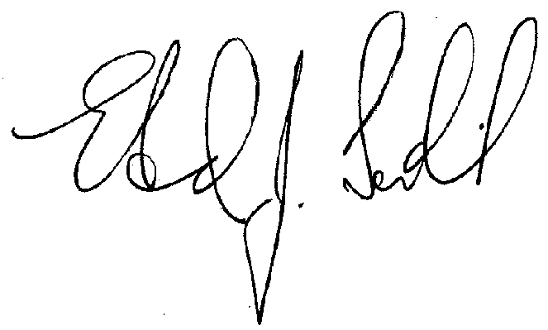
Edward J. Sondik, Ph.D.
Director

P.S. If you have questions call Mr. George Zipf of my staff at 1-800-452-6115.
The call is free, and we would be happy to answer your questions.

School Excuse Letter

DEPARTMENT OF HEALTH & HUMAN SERVICES
National Center for Health Statistics
3311 Toledo Road
Hyattsville, Maryland 20782

Dear Principal:

Please excuse the below named student from class to participate in a national health survey conducted by the National Center for Health Statistics, part of the Centers for Disease Control and Prevention. The date and arrangements we have made for transportation are indicated below.

NAME ____________________________________

DATE ____________________________________

□ Parent will pick up.
□ Taxi will pick up.
□ One of our representatives will pick up.
□ Student will leave from home.

Thank you for your cooperation and your appreciation of the valuable contribution this student is making to our study. If you need to contact us, please call ___________________.

Sincerely,

_________________________
Stand Manager

As parent/guardian of the above named child, I consent to the arrangements indicated.

_________________________
Signed (Parent/Guardian)

Transportation form

NATIONAL HEALTH SURVEY
AUTHORIZATION FOR TRANSPORTATION ARRANGEMENTS FOR
PERSONS UNDER 16 YEARS OF AGE

NAME OF CHILD: _____________________________ AGE: ___________

- I consent to transportation of my child to and from the Mobile Exam Center/Field Office by members of the CDC health survey staff.

- I consent to transportation of my child to and from the Mobile Exam Center/Field Office in a taxi arranged and paid for by the CDC health survey.

- I will drive.

Children under 12 must come to the Mobile Exam Center accompanied by someone aged 12 and over. Please complete the subsequent section with this in mind. Children under 12 who arrive alone will not be examined.

- Mother will accompany.

- Father will accompany.

- Other person 12 and over will accompany ___________________
Specify

- Will come alone (only for children ages 12 - 16).

_____________________ _________________________________
(Date) (Signature of Parent or Guardian)

_____________________
(Witness)

SP ID _ _ _ _ _ _
Follow-up letter

NOTE: This follow-up letter is a model that will be adapted for different non-response situations

< on official letterhead>

Dear Ms.:

We were sorry to learn you are not interested in taking part in our health survey. We would like to explain just how important your help can be. -- And, it’s easy to take part.

Our major goal is to learn how we can improve health and better meet health care needs of all persons living in the United States. The more facts we can gather, the better job we can do.

We selected you and your household in a carefully designed sample of people living in the U.S. We cannot choose someone in your place because no one has the same health characteristics as you. By helping us, you will also be helping yourself and your family. You will each receive a free health examination. The exam is not painful, and all results are kept confidential.

We will also pay you to drive yourself to the exam center -- or, if you wish, arrange free taxi service. At the end of the exam, you will each receive a cash payment. This is our way of saying, “Thanks for your help.”

In hope that you will help, one of our representatives will call on you to arrange a good time to talk with you about this important survey. I have enclosed some material that will give you a better idea of what we are all about. Please take a few minutes to look at this material.

Please call our office if you have any questions or to set up a time for our representative to come talk with you. Our office number is (000) 000-0000 or 1-800-452-6115 if long distance.

Sincerely,

Kathryn S. Porter, M.D.
Medical Officer

Screener Brochure

What is the National Health and Nutrition Examination Survey?

The National Health and Nutrition Examination Surveys (NHANES) is a study conducted by the National Center for Health Statistics -- a Federal agency that gathers health data for the United States.

For nearly 50 years, we have had short interviews around the country in homes like yours. The short interview includes questions about this building, questions about the age, sex, and ethnic background of the people who live in this household, and questions about household income.

We use these short interviews to choose households to take part in the survey. The survey includes more detailed interviews and physical exams for some people in each household. The exams are conducted in mobile centers that are located in the communities selected for the survey.

From NHANES, we learn about the health of people in the United States. We find out about dental health, hearing and vision, and the kind of nutrition each person has. We take body measurements, such as height and weight, and look for certain diseases and health conditions.

We use the data to solve health problems, to develop health programs, and to improve the quality of health care.

The current NHANES survey began in 1999. It will now be an on-going program and will go to locations in all parts of the United States.

How will I recognize the survey interviewer?

The person who comes to your home will have an official identification card from U.S. Department of Health and Human Services, CDC. His or her photo will be on the card.

How was I chosen for the interview?

Because we cannot talk to everyone in the country, we choose certain households to represent many others. To do this scientifically, we begin by selecting certain counties or cities. Then in these areas, we choose smaller areas such as blocks. Finally, we select a few houses within the small areas.

The people who live in these houses make up a “sample” of the people in the counties and cities chosen. We do not know who lives in any of the houses before we arrive to conduct the interview.

Your home has been chosen to take part in the short interview that we use to decide who will take part in this NHANES.

How do I know that information about me will be kept confidential?

We respect your privacy. Public laws keep all information you give confidential.

We will hold all data we collect in the strictest confidence. We gather and protect all information according to requirements of Federal Laws: The Public Health Service Act (42 USC 242k) authorizes collection and Section 308(d) of that law (42 USC 242m) and the Privacy Act of 1974 (5 USC 552A), and the Confidential Information Protection and Statistical Efficiency Act (PL 107-347), prohibit us from giving out information that identifies you or your family without your consent. This means that we cannot release any fact about you without your consent, even if a court of law asks for it. We will keep all survey data safe and secure. When we allow researchers to use survey data, we protect your privacy. We assign code numbers to replace names or other facts that could identify you.

We combine your answers with those from thousands of other people. We report survey findings in percentages and totals to protect the privacy of those who took part in the survey.

We appreciate your talking with our survey interviewer. By taking part in this survey, you will help add to our information about the health of people living in the United States.

For more information about the survey, you may visit our web site at: http://www.cdc.gov/nhanes

