“Exploring HIV Prevention Communication Among Black Men Who Have Sex with Men in New York City: Project BROTHA”

0920-XXXX

Attachment 4b. Audio Recording Consent

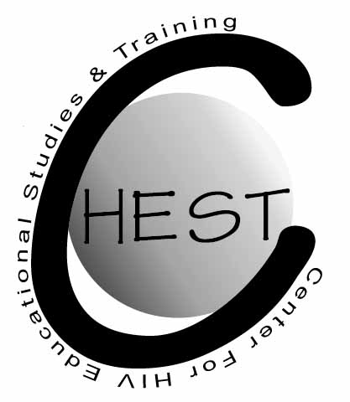

CONSENT TO SERVE AS A PARTICIPANT IN A RESEARCH PROJECT

EXPLORING HIV PREVENTION COMMUNICATION AMONG
BLACK MEN WHO HAVE SEX WITH MEN IN NEW YORK CITY

AUDIO TAPE RECORDING RELEASE CONSENT FORM

Protocol #: _______________________________________

Researcher(s): Dr. Jose Nanin

As part of this project, an audio tape recording will be made of you during your participation in the interview portion of this research project. Please indicate below the uses of these audio tapes to which you are willing to consent. This is completely voluntary and up to you. In any use of the audio tapes, we will not identify you personally.

1. The audiotapes can be studied by the research team for use in the research project. ______
Initials
2. The audiotapes can be shown to subjects in other experiments. ______
Initials

3. The audiotapes can be shown at meetings of scientists interested in the study of Black men and their friends and peers and how they communicate with each other about HIV prevention. ______
Initials

4. The audiotapes can be played in classrooms for students to listen to for educational purposes. ______
Initials

5. The audiotapes can be played in public presentations to non-scientific groups. ______
Initials

6. The audiotapes can be played for television and radio. ______
Initials

I have read the above description and give my consent for the use of audiotapes as indicated above. I have you also been given a separate consent form.

Participant’s Name: __________________ Signature: ________________________ Date:_______

Researcher’s Name: Dr. Jose Nanin Signature: ________________________ Date:_______

