“Exploring HIV Prevention Communication Among Black Men Who Have Sex with Men in New York City: Project BROTHA”

0920-XXXX

Attachment 5a. Recruitment Card and Script

RECRUITMENT CARD

Side 1 Side 2
 | Tell us what you think about HIV prevention and testing.  Tell us how you talk to other guys about this.  Call 212-206-XXXX to make an appointment.  You will be reimbursed for your time.  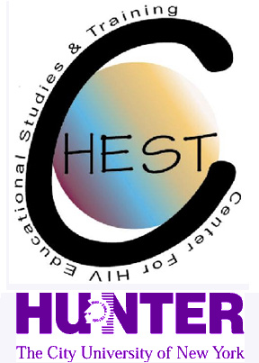

SAMPLE RECRUITMENT SCRIPTS
“Hi there, we’re asking brothas to come in and share their thoughts about HIV prevention and testing.”
“It’s private.”
“Your experiences may be helpful to others in our communities.”
“The study is about brothas ‘in the life’ and their thoughts about HIV, like testing, prevention, and other relevant topics.”
“If you ever wanted to talk about these topics, here’s your chance to make your thoughts known!”
“We will reimburse you $60.00 for your time.”

