HIV/AIDS Risk Reduction Interventions for African-American
Heterosexual Men

0920-09XX

Attachment 5c4
Invitation Email for Screening- UNCG

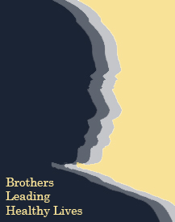Invitation Email for Screening Survey
Flesh Kincaid Grade Level: 9.01

Dear <Student’s first Name>:

Brothers Leading Healthy Lives Brotherhood Retreat is a program conducted by the Department of Public Health Education at UNCG with assistance from the Centers for Disease Control and Prevention (CDC). We want to help African American college men, ages 18-24, reduce their risk of HIV and other sexual health issues!

We invite you to be in our study if you meet all of the following criteria.

- You consider yourself to be an African American male student.
- You are currently enrolled at UNCG.
- You are at least 18 years of age.

The screening is a 5-minute survey that will ask you about your sexual health & health practices. For taking the screening, you will receive a $5 gift card as a token of appreciation.

We use an on-line survey system that allows us to give you a unique ID. You can use to access the on-line survey in the privacy of your dorm room or home. We also have a project office where you can complete the online survey and pick up your gift cards.

You will find out if you are eligible once you complete the screening. If you are eligible, you will receive a personal invitation to the Brotherhood Retreat located at Piney Lakes recreation center.

Just click on the link below to get started.

[Insert unique URL here]

Thank you for your help with this effort.

Sincerely,

Regina Pulliam
Project Coordinator

Brothers Leading Healthy Lives Project (BLHL)
161 McIver Bldg., Greensboro, NC 27402-6170

Office: 336.334.3245 Email: BLHL@uncg.edu

