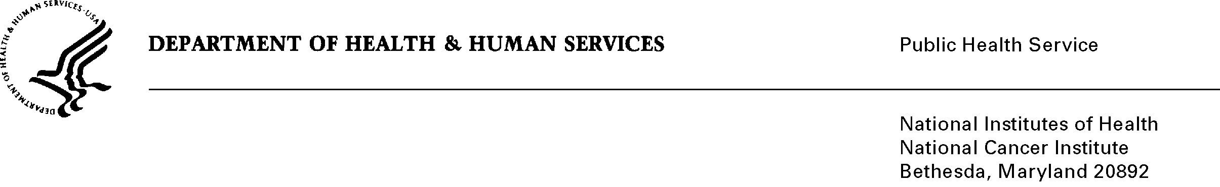

Date: August 16, 2010

To: Office of Management and Budget (OMB)

Through: Seleda Perryman, DHHS Report Clearance Officer
Mikia Currie, NIH Program Analyst, OPERA

From: Vivian Horovitch-Kelley, NCI OMB Project Clearance Liaison
Office of Management Analysis and Assessment
National Cancer Institute/NIH

Subject: Non-substantive Change Request for Generic, “Questionnaire Cognitive Interviewing and Pretesting (NCI)”
(OMB No. 0925-0589, Expiration Date 5/31/11)

I am requesting a non-substantive, non-material change to the total burden that is reported in ICRAS/ROCIS for this generic information collection. This would be to correct an administrative error that has occurred; it is not a request to increase or decrease the burden hours or respondents.

The original burden, based on the 2008 OMB-approved Supporting Statement A, p. 32 requested an annual participant burden of 600 hours with 600 respondents.

The burden reported in the ICRAS/ROCIS is a total of 600 hours and respondents. This number should actually be 1800 hours and respondents, since this information collection was approved for three years.

