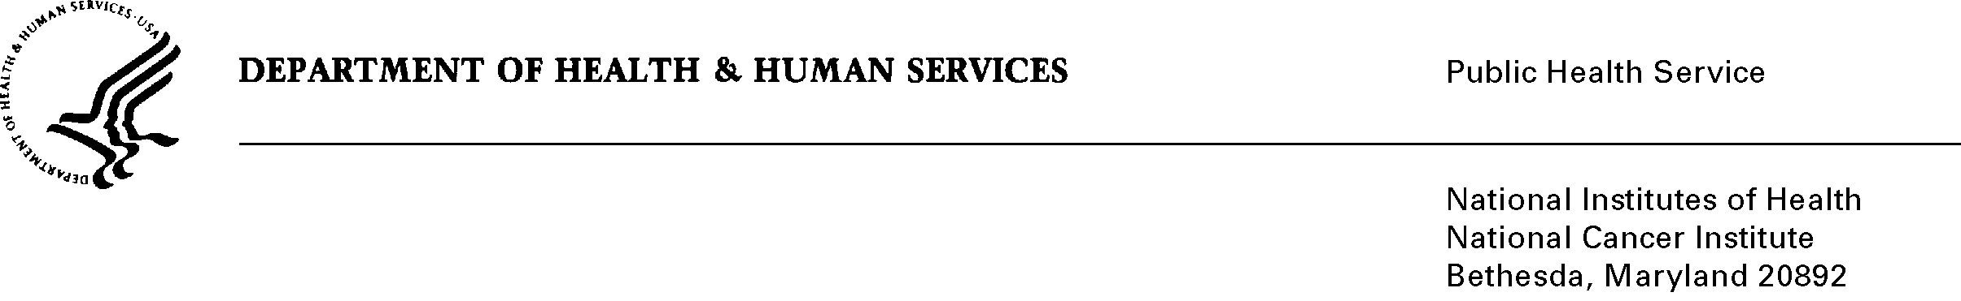
Date: October 5, 2010 (Revised from September 7, 2010 submission)

To: Office of Management and Budget (OMB)

Through: Seleda Perryman, DHHS Report Clearance Officer
Mikia Currie, Program Analyst, NIH Project Clearance Branch, OPERA

From: Vivian Horovitch-Kelley, NCI OMB Project Clearance Liaison, OMAA
National Cancer Institute/NIH

Subject: Bundled Generic Sub-Study Packages for 0925-0046, #3 and #4

Based on comments from OMB dated October 4, 2010, NCI has revised these submissions to clarify language with respect to information security and the payment of an honorarium.

The “Combined Generic Sub-study (GS) Forms” for these requests highlight the abstracts for the two sub-studies included in this submission.

The key to understanding the files and attachments in ICRAS/ROCIS is as listed below:

Sub-study #3
“In-Depth Interviews (IDI) and Online Focus Group on Clinical Research and Clinical Trials in Undergraduate Nursing Education”
Attachments are labeled “A” and there are two files which include:
- Justification Memo and Attachments A1 and A2 (Consents), A6 and A8 (Invitation Email and Letter)
- Attachments A3, A4, A5 (Discussion Guides), A7 (Script and Screener), and A9 (Focus Group Guide)

Sub-study #4
“Genomics and Genetic Testing: Message Testing Research with Consumers and Advocates”
Attachments are labeled “B” and there are two files which include:
- Justification Memo and Attachments B1 (Messages to be tested) and B6 (Consent Form)
- Attachments B2 (Moderator’s Guide for Focus Groups), B3 (Moderator’s Guide for Triad Discussions), B4 (Screener for Focus Groups) and B5 (Screener for Triad Discussions)

Notes to OMB: The total requested responses and burden was calculated by taking the sum for the two sub-studies.

