Date: November 9, 2010
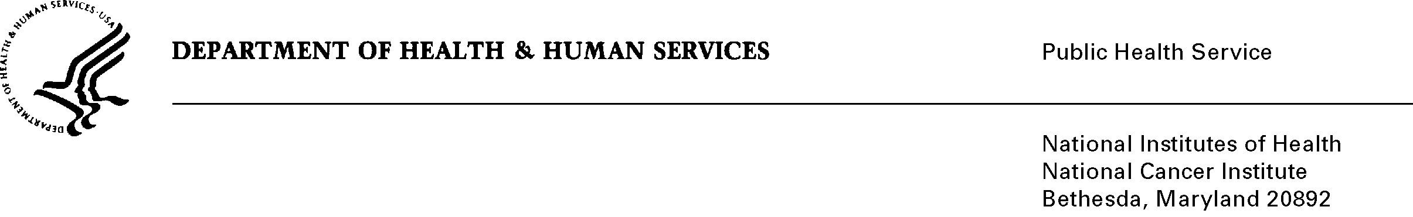

To: Office of Management and Budget (OMB)

Through: Seleda Perryman, DHHS Report Clearance Officer
Mikia Currie, Program Analyst, NIH Project Clearance Branch, OPERA

From: Vivian Horovitch-Kelley, NCI OMB Project Clearance Liaison, OMAA
National Cancer Institute/NIH

Subject: Bundled Generic Sub-Study Packages for 0925-0046-05 and -06

The goal of the awareness campaign is to show the benefits of clinical trials and the importance of NIH-supported clinical research for the public’s health, and highlight the need for clinical trial participants. In an effort to increase public awareness about clinical trials, particularly treatment trials, the National Cancer Institute’s Office of Market Research and Evaluation (OMRE) will conduct message testing research to inform the campaign planning.
The “Combined Generic Sub-study (GS) Form” for sub-study #5 and #6 highlights the abstract for each and is included in this submission.

The key to understanding the attachments and files in ICRAS/ROCIS is as listed below.

Sub-study #5:
Full title: “Testing of Messages for an NIH Clinical Trial Public Awareness Campaign”
Attachments are labeled “#5” and include:
- Justification Memo and Attachments 5C (Consent Form)
- Attachments 5A (Focus Group Moderator Guide) and 5B (Focus Group Screener)

Sub-study #6:

Full title: “Survey to Assess Communications Designed to Raise Awareness of Clinical Research”
Attachments are labeled “#6” and include:
- Justification Memo and Attachments 6A (Email and Mailed Invitations) and 6C (Consent Form)
- Attachments 6B (Web-based Survey)

Notes to OMB: There is a possibility that small entities and private sector (business or other for-profits) maybe be included when physicians from the medical community are recruited for Sub-study #6. This was noted in the electronic system as the maximum number under “small entity #.” However, this was not reported in the “Affected Public” since the majority of participants will be “Individuals”, not “Private Sector.” Additionally, the total requested responses and burden was calculated by taking the sum for the two sub-studies to account for the total in the electronic system.

