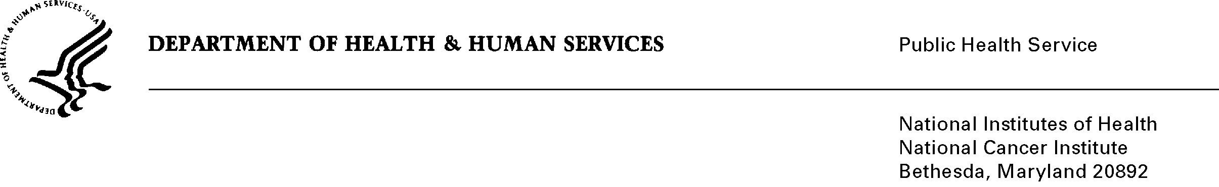
Date: March 7, 2011

To: Office of Management and Budget (OMB)

Through: Seleda Perryman, Report Clearance Officer, HHS
Mikia Currie, Program Analyst, Project Clearance Branch, OPERA, NIH

From: Vivian Horovitch-Kelley, OMB Project Clearance Liaison, OMAA
National Cancer Institute (NCI)/NIH

Subject: Bundled Generic Sub-Study Packages for 0925-0046-09 and -10

Both submissions come from the same division at NCI, the Division of Cancer Treatment and Diagnosis (DCTD), and are short web-based surveys initiated by an email invitation. The topics are very different and the “Gen IC Forms” for sub-study #9 and #10 highlight the abstract for each project.

The key to understanding the attachments and files in ICRAS/ROCIS is as listed below.

Sub-study #9:

Full title: “Survey to Determine IRB Policy Regarding NCI Action Letters”
Files and attachments are labeled “#9” and include:
- Justification Memo and Attachments 9A (Email to Respondents)
- Attachment 9B (Survey)

Sub-study #10:

Full title: “NCI Cancer Research Imaging Camp”
Attachments are labeled “#10” and include:
- Justification Memo and Attachments 10A (Invitation Letter) and 10B (Consent Form)
- Attachment 10C (NCI Cancer Research Imaging Camp Survey)

Notes to OMB: The total requested responses and burden was calculated by taking the sum for the two sub-studies to account for the total in the electronic system.

Estimates of Hour Burden for Sub-Studies #9 and #10
Type of Respondents | Instruments | Number of Respondents | Frequency of Response | Average Response Time  (minutes/hour) | Hour Burden
IRB Chairs and Directors  (Sub-study #9) | Survey  (Attach 9B) | 600 | 1 | 5/60  (0.083) | 50
Former and New Camp Students  (Sub-study #10) | (Attach 10C) | 110 | 1 | 10/60  (0.167) | 17
Total |  | 710 |  |  | 67

