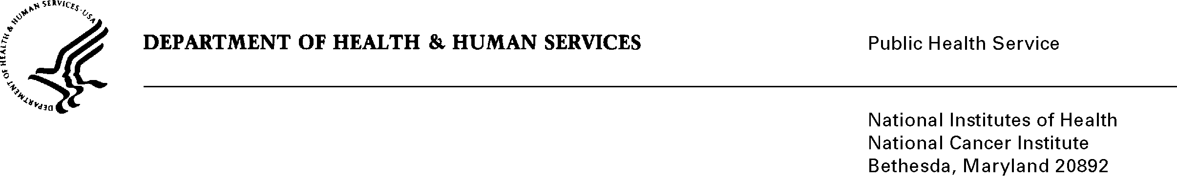

# **Date:** May 11, 2011

# **To:** Office of Management and Budget (OMB)

**Through:** Mary Forbes, Report Clearance Officer, HHS

Seleda Perryman, Program Officer, Project Clearance Branch, OPERA, NIH

# **From:** Vivian Horovitch-Kelley, NCI OMB Project Clearance Liaison, OMAA

# National Cancer Institute (NCI)/NIH

**Subject:** **Bundled Generic Sub-Studies for:**

**OMB Numbers: 0925-0046-14, -15, and -16**

This is a bundled generic sub-study submission of three projects. All three studies directly involve the Office of Communications and Education (OCE) at NCI. Two of the studies are a collaboration between OCE and the Division of Cancer Treatment and Diagnosis (DCTD). Sub-study #14 (WYNTK) uses in-depth interviews to assess whether a booklet is meeting the needs of its audience and how the content may be improved. Sub-studies #15 (Accrual CT) and #16 (CIRB Pilot) are both web-based surveys used to assess and improve the services offered by DCTD.

The topics are very different and the “Bundle Gen IC Form” for sub-studies #14, 15 and #16 highlight the abstract for each project.

The key to understanding the attachments and files in ICRAS/ROCIS is as listed below.

*Sub-study #14:*

Full title: **“In-Depth Interviews on NCI’s “What You Need To Know About Breast**

**Cancer” Booklet”**

Short Title: WYNTK

Files and attachments are labeled “#14” and include:

* Justification Memo and 14C (Review Guidelines) and 14D (Consent Form)
* Attachment 14A (Interview Guide) and 14B (Screener)

*Sub-study #15:*

Full title: **“Rapid Feedback Tool to Identify Accrual Problems with Active NCI Clinical**

**Trials”**

Short Title: Accrual CT

Attachments are labeled “#15” and include:

* Justification Memo
* Attachment 15A (Oncology Feedback) & 15B (Staff Feedback) Surveys

*Sub-study #16:*

Full title: **“A Pilot Study to Test a Proposed New Model for the NCI’s CIRB Participating Institution”**

Short Title: CIRB Pilot

Attachments are labeled “#16” and include:

* Justification Memo and Attachment 16A (Consent)
* Attachment 16B (Baseline, Midpoint, and Endpoint Surveys), 16C (Institution Worksheet), 16D (Principal Investigator Worksheet), 16E (Study-Specific Worksheet), and 16F (Study Transfer Worksheet).

Notes to OMB: The total requested responses and burden was calculated by taking the sum for the three sub-studies to account for the total in ICRAS. Types of respondents include both Individuals and Public Sector (Institutions), however because of the limitation of ICRAS, only Individuals will be entered.

|  |  |  |  |  |  |
| --- | --- | --- | --- | --- | --- |
| Estimates of Hour Burden for Sub-Studies #14, 15 and #16 | | | | | |
| Type of Respondents | Instruments | Number of Respondents | Frequency of Response | Average Response Time  (minutes/hour) | Hour Burden |
| Breast Cancer Patients  (Sub-study #14) | Screener  (Attachment 14B) | 50 | 1 | 15/60 | 13 |
| Review Instructions  (Attachment 14C) | 24 | 1 | 60/60 | 24 |
| Interview Guide  (Attachment 14A) | 24 | 1 | 60/60 | 24 |
| Oncologists and Research Staff for NCI-Sponsored Trials  (Sub-study #15) | Oncology Feedback Survey  (Attachment 15A) | 912 | 1 | 5/60  (0.08) | 76 |
| Staff Feedback Survey  (Attachment 15B) | 912 | 1 | 5/60  (0.08) | 76 |
| Principal Investigators and Institutions  (Sub-study #16) | Baseline Survey  (Attachment 16B,  pages 2-6) | 125 | 1 | 20/60  (0.33) | 42 |  |
| Midpoint Survey (Attachment 16B,  pages 7-10) | 125 | 1 | 20/60  (0.33) | 42 |
| Endpoint Survey  (Attachment 16B,  pages 11-14) | 125 | 1 | 20/60  (0.33) | 42 |
| Institution Worksheet  (Attachment 16C) | 25 | 1 | 30/60  (.50) | 13 |
| Principal Investigator Worksheet  (Attachment 16D) | 125 | 1 | 60/60  (1 hour) | 125 |
| Study-Specific Worksheet  (Attachment 16E) | 250 | 1 | 15/60  (.25) | 63 |
| Study Transfer Worksheet  (Attachment 16F) | 625 | 1 | 10/60  (.166) | 104 |
| Total |  | 3322 |  |  | 644 |