Date: May 3, 2010
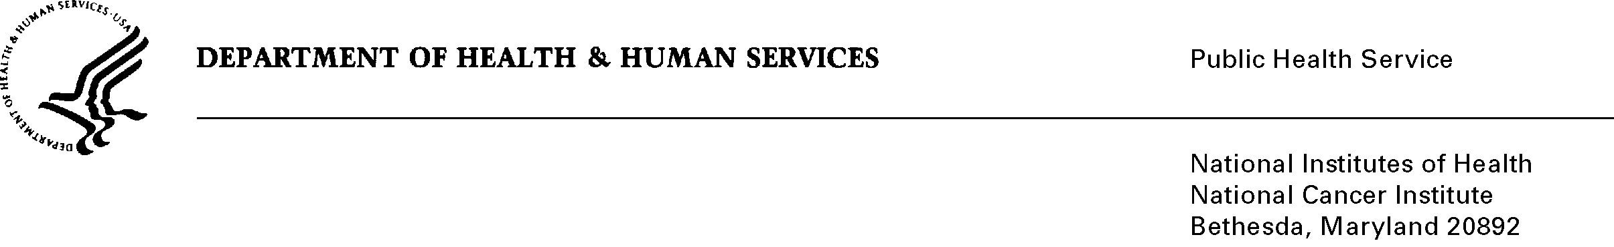

To: Office of Management and Budget (OMB)

Through: Mary Forbes, Report Clearance Officer, HHS
Seleda Perryman, Program Officer, OPERA, NIH
Vivian Horovitch-Kelley, PRA OMB Project Clearance Liaison OMAA, NCI

From: Nina Goodman, Project Officer
Office of Communications and Education (OCE)
National Cancer Institute/NIH

Subject: Generic Sub-study, In-Depth Interviews on NCI’s “What You Need To Know About Breast Cancer ” Booklet under “Formative Research, Pretesting, and Customer Satisfaction of NCI’s Office of Communications and Education,”
(OMB No. 0925-0046-14, Expiry Date 02/28/2013).

This information collection request described in this memo supports the Office of Communications and Education (OCE) at the National Cancer Institute (NCI).
The OCE submits for OMB review the proposed NCI research project, “In-Depth Interviews on NCI’s ‘What You Need To Know About™ Breast Cancer’ Booklet.” In addition to being the world leader in cancer research, NCI, through its Office of Communications and Education (OCE), disseminates research results and the latest evidence-based cancer information to diverse audiences in order to improve the lives of those affected by cancer. Patient education materials, such as the ‘What You Need To Know About™ Breast Cancer” booklet, are part of these information dissemination efforts.
The research objectives guiding this sub-study are learn the extent to which the booklet is meeting the expectations and needs of its audience and to identify ways in which the content of the booklet may be improved. The results from this research are not only expected to help inform NCI’s revisions to this booklet, but to other similar booklets published by NCI.

Background on Project
Since 1978, the National Cancer Institute (NCI) has been publishing the What You Need to Know About™ Cancer series and updating each booklet on a 2- to 5-year schedule, depending primarily on inventory requirements. These booklets, written in simple language, describe possible risks, symptoms, diagnosis, and treatment for a wide range of cancers. A total of 23 English booklets are available in the series—one focuses on cancer in general while the rest focus on specific types of cancer (e.g., breast cancer, colon cancer). The booklets are available both in print and online on the NCI’s website (www.cancer.gov). Spanish translations of 9 of the booklets are also available on the website.
Although formative audience research was conducted in the 1970s and 1980s with several titles in the series, the National Cancer Institute last conducted audience research in 1998. At that time, interviews were conducted with a sample of colorectal cancer patients to gather feedback on a prototype of a revised format for the What You Need to Know About™ Cancer of the Colon and Rectum booklet. Findings from this formative research helped inform revisions to this booklet, as well as others in the series. The NCI’s Office of Communications and Education (OCE) is interested in once again conducting formative audience research on a booklet in the series— this time to gather feedback on the What You Need to Know About™ Breast Cancer booklet. The What You Need to Know About™ Breast Cancer booklet is currently the most popular in the series, with more than 10,000 copies requested per month despite a distribution limit of 100 copies per order.

The proposed data collection will inform revisions to “What You Need to Know About ™ Breast Cancer” booklet in order to better meet the needs of its audience. It is expected that the results from this research will not only help inform revisions to the breast cancer booklet, but also to others in the series.
The proposed methodology for this data collection is through in-depth interviews.

Background Information on In-Depth Interviews

In-depth interviews are being used because they are useful when the goal of the data collection is to obtain extremely detailed information about a person’s thoughts and behaviors or when the goal is to explore new issues in depth – both of which are true in this instance. In-depth interviews are also being used because this research is seeking to gather the opinions of individuals without the influence of a group, as might occur in a focus group.

Proposed Research: In-depth Interviews with Breast Cancer Patients

NCI proposes conducting in-depth interviews with 24 breast cancer patients. There will be two groups of 12 participants; one group will include recently diagnosed patients (less that 1 year since diagnosis) and the other group will include individuals for which a longer period of time has passed since diagnosis (1 to 3 years since diagnosis). Approximately half of the participants in each group will have been diagnosed at an early stage (Stage 0, Stage I and II) while the other half will have been diagnosed at a later stage (Stage III and IV). Only female breast cancer patients will be included in the study.

The questions and topic areas that will be addressed in the interview will include, but are not limited to, the following:

- General reactions to the booklet (e.g., likes, dislikes)
- Ease of reading and understanding the booklet
- Expectations about the content of the booklet based on its title
- Sections of greatest interest to participants (e.g., where do they go to first when they start reading the booklet?)
- Reactions to its format and organization
- Helpfulness of the different sections and content (e.g., treatment options, dictionary, questions to ask the doctor)
- Opinions regarding the booklet’s length (i.e., is it too long?)
- Whether there is other content that should be omitted or added (e.g., is there too much information? Should the risk factors section be removed?)
- Reactions to the images and illustrations on the booklet (e.g., are they helpful? Do they prefer photos or drawings?)
- Based on their cancer journey experience, is there other content that should be omitted or added (e.g., is there too much information? Should the risk factors section be removed? Is there information they would have liked immediately following diagnosis or to inform treatment options?)
- Resources used (both print and Web) immediately following diagnosis and to inform treatment options

Attention will also be given to identifying whether there are any variations in terms of information needs between participants who were diagnosed at an earlier cancer stage versus those diagnosed at a later stage.

NCI will use a contractor, AED, to conduct data collection activities. An interview guide will be used to facilitate the discussion with participants. The guide is attached (Attachment 14A). The interview guide will be used to ensure that the questions are easy to understand and answer, well-organized, and flow well. The experienced interviewer will also be instructed to keep the interview at 60 minutes to limit respondent burden with respect to their time. Participation will be voluntary and respondents will be asked to participate only once.

Recruiters will use a screener to screen interview participants on several key dimensions (see attachment 14B for screener). The screening questionnaire has been carefully thought out so that the questioning process is short, easy to-understand, friendly, and efficient.

AED will work with an experienced recruitment agency to recruit and schedule the participants for the interviews. All participants will be screened prior to scheduling the interview to ensure that they meet the eligibility criteria. Recruitment efforts will be carried out until all participants are recruited. Recruitment may resume if any recruited respondents are unable to complete an IDI. Each IDI will be scheduled in advance at a time that is convenient for the respondents. AED will inform NCI staff on a regular basis of the recruitment progress. In the event that any difficulties arise in identifying potential participants for the study, AED may ask for assistance from NCI staff to reach out to national organizations and community-based organizations to help reach potential participants.

Once each participant is scheduled for an interview, a copy of the booklet will be mailed to them along with a set of review guidelines (see attachment 14C for review guidelines). The review guidelines will direct participants to spend about an hour reading and reviewing the booklet prior to the interview. They will be encouraged to read the entire booklet but may also be directed to pay particular attention to certain information or aspects of the booklet that will be more thoroughly addressed during the interview. Interviews with all participants will be scheduled for at least 10 days after the scheduling date to allow enough time for participants to receive and review the booklet before the interview.

The day prior to each interview, participants will be contacted to confirm the interview time, and confirm they have received and read the booklet. If the participant indicates they have not read the booklet, they will be given the option to reschedule the interview for a different day. All participants will be asked to have their copy of the booklet with them during the interview. Once the interview is completed, participants will be given a choice to return their booklets if they have marked any written comments or edits that they would like to share with NCI (a self-addressed stamped envelope will be provided to those participating if the interview is done remotely). Any returned booklets will be reviewed by NCI to complement the findings from the interviews. Participants who turn in their booklets will be given another copy to keep.

Interviews will be conducted in person or remotely by an experienced AED interviewer. In-person interviews will be conducted either in NCI’s office in Rockville, MD or in AED’s offices in Washington, DC. Remote interviews will be conducted either by phone only or via a web conferencing service (e.g., Go-To-Meeting) that would allow for online viewing/sharing of materials. Participants will be given the choice of selecting the most convenient mode for participating in the interview.

All respondents will receive modest remuneration of $75. This remuneration will provide participants with compensation in order to defray the cost of participation (which includes approximately 2 hours and 15 minutes of their time going through the screening procedures, providing consent, reviewing the materials in advance of the interview, and participating in the interviews). Research on participation in qualitative research indicates that, without providing minimal levels of incentive, insufficient numbers of participants will attend and costs associated with additional recruitment efforts be useful. In a previous Generic Sub-Study, “NCI Cancer.gov Evolution - User Focus Groups and Triads” (OMB No. 0925-0046-02, Expiration Date 2/28/13), AED reached out to professional recruitment firms to provide practical insight into the amount of remuneration qualitative research participation. While the qualitative research methodologies varied somewhat, estimates ranged from $75 to $100 for a two-hour research commitment.

All data will be collected by the contractor, AED, and all personal identifiers will be excluded from the data records. Participation will be strictly voluntary and based on informed consent (see attachment 14D for consent form). Participants who participate remotely will be asked to fax or mail their consent forms prior to participating in the interview. Individual respondents will not be identified. The data each participant provides will be grouped with the data from others for the purpose of reporting and presentation. Participant names will not be used. Any necessary identifying or potentially identifying information (e.g., signed consent agreements) will be secured and kept separate from the data records. The interviews will be audiotaped if the participant consents, but participant faces will not be video-taped. The voice recordings will only be listened to by the research team to aid with report writing. The recordings will be kept secured location and will be destroyed by December 31, 2015.

All information provided by respondents will be kept secure to the extent permitted by law. AED will do the analysis of the data and write the report of the findings. Findings in the report delivered to NCI will be reported in the aggregate and no identifiable individual responses will be provided. NCI and AED’s Institutional Review Board (IRB) Research Integrity Officers will review the research instruments and ensure that all necessary human subject protection procedures are in place.

To prevent the misinterpretation of the data, particularly the perception that the results are generalizable, NCI will take steps to ensure that the research findings are not taken out of context, misrepresented, or misused. NCI will include the purpose and formative nature of the sub-study, as well as the qualitative research methodology along with its limitations, in any presentation of data and results generated from this sub-study.

Participant Burden

There will be a maximum of 24 participants. An average total participation time will be 2¼ hours; this include 60 minutes for the booklet review, 60 minutes for the interview, and 15 minutes for the recruitment time and for consent procedures. This culminates in a maximum total hour burden of approximately 61 hours.

Estimates of Hour Burden
Types of Respondents | Form | Number of Respondents | Frequency of Response | Average Response Time (Hours) | Total Annual Hour Burden
Breast Cancer Patients | Screener  (Attachment 14B) | 50 | 1 | 15/60  (0.25) | 13
Breast Cancer Patients | Review Instructions  (Attachment 14C) | 24 | 1 | 60/60  (1) | 24
Breast Cancer Patients | Interview Guide  (Attachment 14A) | 24 | 1 | 60/60  (1) | 24
Total |  | 98 |  |  | 61

The full generic study, approved on February 10, 2010, requested a total of 7,050 burden hours. There have been 13 previous sub-studies approved by OMB under this umbrella submission, totaling 1,876 burden hours requested to date. Approval by OMB of this sub-study would bring the total burden hour requested to date for 0925-0046 to approximately 1937, which is approximately 28% of the total burden hours allowed.

Thank you for your consideration of this proposed sub-study 0925-0046-14. Please feel free to contact me if you have any questions.

Nina Goodman
Deputy Director
Office of Market Research and Evaluation
National Cancer Institute
Telephone: 301-435-7789
Email: goodmann@mail.nih.gov

Attachments (attached below):
14C) Booklet review guidelines
14D) Consent form

Attachments (separate file):
14A) Interview guide
14B) Recruitment screener

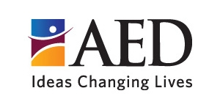
Attachment 14C: Book Review Guidelines
[Date]
Dear [Participant Name]:
Thank you for agreeing to participate in a study being conducted by the National Cancer Institute (NCI). We greatly appreciate your interest in contributing your time and valuable insight to this research.
Enclosed in this packet you will find a copy of the booklet What You Need to Know About™ Breast Cancer, a publication from NCI. This booklet is currently in the process of being updated and revised. As part of this revision, NCI is interested in gathering feedback from individuals diagnosed with breast cancer to identify opportunities to improve the booklet in order to better meet the needs of patients.

In preparation for the interview we have scheduled with you on [Date/Time], we would like to ask you to spend about 1 hour reading and reviewing the booklet. To help you in your review of the booklet, we have enclosed a sheet with instructions. We have also included 2 highlighters, one green and one yellow. Please read the instructions to learn how to use each of these highlighters as you review the booklet. These highlighters are yours to keep. In addition, we have included a prototype of what the layout and design of the new booklet may look like. Although we would like to ask you to take a few minutes to glance at the prototype pages before the interview, please focus on reading and reviewing the content of the current version of the booklet.
You will also find in this packet a sheet with directions for the day of the interview as well as a consent form to participate in the study. Before the interview, please read, sign and return the enclosed consent form. You can return the signed form either by fax (202-884-8713), e-mail (lplanas@aed.org) or regular mail (in one of the self-addressed stamped envelopes).
Please keep in mind that you should have the booklet and prototype pages with you during the interview. You will need to refer to them while the interview is taking place.

Once you have completed the interview, we would like to encourage you to return the booklet with your written comments to AED in one of the enclosed self-addressed stamped envelopes. AED will share the booklet you reviewed with the NCI staff so they can take your written comments and suggestions into consideration as they make revisions to the booklet before it is sent to print again. If your name or any other identifying information appears on the booklet you return to AED, it will be removed before it is shared with the NCI. If you choose to send to us the booklet with your written comments, we will send you another clean copy of the booklet for you to keep.
If you have any questions, please contact Laura Planas, from the Academy for Educational Development (AED), at lplanas@aed.org or (202) 884-8656. AED is the organization contracted by NCI to conduct this study.
Thank you very much for your time and participation. We look forward to the interview.
Sincerely,
Laura Planas, MPH
Academy for Educational Development (AED)
1825 Connecticut Ave, NW
Washington, DC 20009
(202) 884-8656; lplanas@aed.org *See the enclosed booklet review instructions*
Instructions for Reviewing the Booklet

As you read and review the booklet, consider the following:

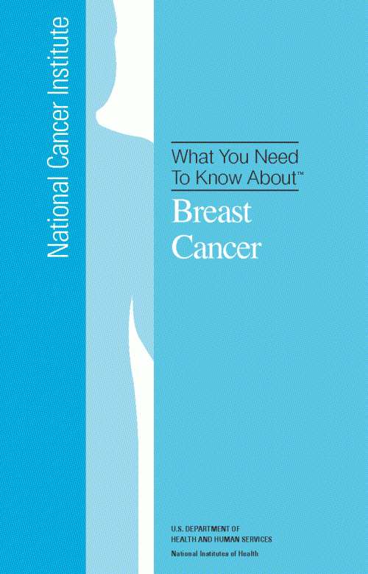
- Is there anything you particularly like about the booklet? Anything you disliked?

- Is the booklet easy to read and understand?
- Is there any information that is confusing or unclear?
- Are the illustrations and images in the booklet helpful? Are they clear? Are they appropriate?
- Is the booklet organized in a logical way? Is information easy to find?
- Is the size and length of the booklet appropriate?
- What are your thoughts about the layout and design of the booklet? (Note: consider this question as you look at both the booklet and the prototype pages)
- Is the amount of information included in the different sections of the booklet appropriate? Is it enough? Too much? Too little?
- In what ways could this booklet be improved? What would you change about it and in what way?
- Is there anything specific about the booklet that should not be changed?
- Is there any information missing from the booklet? Is there information or content that you would like to see added to the booklet?
- Is there content that should be removed from the booklet?
- What information in the booklet would have been most useful to you right after your diagnosis?

How to Use the Green and Yellow Highlighters

- Highlight in green anything you particularly like and that you think should NOT be changed.
- Highlight in yellow anything you dislike or think may be confusing.
We encourage you to write on the margins why you highlighted something in green or yellow.

We also encourage you to write any other comments or suggestions you may have on the margins or any other place on the booklet.

Attachment 14D: Informed Consent Form

Identification of Project | Formative Research on “What You Need To Know About™ Breast Cancer” Booklet
Statement of Age of Subject | I state that I am at least 18 years of age, in good physical health, and wish to participate in a program of research being conducted by the Office of Market Research and Evaluation of the National Cancer Institute (NCI), Bethesda, MD 20742.
Purpose | The purpose of this research is to explore the opinions and thoughts of individuals who have been diagnosed with breast cancer regarding NCI’s booklet “What You Need To Know About™ Breast Cancer” and identify opportunities to improve it. This research will also explore participants’ experiences regarding their cancer-related information needs after diagnosis.
Procedures | Participants will be asked to join an interview either in person or remotely (web conference and/or phone) about their thoughts and opinions regarding NCI’s “What You Need To Know About™ Breast Cancer” booklet and about their experiences related to their cancer-information needs post-diagnosis. The total time involved in the interview, including instructions, will be no more than 60 minutes. Participants will also be asked to spend about 1 hour, before the interview, reviewing the booklet.
Confidentiality | All information collected in this study will be kept secure to the extent permitted by law. I understand that the data I provide will be grouped with data others provide for the purpose of reporting and presentation and that my name will not be used. I understand that the interview will be audiotaped, but my face will not be video-taped. My voice recording will not be played to others besides the research team without my written permission. The recordings will be kept secured location and will be destroyed by December 31, 2015.
Risks | I understand that the risks of my participation are expected to be minimal in nature.
Benefits, Freedom to Withdraw, & Ability to Ask Questions | I understand that this study is not designed to help me personally. Rather, investigators hope to gain a better understanding of the thoughts, opinions and experiences of individuals diagnosed with breast cancer in order to make improvements to a breast cancer booklet published by the NCI and to inform NCI’s future research and efforts in this area. I am free to ask questions or withdraw from participation at any time and without penalty.
Contact Information of Investigators | Deputy Director, Office of Market Research and  Evaluation, National Cancer Institute  Telephone: 301-435-7789  Email: goodmann@mail.nih.gov

Printed Name of Research Participant _____________________________

Signature of Research Participant ________________________________

Date______________________

