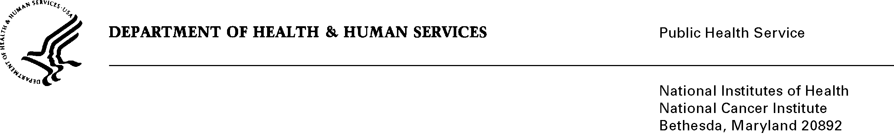

## Date: October 18, 2011

To: Office of Management and Budget (OMB)

Through: Mary Forbes, Report Clearance Officer, HHS

Seleda Perryman, Program Officer, Project Clearance Branch, OPERA, NIH

Vivian Horovitch-Kelley, PRA OMB Project Clearance Liaison, OMA, NCI

From: Holly A. Massett, PhD and

Nina Goodman, Project Officer

Acting Associate Director, Office of Market Research and Evaluation,

Office of Communications and Education (OCE),

National Cancer Institute (NCI)/NIH

Subject: Generic Sub-study, **Addendum to Pilot Study Proposed New Model for the CIRB Participating Institution** under “Formative Research, Pretesting, and Customer Satisfaction of NCI’s Office of Communications and Education,”

(OMB No. 0925-0046-**19**, Expiry Date 02/28/2013).

Background/Need and Use of Information

This information collection request described in this memo supports the Clinical Investigations Branch of the Cancer Therapy and Evaluation Program in the Division of Cancer Treatment and Diagnosis (DCTD). The process to obtain IRB approval for new clinical trials has historically contributed to a delay in trial activation and to timely accrual of clinical trial participants. The primary objective of the Central Institutional Review Board (CIRB) is to reduce the local administrative burdens through improved efficiency, while maintaining a high level of human subjects’ protection.

This submission is an addendum to the previous generic sub-study, “A Pilot Study to Test a Proposed New Model for the NCI’s CIRB Participating Institution” which was approved by OMB on June 15, 2011 (OMB No. 0925-0046-16). The program staff seek approval of two additional forms which are part of the previously approved pilot study, but were not finalized in time for the OMB review (in May-June, 2011). The purpose of the additional worksheets is to collect necessary information required to implement and evaluate the processes necessary for the new pilot model to be in compliance with regulations and guidelines.

The findings from this project are integral to CIRB in developing its program and all relevant, related communication materials should the new program be perceived as more satisfactory over the original program. The Supporting Statement A in the full generic clearance (OMB No. 0925-0046) state that sub-study projects are to: 1) conduct formative research and pretesting activities to ensure that messages have the potential to be received, understood, and accepted by those for whom they are intended; and 2) assess customer satisfaction of NCI’s programs and products. The intent of these additional forms is to add depth to the already approved pilot study which assesses satisfaction of a new CIRB program among oncology researchers in the field and formatively tests new materials that CIRB might use to communicate with future enrollees.

This project does not duplicate any other previous or current data collection effort. No known research efforts have been done in this area as NCI has used a shared responsibility model from the onset, and there are no comparable IRB models used within the government that have been assessed. The findings will be critical in deciding whether or not the NCI should invest additional resources to fully transition to the “independent” model or continue to use the shared responsibility model. Also, NCI is interested in learning how changes to the pilot program can lead to greater adoption of the new model.

Participants/Methodology and Research Instrument

The NCI is conducting a 9-month pilot study with twenty-five cooperative group sites implementing and following the new model’s processes and commitments. Twenty of the groups have been randomly selected from among those already using the CIRB. Five of the sites had not currently been enrolled in CIRB but were selected based on their decision to volunteer to be part of the pilot study of the new model.

Each participating institution enrolled in the pilot study will complete **Attachment 19A and 19B**, as needed. Attached forms: **Attachment 19A**, Potential Unanticipated Problems and/or Serious or Continuing Noncompliance Reporting Worksheet, will be used to collect information about incidents, experiences, or outcomes that could be considered unanticipated problems based on federal regulations and/or incidents of serious or continuing noncompliance. **Attachment 19B**, Locally-Developed Material Submission Worksheet, will be used to provide to the CIRB any participant-directed locally-developed material that requires IRB review. The previously approved forms (in OMB No.: 0925-0046-16, Attachments 16C-F) include institution’s contact information, information related to the Principal Investigators, research staff and local processes, study-specific worksheets, and information about the facilitated reviews of the current and pilot CIRB models.

The forms are related to the operational process of the pilot study and thus analysis will not be conducted on the individual forms. However, statistical analysis will be conducted on the surveys that were approved as part of this project and this information can be found in the Justification Memo for OMB No. 0925-0046-16.

It is anticipated that the findings from this pilot study will be submitted for publication in a journal such as the *Journal of Clinical Oncology*, which is expected to be read by individuals overseeing their IRB processes and in consideration of adopting a central model or changing their existing model to improve efficiencies. It is understood that the information collected and reported for the pilot study will be useful to aid decision-making to those who oversee IRB processes for clinical trials, the results will be from a sample of 25 sites and not representative of the overall population’s perceptions and attitudes toward the new model and its adoption. The publication will include specific discussion of this limitation as well as others related to the pilot process.

Other Considerations

A review by the Officer of Human Subjects Research (OHSR) has concluded that this activity is designed as exempt (**Attachment 19C**). A consent form will be obtained from the individuals submitting information (**Attachment 19D**).

The NIH Privacy Act Officer has reviewed this information collection and stated that this information will be covered under the Privacy Act (**Attachment 19E**). Personally Identifiable Information (PII) from respondents will be collected such as name, organization, and position at organization. However, this information is not beyond the information that is available to the public as a result of their professional role. The data collection is covered by NIH Privacy Act Systems of Record 09-25-0156, “Records of Participants in Programs and Respondents in Surveys Used to Evaluate Programs of the Public Health Service, HHS/PHS/NIH/OD.”

Burden

Institutional staff and Principal Investigators will complete documents as part of the pilot study. The total burden to complete these two documents is estimated to be 29 hours.

There have been 18 previous sub-studies approved by OMB under Generic submission OMB No. 0925-0046, totaling 2,676 burden hours requested to date. Approval by OMB of this sub-study would bring the total burden hour requested to date to approximately 2705, which is 38% of the total burden hours allowed (7050).

|  |  |  |  |  |  |
| --- | --- | --- | --- | --- | --- |
| Estimates of Burden Hours | | | | | |
| Types of Respondents | Instrument | Number of Respondents | Frequency of Response | Average Time Per Response (Hours) | Total  Hour Burden |
| Institutional Staff and Principal Investigator | Potential Unanticipated Problems and/or Serious or Continuing Noncompliance Reporting Worksheet  (Attachment 19A) | 25 | 2 | 30/60  (.50) | 25 |
| Institutional Staff and Principal Investigator | Locally-Developed Material Submission Worksheet  (Attachment 19B) | 25 | 1 | 10/60  (.166) | 4 |
| Total |  | 50 |  |  | 29 |

**Attachments (separate files)**

19A. Potential Unanticipated Problems and/or Serious or Continuing Noncompliance Reporting Worksheet for CIRB Pilot

19B. Locally-Developed material Submission for CIRB Pilot

**Attachments (below)**

19C. Office of Human Subjects Research (OHSR) Review

19D. Consent Form

19E. NIH Privacy Act Memo

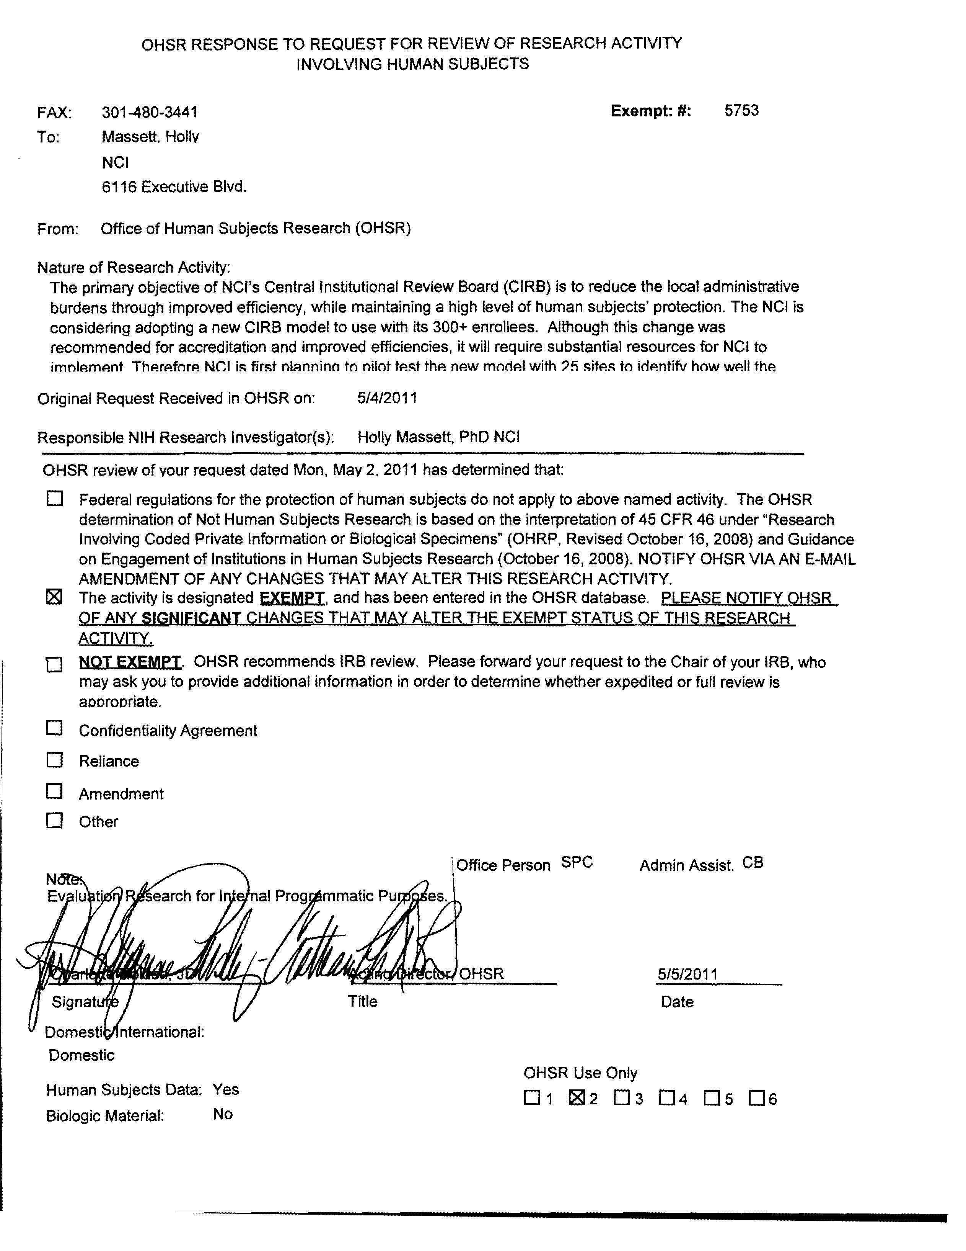**Attachment 19D: Informed Consent Form**

|  |  |
| --- | --- |
| **Identification of Project** | **Pilot Study to Test a Proposed New Model for the  NCI’s CIRB Participating Institution** |
| **Purpose** | The National Cancer Institute (NCI) is conducting a pilot of a new model for the Central Institutional Review Board (CIRB). The purpose of the survey is to systematically assess program implementation and perceptions of the original model compared to the piloted, independent CIRB model across the 25 sites to determine the feasibility of the new model across all 300+ sites, and if it produces a more efficient and satisfactory outcome on IRB processes for NCI cooperative group studies. The findings will be critical in deciding whether or not the NCI should invest additional resources to fully transition to the “independent” model or continue to use its current, shared responsibility model. |
| **Procedures** | NCI will ask you to complete three confidential web-based surveys asking your opinions about the new CIRB model and level of effort required to participate in the pilot. You will receive an email with a link to each survey at the following times:   1. Pre-study immediately before beginning the pilot (baseline), 2. Half way through the pilot study (between 4-5 months), and 3. Post-study immediately following the conclusion of the 9-month pilot. |
| **Confidentiality** | All information collected in this study will be kept secure to the extent permitted by law. I understand that the data I provide will be grouped with data others provide for the purpose of reporting and presentation and that my name will not be used. |
| **Risks** | I understand that the risks of my participation are expected to be minimal in nature. |
| **Benefits, Freedom to Withdraw, & Ability to Ask Questions** | I understand that this study is not designed to help me personally but that the investigators aim to assess the feasibility of a new CIRB model to manage NCI cooperative group studies. I am free to ask questions or withdraw from participation at any time and without penalty. |
| **Contact Information of Investigators** | Name: Holly Massett, PhD  Position: Associate Director, OMRE/OCE/NCI  Telephone: 301-594-8193  Email: massetth@mail.nih.gov  FAX to: 301-480-3441 |

Printed Name of Research Participant _____________________________

Signature of Research Participant ________________________________

Date______________________

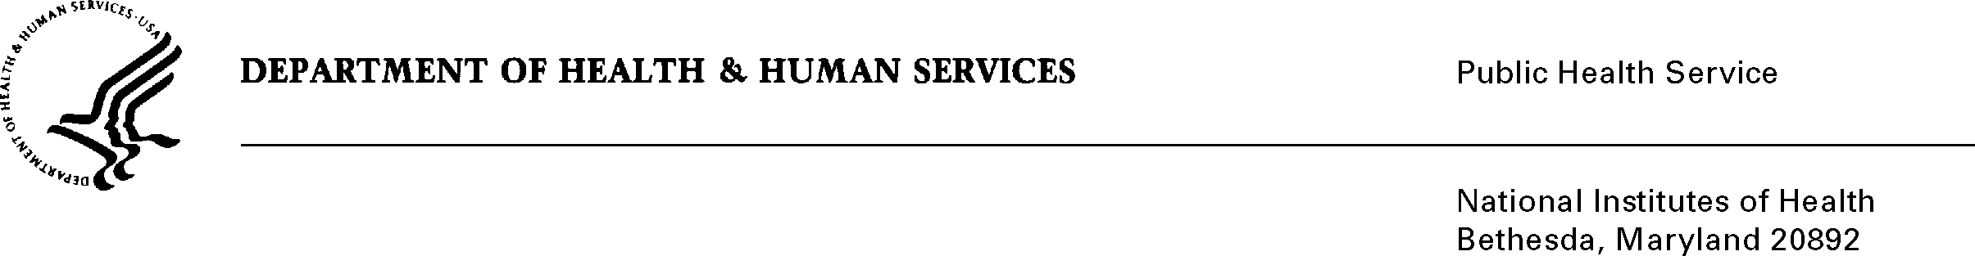

**Attachment 19E: NIH Privacy Act Memo**

**DATE:** June 6, 2011

**TO:** Holly A. Massett, Ph.D.

Associate Director, Office of Market Research and Evaluation

Office of Communications and Education, NCI

Nina Goodman, Project Officer

Office of Communications and Education, NCI

**FROM:** NIH Privacy Act Officer

**SUBJECT:** Applicability of the Privacy Act: Generic Sub-study, “A Pilot Study to Test a Proposed New Model for the NCI’s Central Institutional Review Board (CIRB) Participating Institution”

I have reviewed the NCI submission to OMB which involves a 9-month pilot study with twenty-five Cooperative Group sites that will implement and follow the new CIRB “independent” review model’s processes and commitments, recommended by the Association for the Accreditation of Human Research Protection Programs (AAHRPP). Twenty of the groups will be randomly selected from among those already using the current CIRB process of a “shared responsibility” model. Five of the sites not currently enrolled in CIRB were selected based on their decision to volunteer to be part of the pilot study of the new model. The Institutional Review Boards (IRB) of those five sites each identified five participants who are currently involved in their local IRB process, to participate in the survey. The findings of the survey will be critical in determining how changes to the pilot program can lead to greater adoption of the new model and help NCI decide whether or not it should invest additional resources to fully transition to the new model or continue to use the current one.

I have determined the Privacy Act will apply to this data collection, which includes the collection of personally identifiable information (PII) such as name, organization, position at organization, opinions and experiences from the Cooperative Group participants (IRB Chair, IRB Staff person, IRB Administrator/Director, Principal Investigator and Research Coordinator).

The participants nominated through their institution based on their knowledge and experience with IRB procedures and ability to react to the new model will be sent an e-mail link directing them to a survey link. Though the link will be unique to each individual and connected to the data for their institution, the participant names and identifying information will be stored separately and not be connected to survey responses. Therefore, it will not be possible to match the contact information from the consent form with the experiences/opinions provided on the questionnaires and study-specific worksheets. Survey responses will be combined across all responses and reported in the aggregate.

Page 2 – NCI/OCE CIRB Pilot Study

However, a database will reside behind the survey web-link that is designed to retrieve participant contact information for the purpose of conducting a follow-up to the baseline survey only.

The data collection is covered by NIH Privacy Act Systems of Record 09-25-0156, “Records of Participants in Programs and Respondents in Surveys Used to Evaluate Programs of the Public Health Service, HHS/PHS/NIH/OD.”

If you have any questions, please contact my office at (301) 496-2832.

Karen M. Plá

Enclosure

cc: Vivian Horovitch-Kelly, NCI PRA Liaison