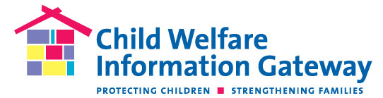
Public reporting burden for this collection of information is estimated to be 1 minute per response to complete this questionnaire. An agency may not conduct or sponsor, and a person is not required to respond to, a collection of information unless it displays a currently valid OMB control number. The control number for this project is 0970-0303. The control number expires on XX/XX/XXXX.

Child Welfare Information Gateway
Comment card – print version

Child Welfare Information Gateway is always looking to improve products and services for the field. To help us better meet your needs, we welcome your comments and suggestions.

- Which of the following best describes your professional background or role in the child welfare field? (Check one.)

- CPS/Child welfare/Foster care professional
- Child abuse prevention/Family support professional
- Adoption professional
- Educator/Faculty
- Other professional:___________________
- Student (e.g., K-12 or University)
- None of the above – I contacted Information Gateway for personal and NOT professional reasons.

- Please provide your comment or suggestion in the space below.

Thank you for your comments and suggestions.

