Attachment A

Transcript of Video Dialogue

1:Intro-->B&B Title
Intro freeze-frame

Scene: Ed turning to camera
Narrator: “In a world where college graduates change addresses, one man makes sure their surveys reach them.”

Black Screen: “Coming Soon: ”
Narrator: "Coming soon…"

Scene: Ed answers phone
Ed: “Hello?”

Voice on phone: “Ed, we need you. Not everyone has updated their addresses for us. We’ve got to find the B&B survey participants.”

Ed: “I’m on it.”

Title Screen: "Baccalaureate and Beyond"
Narrator: "…it's Ed in Baccalaureate and Beyond"

2: The searches
Scene: Montage of Ed underwater, in the jungle, in the desert, on the moon.
Narrator: “Searching the deepest oceans… the thickest jungles… the driest deserts… and the mooniest moons,

3: Study member’s (SM's) house greeting
Narrator: until finally…

Scene: Ed walks up to the house, dialogue ensues
SM: “Hello?”

Ed: “I’m Ed from the U.S. Department of Education. I’m glad I found you. We’re updating contact information for Baccalaureate and Beyond survey participants.”

S.M.: “Why?”

Ed: “We’re going to do a follow-up survey in 2011 to ask you more questions about what you’ve been doing since graduation.”

4: Just prior to moving truck --> Map
S.M.: “Good thing you got here today [scene changes to moving van] I’m moving to Maine tomorrow for a new job.”

Ed: “Then the Department of Education definitely needs you to update your contact information.”

Scene: Shot of S.M. talking
S.M. “How do I do that?”

Scene: Shot of Ed talking
Ed: We’ll be contacting everyone via mail or email with instructions so they can confirm their contact information, or in cases like yours, provide us with a new address.

Scene: U.S. map from above
Ed: “We understand how common it is to move in the years after you graduate. People move for jobs or for family. They may move across the country or across town. We need you to update your contact information so we can include you in the B&B survey in 2011. If we can’t find you, we won’t know what has happened to you since graduation.”

Scene: Ed from overhead
Ed: “As a recent college graduate, you are in a special position to provide us with vital information on your experiences after graduation. With your help we can develop better programs that help college grads like you find success in jobs, graduate school, and beyond.

Display contact screen with URL for study website (TBD?)
Narrator: “Make Ed’s job easier by updating your contact information. You can do this online at this website or by returning the update form that you will be receiving soon by mail.”

Attachment B

Web-based Address Update Forms

Control Group Address Update Form

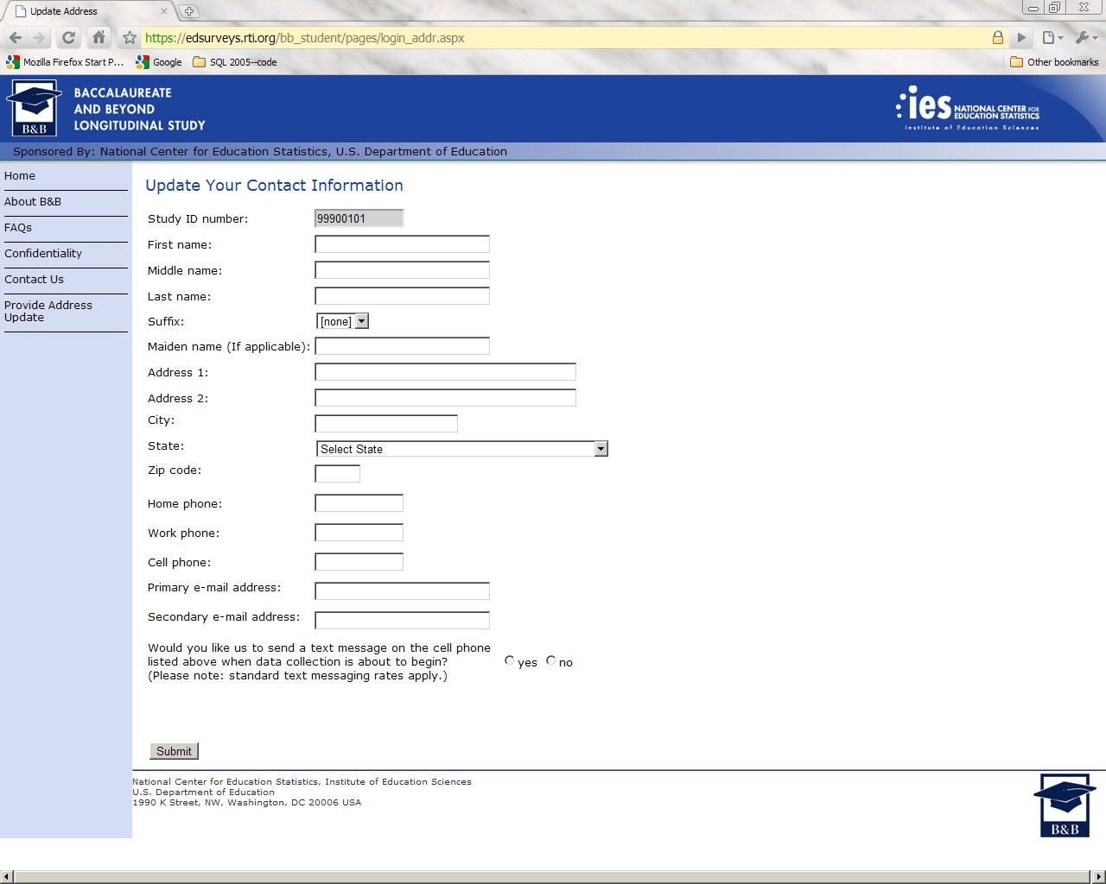

Treatment Group Address Update Form

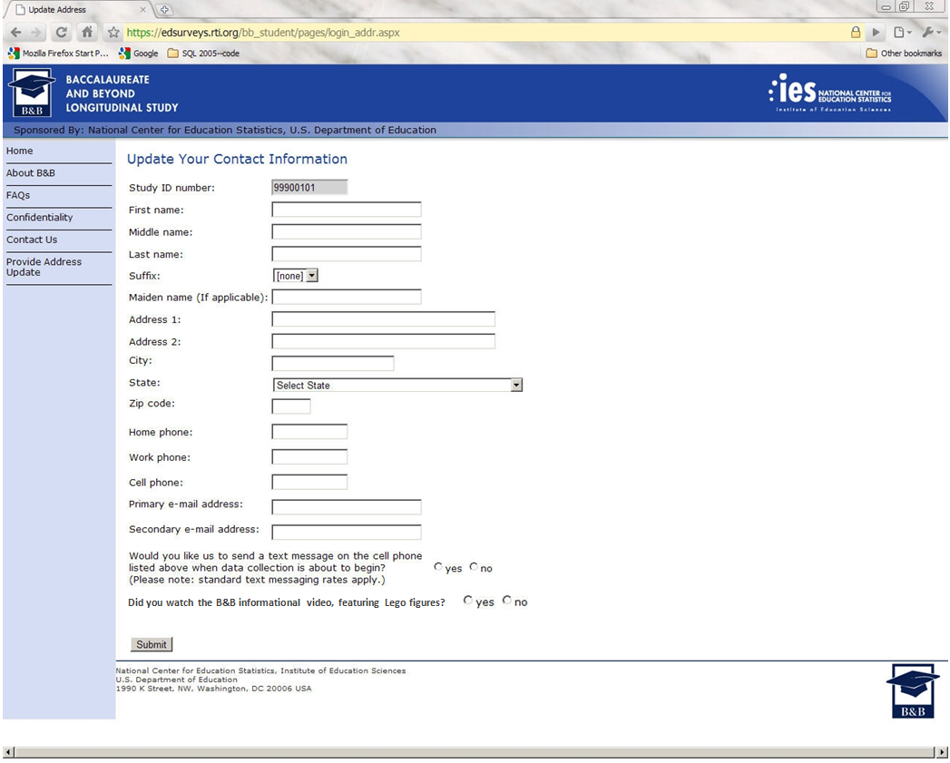
Confidentiality Statement

Your participation, while voluntary, is critical to the study’s success. Federal law requires that we protect your privacy. Your information will be secured behind firewalls and will be encrypted during Internet transmission. Your information will be used only for statistical purposes and may not be disclosed, or used, in identifiable form for any other purpose, except as required by law (P.L. 107-279, Title I, Part E, Sec. 183).

Attachment C

Address Update Postcards and Instructions

Control Group Postcard
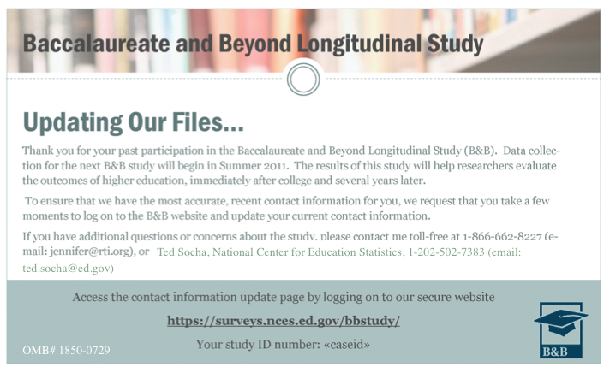

Treatment Group Postcard

