TEACH.gov

**Job Listings Publishing Requirements**

**July 29, 2010**

**Version 1.7**

Document Control

**Document Information**

|  |  |
| --- | --- |
| Title | Job Listings Publishing Functional Requirements |
| Revision | Version 1.7 |
| Issue Date | July 29, 201011/10/200102/27/2004 |
| Security Level | Unclassified |
| File Name | TEACHgov-Reqs-JobListings-072910.doc |

Review History

|  |  |  |  |
| --- | --- | --- | --- |
| Version Number | Date | Responsible Individual | Summary of Change |
| 1.0 | 07/06/10 | Jason Hoekstra | Initial draft |
| 1.1 | 07/07/10 | Jason Hoekstra | Content updates: categories for fields, scope, TOU section |
| 1.2 | 07/08/10 | Jason Hoekstra | Content updates: terms, overview, heading descriptions |
| 1.3 | 07/14/10 | Jason Hoekstra | Content updates: document format, scope, project summary, expand data interactions, collected information for jobs and users |
| 1.4 | 07/15/10 | Jason Hoekstra | Content updates: CSV/XML specs, type codes, other content |
| 1.5 | 07/16/10 | Jason Hoekstra | Content updates: Council recommendations, formatting, job listing display section |
| 1.6 | 07/16/10 | Jason Hoekstra | Formatting updates |
| 1.7 | 07/29/10 | Jason Hoekstra | Inserted visualizations + burden statement |

Table of Contents

1. Introduction 4

1.1 Project Summary 4

1.2 Intended Audience 4

1.3 Project Scope 5

2. Functional Requirements 6

2.1 Job Listing Specification 6

2.1.1 Overview 6

2.1.2 Job Listing Data 6

2.1.3 Position Categories 6

2.1.4 Position Levels 7

2.1.5 NCES Agency Identifiers 8

2.2 Job Provider Requirements 8

2.2.1 Overview 8

2.2.2 Terms of Service Agreement 8

2.2.3 Job Provider Collected Information 9

2.2.4 Authorizing Process 9

2.3 Job Listing Collection 10

2.3.1 Overview 10

2.3.2 XML Data File 10

2.3.3 Posting via TEACH.gov web form 10

2.3.4 Moderation 11

2.4 Job Listing Display, Searching and Alerting 11

2.4.1 Overview 11

2.4.2 Job Listing Web Page Display 11

2.4.3 Job Listing Search 12

2.4.4 Email Alerts 12

3. Technical Requirements 13

3.1 XML Data File Specification 13

3.1.1 Data Field Specification 13

3.1.2 XML Sample 13

3.2 Excel (CSV) Data File Specification 14

3.2.1 Data Field Specification 14

3.3 TEACH.Gov Data File Type Codes 15

3.3.1 Position Type Codes 15

3.3.2 Position Level Codes 15

3.4 Visualizations for Job Listing Process 16

3.4.1 Manage Job Listings 16

3.4.2 Add A Job Listing 17

3.4.3 Upload Job Listings 18

3.4.4 XML Feed Process 19

4. Paperwork Burden Statement 20

Appendix A: Acronyms and Abbreviations 21

# 

# Introduction

## Project Summary

TEACH.gov will be a clearinghouse for information for teachers who are interested in becoming a PK-12 teacher, including, but not limited to, preparation information, financial packages, certification resources, job listings, and state/district profiles. The purpose of this document is to describe the requirements for collecting and publishing job listings from schools and school districts.

TEACH.gov will provide a listing of teacher jobs available throughout the United States based on the information provided to the U.S. Department of Education (Department) from commercial listing sources, schools, and school districts. TEACH.gov is designed to be an inclusive, comprehensive source of job listings and will allow multiple sources to publish listings on the web site. However, TEACH.gov does not aim to be a sole authoritative source for job listings. The web site will only publish enough information to give a teacher an overview of the position and refer to the original provider of that listing.

The data for TEACH.gov job listings will come from a “job listing provider.” For the purposes of this document and project, a job listing provider is considered a commercial listing service[1], state educational agencies (SEAs), local educational agencies (LEAs/school districts) and individual schools.

TEACH.gov will collect job listings using two primary methods (methods are non-exclusive, multiple may be used by sources). Each job provider must establish a relationship with TEACH.gov via a Terms of Service (ToS) agreement prior to publishing a listing and publish any listing in accordance with the terms and conditions contained in the ToS.

* **Data file collection** – TEACH.gov will pick up a job listing data file on a daily basis from job provider web sites. This data file will be imported into the TEACH.gov job listing database. A job listing data file specification will be provided for providers beforehand to format their data.
* **TEACH.gov web site data entry** – TEACH.gov will provide web forms for providers to manually enter and/or bulk import their job listings. This web form will be presented upon login by a job provider using TEACH.gov provided credentials. Job providers will also be able to edit or delete listings at will.

## Intended Audience

This document is intended for usage by any parties interested in how TEACH.gov will collect and republish teacher job listings. Interested parties in that group are TEACH project leadership, legal, privacy, information technology, and contracting teams, external job listing sources (commercial providers, school districts and individual schools), and other external partners.

## Project Scope

For the initial launch of TEACH.gov job listings, the following scope for an eligible listing will be limited to:

* **School selection**: public schools, including vocational/technical and charter schools. Selection of schools is based on NCES Common Core of Data listings.
* **Grade levels**: Elementary and Secondary Education, Pre-kindergarten through Level 12
* **Job Type**: PK-12 teachers (excluding administrative, counseling, aide and support staff)
* **Location**: United States and its territories exclusively

The scope of eligible job listing providers is constrained to:

* Commercial and non-profit job listing services
* State educational agencies
* Local educational agencies (public school districts)
* Public schools not operating under an LEA

# Functional Requirements

## Job Listing Specification

### Overview

TEACH.gov will provide a listing of teacher jobs available throughout the United States based on the information provided to the Department from job listing providers. TEACH.gov does not aim to be a sole authoritative source for PK-12 job listings and will only publish enough information to refer interested candidates to the original provider of that listing.

### Job Listing Data

The following data fields will be collected from a job provider for each job listing:

* **Position Title** – Title of the posted position, for example, “Physics Teacher”
* **Position Category** – Educational topic of the teaching position, for example, “English” *(fully enumerated in 2.1.3 Position Categories)*
* **Position Level** – Grade level of the position, for example, “High School (9-12)” *(fully enumerated in 2.1.4 Position Levels)*
* **NCES District or School ID** – NCES District or School ID as published in NCES Common Core of Data (CCD). Using this, TEACH.gov will be able to use other district and school information contained within the database for display selection and enable meaningful search results. *(more information specified at 2.1.5 NCES Agency Identifiers)*.
* **Source Web Site Link** – A web link back to the job provider’s detail and application page for the listing.
* **Listing Expiration Date** – Expiration date of job listing. Maximum of 30 days from current date. The provider will be notified via email of their expired listing and automated removal from TEACH.gov. The provider will be able to repost the listing after this date.

### Position Categories

The following are position categories for a TEACH.gov job listing:

* Career/Technical Education
* Early Childhood/Elementary
* English
* Gifted
* Foreign Languages
* Mathematics
* Music
* Physical Education
* Science
* Social Studies
* Special Education
* Substitute
* Technology

### Position Levels

The following are position levels for a TEACH.gov job listing:

* Pre-Kindergarten
* Kindergarten
* Elementary (K-5)
* Middle School (6-8)
* Elementary + Middle School (K-8)
* High School (9-12)
* Grade 1
* Grade 2
* Grade 3
* Grade 4
* Grade 5
* Grade 6
* Grade 7
* Grade 8
* Grade 9
* Grade 10
* Grade 11
* Grade 12

### NCES Agency Identifiers

NCES has a reference for CCD fields and full descriptions are available at: <http://nces.ed.gov/ccd/psadd.asp>

* **NCES District ID** – This is the seven digit code used by NCES to uniquely identify a school district. The first two digits are the state FIPS code.
* **NCES School ID** - This field displays the 12 digit school identification number. This number can be used to link the school to the district on the school district address file. The first 7 digits of the 12 digit school ID are the district ID, the last five are the school ID, combined, they make a 12 digit unique code for each school.

## Job Provider Requirements

### Overview

An eligible job listing provider to publish a listing on TEACH.gov is constrained to:

* Commercial or non-profit job listing service
* State educational agencies
* Local educational agencies (public school districts)
* Public schools not operating under an LEA

### Terms of Service Agreement

To publish job listings on TEACH.gov, a provider must establish a TEACH.gov Job Listing Terms of Service (ToS) agreement as furnished by the U. S. Department of Education.

Below is a list of authorities that will have the ability to provide sign-off for this agreement:

* Commercial job listing service - Company officer (President, CEO, etc) or their authorized designee
* State educational agencies - Chief State School Officer or their authorized designee
* Local educational agencies (public school districts) - District Superintendent or their authorized designee
* Public schools – Principal or their authorized designee

### Job Provider Collected Information

In order to establish a ToS agreement, the job provider will have to furnish the following information:

* **Organization Name** – Company name, agency name or school name
* **NCES District or School ID** – If the organization is a district or school, then the NCES agency ID is required.
* **Organization Display Name** – Same as above, but with the organization’s preference of how to display the name on TEACH.gov
* **Organization Web Site Link** – Web link / URL to organization’s web site
* **Authorizing Contact Name** – A contact name of the person authorized to post job listings on the organization’s behalf
* **Authorizing Contact Title** – A contact title of the person authorized to post job listings on the organization’s behalf
* **Authorizing Contact Email Address** –– A contact email address of the person authorized to post job listings on the organization’s behalf. This email address must match the organization’s official email/web domain.
* **Authorizing Contact Phone Number** – A contact phone number of the person authorized to post job listings on the organization’s behalf
* **Authorizing Contact Password** – A password for the contact to log into the system once approved
* **Checkbox Certifying Authority** – Checkbox acknowledging that the person completing the ToS agreement is authorized to do so on behalf of his or her organization

### Authorizing Process

Below describes the process in which a new job provider receives authorization to publish its job listings on the TEACH.gov job listing directory:

1. An interested party will be directed to a TEACH.gov job listing publishing ToS Agreement page.
2. After fully reading through the ToS page, the user will be presented with a web form to submit the information above.
3. The user will type in the information on the web form. The user will not be allowed to submit the form until all required fields have been completed.
4. The user will receive a confirmation message both on-screen and via email with further instructions.
5. A representative from TEACH.gov will call the authorizing contact via telephone to verify:
   1. the contact submitted an account request and
   2. the contact is authorized to post job listings for the organization.
6. The representative from TEACH.gov will activate the contact’s user account. (If the user is not authorized or not available, the account will not be activated and the authorization process stops.)
7. Upon authorization, the contact will be able to post job listings. Another email with links and instructions will be sent to the contact.

## Job Listing Collection

### Overview

Job providers will have the ability to list available teacher job listings on TEACH.gov. The following describes three methods which a provider may use to publish a listing(s). A provider may use one or more of these methods to list on TEACH.gov.

### XML Data File

This method is intended for providers with a large amount of available job listings (100+ per month). This method also assumes listing providers have a level of technical capacity to implement. The process for this method is as follows:

1. A job provider produces daily “data dump” XML file of their job listings given the XML data file specification detailed below in Section 3.1.
2. The XML file will be placed on the provider’s web site, protected by a username and password provided for TEACH.gov.
3. TEACH.gov will pick up this XML data file on a nightly basis.
4. TEACH.gov will upload the job listing database accordingly.
5. An email will be sent to the authorized contact reporting success and/or failures encountered while importing this file.

### Posting via TEACH.gov web form

#### Web Form Posting

Using the Web Form Posting method, a job provider will follow the steps below to post a job listing:

1. A job listing provider will log into TEACH.gov with a previously established and authorized user account.
2. The user will be presented a job listing administration panel to Add, Edit and Delete job listings.
3. Adding a new job listing collects the information as specified in Section 2.1.2.
4. After a posting is listed, a user may edit the posting at any time.
5. After a posting is listed, a user may delete the posting at any time.

#### Excel (CSV) File Upload

Provider logs into TEACH.gov, uploads an Excel file for bulk job additions. Manually manages each job listing thereafter via web form. TEACH.gov provides sample job listing template and instructions.

### Moderation

TEACH.gov representatives will scan on a frequent basis new job listings to detect undesired content. Given the posting agencies are well-known, verified public agencies (or acting on behalf of) and the amount of posted text is limited to position title, the amount of undesired content is assumed to be very infrequent and very low volume, so job listings will appear live without TEACH.gov individual approval of each listing. Job providers will be given the specific requirements and conditions of job listings within the Terms of Service agreement.

## Job Listing Display, Searching and Alerting

### Overview

TEACH.gov users will be able to access job listings using three methods: TEACH.gov web page display, TEACH.gov path to teaching search results, job listing search and email alerting on saved searches. This section details that usage.

### Job Listing Web Page Display

TEACH.gov will display job listings on various web pages within the web site:

* + - * **Job listing section** – A section will be dedicated exclusively to job listings on TEACH.gov. This section will offer an interactive map, a sample listing of recently posted listings and a link to a job listing search page.
      * **School district detail pages** – If a job listing exists for a particular school district, the job listing(s) will appear on that page.
      * **State detail page** – A sample of job listings will appear on each state detail page and refer larger selections to each job listing section or school district detail pages.

### Job Listing Search

A job listing search will be presented to allow a user to specifically target listings which apply to them. Within this job search, a user will be able to search on the following criteria:

* + - * **Job Title Search** – a free text/keyword search on a job title
      * **Category Search** – selection-based search on job categories
      * **Grade Level Search -**  selection-based search on job grade level
      * **State Search –** selection-based search on job location state
      * **Zip Code Search –** selection-based search on job location zip code
      * **County Search –** selection-based search on job location county
      * **District Search –** selection-based search on school district

### Email Alerts

A user will be able to save search criteria from the job listing search. As new job listings come in which meet the saved criteria, an email listing will be delivered to the user at the frequency they specified. (The user will have to opt-in for this service and will be able to opt-out at any time.)

# Technical Requirements

## XML Data File Specification

### Data Field Specification

|  |  |  |  |  |
| --- | --- | --- | --- | --- |
| Field Name | Title | Description | Format | Maximum Length |
| ID | Unique Identifier |  | Alphanumeric | 50 characters |
| TITLE | Position Title | Title of the posted position | Alphanumeric | 50 characters |
| CATEGORY | Position Category | Educational topic of the teaching position | 3.3.1 Position Type Code |  |
| LEVEL | Position Level | Grade level of the position | 3.3.2 Level Type Code |  |
| DISTRICT_ID | NCES District ID | NCES District ID as published in NCES Common Core of Data (CCD) | Numeric, 7 digits | Fixed length: 7 digits |
| SCHOOL_ID | NCES School ID | NCES District ID as published in NCES Common Core of Data (CCD) | Numeric, 12 digits | Fixed length: 12 digits |
| URL | Job listing detail page | A web link back to the job provider’s detail and application page for the listing. | IETF URI Specification, must begin with http:// or https:// |  |
| END_DATE | Ending Date | Expiration date of job listing. Maximum of 30 days from current date. | XS:DATE – YYYY-MM-DD | Fixed length: 10 characters |

### XML Sample

<?xml version=”1.0” encoding=”utf-8”?>

<jobs>

<provider>

<source>Sample Job Provider</source>

</provider>

<listings>

<listing>

<id>1234</id>

<title>Science Teacher</title>

<category>SCI</category>

<level>EM</level>

<district_id>1234567</district_id>

<url>[http://schooldistrict.us.dc/jobs/123456</url](http://schooldistrict.us.dc/jobs/123456%3c/url)>

<end_date>2010-10-01</end_date>

</listing>

</listings>

</jobs>

## Excel (CSV) Data File Specification

### Data Field Specification

|  |  |  |  |  |
| --- | --- | --- | --- | --- |
| Field Name | Title | Description | Format | Maximum Length |
| ID | Unique Identifier |  | Alphanumeric | 50 characters |
| TITLE | Position Title | Title of the posted position | Alphanumeric | 50 characters |
| CATEGORY | Position Category | Educational topic of the teaching position | 3.3.1 Position Type Code |  |
| LEVEL | Position Level | Grade level of the position | 3.3.2 Level Type Code |  |
| DISTRICT_ID | NCES District ID | NCES District ID as published in NCES Common Core of Data (CCD) |  | Fixed length: 7 digits |
| SCHOOL_ID | NCES School ID | NCES District ID as published in NCES Common Core of Data (CCD) |  | Fixed length: 12 digits |
| URL | Job listing detail page | A web link back to the job provider’s detail and application page for the listing. | IETF URI Specification, must begin with http:// or https:// |  |
| END_DATE | Ending Date | Expiration date of job listing. Maximum of 30 days from current date. | YYYY-MM-DD | Fixed length: 10 characters |

## TEACH.Gov Data File Type Codes

### Position Type Codes

Below is a listing of position type codes to be used in the XML or CSV job listing file:

|  |  |
| --- | --- |
| CTE | Career/Technical Education |
| ECE | Early Childhood/Elementary |
| ENG | English |
| GFT | Gifted |
| FLG | Foreign Languages |
| MAT | Mathematics |
| MUS | Music |
| PED | Physical Education |
| SCI | Science |
| SSS | Social Studies |
| SED | Special Education |
| TCH | Technology |

### Position Level Codes

Below is a listing of position level codes to be used in the XML or CSV job listing file:

|  |  |
| --- | --- |
| PK | Pre-School |
| KI | Kindergarten |
| ES | Elementary (PK-5) |
| MS | Middle School (6-8) |
| EM | Elementary + Middle (K-8) |
| HS | High School (9-12) |
| 01 | Grade 1 |
| 02 | Grade 2 |
| 03 | Grade 3 |
| 04 | Grade 4 |
| 05 | Grade 5 |
| 06 | Grade 6 |
| 07 | Grade 7 |
| 08 | Grade 8 |
| 09 | Grade 9 |
| 10 | Grade 10 |
| 11 | Grade 11 |
| 12 | Grade 12 |

## Visualizations for Job Listing Process

### Manage Job Listings

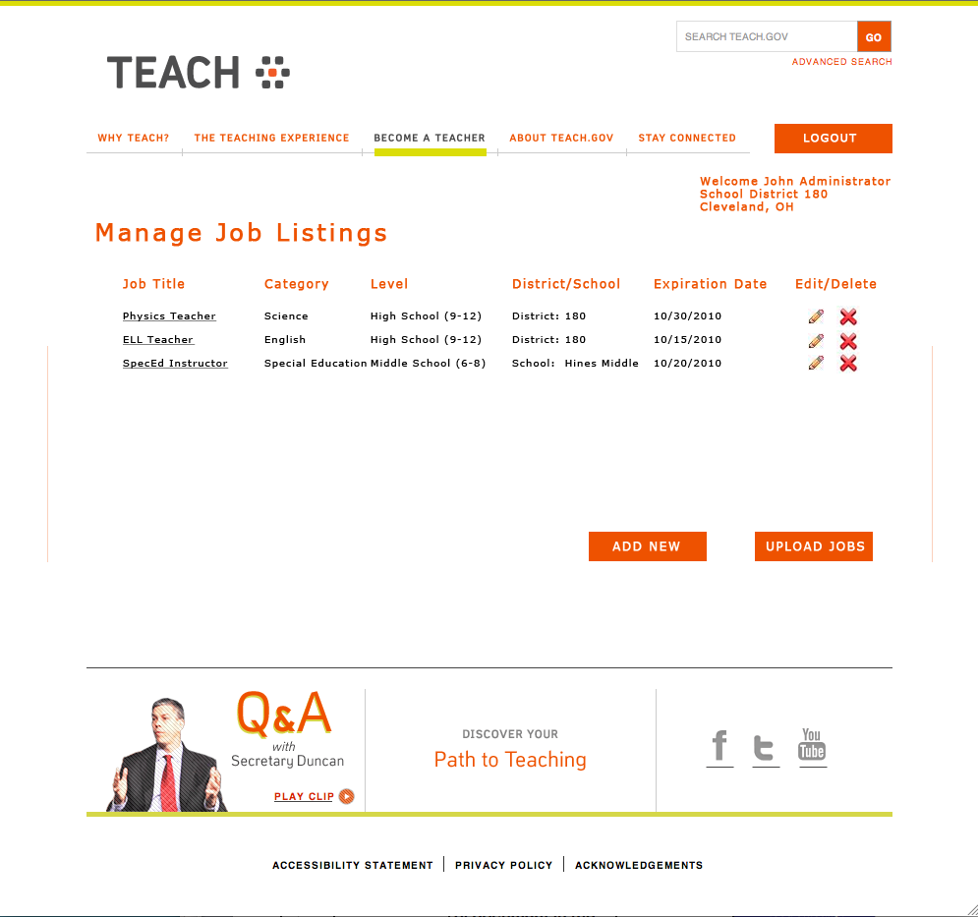

### Add A Job Listing

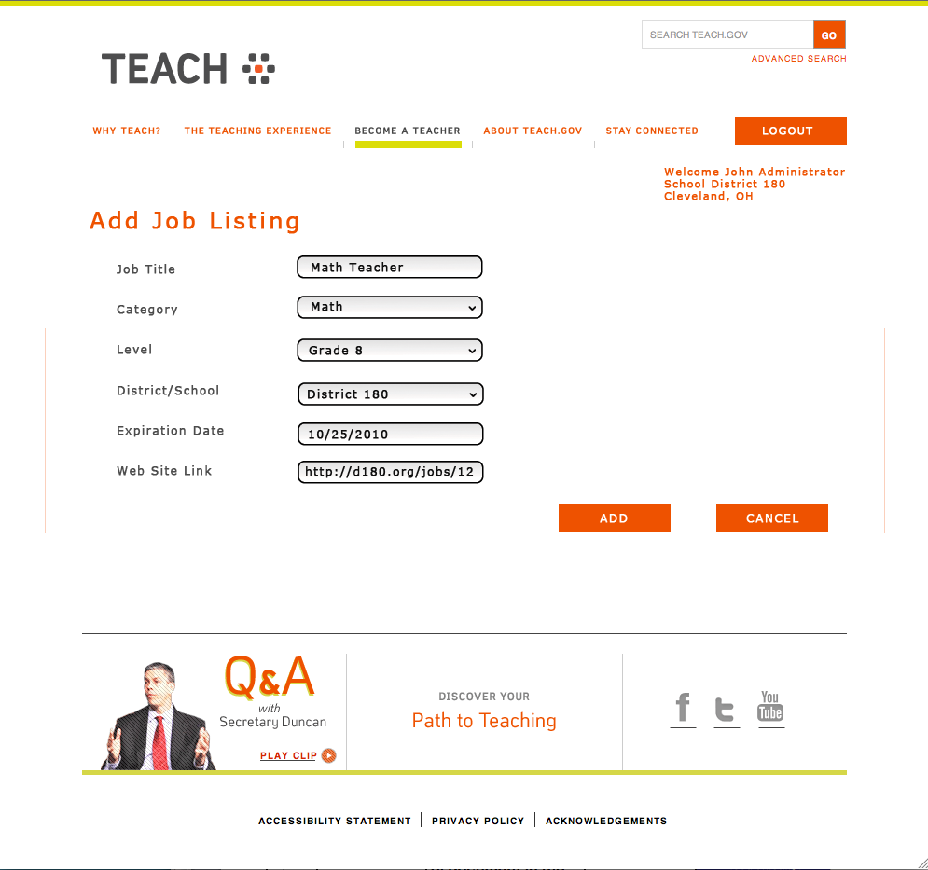

### Upload Job Listings

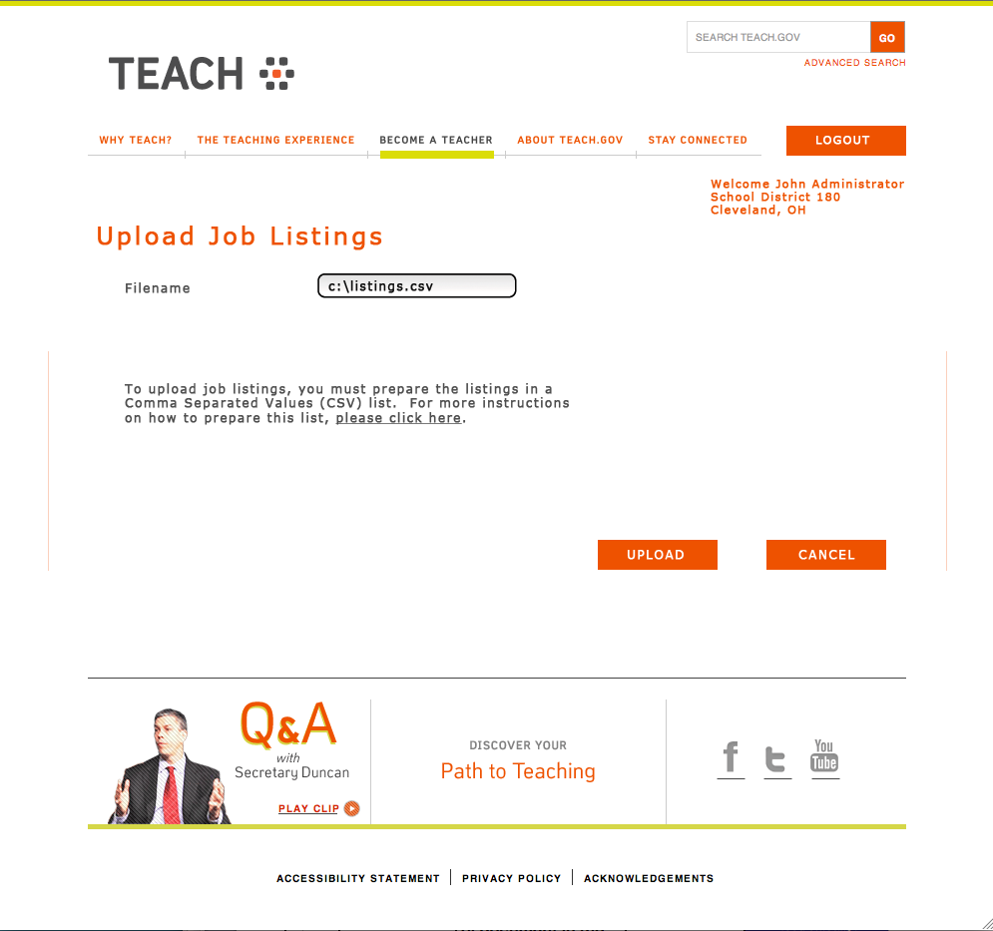

### XML Feed Process

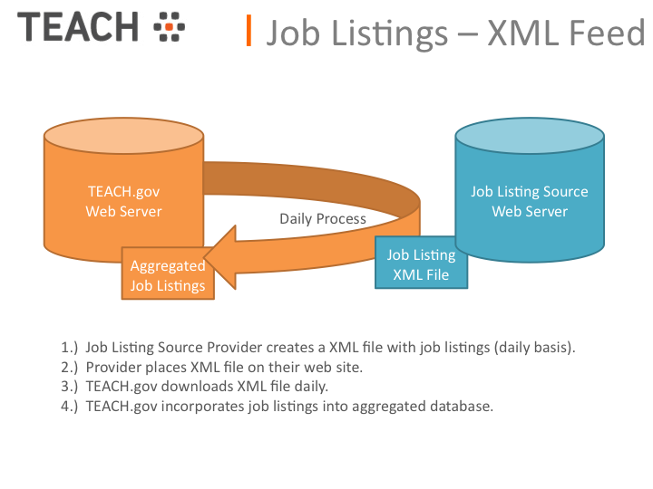

# Paperwork Burden Statement

Paperwork Burden Statement

According to the Paperwork Reduction Act of 1995, no persons are required to respond to a collection of information unless such collection displays a valid OMB control number. The valid OMB control number for this information collection is **1855-NEW**. The time required to complete this information collection is estimated to average 4.5 minutes per response, including the time to review instructions, search existing data resources, gather the data needed, and complete and review the information collection. **If you have any comments concerning the accuracy of the time estimate(s) or suggestions for improving this form, please write to:** U.S. Department of Education, Washington, D.C. 20202-4537. **If you have comments or concerns regarding the status of your individual submission of this form, write directly to:** TEACH Campaign, U.S. Department of Education, 400 Maryland Avenue, S.W., 7C111, Washington D.C. 20202-4537.

Appendix A: Acronyms and Abbreviations

The following is a listing and definition of acronyms and abbreviations referenced in this document:

|  |  |  |
| --- | --- | --- |
|  | CCD | Common Core of Data (a NCES publication) |
|  | CSV | Comma-separated values |
|  | ED | U.S. Department of Education |
|  | FIPS | Federal Information Processing Standards |
|  | LEA | Local education agency |
|  | NCES | National Center of Education Statistics |
|  | SEA | State education agency |
|  | ToS | Terms of Service |
|  | XML | Extensible Markup Language |

1. Examples: CareerBuilder.com, K12JobSpot.com, Monster.com, SchoolSpring.com, TeacherJobs.com, Teachers-Teachers.com, etc.